2

**REACT JS**



React was created by **Jordan Walke,** a software engineer at [Meta](https://en.wikipedia.org/wiki/Meta_Platforms), who initially developed a prototype called "F-Bolt"[[45]](https://en.wikipedia.org/wiki/React_(JavaScript_library)#cite_note-How_A_Small_Team_of_Developers_Created_React_at_Facebook_|_React.js:_The_Documentary-45) before later renaming it to "FaxJS". This early version is documented in Jordan Walke's GitHub repository.[[1]](https://en.wikipedia.org/wiki/React_(JavaScript_library)#endnote_Walke,_Jordan._%22FaxJS.%22_GitHub._https://github.com/jordwalke/FaxJs._Accessed_11_July_2019.) Influences for the project included [XHP](https://en.wikipedia.org/wiki/XHP), an [HTML](https://en.wikipedia.org/wiki/HTML) component library for [PHP](https://en.wikipedia.org/wiki/PHP).

-React was first deployed on Facebook's [News Feed](https://en.wikipedia.org/wiki/News_Feed) in 2011 and subsequently integrated into [Instagram](https://en.wikipedia.org/wiki/Instagram) in 2012 [[*citation needed*](https://en.wikipedia.org/wiki/Wikipedia:Citation_needed)]. In May 2013, at JSConf US, the project was officially open-sourced, marking a significant turning point in its adoption and growth.[[2]](https://en.wikipedia.org/wiki/React_(JavaScript_library)#endnote_H%C3%A1mori,_Emergent._%22React_-_The_Pragmatic_Guide.%22_2022.)

-[React Native](https://en.wikipedia.org/wiki/React_Native), which enables native [Android](https://en.wikipedia.org/wiki/Android_(operating_system)), [iOS](https://en.wikipedia.org/wiki/IOS), and [UWP](https://en.wikipedia.org/wiki/Universal_Windows_Platform) development with React, was announced at Facebook's React Conf in February 2015 and open-sourced in March 2015.

-story of React.js begins in 2010, when Jordan Walke, a software engineer at Facebook, created an early prototype of React.js called "FaxJS." Walke was inspired by XHP, an HTML component library for PHP. He wanted to create a similar library for JavaScript that would make it easier to build and maintain complex user interfaces.

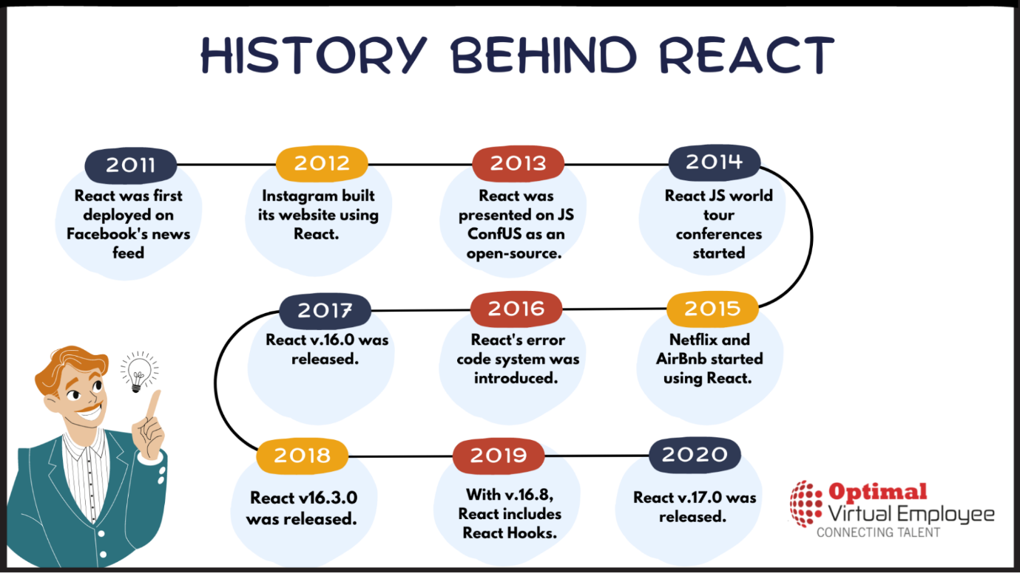

**HISTORY**

**The need for a better code**

-Back in 2011, the developers at Facebook started to face some issues with code maintenance. As the Facebook Ads app got an increasing number of features, the team needed more people to keep it running flawlessly. The growing number of team-members and app-features slowed them down as a company. Over time, their app became difficult to handle, as they faced a lot of cascading updates.

-After a while, engineers at Facebook couldn’t keep up with these cascading updates. Their code demanded an urgent upgrade to become more efficient.

-They had the model right, but they needed to do something about user experience. So, Jordan Walke built a prototype that made the process more efficient, and this marks the birth of React.js.  
([source](https://www.youtube.com/watch?v=KVZ-P-ZI6W4&t=0s&list=PLb0IAmt7-GS1cbw4qonlQztYV1TAW0sCr&index=1))

**Let’s look at the history of React.js on a timeline**

From 2010 until now (March 2018):

*-We got a feedback that certain dates were incorrect in our timeline: React was open sourced in May, during the JS ConfUS 2013, and React London 2014 was held on April 7-9. Now, we have updated our timeline. Please, if you find any other inaccuracies, do let us know in the comment section below or on Twitter.*

**2010 – The first signs of React**

* [Facebook introduced xhp into its php stack](https://www.facebook.com/notes/facebook-engineering/xhp-a-new-way-to-write-php/294003943919/) and open sourced it.  
  Xhp allowed creating composite components. They introduced this syntax later in React.

**2011 – An early prototype of React**

* Jordan Walke created [FaxJS](https://github.com/jordwalke/FaxJs), the early prototype of React – shipped a search element on Facebook.

**2012 – Something new had started at Facebook**

* Facebook Ads became hard to manage, so Facebook needed to come up with a good solution for it. Jordan Walke worked on the prototype and created React.
* April 9: [Instagram was acquired by Facebook.](http://money.cnn.com/2012/04/09/technology/facebook_acquires_instagram/index.htm)  
  Instagram wanted to adopt Facebook’s new technology. By this, Facebook had a pressure to decouple React from Facebook and make it open-sourceable. Most of this was done by Pete Hunt.
* Sept 8-12: [TechCrunch Disrupt San Francisco](https://techcrunch.com/2012/09/11/mark-zuckerberg-our-biggest-mistake-with-mobile-was-betting-too-much-on-html5/), Mark Zuckerberg: “Our Biggest Mistake Was Betting Too Much On HTML5”. He promised that Facebook would deliver better mobile experiences very soon.

**2013 – The year of the Big Launch**

* May 29-31: JS ConfUS. [Jordan Walke introduced React](https://www.youtube.com/watch?v=GW0rj4sNH2w). **React gets open sourced**. *Fun Fact: The audience was skeptical. Most people thought React was a huge step backward. This happened as mostly ‘early adopters’ attended this conference, however, React targeted ‘innovators.’ The creators of React realized this mistake on time, and decided to start a ‘React tour’ later on to turn haters into advocates.*
* June 2: React (by Facebook) [is available on JSFiddle](https://twitter.com/jsfiddle/status/341114115781177344?ref_src=twsrc%5Etfw&ref_url=https%3A%2F%2Freactjs.org%2Fblog%2F2013%2F06%2F02%2Fjsfiddle-integration.html)
* July 30: [React and JSX in available in Ruby on Rails](https://reactjs.org/blog/2013/07/30/use-react-and-jsx-in-ruby-on-rails.html)
* August 19: [React and JSX available in Python Applications](https://reactjs.org/blog/2013/08/19/use-react-and-jsx-in-python-applications.html)
* Sept 14-15: JSConfEU 2013. Pete Hunt’s speech of [rethinking best practices](https://www.youtube.com/watch?v=x7cQ3mrcKaY).
* Dec 17: David Nolen [Introduces OM, based on React](http://swannodette.github.io/2013/12/17/the-future-of-javascript-mvcs). Explains how React is awesome – which reached early adopters. This article showed how React is better than the other alternatives out there, which boosted the acknowledgement of React.

**2014 – The year of Expansion**

React had gradually gained its reputation and started to go through to ‘early majority’ of its potential users. At this point, they needed a new message instead of solely relying on its technical benefits, and it is: how is React stable? By focusing on this, they aimed to appeal to enterprises, like Netflix.

* Early 2014: #reactjsworldtour conferences started, to build community and to ‘turn haters into advocates’.
* Jan 2: [React Developer Tools](https://reactjs.org/blog/2014/01/02/react-chrome-developer-tools.html) becomes an extension of the Chrome Developer Tools.
* February: Atom was introduced – A hackable text editor for the 21st Century
* April 7-9: [React London 2014](http://reactconf.org/2014/london/)
* June: [ReactiveX.io](http://reactivex.io/intro.html) emerged.
* July 13: The Release of [React Hot Loader](https://github.com/gaearon/react-hot-loader). React Hot Loader is a plugin that allows React components to be live reloaded without the loss of state.
* Dec 12: [PlanOut](https://github.com/facebookarchive/planout): A language for online experiments. The release of PlanOut 0.5, which includes a React-based PlanOut language editor, and brings the interpreter into feature-parity with the latest version of PlanOut used internally at Facebook.

**2015 – React is Stable**

* Early 2015: Flipboard releases [React Canvas](https://github.com/Flipboard/react-canvas).
* January: [Netflix likes React](https://medium.com/netflix-techblog/netflix-likes-react-509675426db)
* Early 2015: Airbnb uses React
* January 28-29: React.js Conf 2015 – Facebook released the [first version of React Native](https://www.youtube.com/watch?v=KVZ-P-ZI6W4&t=0s&list=PLb0IAmt7-GS1cbw4qonlQztYV1TAW0sCr&index=1)for the React.js Conf 2015 during a technical talk.
* February: [Introducing Relay and GraphQL](https://reactjs.org/blog/2015/02/20/introducing-relay-and-graphql.html) at React.js Conf.
* March 25: Facebook announced that [React Native for iOS is open and available on GitHub](https://code.facebook.com/posts/754869551286944/f8-big-technology-bets-and-open-source-announcements/).
* June 2: Redux was released by Dan Abramov and Andrew Clark.
* Sept 2: The first stable version of the new [React Developer Tools](https://reactjs.org/blog/2015/09/02/new-react-developer-tools.html) launched.
* Sept 14: [React Native for Android](https://code.facebook.com/posts/1189117404435352/) was released.

**2016 – React gets mainstream**

* March: The introduction of [Mobx](https://mobx.js.org/index.html)
* February 22-23: [React.js Conf 2016](https://www.youtube.com/watch?v=MGuKhcnrqGA&list=PLb0IAmt7-GS0M8Q95RIc2lOM6nc77q1IY&t=0s&index=1), San Francisco
* [Draft.js was introduced](https://www.youtube.com/watch?time_continue=3&v=feUYwoLhE_4) at React.js Conf by Isaac Salier-Hellendag
* March: The introduction of [React Storybook](https://storybook.js.org/)
* June 2-3: [ReactEurope 2016](https://2016.react-europe.org/)
* July 11: Introducing React’s [Error Code System](https://reactjs.org/blog/2016/07/11/introducing-reacts-error-code-system.html).
* November: the introduction of [Blueprint](http://blueprintjs.com/) – A React UI toolkit for the web

**2017 – The year of further improvements**

* Early 2017: Airbnb introduces their new open source library [React Sketch.app](https://airbnb.design/painting-with-code/)
* Apr 19: [React Fiber](https://code.facebook.com/posts/1005990452878946/facebook-open-source-at-f8-2017/) gets open sourced at F8 2017.
* Sept: [Relicensing React, Jest, Flow, and Immutable.js](https://code.facebook.com/posts/300798627056246/relicensing-react-jest-flow-and-immutable-js/)
* Sept 26: [React 16: error boundaries, portals, fragments and the Fiber architecture](https://reactjs.org/blog/2017/09/26/react-v16.0.html)
* October: [Netflix removes client-side React.js](https://twitter.com/NetflixUIE/status/923374215041912833)
* November 28: React v16.2.0: [Improved Support for Fragments](https://github.com/facebook/react/releases/tag/v16.2.0)

**2018 – What’s up with React now?**

* March 1-2: [JSConf Iceland](https://2018.jsconf.is/) – [Beyond React 16 by Dan Abramov](https://reactjs.org/blog/2018/03/01/sneak-peek-beyond-react-16.html)
* 2018 March 29: [React 16.3.0](https://reactjs.org/blog/2018/03/29/react-v-16-3.html) was released.

**LIBRARY**

-In Library Your code is calling to Library.

-In case of Library there is more freedom.

-The Developer Also Create their own libraries.

**Pros of libraries**

-There are several benefits to using programming libraries:

* **Reusability**: Programming libraries allow you to reuse code that has already been written and tested, saving you time and effort. This means you don’t have to reinvent the wheel whenever you want to perform a common task.
* **Quality**: Programming libraries are typically well-tested and debugged, so you can be confident that the code is reliable and will work as intended.
* **Maintainability**: Programming libraries can make maintaining your code easier over time. Since the library code is separate from your code, you can update or upgrade the library without affecting your codebase.
* **Community support**: Many popular programming libraries have large user bases and active communities, so you can often find help or resources online if you have questions or run into issues.
* **Standardization:** Programming libraries help ensure that your code is consistent and follows established best practices. This can make it easier for other developers to understand and work with your code.
* **Encapsulation**: Ignores global state management issues like HTTP and routing in favor of concentrating directly on the functionality that the library implements.
* **Developer time:** Lowers the cost of developing applications by providing pre-built solutions to handle random tasks.

**Cons of libraries**

There are equally some potential drawbacks to using programming libraries:

* **Dependencies**: Using programming libraries can introduce dependencies into your codebase. This means that if the library changes or is no longer supported, it could break your code or require you to make changes. This is particularly a problem with dynamic libraries.
* **Bloat**: Depending on the size and complexity of the library, it could add unnecessary bloat to your codebase, which could impact the performance of your application.
* **Compatibility**: Not all libraries are compatible with all programming languages or platforms. This means you may have to choose a different library or find a way to make it work with your technology stack.
* **Lack of control**: When you use a programming library, you have to rely on its functionality. This means you may have less control over how a particular task is performed than writing your code from scratch.
* **Learning curve**: Using a new programming library can take time to learn and understand. This can be a barrier for some developers, especially if the library has a steep learning curve or needs better documentation.
* **Performance**: A [wrapper](https://www.ionos.com/digitalguide/websites/web-development/what-is-a-wrapper/%22%20%5Ct%20%22_blank) is required when using a library in an unsupported environment, which slows the application.

**FRAMWORK**

**-**In case of Framework the Framework Is calling to Code then after that your code is calling to Library.

-In case of Framework there are more restricted rules it makes developer to complicated to write a code.

**Pros of Frameworks**

-There are several benefits to using frameworks in programming:

* **Structure and organization**: Frameworks provide structure and organization for your code, making it easier to develop and maintain common types of applications by bringing together the libraries and tools needed. This can be especially helpful for large or complex projects.
* **Reusability**: Frameworks often include reusable components or libraries that can save you time and effort. This means you can write less code from scratch and offers quicker solutions for web development.
* **Best practices**: Frameworks often embody established best practices and design patterns, which can help ensure that your code is well-designed and maintainable.
* **Community support**: Many popular frameworks have large user bases and active communities, so you can often find help or resources online if you have questions or run into issues.
* **Scalability**: Frameworks are often designed with scalability in mind, which means they can handle large requests or traffic without performance issues. This can be especially important for applications that are expected to grow or have high usage levels.
* **Encapsulation**: The entire application is unaffected by a change to a single component.
* **Compatibility**: Encourages the development of cross-platform applications.
* **Quality**: Creates rich, [dynamic content](https://www.omniconvert.com/what-is/dynamic-content/%22%20%5Cl%20%22:~:text=Dynamic%20content%20(aka%20adaptive%20content,a%20user%20requests%20a%20page.%22%20%5Ct%20%22_blank) that offers a better user experience with less skill required.
* [**Data binding**](https://www.techtarget.com/whatis/definition/data-binding%22%20%5Ct%20%22_blank): Because several JavaScript frameworks, like Angular, are built on a common architectural pattern called [MVC](https://www.tutorialspoint.com/mvc_framework/mvc_framework_introduction.htm%22%20%5Ct%20%22_blank).

**Cons of frameworks**

There are a few potential drawbacks to using frameworks in programming:

* Complexity: Some frameworks can be complex and have a steep learning curve, which can be intimidating for beginner developers.
* Limited flexibility: Frameworks often have a specific way of doing things, which can be inflexible if you want to do something outside the framework’s scope. Also, a framework’s ready-to-use features restrict programmers from fully knowing the programming language.
* [Performance overhead](https://cs.stackexchange.com/questions/23591/how-do-people-measure-performance-overhead%22%20%5Ct%20%22_blank): Some frameworks can add a performance overhead, which can impact the speed of your application.
* Dependency on the framework: If you build your application using a specific framework, you may become reliant on it, making it more challenging to switch to a different one.
* Lock-in: Using a framework can also lead to lock-in, where you are tied to a specific set of technologies and unable to switch to alternatives easily.
* Complexity: For example. in MVC, separating the presentation layer from the business logic might be challenging.
* Compatibility: Only a browser environment that supports JavaScript can use JavaScript frameworks.
* Unexpected consequences: As an example, if recommended framework guideline is not followed while developing, there is a chance of a security breach.

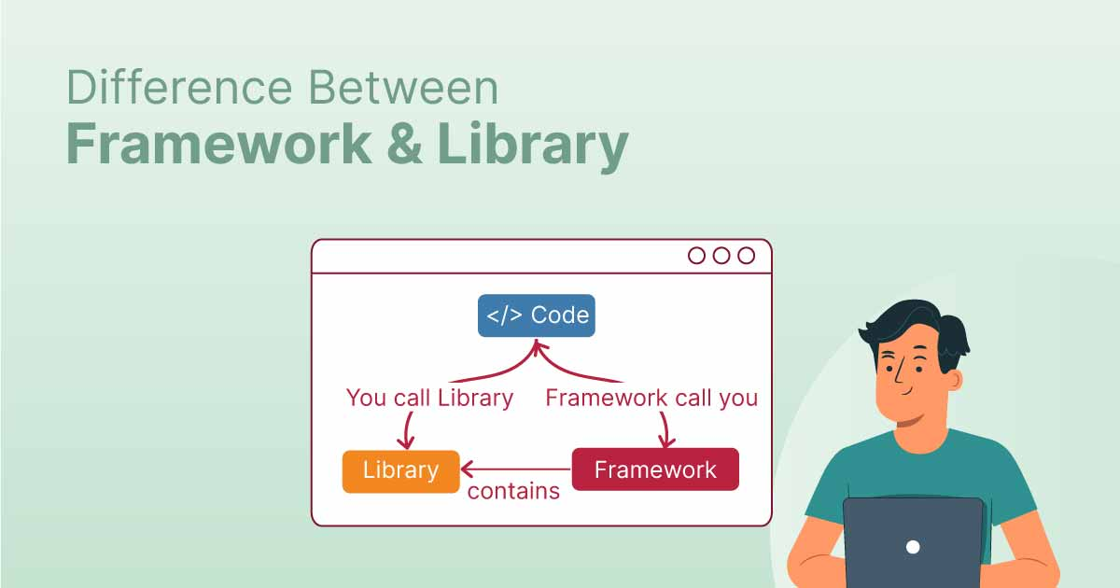

|  |  |  |
| --- | --- | --- |
| **Parameters** | **Library** | **Framework** |
| Definition | Libraries provide developers with predefined functions and classes to make their work easier and boost the development process. | Framework, on the other hand, is like the foundation upon which developers build applications for specific platforms. |
| Inversion of Control | By using a library, you can control the flow of the application and call the library. | In contrast, when you use a framework, the control is inverted, i.e., the framework controls the flow and calls your code. |
| Collection | Generally, libraries are a collection of helper modules, objects, classes, functions, message templates, pre-written code, etc. | Frameworks consist of a lot of APIs, compilers, toolsets, support programs, libraries, etc. |
| Code Modification | Codes in libraries are geared toward a particular program or to solve a specific development problem. Therefore, developers must modify library code to meet their needs. | Despite the fact that frameworks generate new codes for developers. These codes cannot be altered or modified later. Unlike libraries, frameworks do not allow users to modify their pre-written codes, so you don’t have to worry about deleting or changing them. |
| Scope | It is possible to call a library out of context. You may use the library wherever you see fit in your code. | On the other hand, you can only call and use what belongs to a Framework within the same Framework. |
| Function | In the program linking and binding process, they play an important role. | Using them, you can build and deploy applications in a standard way as the framework already provides code to perform common tasks and uses code provided by a developer for custom functionality. |
| Complexity | Having a library means understanding the functionality of each method, and it isn’t easy to create complex interactions since you need to call many methods to get the desired results. | Frameworks, on the other hand, embody the basic flow, and since plugins need to be added to code, it is easier to do the right modification. |
| Extensibility | Generally, libraries aren’t designed for extensibility; they are designed to accomplish a specific purpose. | Frameworks provide general functionality. Because of this, they are built to be extensible, which allows developers to incorporate app-specific features without modifying the framework’s source code. |
| Replaceable | It is easy to replace a library with another library. For instance, if you do not like the jQuery date picker library, you can use another date picker like a bootstrap date picker or pick date. | Frameworks are difficult to replace. If, for instance, you were using AngularJS to build your product, you cannot simply swap it out for another framework. It requires rewriting the entire codebase. |
| Performance | Less code is required to build libraries, which leads to faster loading times and better performance. | Developing a framework requires a lot of coding, which increases loading times and decreases performance. |
| Usage | The purpose of libraries is to perform a defined and specific task. Eg: Image manipulation, network protocols, math operations, etc. | Frameworks can be used for performing a wide range of tasks. Among these are Web application systems, plug-in managers, GUI systems, and so on. |
| Existing Projects | You can integrate libraries seamlessly into existing projects to add functionality. | Incorporating frameworks seamlessly into an existing project is impossible. Instead, frameworks should be used when starting a new project. |
| Benefits | Good code quality, reusability, and control, enhanced speed and performance of the program, etc. | Faster programming, support from the community, great support for MVC (Model View Controller) pattern, etc. |
| Examples | JQuery, React JS, etc. | Spring, NodeJS, AngularJS, Vue JS, etc. |

|  |  |  |
| --- | --- | --- |
|  | Library | Framework |
| Control | User controls the application flow | Framework controls the application flow |
| Integration | Can be easily linked into existing programs | Difficult to incorporate into existing projects |
| Development | Requires less code, improving performance and load time | Requires large amounts of code, reducing performance and increasing load time |
| Use | Collection of functions that other programs can use | Set of rules for how a project is organized |
| Comparison | Like a tool, such as a hammer or screwdriver | Like a set of blueprints for building a house |

-Libraries and frameworks are both collections of pre-written code that developers can use to speed up the creation of software programs. They both offer classes or functions that can carry out typical activities, such as communicating with databases, managing user input, or producing graphics.

-For Example in general Your Home Is Library and Your School Is Framework. In School there are certain rules or protocols you have followed like there is time limit or there place you put your school bag. Unlike Home there are is also rules but you can ignored it not strictly followed you put your bag anywhere.

**WEBSITE**

**What is Website?**   
Website is the collection of web pages, different multimedia content such as text, images, and videos which can be accessed by the URL which you can see in the address bar of the browser. For example: [https://www.geeksforgeeks.org](https://www.geeksforgeeks.org/) .

**How to access Websites?**   
When we type a certain URL in a browser search bar, the browser requests the page from the Web server and the Web server returns the required web page and its content to the browser.

**Types of Website:**

* Static Website
* Dynamic Website

**Static Website:**

-These websites are made up of individual HTML files and display fixed content that doesn't change. They don't interact with users or change in real time. Static websites are built using HTML, CSS, and JavaScript.

-In Static Websites, Web pages are returned by the server which are prebuilt source code files built using simple languages such as HTML, CSS, or JavaScript. There is no processing of content on the server (according to the user) in Static Websites. Web pages are returned by the server with no change therefore, static Websites are fast. There is no interaction with databases. Also, they are less costly as the host does not need to support server-side processing with different languages.

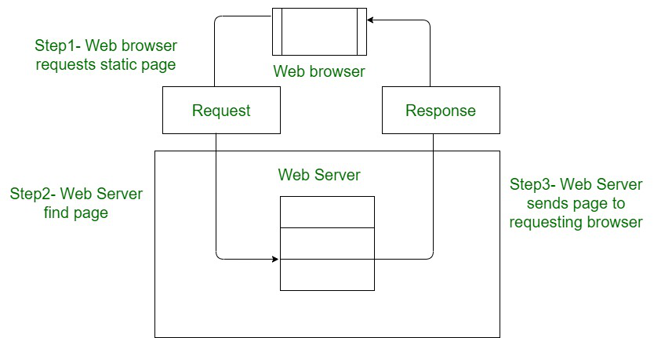

**Dynamic Website:**

-These websites use back-end code to build each web page on the fly, allowing them to change based on the user, time, or other factors. They can adjust to the viewer's screen size, change language automatically, and provide custom recommendations. Dynamic websites use server-side languages like PHP, Ruby, Python, and server-side JavaScript.

-In Dynamic Websites, Web pages are returned by the server which are processed during runtime means they are not prebuilt web pages but they are built during runtime according to the user’s demand with the help of server-side scripting languages such as PHP, Node.js, ASP.NET and many more supported by the server. So, they are slower than static websites but updates and interaction with databases are possible.

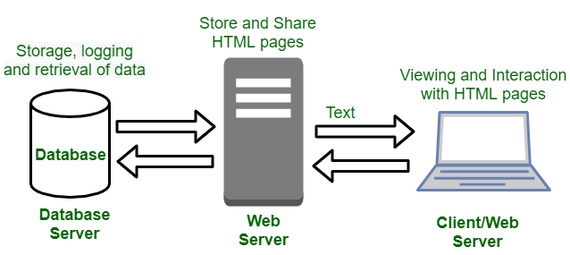

**Difference Between Static Website and Dynamic Website**

-The main difference between static and dynamic websites is that static websites display the same content to all users, while dynamic websites can change based on the user or other factors:

|  |  |
| --- | --- |
| Static Website | Dynamic Website |
| Content of Web pages cannot be change at runtime. | Content of Web pages can be changed. |
| No interaction with database possible. | Interaction with database is possible. |
| It is faster to load as compared to dynamic website. | It is slower than static website. |
| Cheaper Development costs. | More Development costs. |
| No feature of Content Management. | Feature of Content Management System. |
| HTML, CSS, Javascript is used for developing the website. | Server side languages such as PHP, Node.js are used. |
| Same content is delivered everytime the page is loaded. | Content may change everytime the page is loaded. |

**Differences Between Web Application And Website:**

|  |  |
| --- | --- |
| Web Application | Website |
| Web application is designed for interaction with end users. | Website basically contains static content. |
| The user of web application can read the content of web application and also manipulate the data. | The user of website only can read the content of website but not manipulate . |
| The web application site should be precompiled before deployment. | The website does not need to be precompiled . |
| The function of a web application is quite complex. | The function of website is simple. |
| Web application is interactive for users. | Web site is not interactive for users. |
| The browser capabilities involved with a web application is high. | The browser capabilities involved with web site is high. |
| Integration is complex for web application because of its complex functionality. | Integration is simpler for web site. |
| Web application mostly requires authentication | In web site authentication is not necessary. |
| EXAMPLE :- Amazon, Facebook, etc. | EXAMPLE :- Breaking News, Aktu website, etc. |

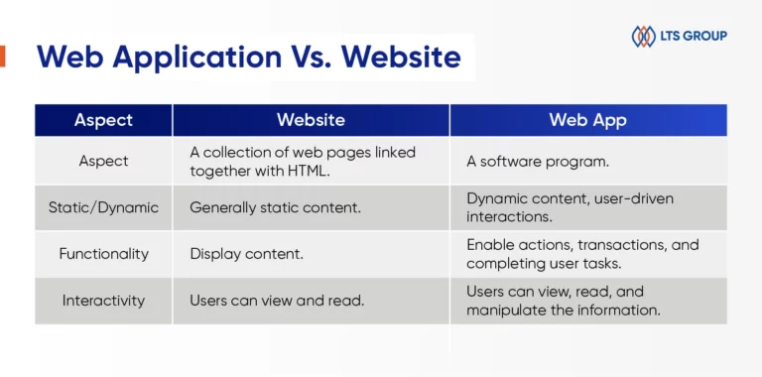

**Difference Between WebApp And Android App**

-The main difference between a web app and an app is that web apps are accessible through a browser and don't need to be installed on a device, while apps are built for a specific platform and need to be installed on a device

Other differences include:

* **Platform**

Web apps work on any platform, device, and version of the system, while apps are built for a specific platform or device type.

* **Development**

Web apps are built using technologies like JavaScript, CSS, HTML, and Python, while apps are built using platform-specific technologies.

* **Features**

Apps may have more complex features and functionalities than web apps, and may have access to system resources like GPS and the camera.

* **Offline** **use**

Apps may work offline, while web apps do not.

* **Testing**

Web app testing ensures quality, functionality, and usability, while app testing refers to testing application software for controlling and handling mobile devices.

| **Mobile Apps[Native] Apps** | **Web Apps** |
| --- | --- |
| Mobile apps are developed for a specific platform, such as iOS for the Apple iPhone or Android | On the other hand, Web Apps are accessed via the internet browser and will function according to the device you’re viewing them on |
| They are downloaded and installed via an app store such as Google Play Store and Apple Store and have access to system resources, such as GPS and the camera of the device. | Web apps are not native to a particular system and there is no need to be downloaded or installed. |
| Mobile apps may work offline. | In order to run web apps need an active internet connection. |
| Native Apps are comparatively faster. | Web Apps are comparatively slower. |
| It is difficult to have a native mobile app approved by the App Store. | In Web Apps App store approval is not required, so web apps can be launched easily. |
| Native apps have more safety and security. | Web apps have comparatively low security. |
| Maintaining and consistently update of native apps cause more cost. | These apps can be set to update themselves or automatically. |

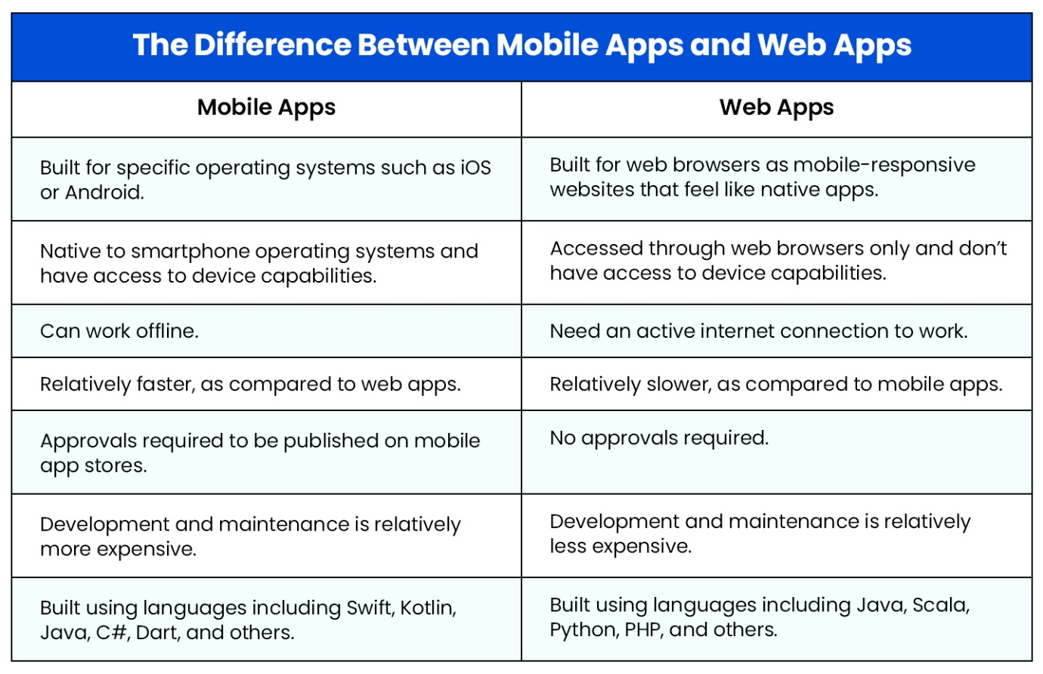

**Difference Between Reloading and Refreshing**

In a browser, refreshing a page requests a new version of the document, while reloading a page clears and starts fresh if something isn't downloading correctly:

|  |  |  |
| --- | --- | --- |
| SrNo | Refresh | Reloading |
| 1 | Requests the latest version of a document | Clears everything and starts fresh if something isn't downloading correctly |
| 2 | Attempts to fetch any recent updates from the server without necessarily clearing the entire cached page, potentially loading faster if only minor changes have occurred. | Forces the browser to download the entire webpage again from the server, essentially starting fresh and ignoring any cached data |
| 3 | Refresh is generally faster than reloading a page. | Reloading is slower than refreshing a page.beacuse it loads entire Page |
| 4 | It refresh Only Particular component | It reloads entire webpage. |
|  | How to Automatically Refresh a Web Page | Update modal ... |

**SINGLE PAGE WEB APPLIACTION [SPA]**

-A single-page application (SPA) only loads one page initially and dynamically updates its content within that page without reloading

**-A single-page application (SPA)** is a modern way to build apps, like the ones Google, Facebook, Twitter, and others use. SPAs are like apps that run in our web browser, and they don’t need to reload the whole page when we use them.

**Pros of Single Page Application**

Single Page Applications come with several advantages that make them a popular choice for web development:

1. **Performance:** SPAs tend to be faster after the initial page load. This is because HTML, CSS, and scripts are loaded just once, and only data is transmitted between the server and the user.
2. **Improved User Experience:**SPAs offer a better user experience by providing faster responses, mobile-friendly interfaces, effortless interaction, and a linear content flow.
3. **Connectivity:** SPAs can work offline to some extent since most of the content is available after the initial load. This makes them accessible even with a poor or no internet connection.
4. **Development Speed:**Developers find SPAs developer-friendly. They require testing fewer elements, allow code reuse, and enable easy network operations monitoring.

**Cons of Single Page Application**

However, SPAs also have some drawbacks:

1. **Initial Loading Time:**SPAs may load many scripts at once, even if users don’t need all of them. This can slow down the initial loading of the first page.
2. **SEO Limitations:** SPAs can pose challenges for **search engine optimization** (SEO) since search engines don’t interpret JavaScript well. Server-side rendering with frameworks like [NextJS](https://nextjs.org/" \t "_blank) or [GatsbyJS](https://www.gatsbyjs.com/" \t "_blank)can help address this issue.

**MULTI PAGE WEB APPLIACTION [MPA]**

-While a multi-page application (MPA) loads a new, complete HTML page from the server for each navigation action, resulting in a full page refresh with every transition between sections of the website.

**-A multiple-page application (MPA)** is a more traditional approach to app development. With MPAs, every time we want to see something new, the whole web page has to reload. E-commerce companies with lots of products often prefer this approach.

**Pros of Multi-Page Application**

1. **SEO Optimization is Possible:** One major advantage of MPAs is their SEO-friendliness. Each page in an MPA has its unique URL, allowing developers to optimize them with meta tags and updated content. If attracting high website traffic and search engine optimization are essential for the business, MPAs are a great choice.
2. **Ease of Scaling:** MPAs provide a flexible canvas for developers. One can add as many pages as needed to accommodate their content and features. However, it is important to note that as the number of pages increases, performance might decrease, so careful planning is required.
3. **Analytic Capabilities:** Compared to SPAs, MPAs offer extensive opportunities for data analysis, such as tracking the number of visitors, their session durations, and target audience behavior. Analytics tools often perform better when the server manages the pages, rather than relying on the browser. While achieving these insights may require additional effort, MPAs have the upper hand in this aspect.

**Cons of Multi-Page Application**

1. **Performance Speed:** In MPAs, every time a page is refreshed or navigates to a new one, the browser has to reload and display all the content from scratch. This can lead to slower performance, especially on slower internet connections.
2. **Cost:** Unlike SPAs, which rely on client-side resources like memory and processors, MPAs require server resources. This means additional costs for hosting and maintaining servers, making them less cost-effective for some projects.

**Difference between Single Page Application and Multipage Application**

|  |  |  |  |
| --- | --- | --- | --- |
| **Sr. No** | **Features and Capabilities** | **Single-Page Application** | **Multi-Page Application** |
| **1** | **Page Navigation** | SPA Loads content dynamically within a single page. | MPA requires a full page reload for each new page. |
| **2** | **User Experience** | As SPA does not require the browser to reload the entire page, SPA offers a more seamless and interactive experience. | MPA results in slower page transitions and perceived delays as it requires the complete page to reload every time. |
| **3** | **Performance** | SPAs load faster than MPAs because they do not have to load a new page for each action. | MPAs can be slower than SPAs because they have to load a new page for each action. |
| **4** | **Development Complexity** | SPAs are more complex to develop than MPAs because they require a deeper understanding of AJAX and javascript frameworks. | MPAs can be less complex to develop than SPAs because they can be developed using traditional web development techniques. |
| **5** | **Security** | SPAs can be more difficult to secure from malicious attacks because all of the application logic is executed in the browser. | By executing the application logic on the server, MPAs can mitigate security risks. That means MPA is more secure than SPA. |
| **6** | **Offline Capabilities** | Using service workers, indexedDB, and local storage SPA provides offline functionality. | In order to load the pages browser needs the server to be accessed every time hence, MPA provides limited offline capabilities, and nearly all MPA needs an internet connection to run. |
| **7** | **Search Engine Friendliness** | SPAs require server access for page loading, resulting in limited offline capabilities. Most SPAs depend on an internet connection to function. | MPA pages are easily navigable and searchable by search engine crawlers because they are made up of multiple static pages. |
| **8** | **Application Size** | SPA has a smaller application file size because they do not need to include all of the static content in the initial download. | MPA has a larger application file size because they need to include all of the static content for each page in the initial download. This includes the HTML, CSS, and JavaScript for each page. |
| **9** | **Initial Page Load** | To provide a more seamless user experience SPA loads all necessary resources upfront. | To be indexed by search engines and to be compatible with older browsers MPA loads resources for the currently requested page only. |
| **10** | **Development Process** | The development process for SPAs is more iterative, as the application is developed and tested in the browser. | The development process for MPAs is typically more linear, as the application is developed on the server and then deployed to the browser. |

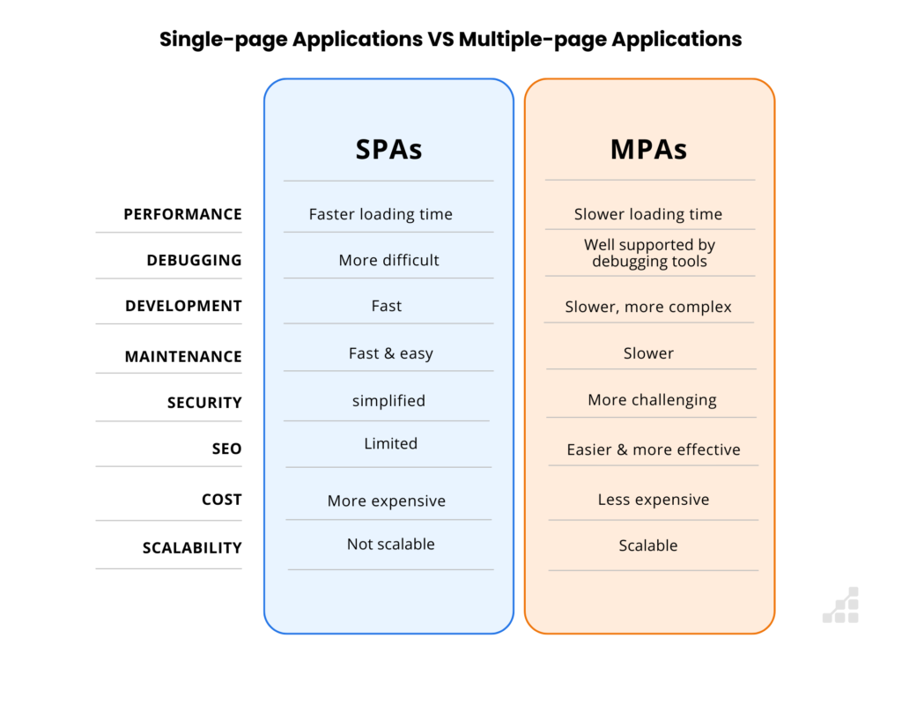

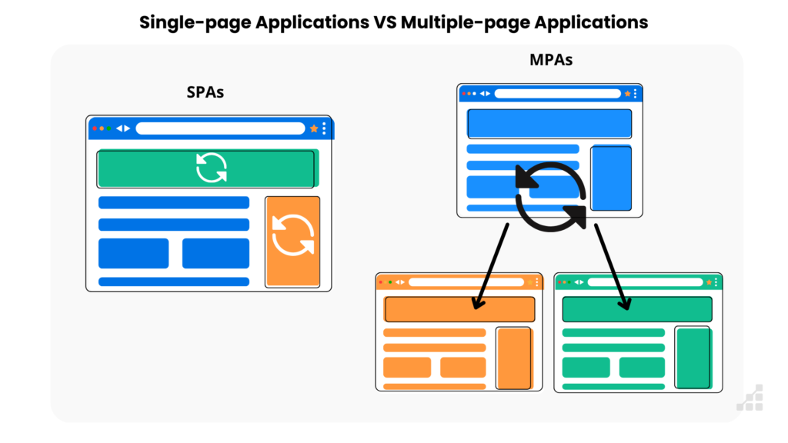

**Key differences:**

* **Page Reloading:**

In an SPA, only the necessary data is updated in the browser, whereas an MPA reloads the entire page from the server each time the user navigates to a new section.

* **User Experience:**

SPAs generally provide a smoother, more responsive user experience due to the lack of page reloads, while MPAs can feel slower with noticeable loading times between pages.

* **Development Complexity:**

SPAs can be more complex to develop due to the reliance on JavaScript to manage the dynamic updates on the client-side, while MPAs are often considered simpler to build.

**11 Reasons to Learn ReactJS in 2024**

-ReactJS is a JavaScript library, which means it is a collection of code on which many developers are working for the last decade. It allows us to build user interfaces for websites and also for other applications like Mobile apps, Desktop apps, and VR apps.

**1. Simple Prerequisites required for learning React!!!**

* [**HTML**](https://www.geeksforgeeks.org/html-tutorials/), [**CSS**](https://www.geeksforgeeks.org/css-tutorials/)(Intermediate)
* [**JavaScript**](https://www.geeksforgeeks.org/javascript-tutorial/)(Basics)

**2. Ease of use**

-React doesn’t require big lines of codes to program an application. In react, we say that everything is a component. A user writes small codes called components and combines them to form another component. Simply, any app made with React is a tree of components.

-For example, if we are building an Instagram app using ReactJS, we will have many components like a separate component for navigation, another one for the story section, also for news feed, then for profile and all other section of the application. Components are like functions. The world has seen a big jump in the increment of the number of developers switching to ReactJS.

**3.**[**DOM elements representation**](https://www.geeksforgeeks.org/reactjs-virtual-dom/)

-There is no actual DOM element in React. It has a virtual DOM. It keeps a lightweight representation of DOM in the memory. This DOM is cheap to create.

-React will compare its elements to the previous ones and figures out what is changed, and then it will update a part of the real DOM to keep it in sync with the virtual DOM. So, we need not worry about DOM in a browser if we use ReactJS. The virtual browser is better than the actual browser in case of user interaction.

**4. Build web pages, mobile apps**,**and VR apps using one technology**

With React, you can build a better website, responsive mobile apps, and VR apps. The popular website of Airbnb, Cloudflare, Dropbox, BBC, Facebook, Instagram is built using ReactJS. Some popular apps like Instagram, Facebook, New York Times, etc. are also built using ReactJS.

**5. Migration on ReactJS**

-Most of the communities that were not aware of ReactJS are now migrating to the ReactJS as it is very easy to understand and implement.

-They have started rewriting the code on ReactJS. Some top companies are Reddit, BBC, Netflix, etc. This increases the job requirement of ReactJS skills in the world.

**6. The ReactJS Documentation**

-ReactJS has its own documentation which supports developers from the beginners level to the advanced. It has very detailed information about the language, installation, and working of it. Also, there are tons of free materials available on the internet (in documentation and video lecture forms) that will help you get started with ReactJS.

**7. The active ReactJS Community**

-It has a very wide community to help the new developers. ReactJS has a better responsive and large community in comparison to the community of other JS frameworks. A huge amount of code is available on the internet and on GitHub that can be freely used by all the React developers. Some popular ReactJS communities are :

* DEV’s React Community
* Reddit’s React Community
* React flux Chat

**8. Pay Scale**

-Of course, salary is important. There are thousands of jobs in the world which demands ReactJS skills. Today react has the best pay scale on most of the job suggesting websites like LinkedIn, Glassdoor. According to research, the average salary of a ReactJS developer is about ₹733,000 and above.

**9. Top Organizations/Brands Using React JS**

-The demand for ReactJS is increasing very rapidly.

-Here is a list of top tech companies in the world that are usingReactJS as a very important technology.

* **Facebook**
* **Instagram**
* **Twitter**
* **Netflix**
* **Khan Academy**
* **WhatsApp**
* **Dropbox**
* **Code academy**
* **New York Times**
* **Tesla**
* **Amazon**
* **Uber**
* **Airbnb**

**Note:**Facebook started using React JS in 2011 for the first time and has been using it for a decade now. After Facebook started using it all other companies started following it since then.

**10. Responsive support on the internet**

-ReactJS is very responsive on Twitter. The latest news about ReactJS including the updates and changes is regularly updated on the Twitter account and on the official blog of ReactJS.

**11. React builds Single Page Static WebApp without Reloading.**

-The main Purpose of ReactJs Is Builds Single Page Static Application without Reloading the Complete Website So that’s why the Facebook Developers caught That Problems because that time in The Facebook getting one Problem When Clicking that Messaging component it will Reloaded that entire website so to recover that problem the Facebook is developed the ReactJs library.

**WHY LEARN REACTJS?**

-ReactJs is Created and maintained by the Facebook when company like facebook uses to react in its own products and invest money and resources to keep the project alive you can rest assured it s never be down anytime.

-it has More Than 100k starts on Github.s

-It has Huge Community behind it.

-React become increasingly popular among developers and is also one of the most sought of skillset by companies right now.

-Today ,many JavaScript Frameworks are available in the market(Angular,Node)use ,but still, ReactJs came into the market and gain popularity among them.

-The previous frameworks flow the traditional Data flow Structure which uses the DOM(Documented Object Model).

-Dom is an object which is created by the browser when Page is loaded.

-It dynamically adds or remove the data at the Back-End and any modification we are done then each time a new DOM is created for the same page.

-This is repeated creation of DOM makes unnecessary memory wastage and reduce the performance of the application

-Therefore a new technology ReactJs library invented which remove this drawbacks.

-Reactjs allows you to divide you entire application into various Component.

-ReactJs still use the same traditional Data flow, but is not directly operating on the browser DOM(Document Object Model)immediately, instead it operates on the Virtual DOM.

-It means rather than manipulating the document in the browser after changes to our data ,it resolve the changes on a DOM built in run entirely in Memory.

-After the virtual DOM has been updated, React determine what changes made to the actual browser DOM.

-The react Virtual DOM exist entirely in Memory and it is a representation of the web Browser DOM(Real DOM).

-Due to this when we write a React Component , we did not write directly to the DOM(Real Dom), instead we are writing the virtual components **that React will turn into the DOM(Real Dom).**

**WHAT IS REACT?**

-React is an open-source JavaScript library to building User Interfaces in effective way.

-It is Not a framework It is a Library.

-It focusing doing one thing and doing thing is really well i.e building reach user interfaces (Focus on UI).

-So React does not focus any other aspects of your application like routing or the HTTP requests it is responsible for building UI.

-So how handle routing and HTTP request and other functionality you don’t worry about ReactJS Reach Eco System and plays really well with other libraries and is and is more than capable of building full-fledged Web Application.

-By using ReactJs we create the Single Page Application.

- The main Purpose of ReactJs Is Builds Single Page Static Application without Reloading the Complete Website So that’s why the Facebook Developers caught That Problems because that time in The Facebook getting one Problem When Clicking that Messaging component it will Reloaded that entire website so to recover that problem the Facebook is developed the ReactJs library.

-React's ability to refresh a page without reloading it improves the user experience and the application's performance.

Yes, React can refresh a page without reloading the entire page:

* React component refresh

This feature can be used to update a UI without reloading the entire page. It can be used for things like updating dynamic data, handling user interactions, or triggering animations.

* Page changes without browser refresh

React can change pages within a web application without triggering a full browser refresh. This improves the user experience and the application's performance.

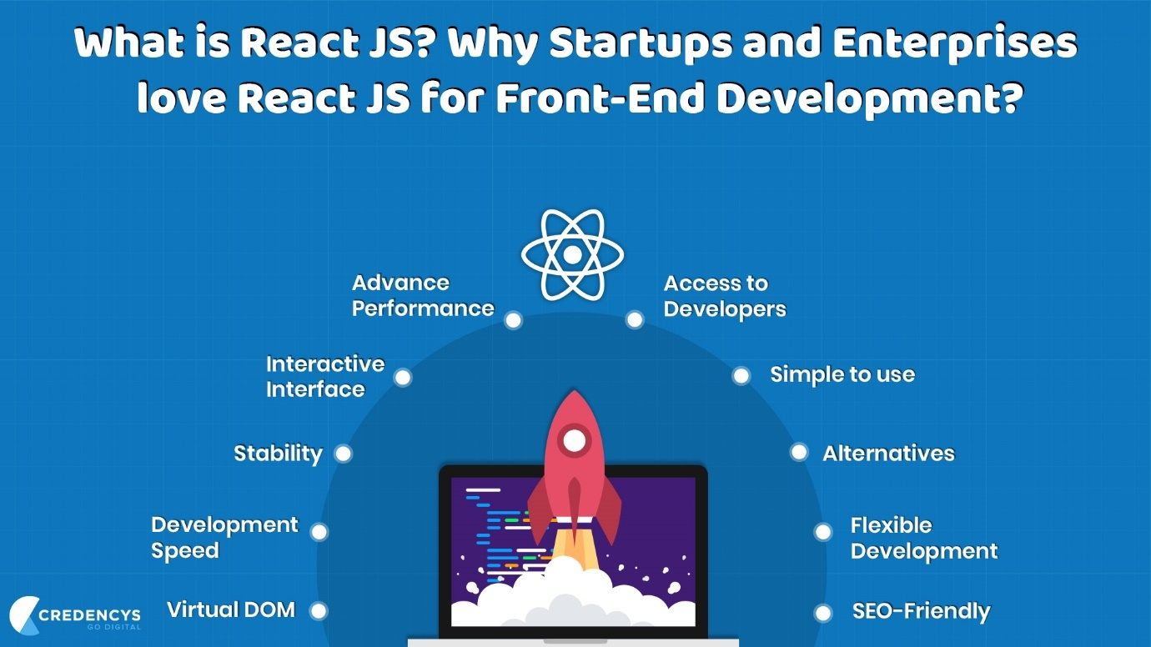

**REACT INSTALLATION SETUP**

-First You have to ensure that the Node Js is Installed.

-NodeJS is the platform needed for the ReactJS development

**Steps to Install React JS on Windows**

**Step 1**: Install Node.js installer for Windows. Click on this [link](https://nodejs.org/en/). Here, install the LTS version (the one present on the left). Once downloaded, open NodeJS without disturbing other settings, and click on the **Next**button until it’s completely installed.

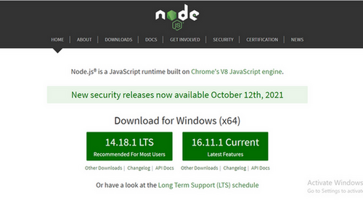

*Install the 14.18.1 LTS*

**Step 2**: Open the command prompt to check whether it is completely installed or not type the command –>

node -v

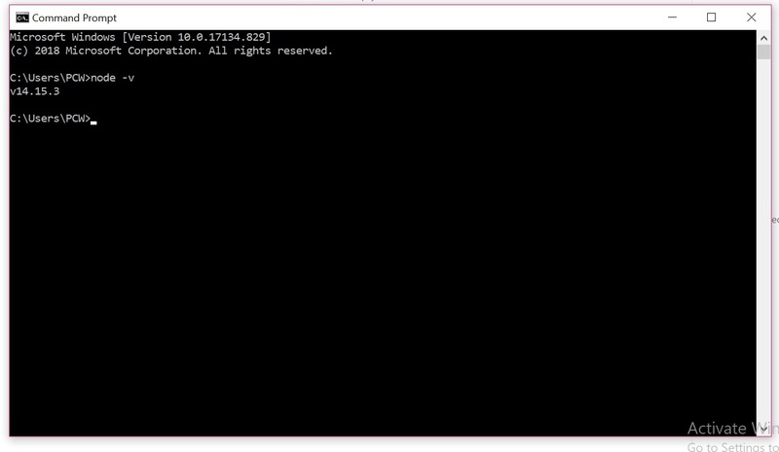

**REACT APP CREATION SETUP**

-We can create the React App in three ways

**1.Using Normal Ways/ create-react-app[ CRA ]**

**2.Using Javascript Tools[vite,nextjs]**

**3.We Use The React using CDN [Not Recommended]**

**1.NORMAL WAYS/CRA[create-react-app]**

-Basically, there are two normal ways to create the React App.

**1.By Using NPM(Node Module Manager)**

npm install create-react-app -g

Create-react-app app-name

Cd app-name

npm start

**2.By Using NPX (Node Package Execute)**

npx create-react-app my-app

cd my-app

npm start

**OTHER NORMAL WAYS**

**Create the Application**

To create the application, open the terminal and execute one of the three commands below depending on your preference between using Npx, Npm, or Yarn:

**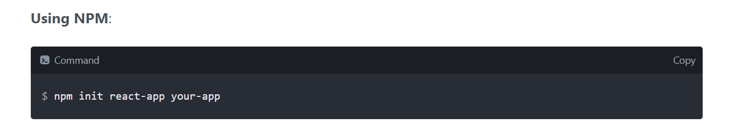**

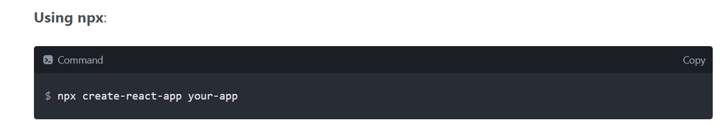

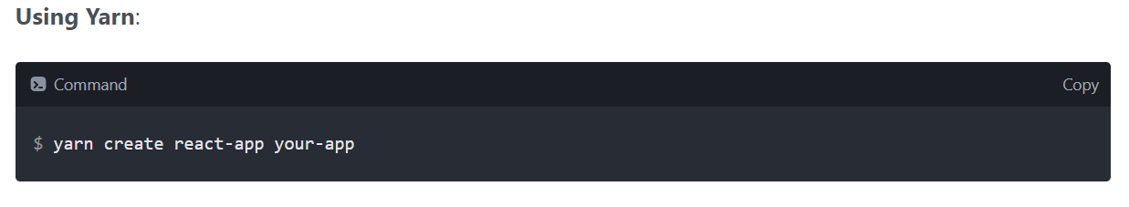

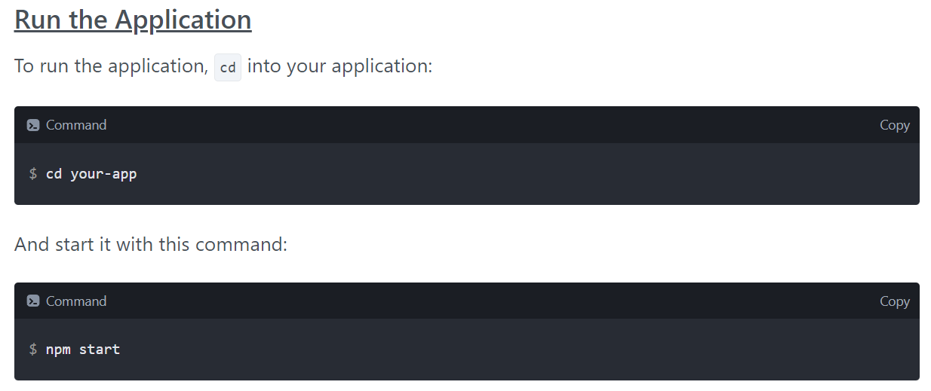

**NPM**



-**npm (Node Package Manager)** is a package manager for **JavaScript**, primarily used with **Node.js**. It allows developers to share, install, and manage reusable code packages or libraries, making it easier to build and maintain JavaScript applications.

**-npm** is the world's largest **Software Library** (Registry)

**-npm** is also a software **Package Manager** and **Installer**

-The registry contains over **800,000** codepackages.

**-Open-source** developers use **npm** to **share** software.

**-npm** is free to use.

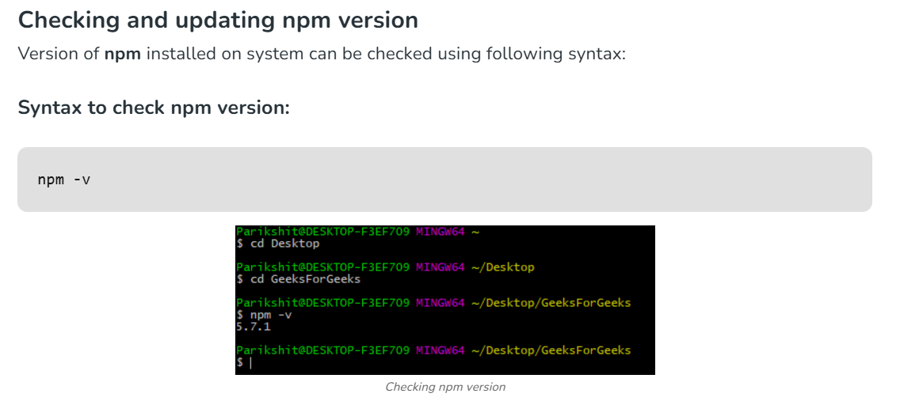

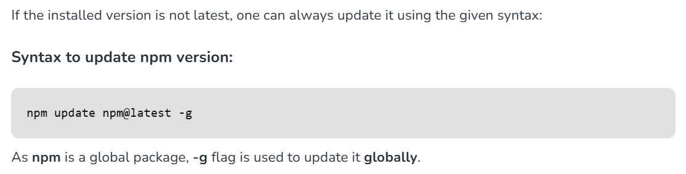



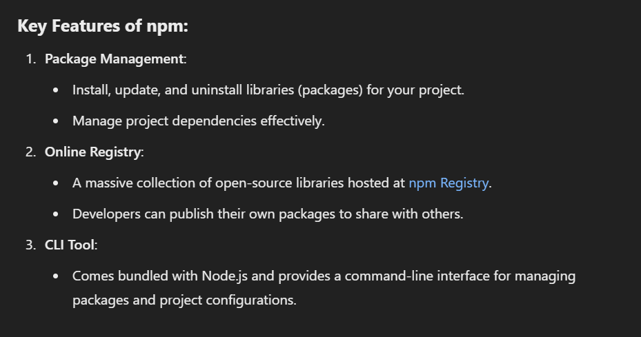

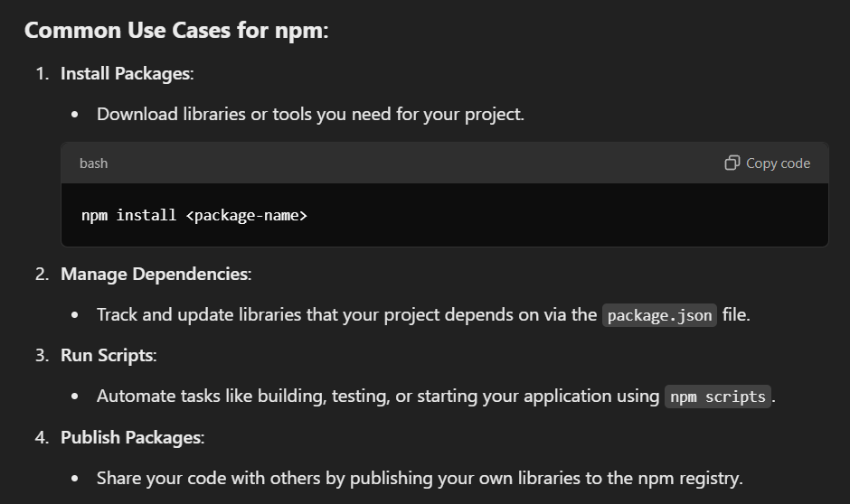

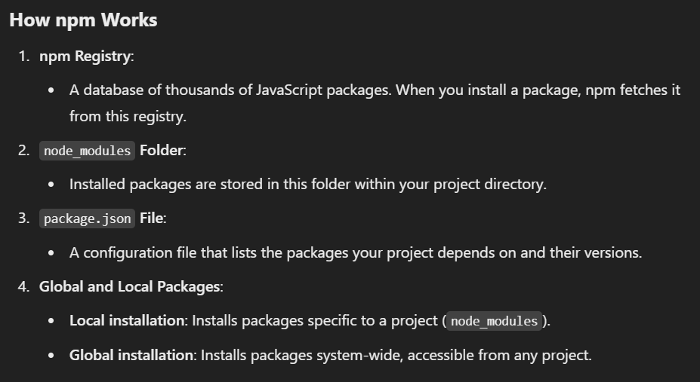

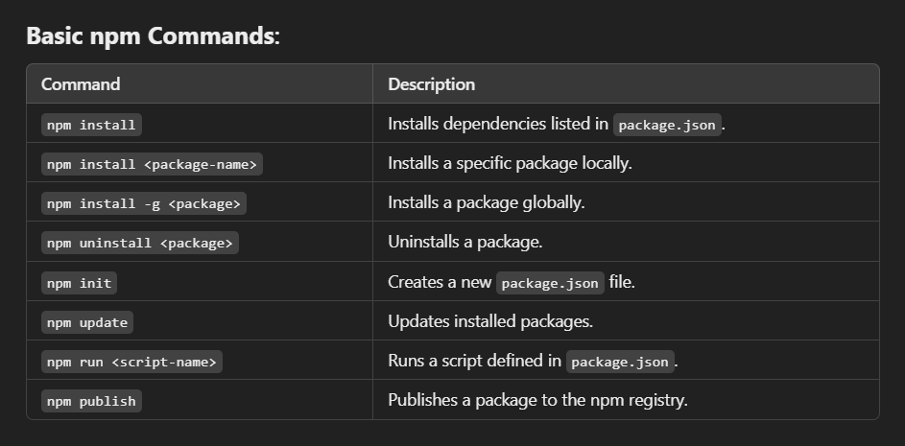

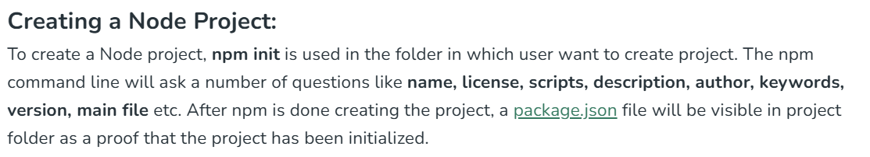

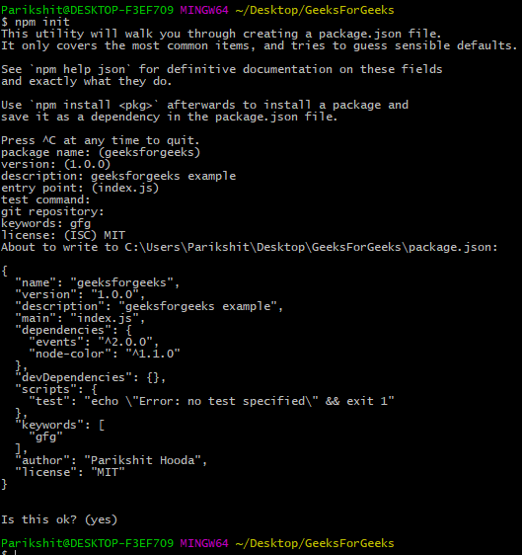

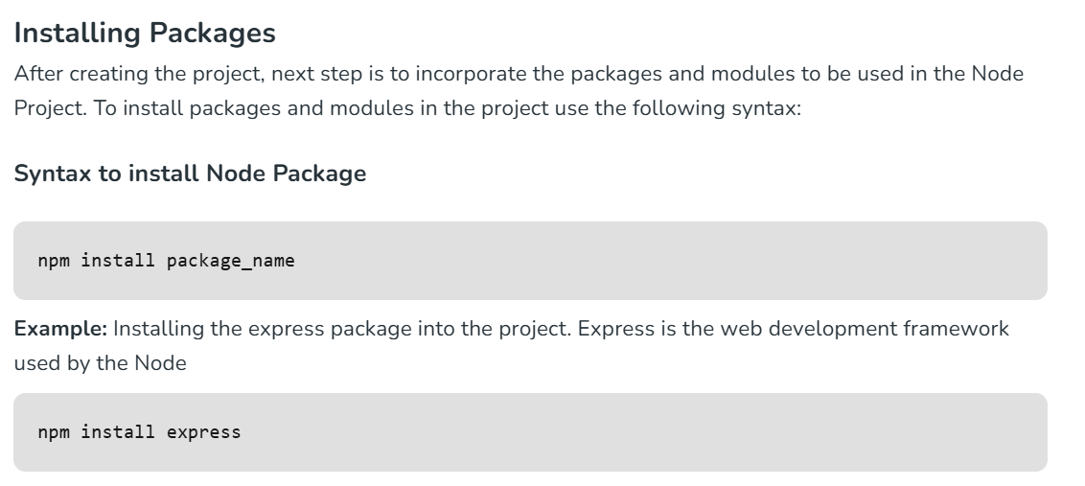

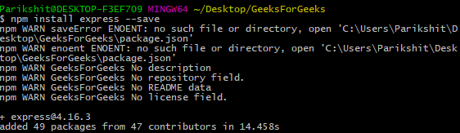

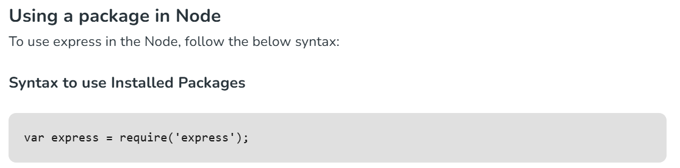

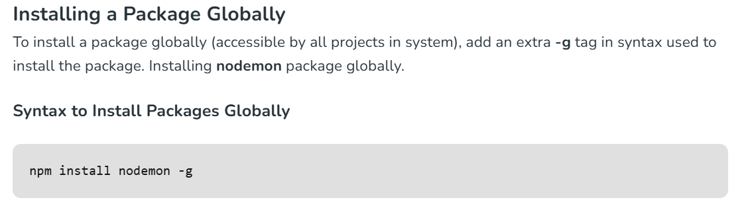

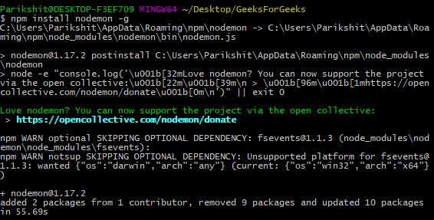

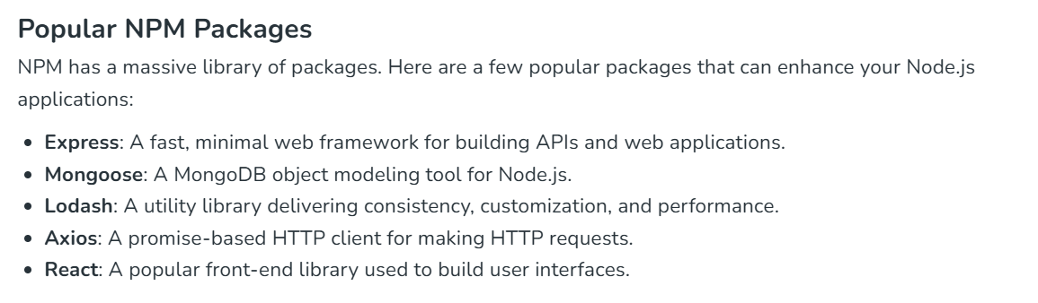

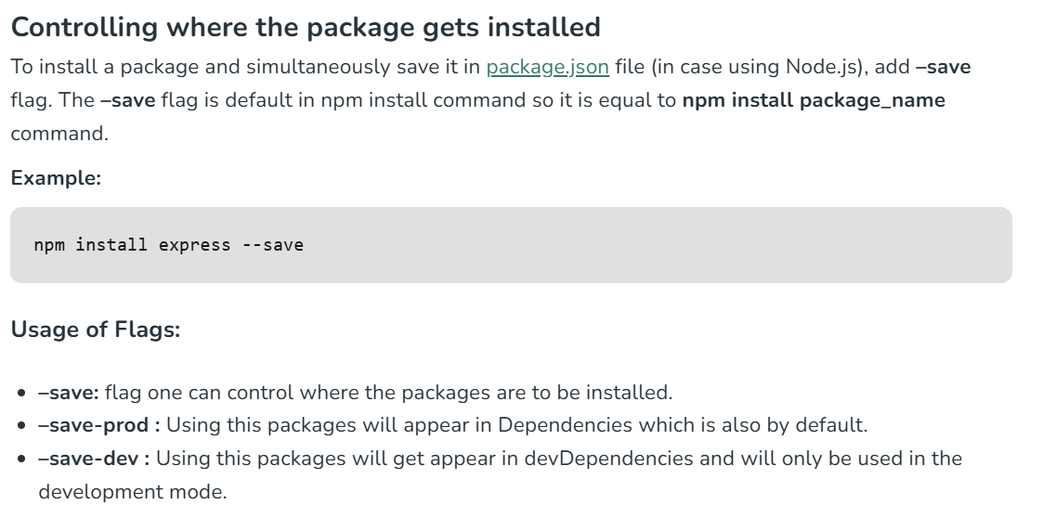

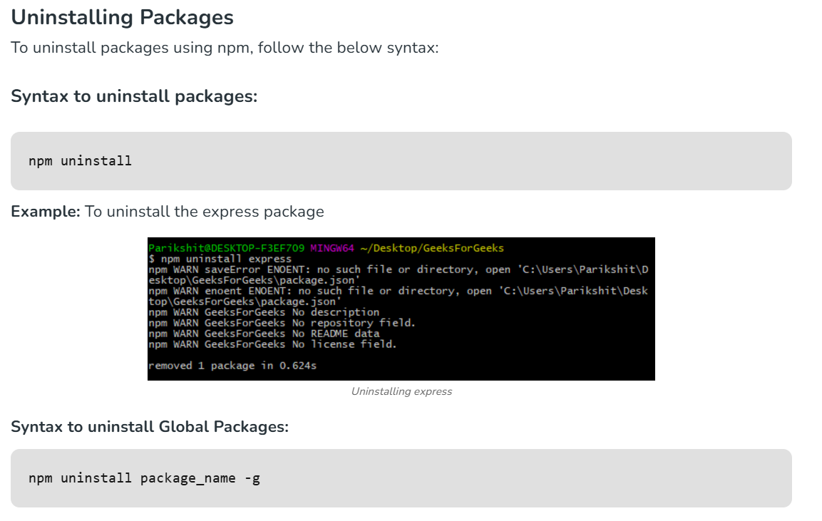

**NPX**



-**npx** (Node Package eXecutor) is a command-line tool that comes with **npm** (version 5.2 and later). It is used to execute **Node.js** packages directly without globally installing them on your system. This makes it convenient for running one-off commands or tools.

-A package executer that's used to run JavaScript packages directly from the npm registry without installing them. It's bundled with npm version 5.2.0 and above

- Npx is a tool that use to execute packages.

You can check npx is installed or not by running the following command:

npx -v

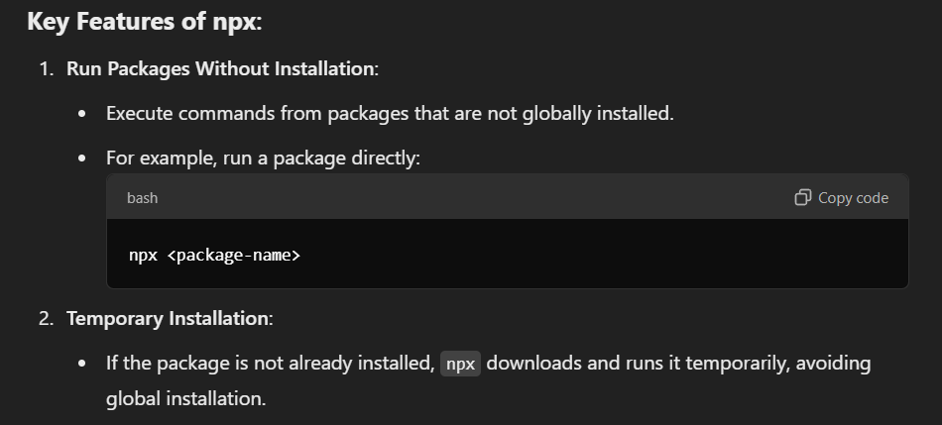

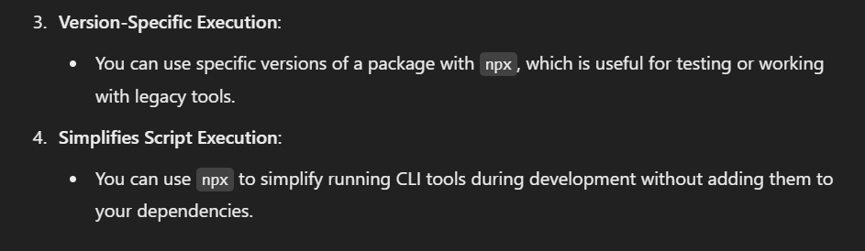

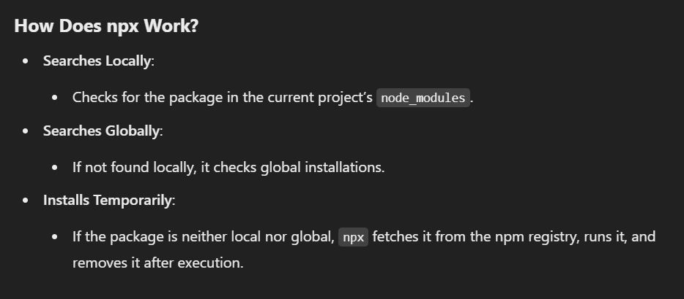

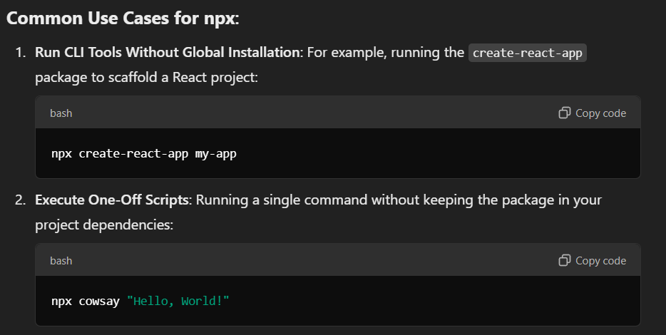

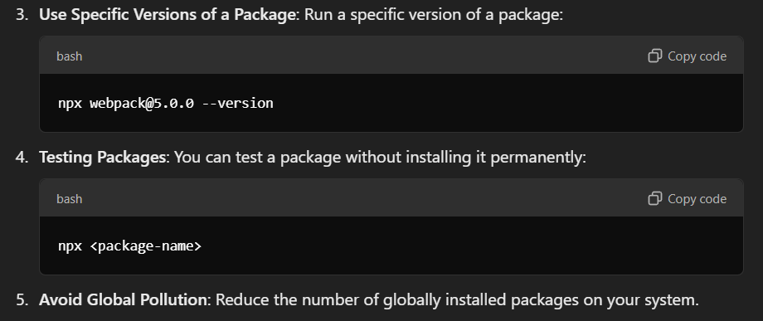

-Packages used by npx are not installed globally. You don’t have to worry about for pollution in the long term.

-First, run following command to verify to check you have NPX installed in your system. npx -v

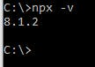

To execute a package with NPX, we need to use below command.

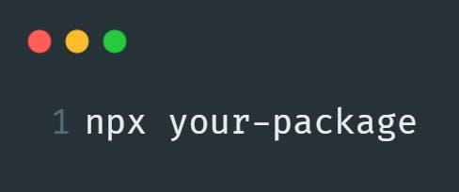

Let's see one example where package is not installed as locally or globally in our system.

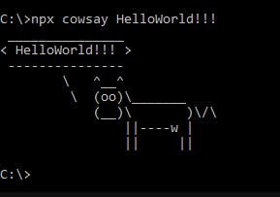

**Benefits**

Using NPX can:

* Save disk space
* Avoid polluting global variables
* Be a powerful tool when you only need to use a package once



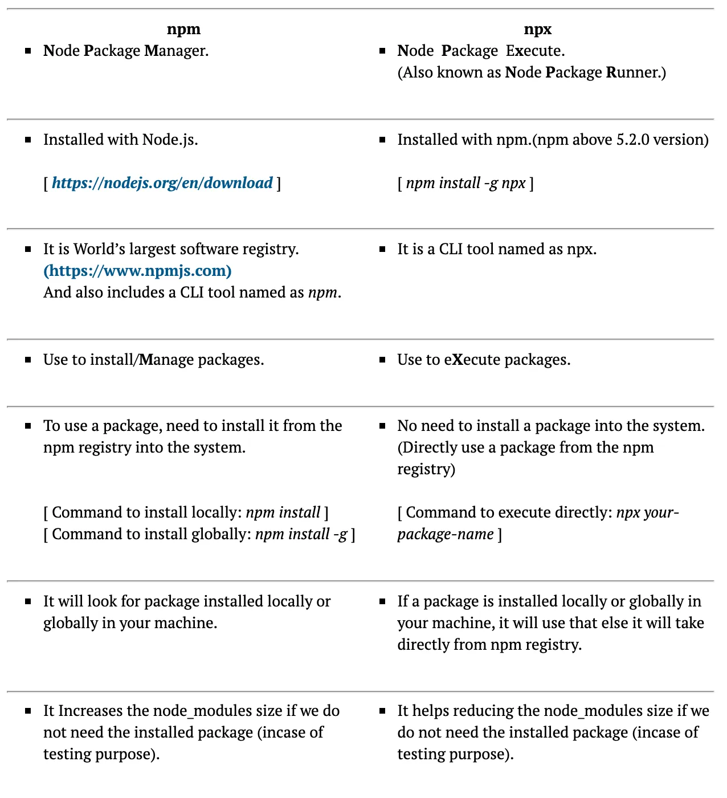

**Difference between NPX vs NPM**

|  |  |  |
| --- | --- | --- |
| SrNo | NPM | NPX |
| 1 | NPM stands for Node Package Module | Npx stands for Node Package Execute |
| 2 | Installed with NodeJs  https://nodejs.org/en/download | Installed with NPM  (Npm Above 5.0 Version) |
| 3 | Npm install Command  **npm install create-react-app -g**  **Create-react-app app-name** | Npx Install Command  **npx create-react-app app-name** |
| 4 | It is world largest Software Registry (and also include CLI tool name as NPM) | It is simply and NPM package runner. |
| 5 | Used to install /Manages packages | Used to execute Packages |
| 6 | To use a package, need to install from the NPM registry into the system | No need to install the package into the System(Directory use a package from NPM registry) |
| 7 | NPM is a package manager used to install, delete, and update Javascript packages on your machine. | NPX is a package executer, and it is used to execute javascript packages directly, without installing them. |
| 8 | NPM installs packages globally, which means that your machine may be polluted by packages that are not required anymore in the long run. | NPX does not install packages, so package pollution on the machine is not a concern. |
| 9 | To use create-react-app using NPM, we would first have to install it globally, and then run it, which makes using NPM in such cases redundant. | The most common application of NPX is the create-react-app command. Since we only need to use it once, i.e., while initializing the project, we do not install it. |

**2.USING JAVASCRIPT TOOLS INSTALLTION**

While Create React App (CRA) is the most popular way to initialize a React project, here are a few other options:

**1. Vite:**

Command: npm create vite@latest my-react-app --template react

* Benefits: Faster development server startup and hot module replacement (HMR) compared to CRA, thanks to its use of native ES modules.

**2. Next.js:**

Command: npx create-next-app@latest

* Benefits: Full-fledged React framework with features like server-side rendering (SSR), static site generation (SSG), routing, and more.

**3.React Boilerplate:**

Command: npx create-react-app my-app --template cra-template-pwa

* Benefits: Offers a more opinionated setup with pre-configured features like Redux, Redux Saga, and styled-components.

**4.Parcel:**

Command: npm init parcel my-app react

* Benefits: Zero-configuration bundler that supports React out of the box.

**1.Vite**

****

-Vite is a JavaScript build tool that helps improve the front-end development experience

-Open source: Vite is developed by an open-source community.

-Supports common web patterns: Vite supports common web patterns, including TypeScript, JSX, and CSS.

Vite has several advantages over Create React App (CRA), including:

* **Speed**

Vite uses the esbuild bundler, which is faster than the Webpack used in CRA. Vite also has a faster development server with near-instant hot module replacement (HMR).

* **Support**

Vite supports many frameworks, including React, Svelte, and more. It also provides out-of-the-box TypeScript support.

* **Configurability**

Vite's configuration is simpler and more flexible than CRA, allowing for easier customization.

* **Build performance**

Vite's build process is optimized for speed and performance, resulting in smaller, faster-loading production builds.

* **Ecosystem**

Vite has a reasonably stable and extensive ecosystem.

* Server-side rendering

Vite has built-in support for server-side rendering, which makes it faster and more convenient for the user to use the site.

When choosing between Vite and CRA, you can consider your project's needs and your level of expertise:

* **CRA**

A solid choice for beginners and for projects that prioritize simplicity and stability.

* **Vite**

Ideal for those seeking top-notch performance and flexibility, especially in projects where bundle size and development speed are critical.

**Prerequisites**

1. Node version ≥ 18.
2. NPM version 8.

# **Create Vite Project**

To create a react project using Vite first you need to go to your desired folder using a terminal.

I will show here two different ways.

## Approach 1:

Run the following command

**npm create vite@latest**

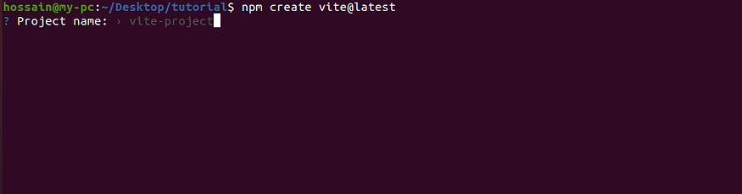

-Give a project name here. That will also be the project folder’s name.

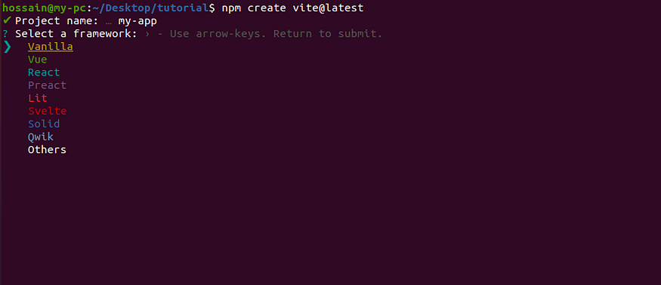

In my case, the project name is **my-app**

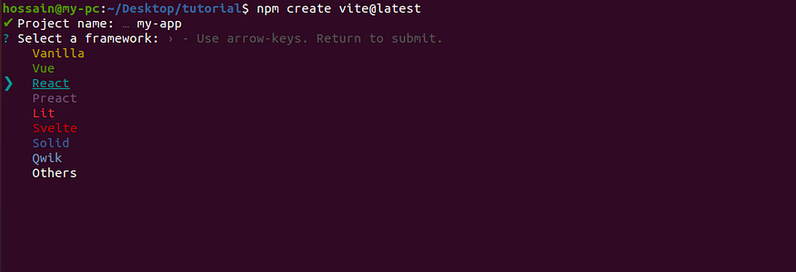

Using the keyboard arrow select **React**. then press enter

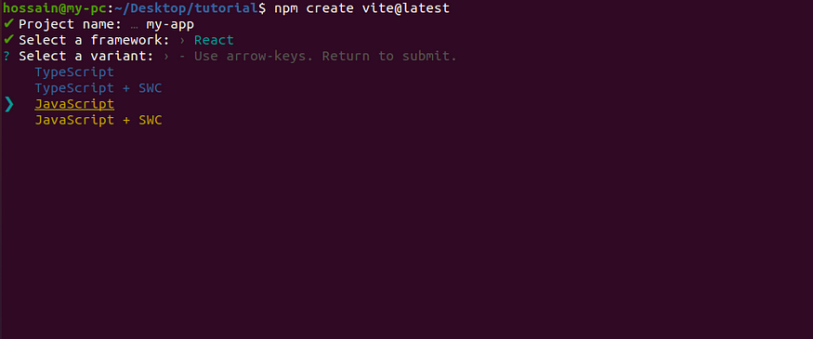

Select typeScript or Javascript whatever you prefer. In my case, I selected **JavaScript**. then press enter

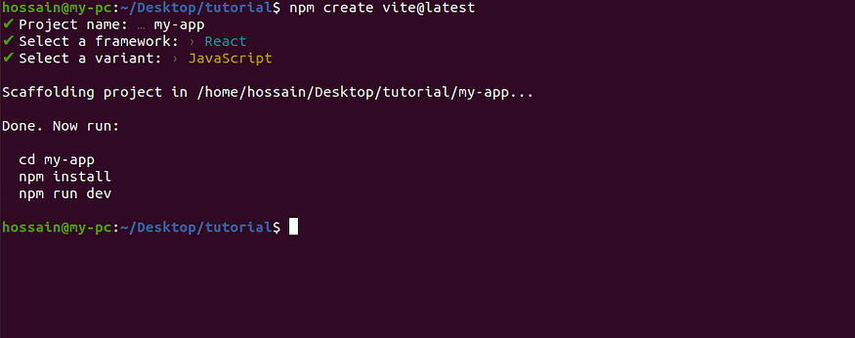

Done.

## Approach 2:

Also, you can create a React project using Vite with a single command.

**npm create vite@latest my-app -- --template react**

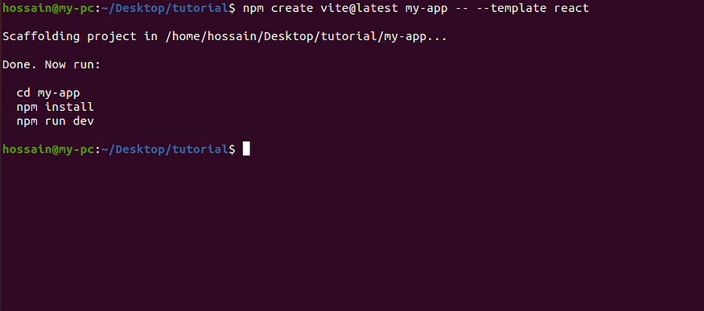

done.

## Install dependencies and run the project

**cd my-app**

Now navigate to your project folder.

**npm install / npm i**

To install the dependencies.

**npm run dev**

finally, start the project



The application is running at [http://localhost:5173](http://localhost:5173/) for my case. The port might be different if it’s already used by others.

**3.USING CDN**

-Both React and ReactDOM are available over a CDN.

<script crossorigin src="https://unpkg.com/react@18/umd/react.development.js"></script>

<script crossorigin src="https://unpkg.com/react-dom@18/umd/react-dom.development.js"></script>

-The versions above are only meant for development, and are not suitable for production. Minified and optimized production versions of React are available at:

<script crossorigin src="https://unpkg.com/react@18/umd/react.production.min.js"></script>

<script crossorigin src="https://unpkg.com/react-dom@18/umd/react-dom.production.min.js"></script>

-To load a specific version of react and react-dom, replace 18 with the version number.

**Why the crossorigin Attribute?**

-If you serve React from a CDN, we recommend to keep the [crossorigin](https://developer.mozilla.org/en-US/docs/Web/HTML/CORS_settings_attributes" \t "_blank) attribute set:

<script crossorigin src="..."></script>

-We also recommend to verify that the CDN you are using sets the Access-Control-Allow-Origin: \* HTTP header:

[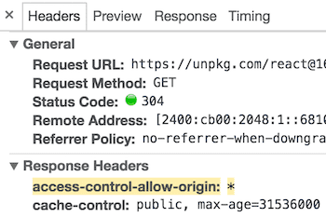](https://legacy.reactjs.org/static/89baed0a6540f29e954065ce04661048/13ae7/cdn-cors-header.png)

This enables a better [error handling experience](https://legacy.reactjs.org/blog/2017/07/26/error-handling-in-react-16.html) in React 16 and later.

<!DOCTYPE html>

<html lang="en">

<head>

    <meta charset="UTF-8">

    <meta name="viewport" content="width=device-width, initial-scale=1.0">

    <script crossorigin src="https://unpkg.com/react@18/umd/react.production.min.js"></script>

    <script crossorigin src="https://unpkg.com/react-dom@18/umd/react-dom.production.min.js"></script>

    <title>Simple React app</title>

</head>

<body>

    <div id="react-app"></div>

    <script language="JavaScript">

        element = React.createElement('h1', {}, 'Hello React!')

        ReactDOM.render(element, document.getElementById('react-app'));

     </script>

</body>

</html>

**FOLDERS STRUCTURE EXPLAINED**

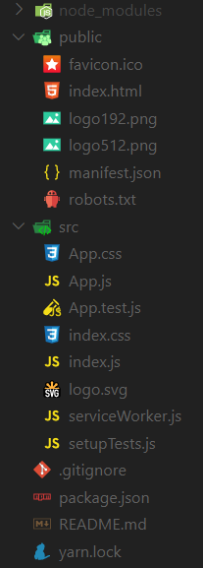

**node modules(Folder)**

Node Modules and root folder files

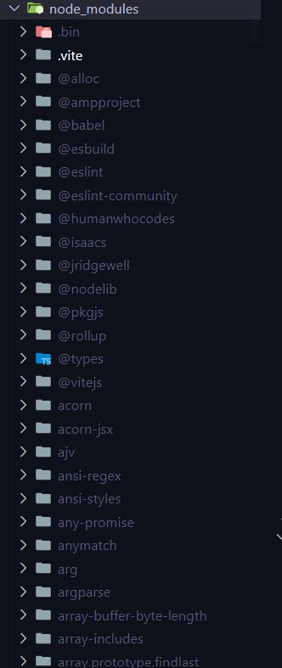

-Contains all the dependencies that are needed for an initial working react app.

-Node module it stores all the data in detail about Predefined packages or externally installed packages.

-In a React project, the node\_modules folder serves the same purpose as in any other Node.js project: it stores all the external libraries and dependencies that your project needs to run.

Here's what you need to know about the node\_modules folder in React:

* **Location:**

It's typically located in the root directory of your React project.

* **Purpose:**

It houses all the packages listed in your project's package.json file, including:

* + React and React-DOM: The core libraries for building React applications.
  + Build tools: Like Webpack, Babel, or Vite, which help bundle and transpile your code for the browser.
  + Utility libraries: Such as Lodash, Moment.js, or Axios, which provide helpful functions and utilities.
  + Other dependencies: Any other third-party packages your project relies on.
* **Management:**

You manage the packages in node\_modules using the Node Package Manager (npm) or Yarn. Commands like npm install or yarn add download and install packages into this folder.

* **Version control:**

You typically don't include the node\_modules folder in your version control system (like Git) because it can be very large. Instead, you rely on package.json and package-lock.json to manage dependencies.

**Key points to remember:**

* Don't modify node\_modules directly: If you need to update a package, use npm update or yarn upgrade.
* Use .gitignore: Make sure your .gitignore file includes the node\_modules folder to keep it out of version control.
* node\_modules is essential: Your React project won't run without the dependencies in this folder.

**Public folder and it’s files**

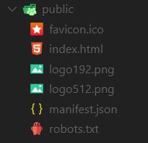

-Root folder that gets served up as our react app.

-In a React.js application created with create-react-app, the public folder serves a special purpose:

What it's for:

* Serving static assets:

This folder holds files that you want to be served directly by the web server, such as:

* + **Images** (\*.jpg, \*.png, etc.)
  + **Fonts** (\*.ttf, \*.woff, etc.)
  + **Icons** (favicon.ico)
  + **HTML files** (index.html)
  + Other static files that you don't want to be processed by webpack
* Accessing files directly:

Files in the public folder can be accessed directly in your HTML or JavaScript code using their relative path from the root of the web server. For example, an image located at /public/images/logo.png can be referenced in your code as /images/logo.png.

Important points:

* Webpack doesn't process it:

-Files in the public folder are not processed by webpack, the build tool used by React. This means you can't use imports or require statements to access them within your JavaScript modules.

* index.html is the entry point:

The index.html file in the public folder serves as the template for your React application. It includes the root <div> element where React will render your components.

**favicon.ico(file)**

-It’s an icon file that is used in index.html as favicon.



**index.html(file)**

-In React, the index.html file is the main HTML file for a React application and serves as the entry point for the web application:

* It contains the basic HTML structure that is initially displayed in the browser.
* It's usually located in the public folder of the React project's root directory.
* The body of the index.html file contains a single <div> where the React application will be rendered.

To migrate HTML from index.html to a React index.js file, you need to convert the HTML elements into JSX format.

You can use Create React App to start a new React app that's fully configured with webpack and live reloading.

<!DOCTYPE html>

<html lang="en">

  <head>

    <meta charset="utf-8" />

    <link rel="icon" href="%PUBLIC\_URL%/favicon.ico" />

    <meta name="viewport" content="width=device-width, initial-scale=1" />

    <meta name="theme-color" content="#000000" />

    <meta

      name="description"

      content="Web site created using create-react-app"

    />

    <link rel="apple-touch-icon" href="%PUBLIC\_URL%/logo192.png" />

    <link rel="manifest" href="%PUBLIC\_URL%/manifest.json" />

    <title>React App</title>

  </head>

  <body>

    <noscript>You need to enable JavaScript to run this app.</noscript>

    <div id="root"></div>

  </body>

</html>

**logo192.png & logo512.png(files)**

-These are react logo which is of dimension 192\*192 px and 512\*512 px and is used in the template file (index.html) by default. [can be removed once you are using your own component].



**manifest.json(file)**

-In React.js, the manifest.json file is a crucial component for creating Progressive Web Apps (PWAs). It provides metadata about your web application, allowing it to behave more like a native app on users' devices.

**Purpose**:

* App Information:

It defines essential details like the app's name, short name, description, icons, and theme color.

* Installation:

It enables users to install the app on their home screens, providing a native app-like experience.

* Offline Access:

It helps configure the app for offline availability, allowing users to access it even without an internet connection.

{

  "short\_name": "React App",

  "name": "Create React App Sample",

  "icons": [

    {

      "src": "favicon.ico",

      "sizes": "64x64 32x32 24x24 16x16",

      "type": "image/x-icon"

    },

    {

      "src": "logo192.png",

      "type": "image/png",

      "sizes": "192x192"

    },

    {

      "src": "logo512.png",

      "type": "image/png",

      "sizes": "512x512"

    }

  ],

  "start\_url": ".",

  "display": "standalone",

  "theme\_color": "#000000",

  "background\_color": "#ffffff"

}

**robots.txt(file)**

-Defines rules for **spiders, crawlers and scrapers** for accessing your app.It is used for the Search Engines Optimization.

# https://www.robotstxt.org/robotstxt.html

User-agent: \*

Disallow:

**User-agent: \***  
Disallow:  
The website is open to all search engines(asterisk) and none of its content is disallowed.

**User-agent: Googlebot**  
Disallow: /  
The Googlebot search engine is disallowed to index any of its contents.

**User-agent: \***  
Disallow: /file.html  
This is partial access. All other contents except file.html can be accessed.

**Visit-time: 0200-0300**  
This bounds the time for the crawler. The contents can be indexed only between the time interval given.

**Crawl-delay: 20**  
Prohibits the crawlers from hitting the site frequently as it would make the site slow.

**Reason to use robots.txt file:**  
-It blocks the contents from search engines.

-It tune access to the site from reputable robots.

-It is used in currently developing website, which need not to show in search engines.

-It is used to make contents available to specific search engines.

**Use of robots.txt file?**  
-The most important use of a robots.txt file is to maintain privacy from the internet. Not everything on our webpage should be showed to open world, thus it is a serious concern which is dealt easily with the robots.txt file.

**Src folder and its files**

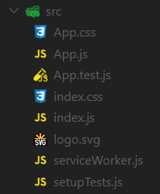

**src(folder)**

-In simplest form it’s our react app folder i.e. containing **components, tests, css files** etc. It’s the mind of our app.

-You cannot change src folder name if trying to do then browser throws an error.

**App.css(file)**

-reuired css For the App css

***-The index.css*** − Used to styles of the entire application. Let us remove all styles and start with fresh code.

**App.js(file)**

-This file has very basic react component defined which can be replaced by our own root component.

**App.js** − Root component of our application. Let us replace the existing JSX and show simple hello react message as shown below −

import './App.css';

function App() {

return (

<h1>Hello React!</h1>

);

}

export default App;

**App.test.js(file)**

-A very basic test(for the default app) is defined in this file which can be replace by our own tests. *[make use of****Jest****].*

* ***App.test.js*** − Used to write unit test function for our component.

**index.css(file)**

Contains styles for general setup of our app.

**index.js**

* The *index.js* − Entry point of our application. It uses *ReactDOM.render* method to kick-start and start the application. The code is as follows −

import React from 'react';

import ReactDOM from 'react-dom';

import './index.css';

import App from './App';

import reportWebVitals from './reportWebVitals';

ReactDOM.render(

<React.StrictMode>

<App />

</React.StrictMode>,

document.getElementById('root')

);

// If you want to start measuring performance in your app, pass a function

// to log results (for example: reportWebVitals(console.log))

// or send to an analytics endpoint. Learn more: https://bit.ly/CRA-vitals

reportWebVitals();

Here,

***React.StrictMode*** is a build-in component used to prevent unexpected bugs by analysing the component for unsafe lifecycle, unsafe API usage, depreciated API usage, etc., and throwing the relevant warning.

* *App* is our first custom and root component of the application. All other components will be rendered inside the *App* component.

**index.js(file)**

-This files renders our component and registers service workers(unregistered by default)

**logo.svg(file)**

-Svg file of react logo, being used in component(App.js) by default.

-Logo in SVG format and can be loaded into our application using import keyword. Let us remove it from the project.

**reportWebVitals.js** − Generic web application startup code to support all browsers.

**serviceWorker.js(file)**

Service worker for pre-caching the scripts files of our react app thereby improving performance.

**setupTests.js(file)**

-As the name suggest this files setups tests and runs them. This file in directly invoked when we run tests from cli(*npm run test*).*[make use of****Jest****]*

* ***setupTests.js*** − Used to setup the testing framework for our application.

**.gitignore(file)**

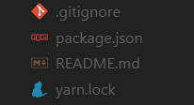

-This file specifies intentionally untracked files that Git should ignore

**package.json(file)**

-This file contains various **metadata** that is relevant to our project. It specifies the **dependencies** being used in the project which helps npm setup same environment on different machine for our project.

-The *package.json* is the core file representing the project. It configures the entire project and consists of **project name**, **project dependencies**, and **commands** to **build** and **run** the application.

{

"name": "expense-manager",

"version": "0.1.0",

"private": true,

"dependencies": {

"@testing-library/jest-dom": "^5.11.6",

"@testing-library/react": "^11.2.2",

"@testing-library/user-event": "^12.6.0",

"react": "^17.0.1",

"react-dom": "^17.0.1",

"react-scripts": "4.0.1",

"web-vitals": "^0.2.4"

},

"scripts": {

"start": "react-scripts start",

"build": "react-scripts build",

"test": "react-scripts test",

"eject": "react-scripts eject"

},

"eslintConfig": {

"extends": [

"react-app",

"react-app/jest"

]

},

"browserslist": {

"production": [

">0.2%",

"not dead",

"not op\_mini all"

],

"development": [

"last 1 chrome version",

"last 1 firefox version",

"last 1 safari version"

]

}

}

The *package.json* refers the below React library in its dependency section.

* *react* and *react-dom* are core react libraries used to develop web application.
* ***web-vitals*** are general library to support application in different browser. Checks the Performance
* *react-scripts* are core react scripts used to build and run application.
* *@testing-library/jest-dom, @testing-library/react and @testing-library/user-event* are testing libary used to test the application after development.
* The ***public folder*** − Contains the core file, *index.html* and other web resources like images, logos, robots, etc., *index.html* loads our react application and render it in user's browser.
* The src folder − Contains the actual code of the application. We will check it next section.
* Eject : - If you want add new Framework then you use this command. It works like it disconnect the current libraries and uses new library.

**Package-lock.json(file)**

-It contains all the detailed information regarding libraries and dependencies.

**readme.md(file)**

-This file can be used to define ***usage, build instructions, summary of project***, etc. It uses markdown markup language to create content.

**yarn.lock(file)**

-This file has same purpose as **package-lock.json**, it ensures that your package is **consistent** across various machines by storing the versions of which dependencies are installed with your package.

## **Ideal Folder Structure**

Assuming you're going to create the next app similar to Facebook, an ideal folder structure would look like this.

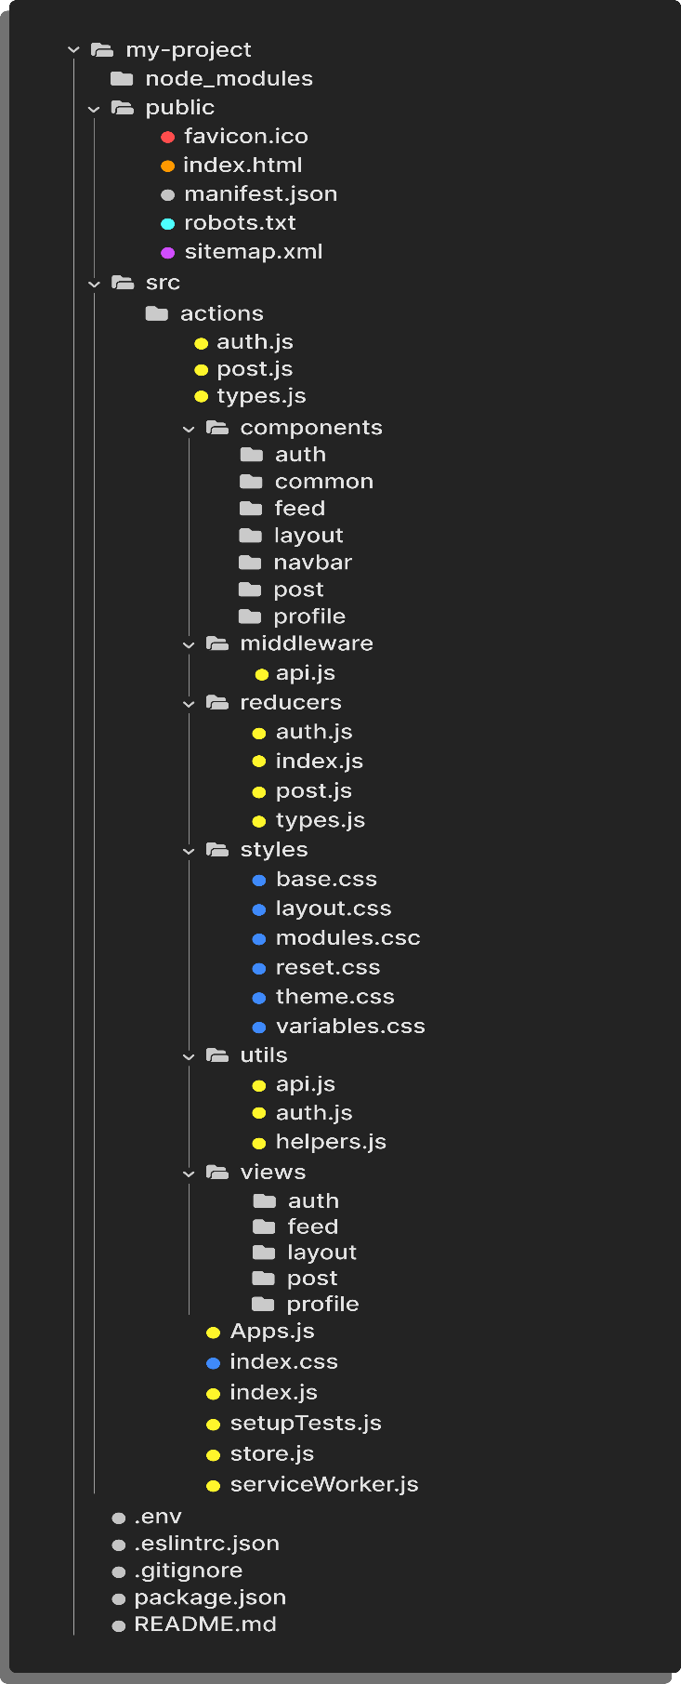

**What is the Folder Structure for React Project?**

The folder structure looks like this.

* Assets Folder
* Layouts Folder
* Components Folder
* Pages Folder
* Middleware Folder
* Routes Folder
* Config Folder
* Services Folder
* Utils Folder

**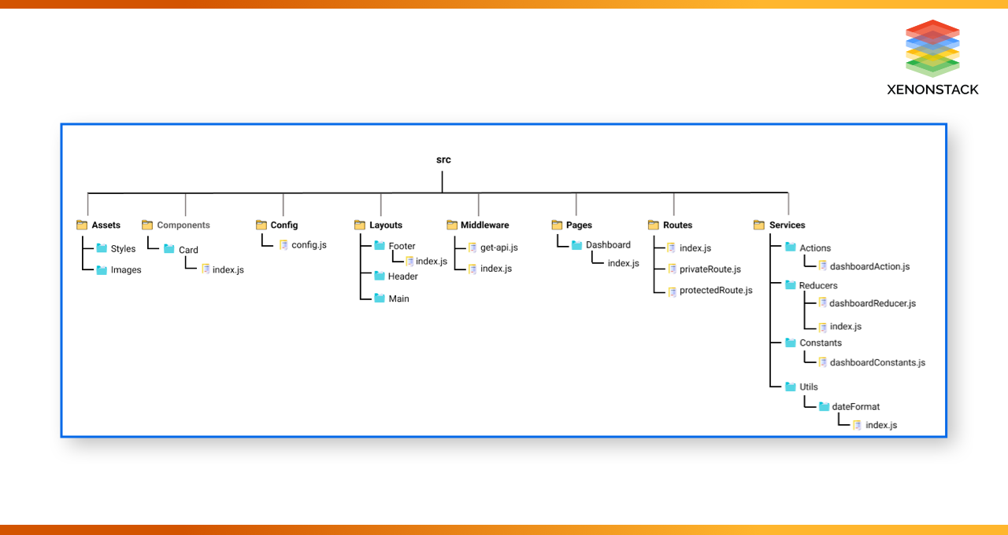**

**-Assets Folder**

As the name says, it contains assets of our project. It consists of images and styling files. Here we can store our global styles. We are centralizing the project so we can store the page-based or component-based styles over here. But we can even keep style according to the pages folder or component folder also. But that depends on developer comfortability.

**Layouts Folder**

As the name says, it contains layouts available to the whole project like header, footer, etc. We can store the header, footer, or sidebar code here and call it.

**Components Folder**

Components are the building blocks of any react project. This folder consists of a collection of [UI components](https://docs.amplify.aws/ui/) like buttons, modals, inputs, loader, etc., that can be used across various files in the project. Each component should consist of a test file to do a unit test as it will be widely used in the project.

**Pages Folder**

The files in the pages folder indicate the route of the react application. Each file in this folder contains its route. A page can contain its subfolder. Each page has its state and is usually used to call an async operation. It usually consists of various components grouped.

**Middleware Folder**

This folder consists of middleware that allows for side effects in the application. It is used when we are using redux with it. Here we keep all our custom middleware.

**Routes Folder**

This folder consists of all routes of the application. It consists of private, protected, and all types of routes. Here we can even call our sub-route.

**Config Folder**

This folder consists of a configuration file where we store environment variables in [config.js](https://www.google.com/url?sa=t&rct=j&q=&esrc=s&source=web&cd=&cad=rja&uact=8&ved=2ahUKEwjju8SAlMLzAhUY3jgGHaL1C0EQFnoECBYQAQ&url=https%3A%2F%2Fwww.npmjs.com%2Fpackage%2Fconfig-js&usg=AOvVaw2OwY-RqWd6L0LnMcvlQme6). We will use this file to set up multi-environment configurations in your application.

**Services Folder**

This folder will be added if we use [redux](https://redux.js.org/) in your project. Inside it, there are 3 folders named actions, reducers, and constant subfolders to manage states. The actions and reducers will be called in almost all the pages, so create actions, reducers & constants according to pages name.

**Utils Folder**

Utils folder consists of some repeatedly used functions that are commonly used in the project. It should contain only common js functions & objects like dropdown options, regex condition, data formatting, etc.

-If you created website using ReactJs it is Not SEO [ Search Engine Optimization] friendly

**React Features**

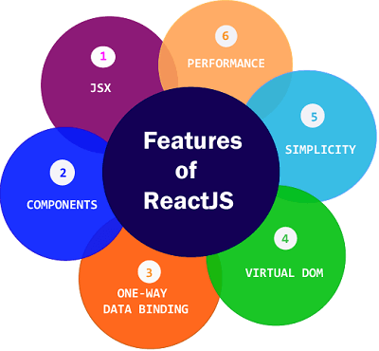

-Currently, ReactJS gaining quick popularity as the best JavaScript framework among web developers. It is playing an essential role in the front-end ecosystem. The important features of ReactJS are as following.

* **JSX**
* **Components**
* **One-way Data Binding**
* **Virtual DOM**
* **Simplicity**
* **Performance**
* **Hot Reloading**

**1.JSX**

-JSX stands for JavaScript XML.

-It is a JavaScript syntax extension.

-Its an XML or HTML like syntax used by ReactJS.

-JSX makes it easier to write and add HTML in React.

-This syntax is processed into JavaScript calls of React Framework.

-It extends the ES6 so that HTML like text can co-exist with JavaScript react code.

-It is not necessary to use JSX, but it is recommended to use in ReactJS.

-JSX allows us to write HTML elements in JavaScript and place them in the DOM without any createElement()  and/or appendChild() methods.

-JSX converts HTML tags into react elements.

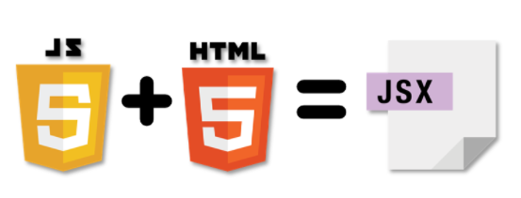

**Example 1**

JSX:

import React from 'react';

import ReactDOM from 'react-dom/client';

const myElement = <h1>I Love JSX!</h1>;

const root = ReactDOM.createRoot(document.getElementById('root'));

root.render(myElement);

-As you can see in the first example, JSX allows us to write HTML directly within the JavaScript code.

**Example 2**

Without JSX:

import React from 'react';

import ReactDOM from 'react-dom/client';

const myElement = React.createElement('h1', {}, 'I do not use JSX!');

const root = ReactDOM.createRoot(document.getElementById('root'));

root.render(myElement);

**Expressions in JSX**

-With JSX you can write expressions inside curly braces { }.

The expression can be a React variable, or property, or any other valid JavaScript expression.

import React from 'react';

import ReactDOM from 'react-dom/client';

const myElement = <h1>React is {5 + 5} times better with JSX</h1>;

const root = ReactDOM.createRoot(document.getElementById('root'));

root.render(myElement);

**Inserting a Large Block of HTML**

import React from 'react';

import ReactDOM from 'react-dom/client';

const myElement = (

<ul>

<li>Apples</li>

<li>Bananas</li>

<li>Cherries</li>

</ul>

);

const root = ReactDOM.createRoot(document.getElementById('root'));

root.render(myElement);

-JSX will throw an error if the HTML is not correct, or if the HTML misses a parent element.

-Alternatively, you can use a "fragment" to wrap multiple lines. This will prevent unnecessarily adding extra nodes to the DOM.

-A fragment looks like an empty HTML tag: <></>.

Example

Wrap two paragraphs inside a fragment:

import React from 'react';

import ReactDOM from 'react-dom/client';

const myElement = (

<>

<p>I am a paragraph.</p>

<p>I am a paragraph too.</p>

</>

);

const root = ReactDOM.createRoot(document.getElementById('root'));

root.render(myElement);

**Elements Must be Closed**

-JSX follows XML rules, and therefore HTML elements must be properly closed.

import React from 'react';

import ReactDOM from 'react-dom/client';

const myElement = <input type="text" />;

const root = ReactDOM.createRoot(document.getElementById('root'));

root.render(myElement);

**2.Components**

-ReactJS is all about components.

-ReactJS application is made up of multiple components, and each component has its own logic and controls.

-Components are like functions that return HTML elements.

-These components can be reusable which help you to maintain the code when working on larger scale projects.

-There are two types components:

**1]Functional Based Components (Stateless Component)**

**2]Class Based Component (Stateful Components)**

**3.One-way Data Binding**

-ReactJS is designed in such a manner that follows unidirectional data flow or one-way data binding.

-The benefits of one-way data binding give you better control throughout the application.

-If the data flow is in another direction, then it requires additional features. It is because components are supposed to be immutable and the data within them cannot be changed.

- Flux is a pattern that helps to keep your data unidirectional. This makes the application more flexible that leads to increase efficiency.

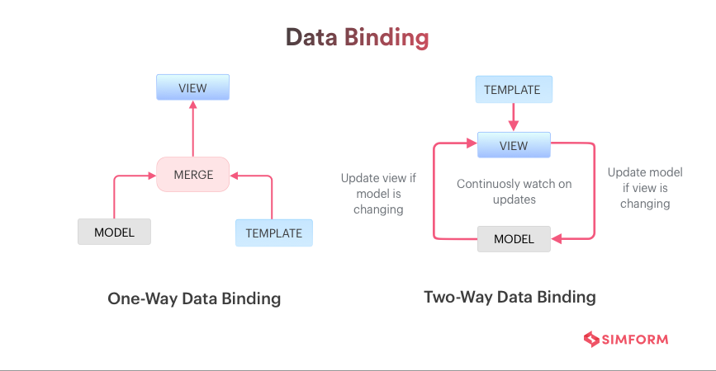

**4.Virtual DOM**

-A virtual DOM object is a representation of the original DOM object. It works like a one-way data binding.

-Whenever any modifications happen in the web application, the entire UI is re-rendered in virtual DOM representation.

-Then it checks the difference between the previous DOM representation and new DOM. Once it has done, the real DOM will update only the things that have actually changed.

- This makes the application faster, and there is no wastage of memory.

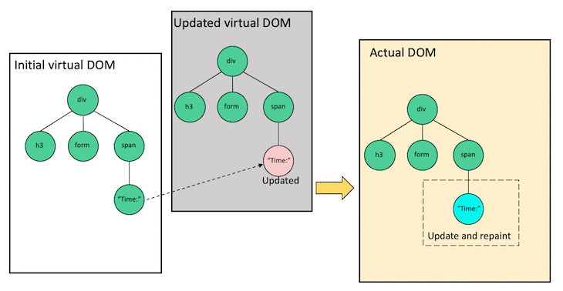

*import* React *from* 'react';

*import* ReactDOM *from* 'react-dom/client';

*import* App *from* './App';

const root = ReactDOM.createRoot(document.getElementById('root'));

root.render(

  <React.StrictMode>

    <App />

  </React.StrictMode>

);

-The Virtual is Present in the **index.js** files

-You can see the below code we have to create one Variable

Called **const root**

const root = ReactDOM.createRoot(document.getElementById('root'));

-Inside that variable we can call **ReactDom** then reactDom calls the one method called **createRoot** it accepts one arguments the **root** which is **ID** of the **<div>** container.

<!DOCTYPE html>

<html lang="en">

  <head>

    <meta charset="utf-8" />

    <link rel="icon" href="%PUBLIC\_URL%/favicon.ico" />

    <meta name="viewport" content="width=device-width, initial-scale=1" />

    <meta name="theme-color" content="#000000" />

    <meta

      name="description"

      content="Web site created using create-react-app"

    />

    <link rel="apple-touch-icon" href="%PUBLIC\_URL%/logo192.png" />

    <link rel="manifest" href="%PUBLIC\_URL%/manifest.json" />

    <title>React App</title>

  </head>

  <body>

    <noscript>You need to enable JavaScript to run this app.</noscript>

    <div id="root"></div>

  </body>

</html>

-That only file Rendered on the browser so that’s why ReactJs called as Single Page Web application.

-The Browser does not understand the JSX.

-The Browser only understand the HTML CSS JAVASCRIPT.

-So **Babel Compiler** convert the JSX into understandable Javascript code so browser will read that code.

**5.Simplicity**

-ReactJS uses JSX file which makes the application simple and to code as well as understand.

-We know that ReactJS is a component-based approach which makes the code reusable as your need. This makes it simple to use and learn.

**6.Performance**

-ReactJS is known to be a great performer.

-This feature makes it much better than other frameworks out there today.

-The reason behind this is that it manages a virtual DOM.

-The DOM is a cross-platform and programming API which deals with HTML, XML or XHTML.

-The DOM exists entirely in memory. Due to this, when we create a component, we did not write directly to the DOM.

-Instead, we are writing virtual components that will turn into the DOM leading to smoother and faster performance.

**7.Hot Reloading**

-Hot reloading in React allows you to see the changes you make to your code reflected in your browser instantly, without having to manually refresh the page. This can significantly speed up development.

Here's how it works and how to use it:

How Hot Reloading Works:

* **Webpack:** Hot reloading is typically achieved using a module bundler like Webpack, which is included in create-react-app by default.
* **Hot Module Replacement (HMR):** Webpack's HMR feature enables the browser to receive updates to modules without a full page reload.
* **React Integration:** React integrates with HMR to update the UI based on the changed modules.

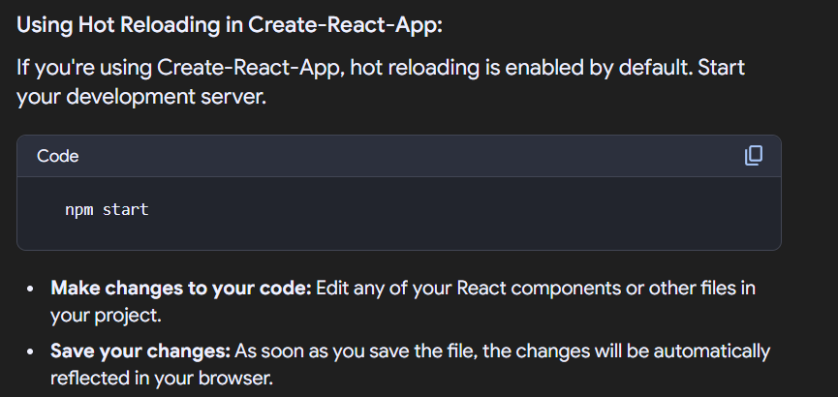

Benefits of Hot Reloading:

* **Faster development:**

You can see the effects of your changes instantly, which speeds up the development process.

* **Improved debugging experience:**

You can debug your application more efficiently without losing the current state.

* **Enhanced developer productivity:**

Hot reloading reduces the time spent on manual refreshes, making you more productive.

**8.Single-Page Web Application**

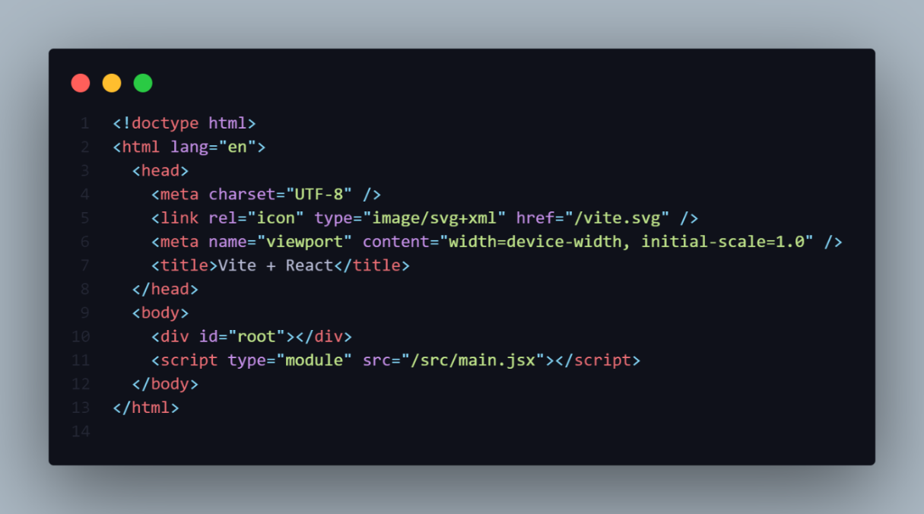

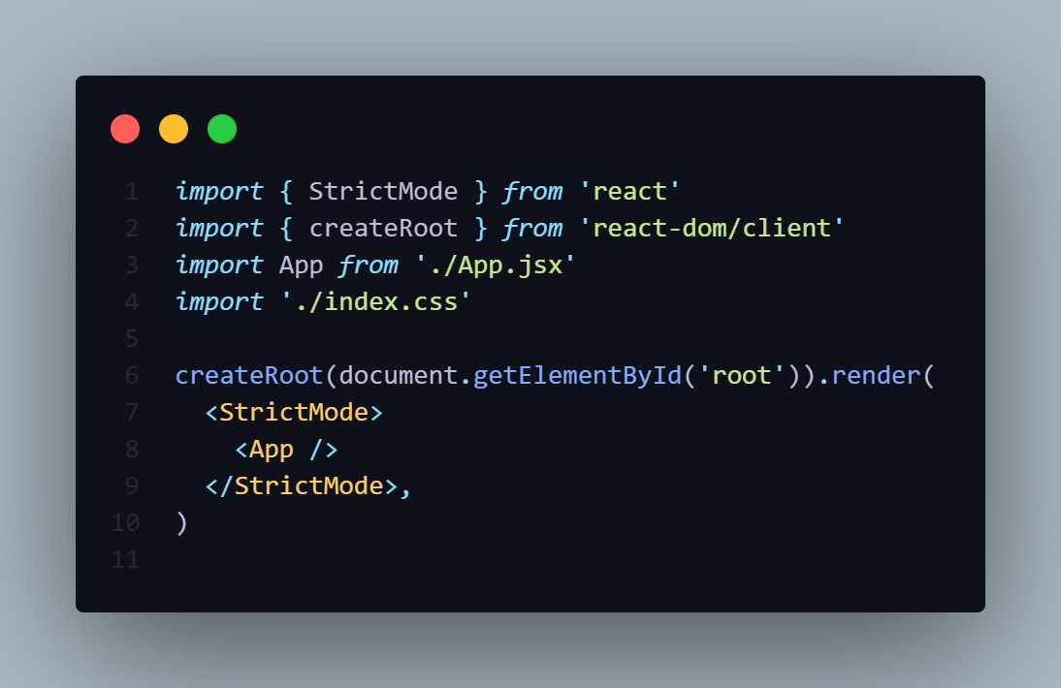

-React Create the Single Page Web-application

-The **Index.html** file is only run on the Browser.

-**createRoot()** method creates the **Virtual DOM takes** the **id** of the **<div id=”root”></div>**.

-The **Render()** method is render the React Component.

**Curly Braces { }**

-In React, curly braces {} are used to embed JavaScript expressions within JSX. This allows you to dynamically render values, evaluate conditions, and perform other JavaScript operations inside your React components.

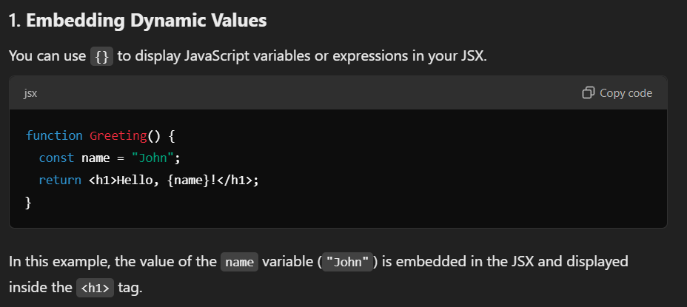

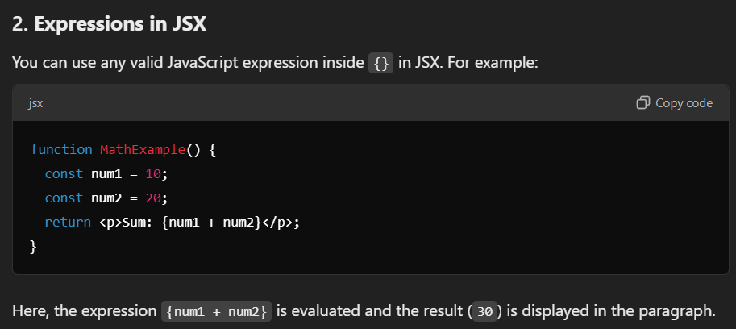

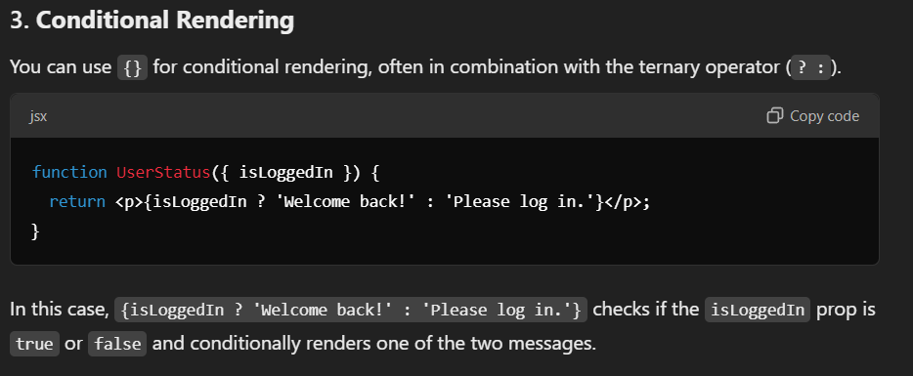

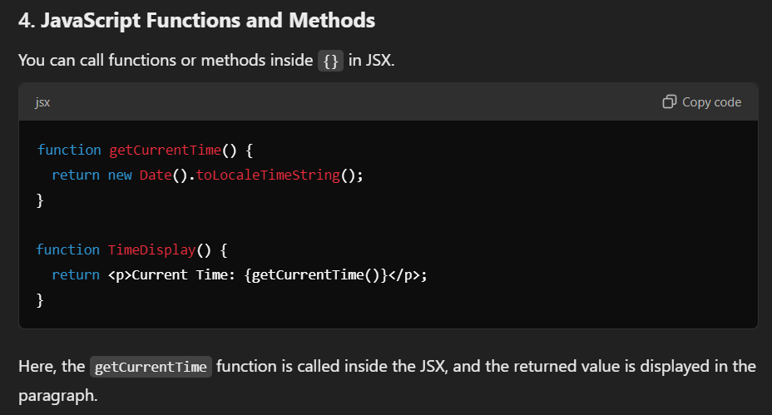

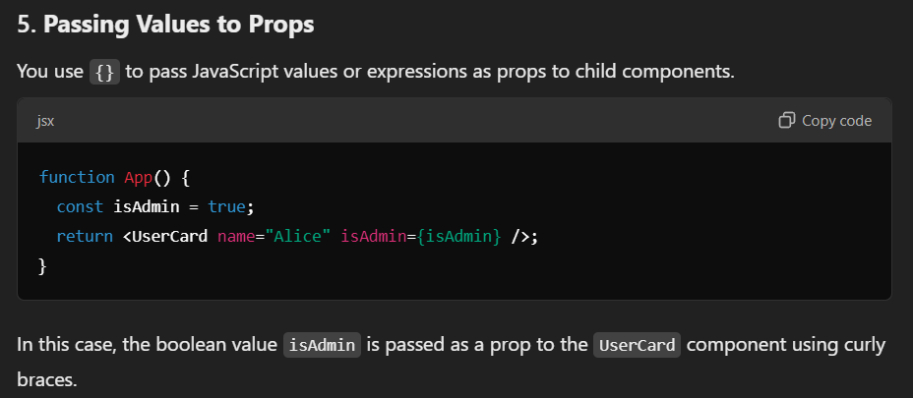

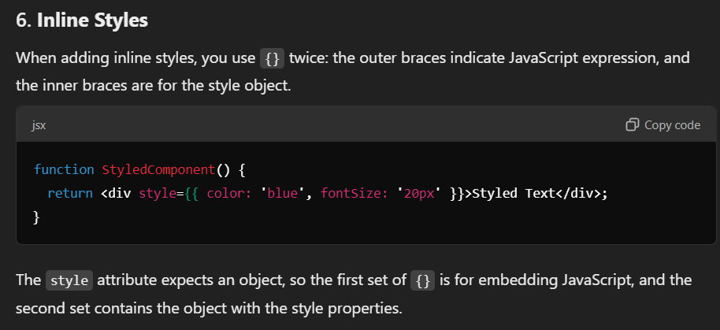

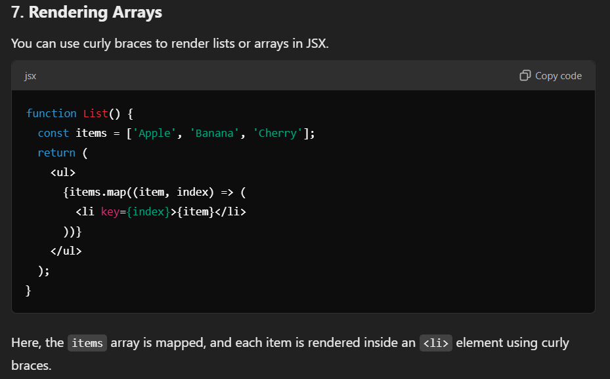

**<STRICTMODE>**

-StrictMode in React is a tool that helps you identify potential problems in your application during development. It activates additional checks and warnings for its descendant components, highlighting issues that might not be obvious in a regular development environment.

**Benefits of StrictMode:**

* **Detecting Unexpected Side Effects:**

StrictMode helps identify unintended side effects in your components, especially in lifecycle methods like componentDidMount or componentWillUnmount. It does this by intentionally double-invoking certain functions, which can reveal issues related to state updates or cleanup logic.

* **Identifying Unsafe Practices:**

It warns you about using deprecated methods, unsafe patterns, or potential compatibility issues with future versions of React.

* **Improving Code Quality:**

By highlighting potential problems, StrictMode encourages you to write cleaner and more robust code.

How to Use StrictMode:

You can enable StrictMode for your entire application or for specific parts of it by wrapping the relevant components with the <StrictMode> component:

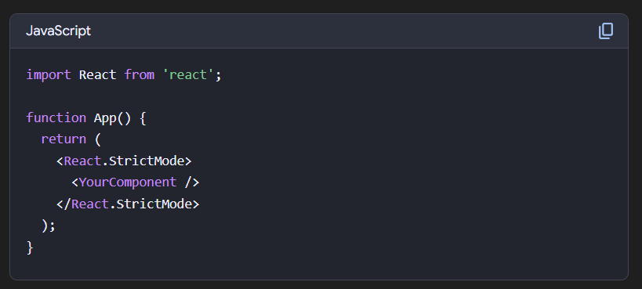

Important Considerations:

* **Development Only:**

StrictMode only runs in development mode and does not impact your production build.

* **Performance Impact:**

The additional checks in StrictMode can slightly slow down your development environment, but it's usually negligible.

* **Not a Substitute for Testing:**

StrictMode is a helpful tool, but it's not a replacement for comprehensive testing.

Some common issues StrictMode helps to identify:

* **Incorrect use of state:** For example, updating state directly in the render method.
* **Side effects in render functions:** StrictMode helps to identify any side effects in the render function.
* **Unsafe lifecycle methods:** Warns about using deprecated methods like componentWillMount.
* **Missing cleanup in effects:** StrictMode helps identify cases where cleanup is not properly implemented in useEffect hooks.

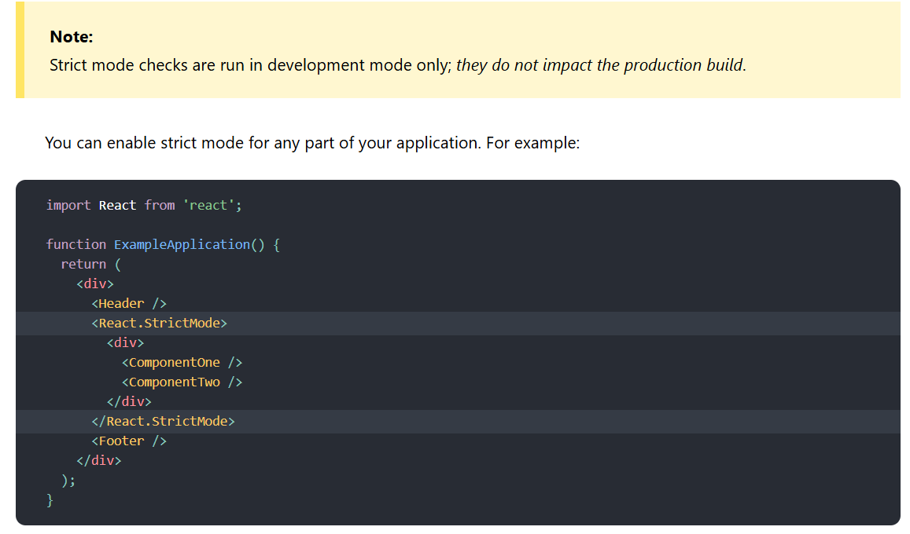

**StrictMode currently helps with:**

* [Identifying components with unsafe lifecycles](https://legacy.reactjs.org/docs/strict-mode.html#identifying-unsafe-lifecycles)
* [Warning about legacy string ref API usage](https://legacy.reactjs.org/docs/strict-mode.html#warning-about-legacy-string-ref-api-usage)
* [Warning about deprecated findDOMNode usage](https://legacy.reactjs.org/docs/strict-mode.html#warning-about-deprecated-finddomnode-usage)
* [Detecting unexpected side effects](https://legacy.reactjs.org/docs/strict-mode.html#detecting-unexpected-side-effects)
* [Detecting legacy context API](https://legacy.reactjs.org/docs/strict-mode.html#detecting-legacy-context-api)
* [Ensuring reusable state](https://legacy.reactjs.org/docs/strict-mode.html#ensuring-reusable-state)

**FRAGMENTS IN REACT**

-Fragment is wrapper that wraps the elements.

const Fragment1 = () =>{

*//! We cannot return Two Fragments*

*// return(*

*//         <h1>Hello from Fragment 1</h1>*

*//         <h2>This is a Fragment</h2>*

*// )*

}

*export* *default* Fragment1;

-In react we cannot return multiple elements at same.

-In react we can return only one element at a time.

-if try to return multiple element as shown in above program it will throw error.

-Because there should only one **Root** Element.

**How to return Multiple Elements in React**

**1] Inside <div> return Multiple Elements**

const Fragment2 = () =>{

*//! First Way*

*return*(

        <div>

            <h1>Element 1</h1>

            <h1>Element 2</h1>

            <p>Element 3</p>

        </div>

    )

}

*export* *default* Fragment2;

-So to Overcome this problem we take One Parent element **<div>**

Inside div you can take multiple child elements as you want.

**2]Write React.Fragment From React**

*import* React *from* "react";

const Fragment3 = () =>{

*//! 2nd Way*

*return*(

        <React.Fragment>

            <h1>Element 1</h1>

            <h1>Element 2</h1>

            <p>Element 3</p>

        </React.Fragment>

    )

}

*export* *default* Fragment3;

**<React.Fragment>**

-**<React.Fragment>** using this you can also wraps the elements but you have import the React from React.

**3]Write Fragment From React**

*import* { Fragment } *from* "react";

const Fragment4 = () =>{

*//! 3rd Way*

*return*(

        <Fragment>

            <h1>Element 1</h1>

            <h1>Element 2</h1>

            <p>Element 3</p>

        </Fragment>

    )

}

*export* *default* Fragment4;

-You can write elements inside the **<Fragment>** For that you have import the **<Fragment>** from React.

**4]Write <></>**

const Fragment5 = () =>{

*//! 4th Way*

*return*(

        <>

            <h1>Element 1</h1>

            <h1>Element 2</h1>

            <p>Element 3</p>

            <span>Element 4</span>

        </>

    )

}

*export* *default* Fragment5;

**<></>**

-It is also called as **Fragment.**

-You can write in simple brackets <></>

**COMPONENT**

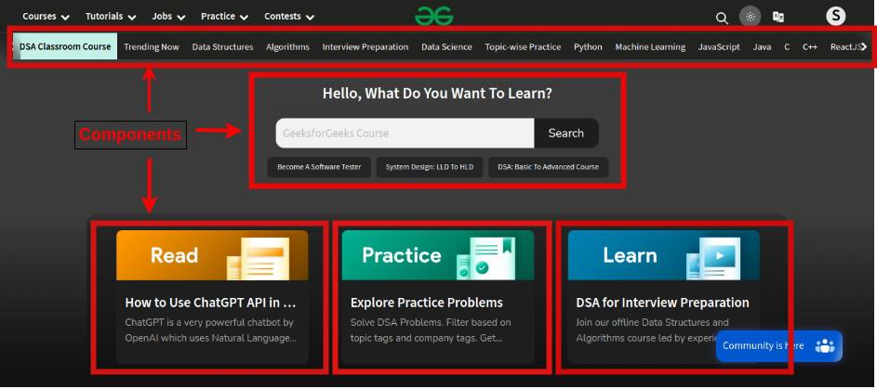

-Components are like functions that return HTML elements.

-Component describe part of the User Interface.

-They are reusable and can be nested inside other component.

-A component is considered the core building blocks of a React Application.

-It makes the tasks of building UI much easier.

-Components are independent and reusable bits of code. They serve the same purpose as JavaScript functions, but work in isolation and return HTML.

-Each component exist in the same space but they work independently from the one another and merge all in parent component which will be the final UI of your application.

-Every React component has its own structure , methods and API

-They can be reusable as per your need.

-For Reusing component we need do import and export the component.

-In addition to rendering the UI, it manages the events belongs to its user interface. To summarize, React component provides below functionalities.

* Initial rendering of the user interface.
* Management and handling of events.
* Updating the user interface whenever the internal state is changed.

React component accomplish these features using three concepts −

* **Properties** − Enables the component to receive input.
* **Events** − Enable the component to manage DOM events and end-user interaction.
* **State** − Enable the component to stay stateful. Stateful component updates its UI with respect to its state.

There are two types of components in React. They are −

* **Functional Components**
* **Class Components**

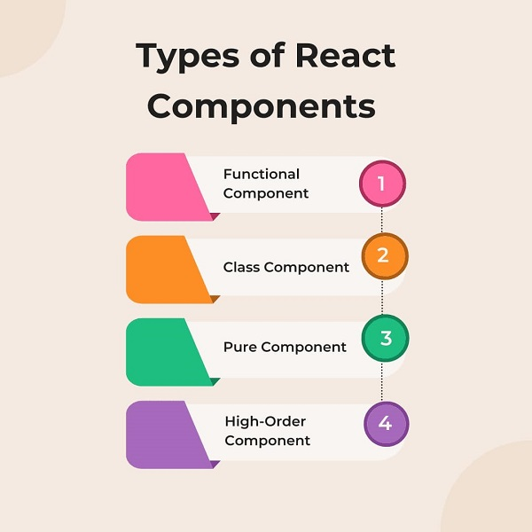

**FUNCTIONAL COMPONENTS [STATELESS]**

-Function component is Simple function.

-Function component accept the props as an Arguments and Return React elements(JSX) i.e HTML.

-Function components can be written using much less code, are easier to understand.

-Use Function component as much as possible.

-Solution without State.

-Absence of This Keyword.

-Functional Component called as Stateless /Dumb /Presentional component.

-In functional component no render() is required.

-Functional Component run from Top-To-Bottom and Ones the Function is returned it can’t be alive.

-React Life cycle method cannot be used in Functional component.

-In Functional Component Constructors are not used.

-To Implement Life Cycle Functionality in Functional Component we use can React Hooks.

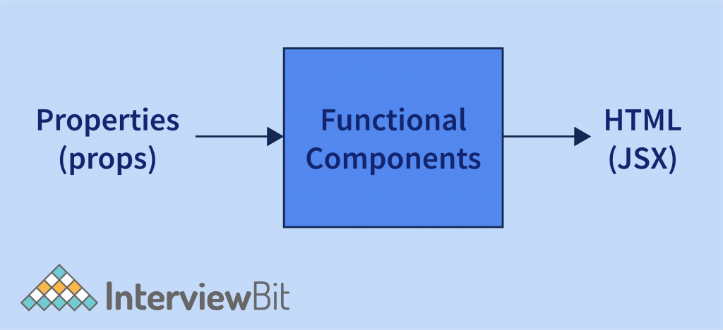



**-Functional Component with Props**

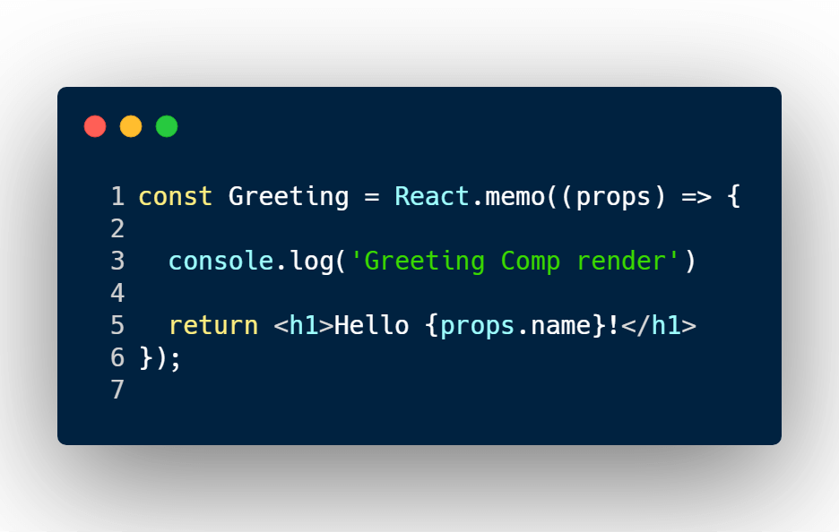

Key points about functional components:

* Simplicity:

They are simpler to write and understand compared to class components, especially for presentational components.

* Performance:

They can be slightly more performant than class components in certain scenarios.

* Hooks:

With the introduction of React Hooks, functional components can now manage state and side effects (e.g., using useState, useEffect), making them just as powerful as class components.

* Preferred approach:

Functional components are now the preferred way to write React components due to their simplicity and the benefits of hooks.

-Function component it just like plain Javascript function that accept Props as an argument and return JSX.

**CLASS COMPONENTS [STATEFUL]**

-Class Component is More Feature rich.

-We can create Class Component in two ways by

**1]Using Extending the Component Class**

**2]Extending the PureComponent Class**

-Class Component Maintain their own Private state.

-Class component used for the complex UI logic

-Provide Lifecycle of Hooks.

-Class component is called as Stateful / Smart /Container component.

-Class Component requires to extract from React.

-Component and create render() methods that return React elements.

-Class component must have render() method which return JSX

-Class Component have different life cycle method which kept it alive.

-Class Component run and invoke depend on the phases of the Class Component.

-React Life cycle method can be used inside class component.

-In class component constructors are used too store the State.

-The Life cycle Methods

**1]Mount**

**2]Unmount**

**3]Update**

-To define a React component as a class, extend the built-in Component class and define a [render method:](https://react.dev/reference/react/Component#render)

-We can create the Class Component in two ways:

**1]By Extending using Component Class.**

**2]By Extending using PureComponent Class.**

**1]By Using Extending The Component Class**

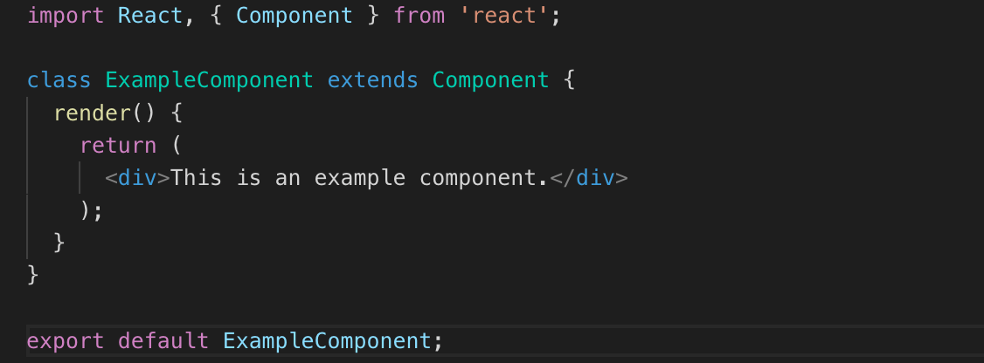

**2] By Using Extending the PureComponent Class.**

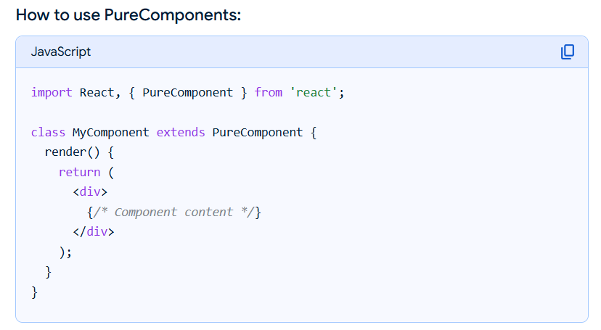

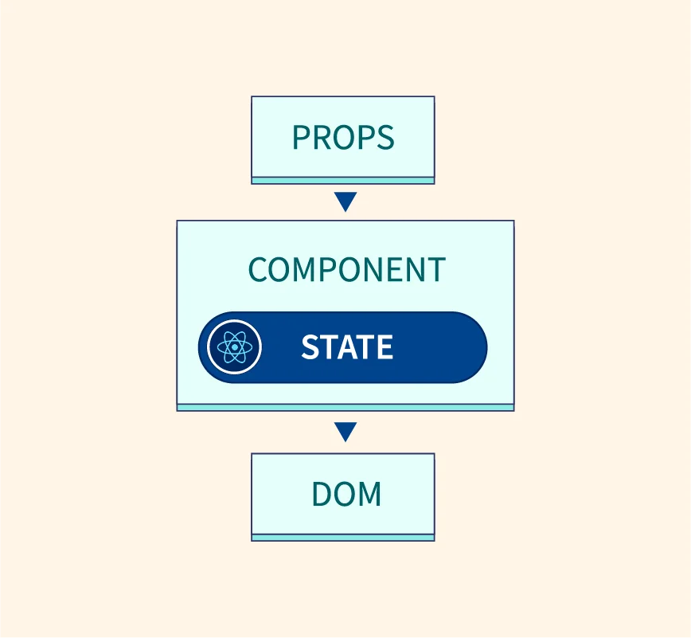

**PROPS**

-**Props** stand for “**Properties**”.

-They are Read only Component (immutable Nature).

-Because Props are passes From Parent Component. So the Parent component owns Props. So we cannot modify the props from inside the component

-Props make component reusable.

-Every component have access of Props.

-It use a way to pass data from one component to the Other component From Parent To Child.

-Props is the Parameter for the component. It is similar to Functional Parameters.

-Props are passed to the component the same way as argument pass to the function.

-Inside the Parent component, we can add the **attributes** called **Props**.

-We can Use Props in Both Component In Functional Component or in Class Component Also.

-In the Functional component we can access the Props using **props.name**.

-In the Class Component we can access the props using **this.props.name**.

**================= NOTE ==================**

1]We can Pass the data Form Parent Component to Child Component with the help of **Props**.

2]We can also Pass the Data from Child Component to Parent Component with the help of **Props**.

**1]Passing Props In Functional Component**

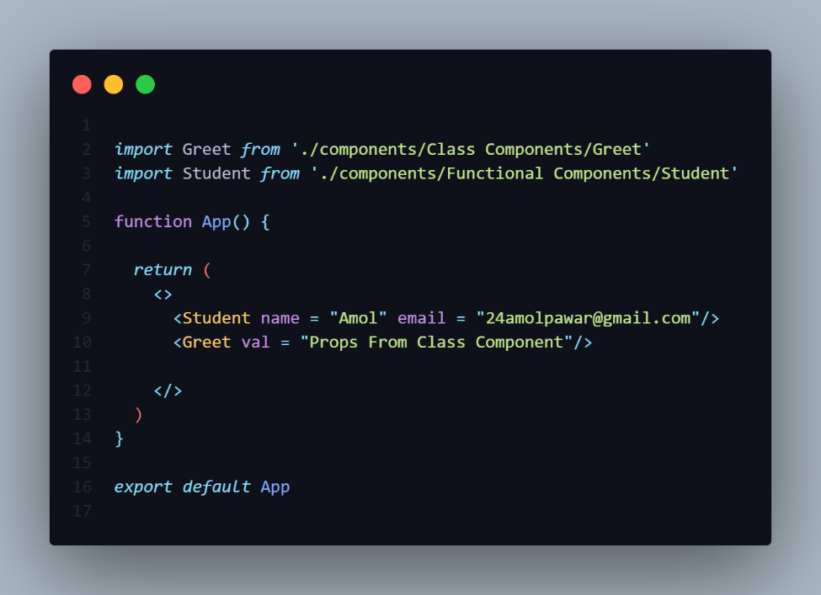

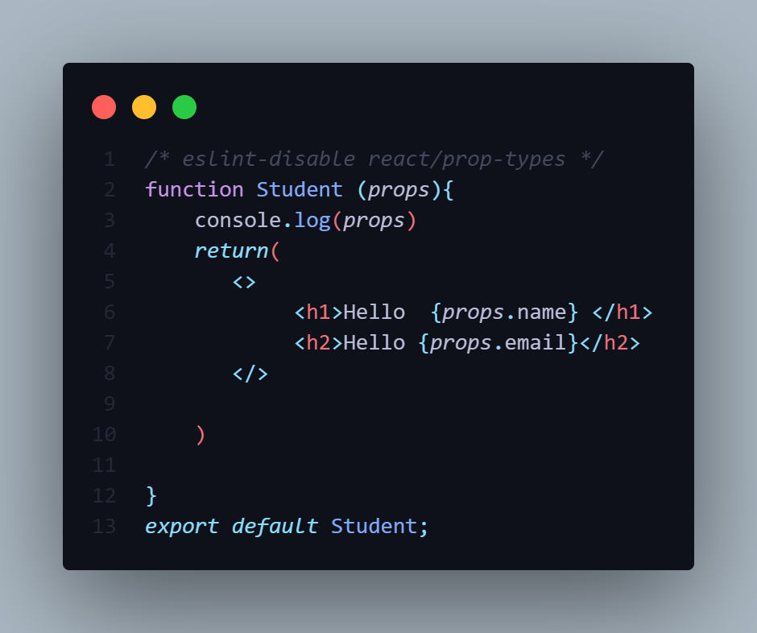

-To access the props inside the child component function(argument)

Note that there should argument present for holding Actual value.

-In the above figure the Argument is **props** is present which holds actual value.

**2]Passing Props In Class Component**



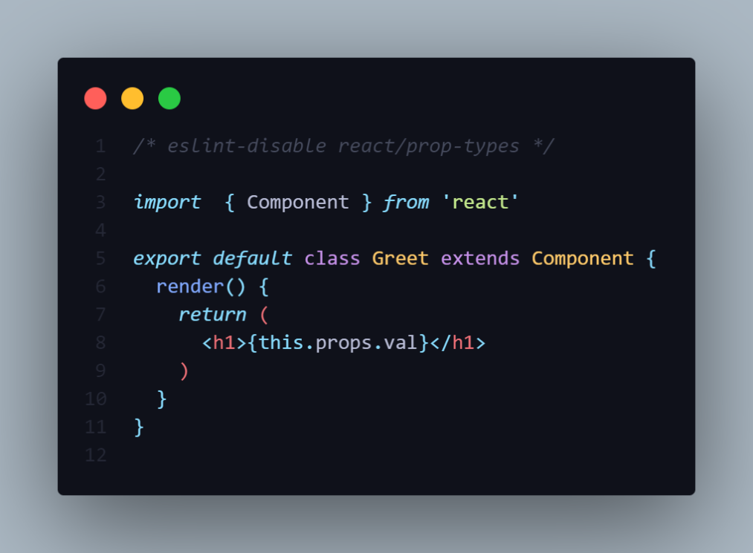

-But in Passing props in the Class Component it works in Different way.

-We need to take the help of **this.props.val** as shown in above program.

**PROPS IN CLASS CONSTRUCTOR**

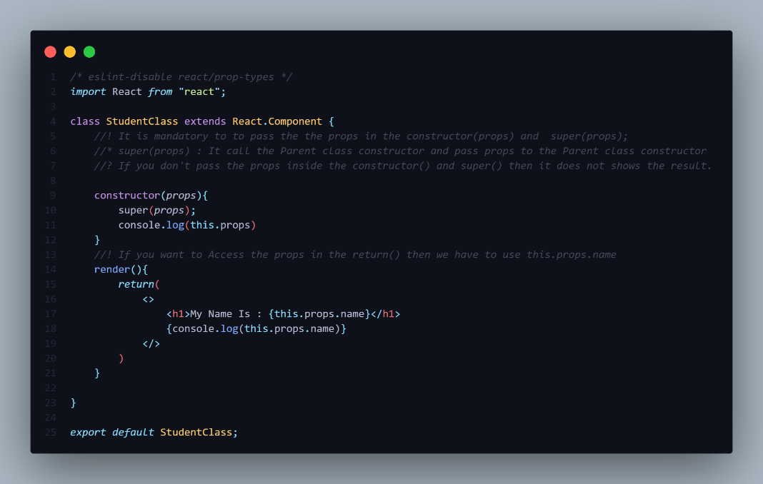

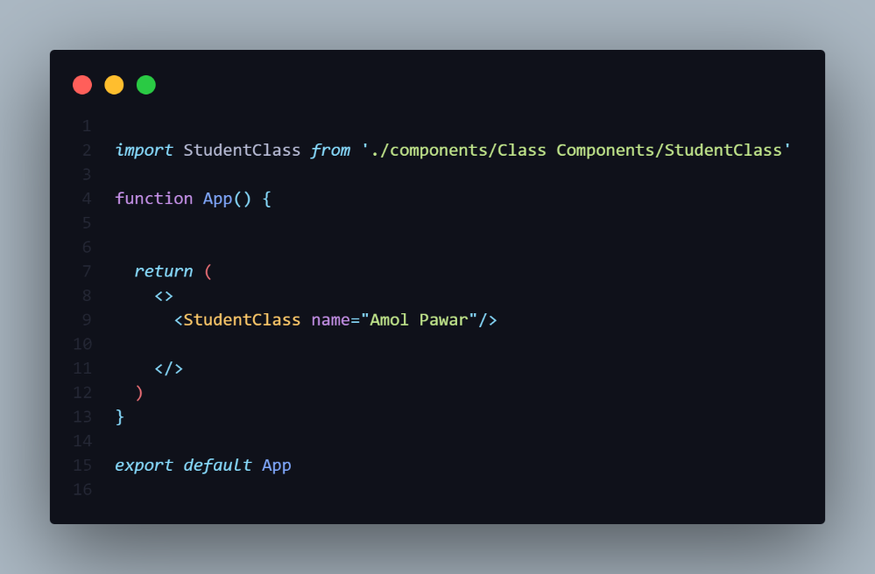

-It is mandatory to pass the props in the constructor(props) and super(props);

-super(props): - It call the Parent class constructor and pass props to the Parent class constructor

-If you don't pass the props inside the **constructor()** and **super()** then it does not shows the result.

**PropsImmutable**

-Props are Read-Only Properties i.e Immutable in nature

-If try to Assign new value to props then you get Error called

Uncaught TypeError: Cannot assign to read only property 'name' of object '#<Object>'

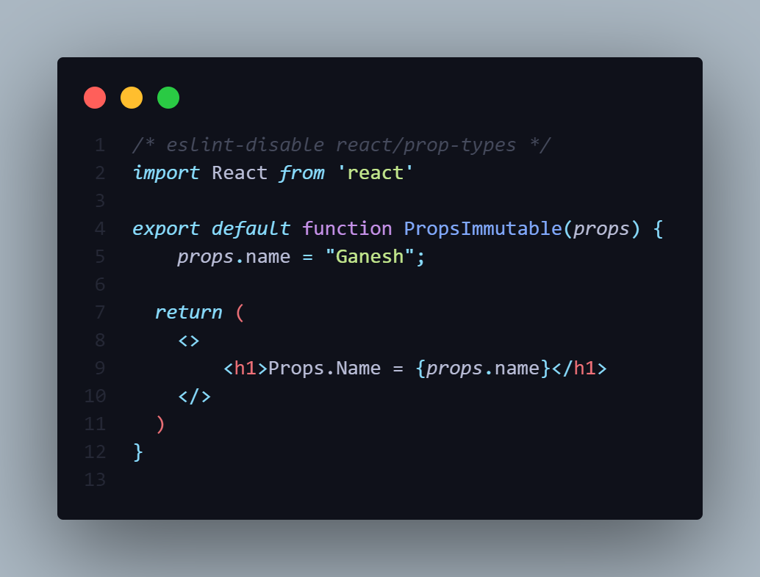

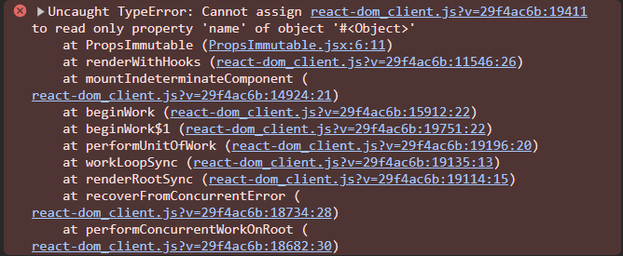

NOTE:- Inside the child component it does not matter if gives name **props** you different name also.

-But At the time of the accessing you have access using same Argument name present inside the function()

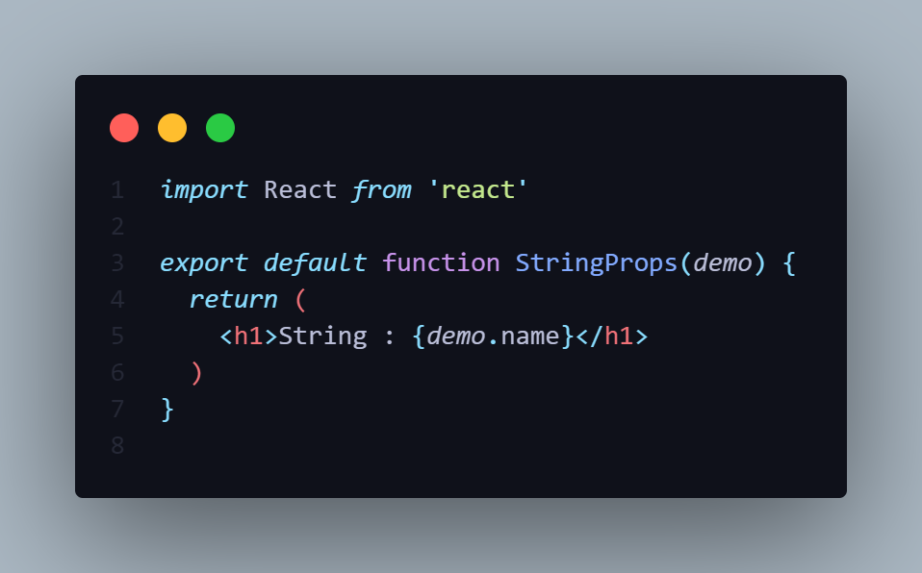

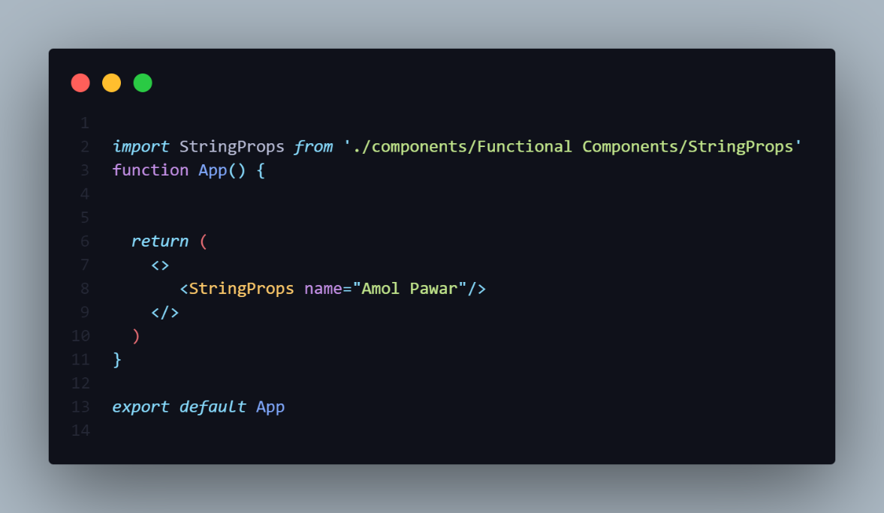

**TYPES OF DATA TO PASS INSIDE PROPS**

-Props are used to pass data from Parent component to Child Component.

-So inside the props we can pass following types of values as an arguments.

**1]String**

**2]Number**

**3]Array**

**4]Object**

**5]Function**

**1]PASSING A STRING IN PROPS**

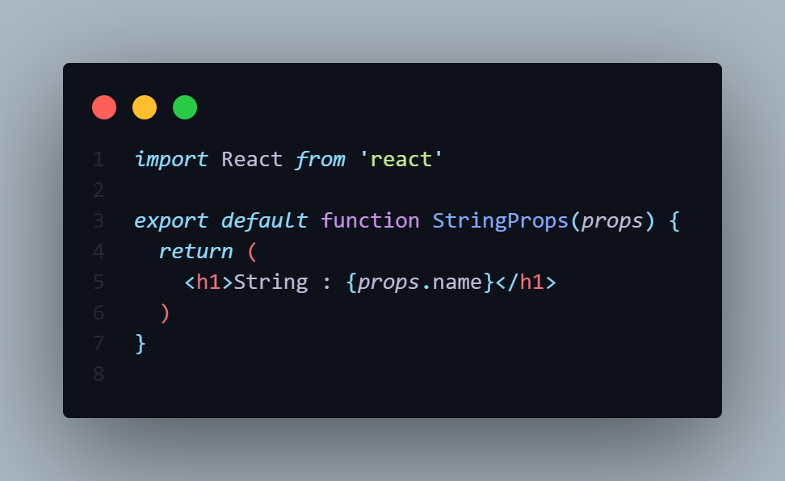



**OUTPUT**

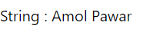

**2]PASSING A NUMBER IN PROPS**

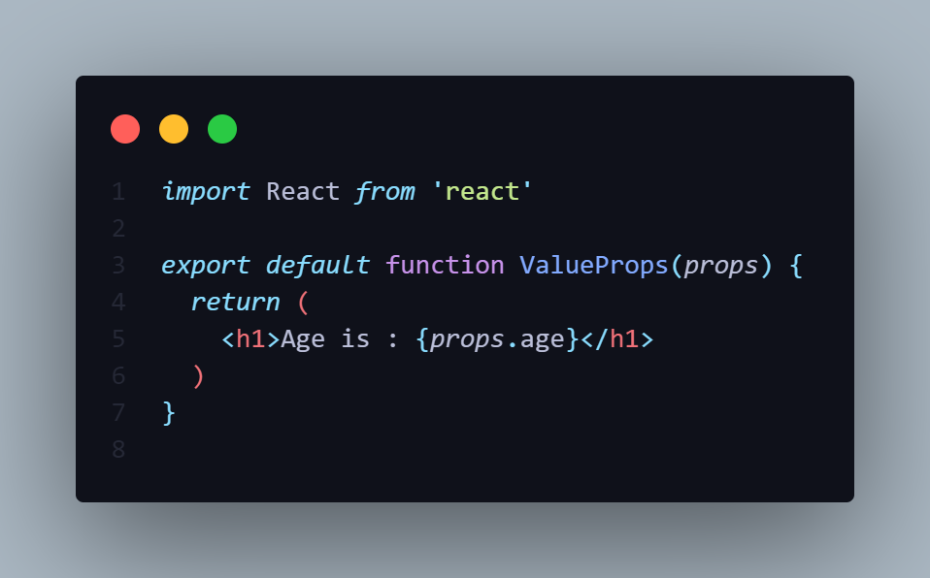

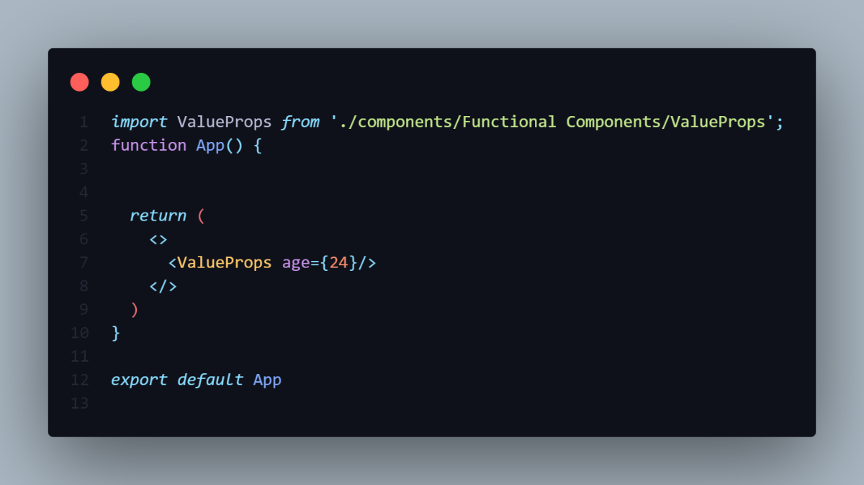

**OUTPUT**



**3]PASSING A ARRAY IN PROPS**

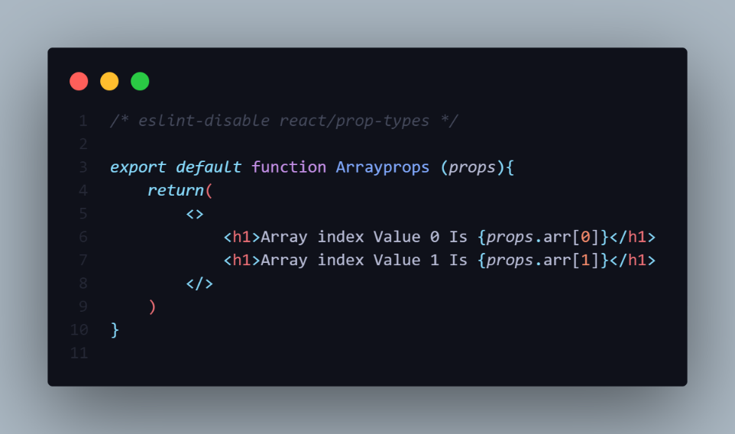

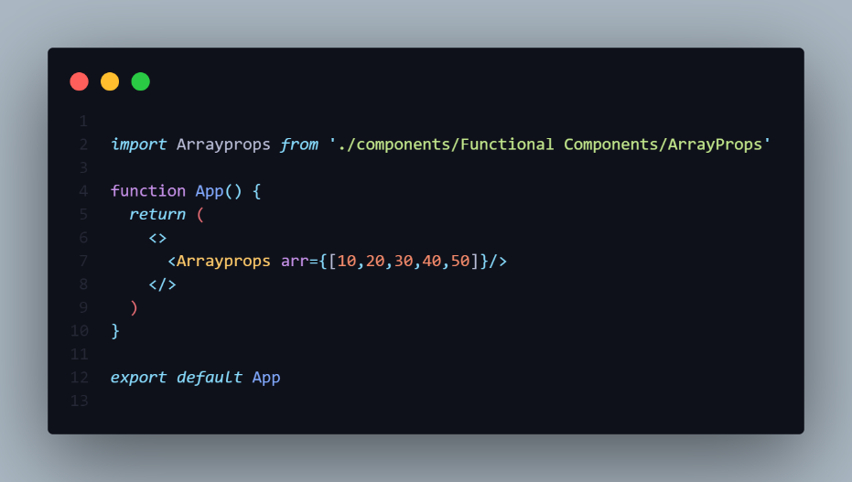

**OUTPUT**

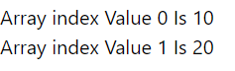

**4]PASSING A OBJECT IN PROPS**

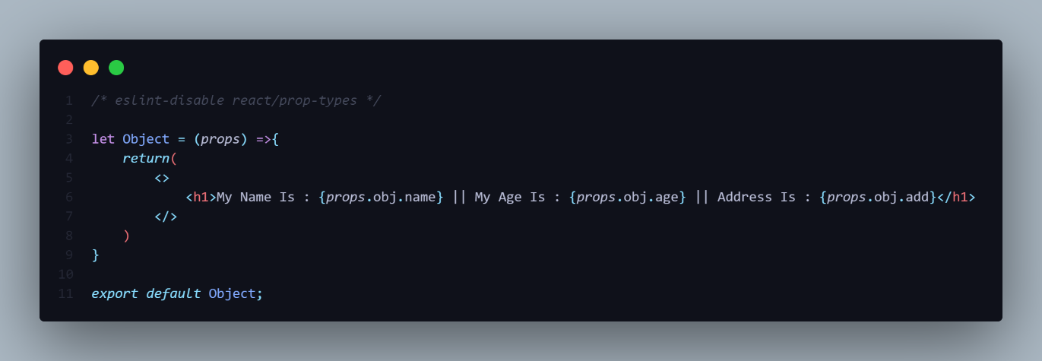

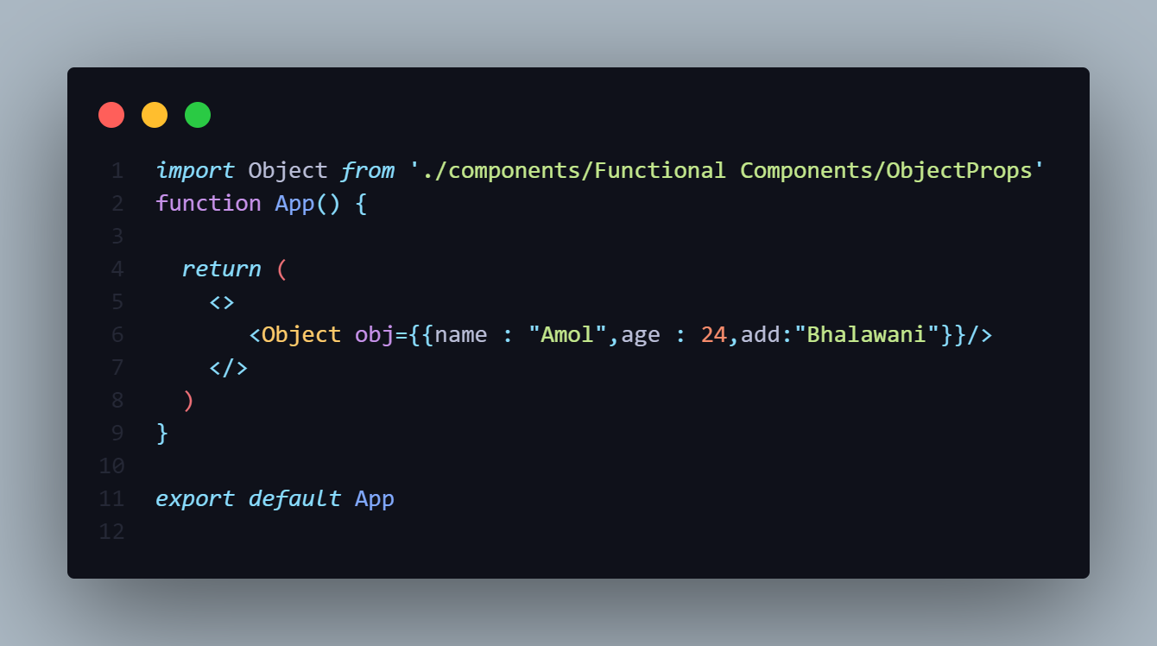

**OUTPUT**



**5]PASSING A FUNCTION IN PROPS**

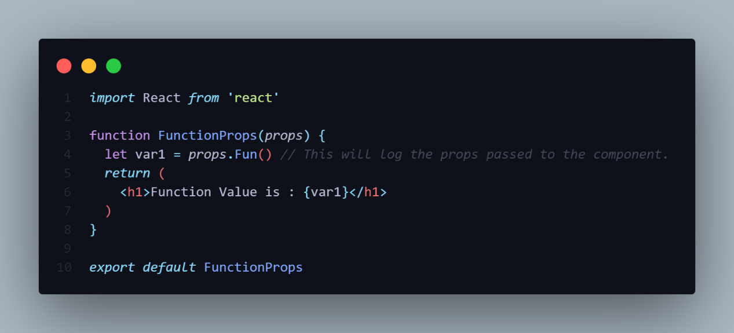

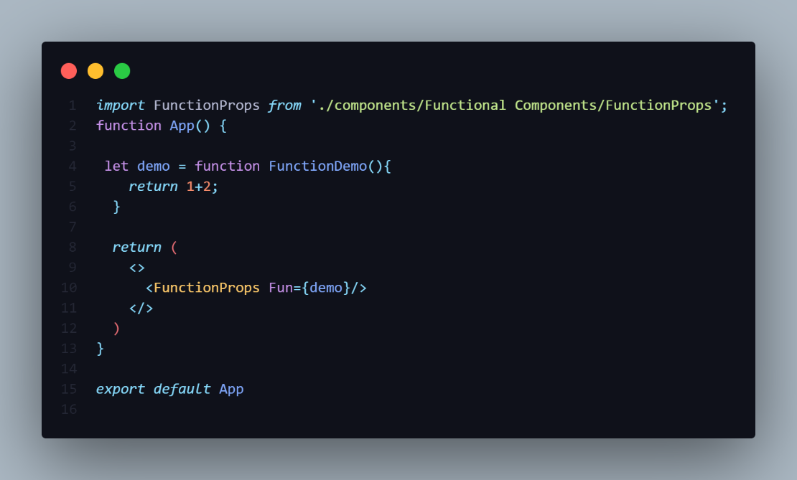

**OUTPUT**

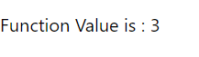

**PROPS DESTRUCTURING**

-In React, props destructuring is a technique that allows you to extract values from the props object and assign them to individual variables.

-This makes your code more concise and readable, especially when dealing with components that receive a large number of props.

-You can do the props de-structuring in both Class component or Functional Component also.

**1]INSIDE THE FUNCTIONAL COMPONENT**

**2]INSIDE THE CLASS COMPONENT**

-If the props contains the default value and then again you initialized the props in the child class it does not take the duplicate values.

-It takes the **default value** Only.

-In props the variable is not initialized you accessed then the output is the **undefined**.

**DEAFULT VALUE**

**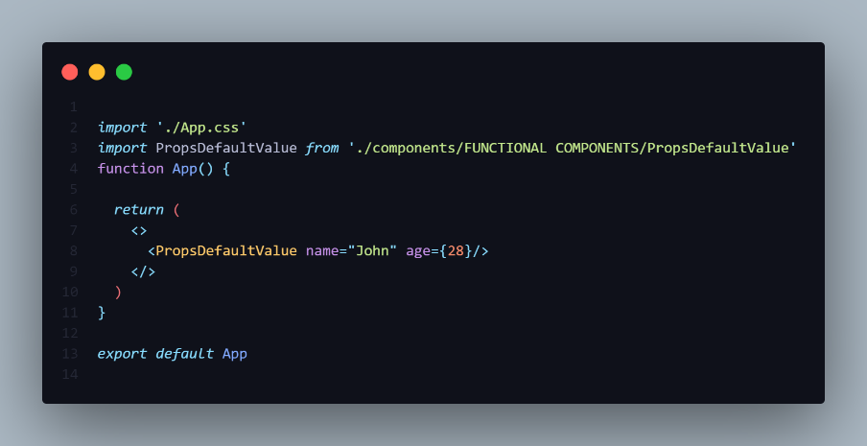**

**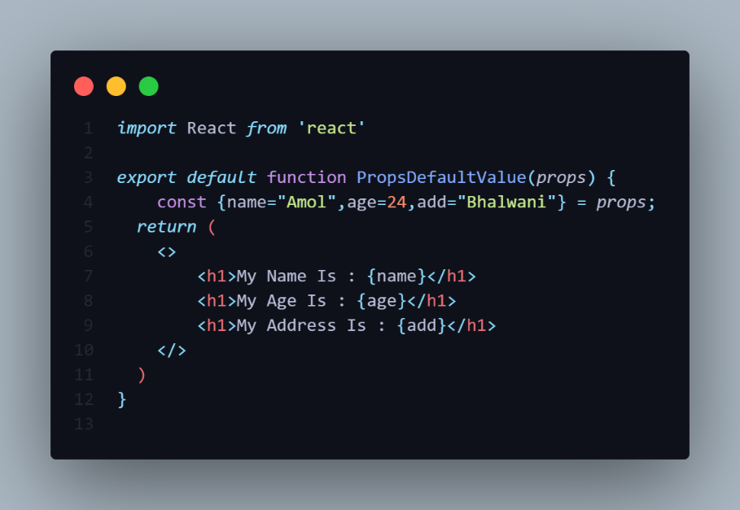**

**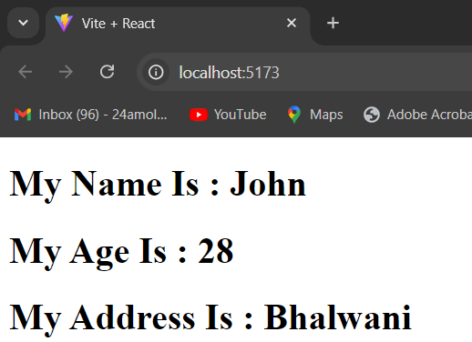**

**NOTE : It takes default value only. It does not take duplicate values.**

**1]INSIDE THE FUNCTIONAL COMPONENT**

**EXAMPLE NO 1**

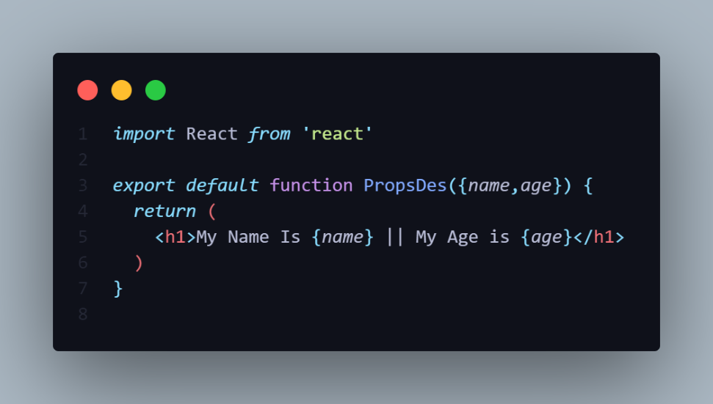

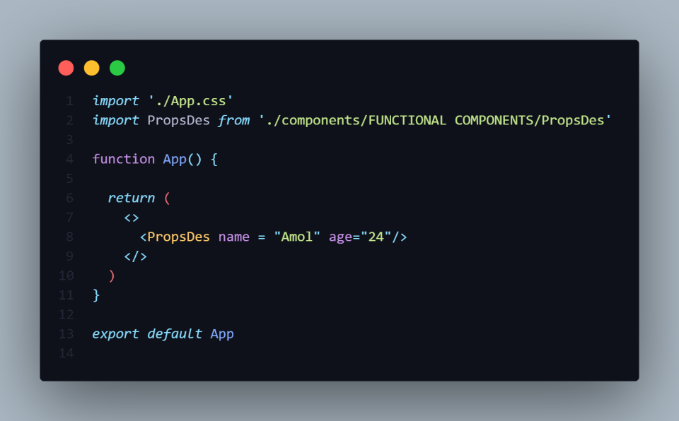

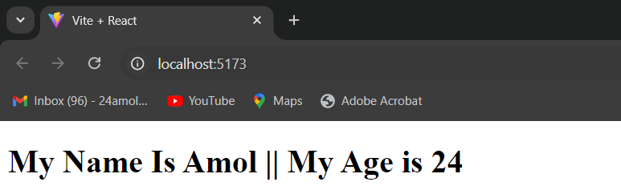

-You can do directly De-Structuring inside the function like shown in above program.

**{name,age,add}**

**EXAMPLE NO 2**

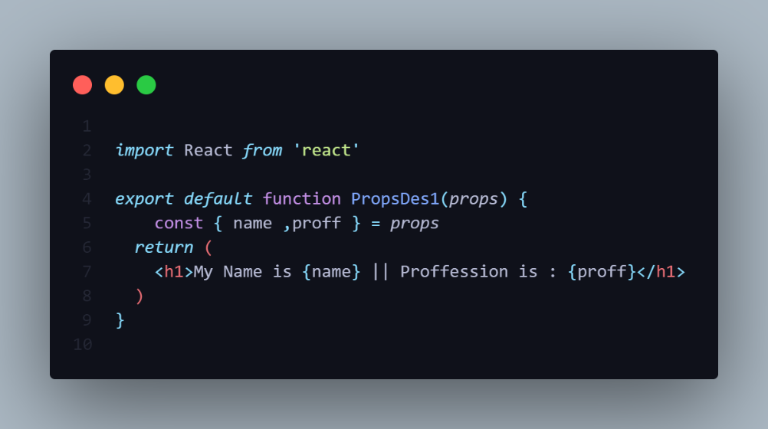

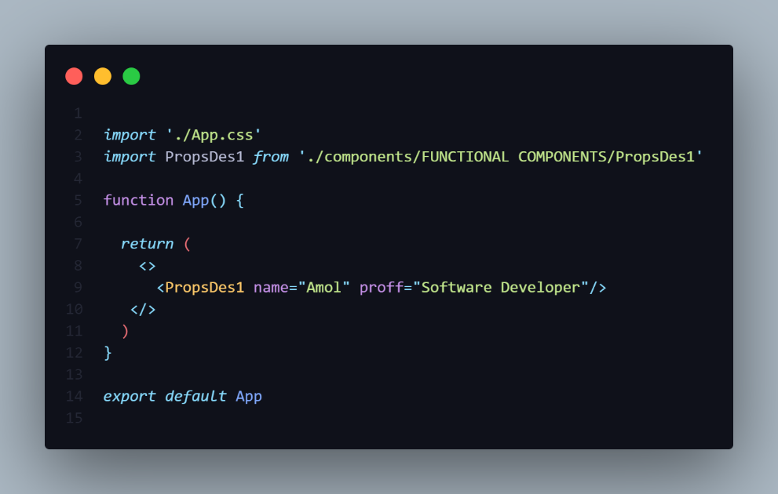

**OUTPUT**

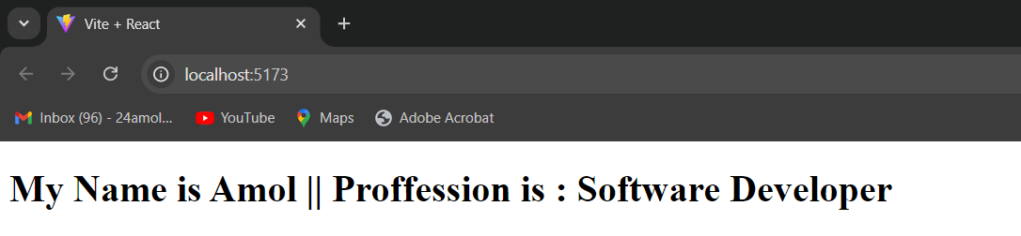

-You Can do De-structuring like this also using initializing the **props** to variable like in Javascsript.

**const {name,age,add}=props;**

**EXAMPLE NO 3**

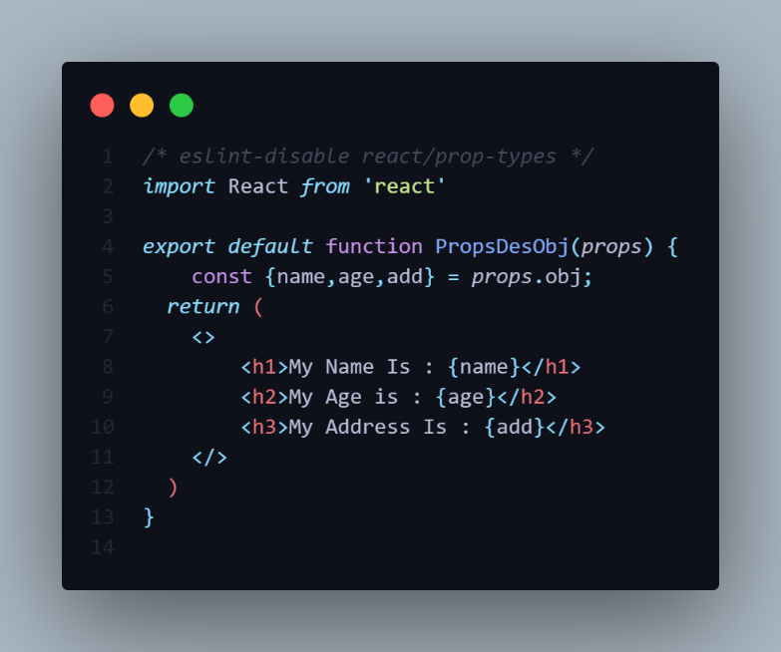

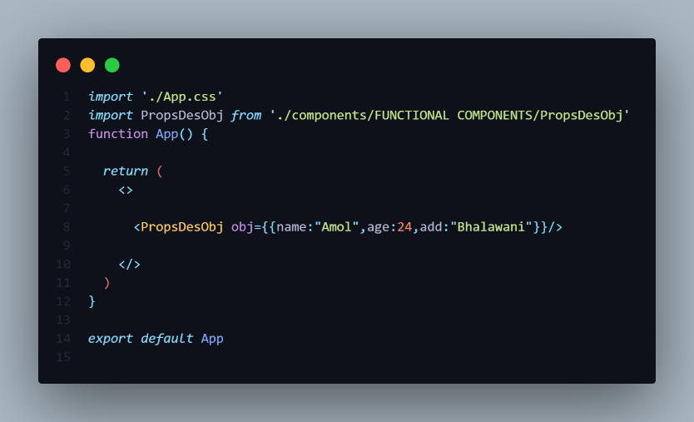

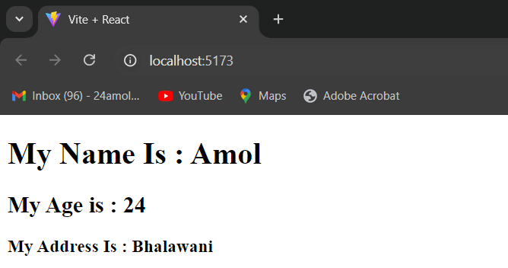

-But When you passing **Object** as an Props then that time you have write the Object name with props like below

**const {name,age,add}=props.obj**

**2]INSIDE THE CLASS COMPONENT**

**EXAMPLE NO 1**

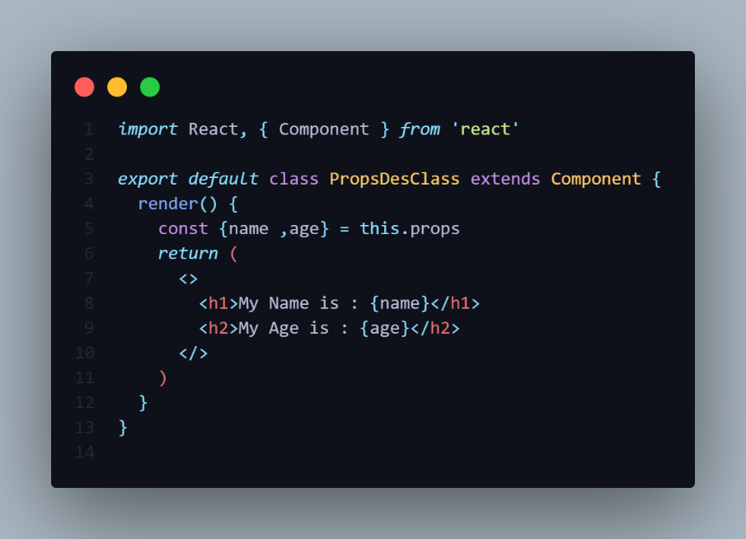

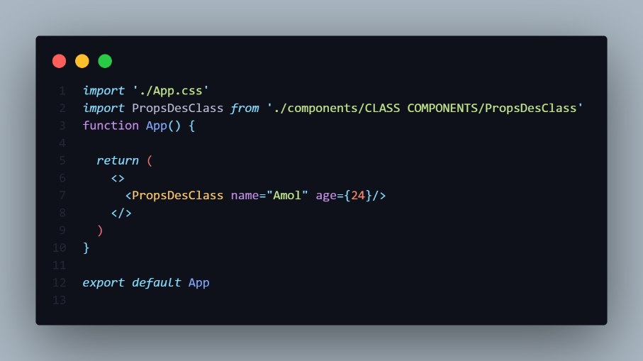

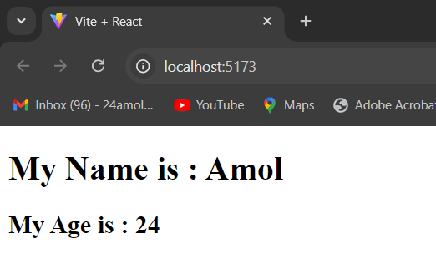

-Inside the class **this** keywordis mandatory to access the props.

**const {name,age,add}=this.props**

**EXAMPLE NO 2**

-You can directly do this using **this.props.name**

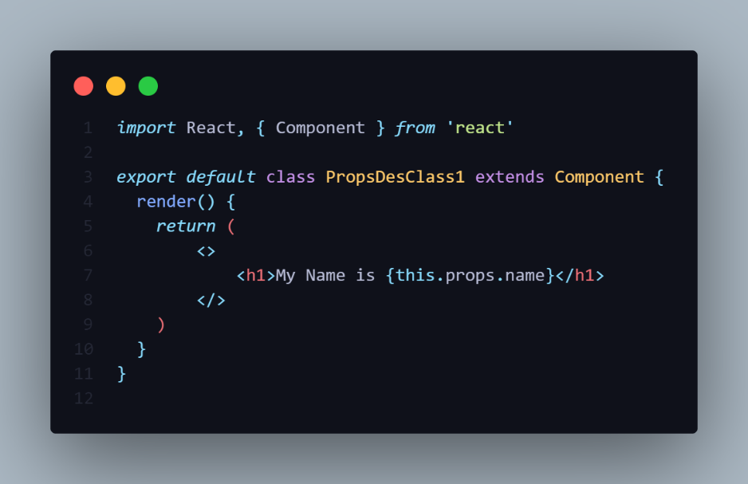

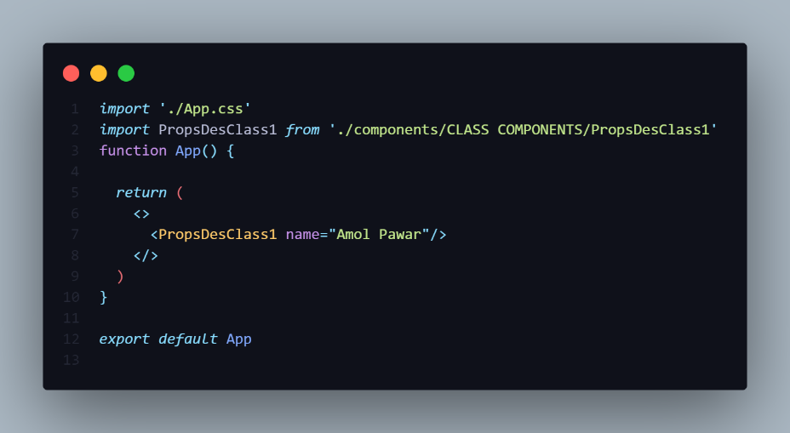

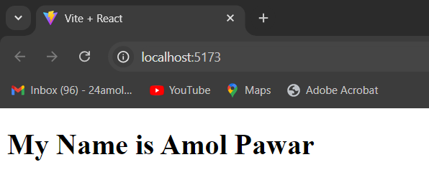

-This Following syntax is used to access the props in class.

**{this.props.name}**

**EXAMPLE NO 3**

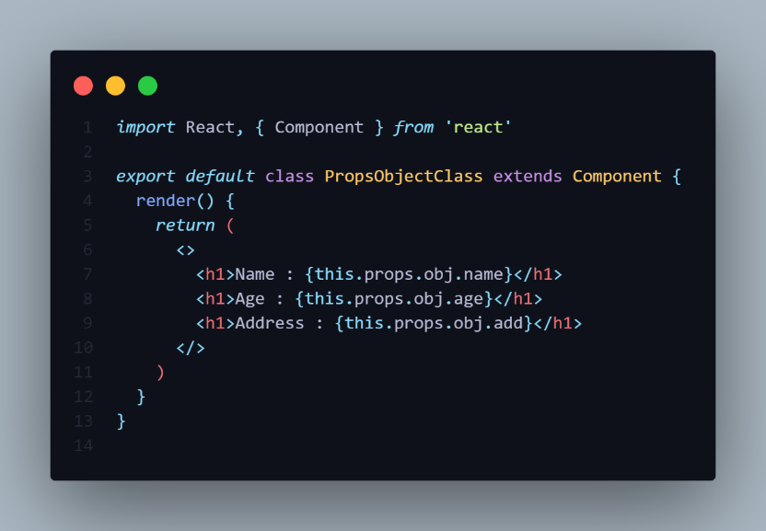

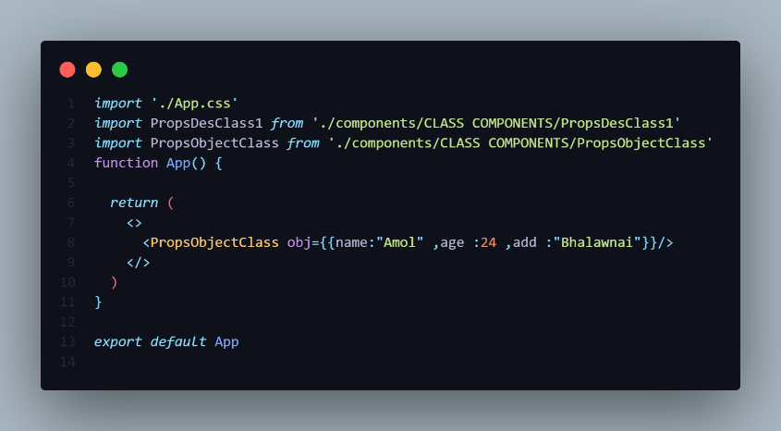

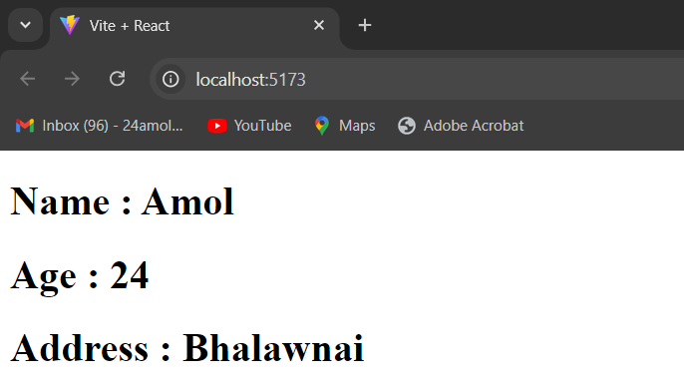

-For accessing the props like object you have to follow the Following syntax.

**{this.props.obj.name}**

**METHOD AS PROPS**

-If child component want to communicate To Parent Component we again use **props**.

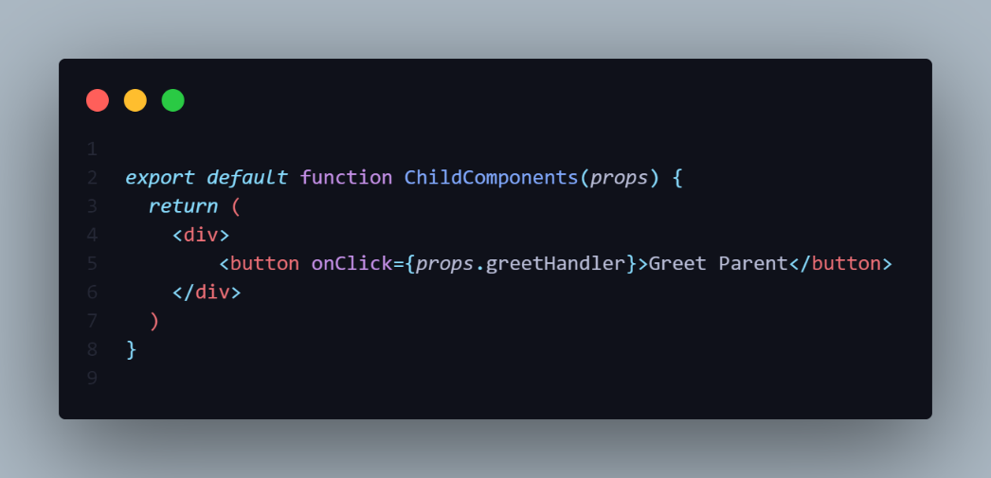

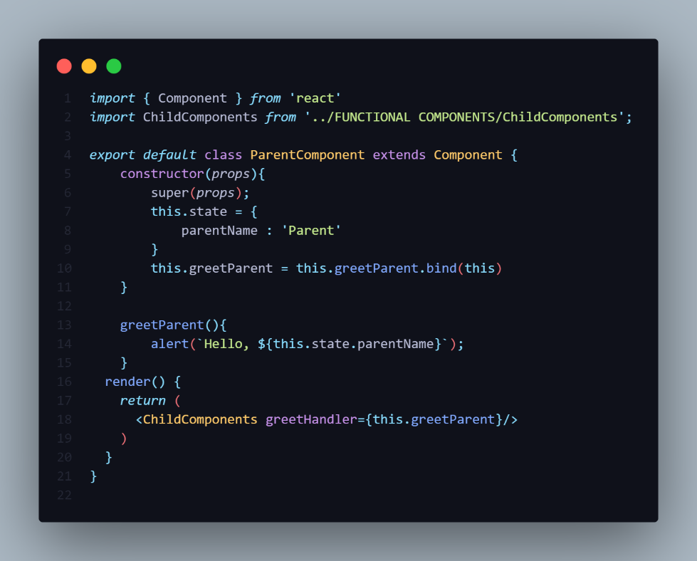

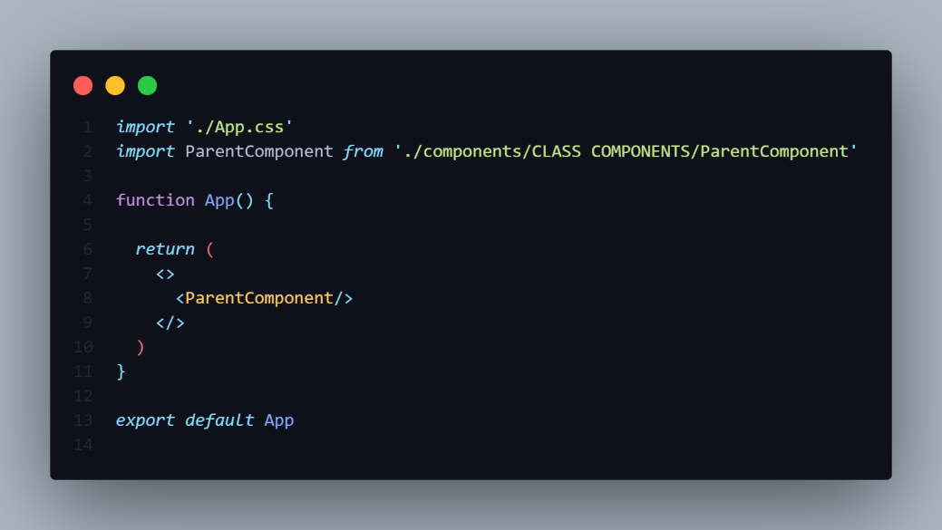

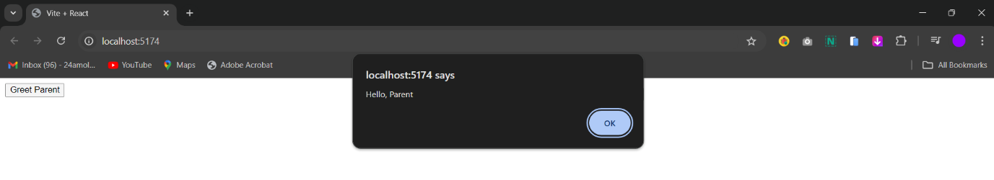

-Using this The Child Component is Renders the Parent Class Method using Props.

-So Here Child Component is Communicating with Parent Component.

-For that Create **Child Component** using **Functional**.

-Create a **Parent Component** using **Class** which accepts the props and states.

-Declare one class **method()** and **bind** this method.

-Then inside the **Render()** method call the **Child Component** and pass the class Component method() as an **props(**attribute**)**.

-Inside the Child Component in the return create a button inside the **OnClick()** event and access the using **props.eventHandler**.

-Call The Parent Component in the **App.jsx**

-If you want pass the **variable** from **Child Component** to the **Parent component** then write **EventHandler(**argument**)** with **Parenthesis** in the **Arrow Function()**.

-Note that **Parent Component** Method() accepts the **Parameter** from the Child Components.

-Call The Parent Component in the **App.jsx**

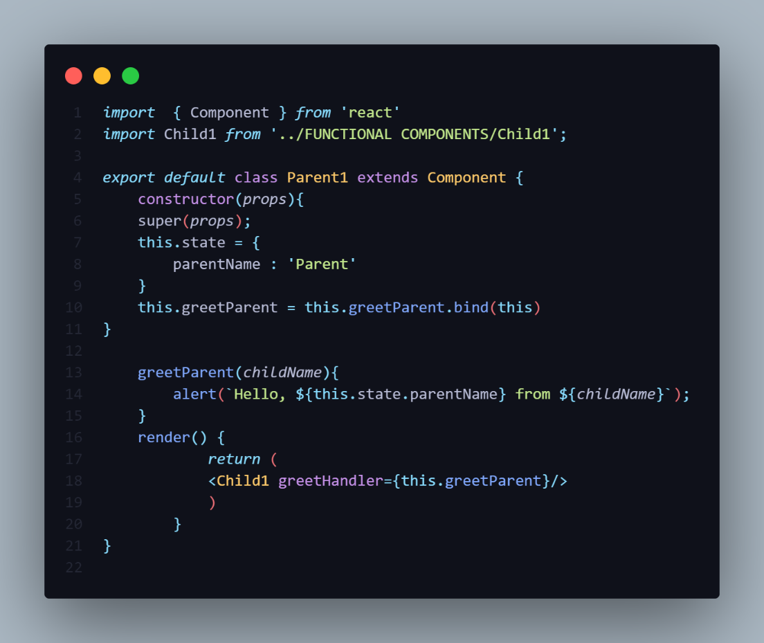

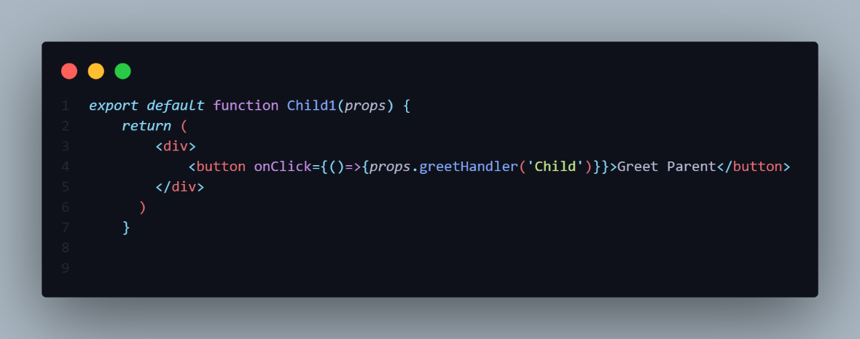

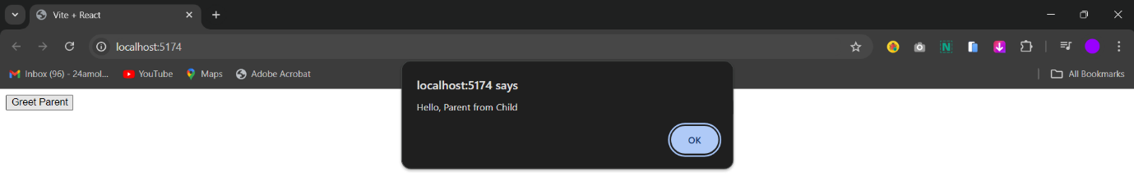

**PASS THE DATA**

1]We can Pass the data From Parent Component to Child Component with the help of **Props**.

2]We can also Pass The Data From Child Component to Parent Component with the help of **Props**.

**1] Passing Data From Parent To Child.**

**2]Passing Data From Child To Parent Component.**

**I]Using Methods**

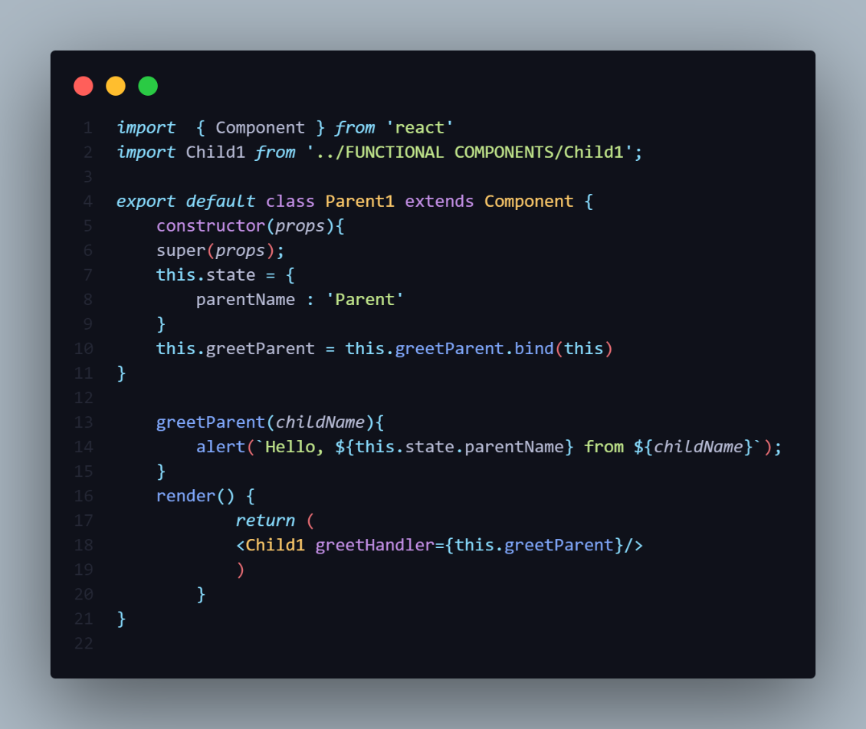

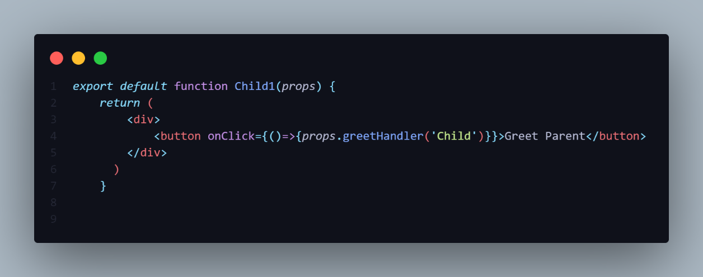

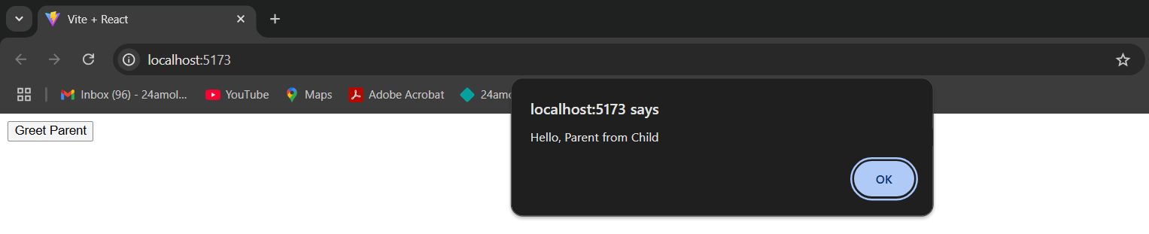

**II]Using Function.**

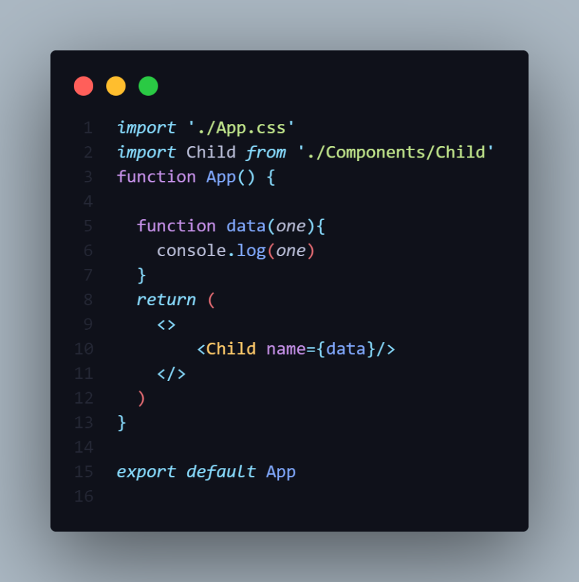

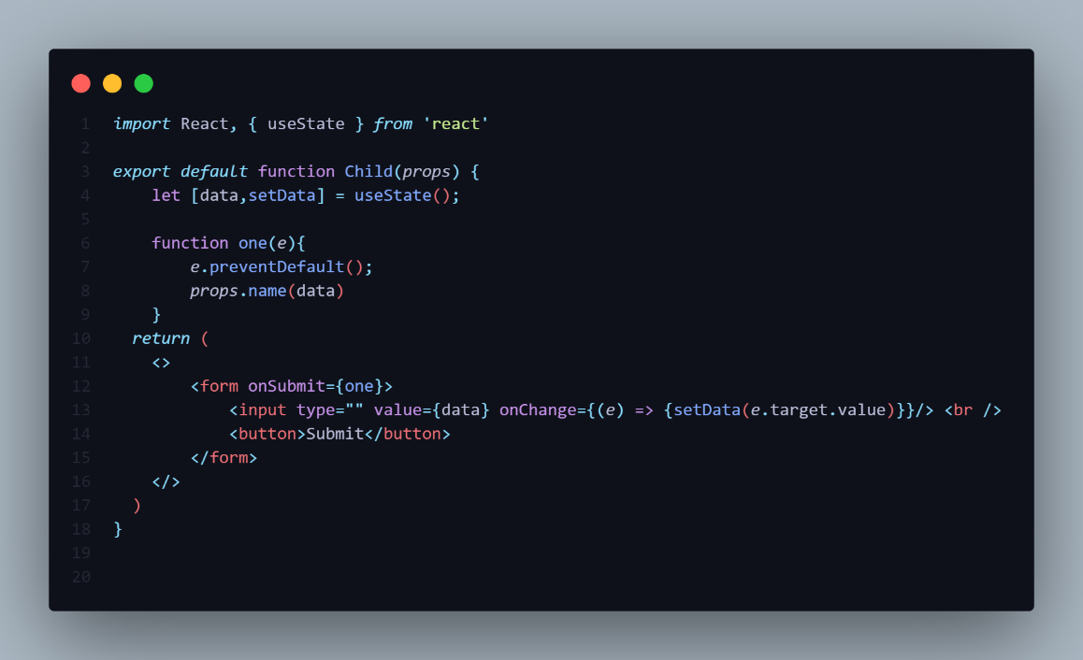

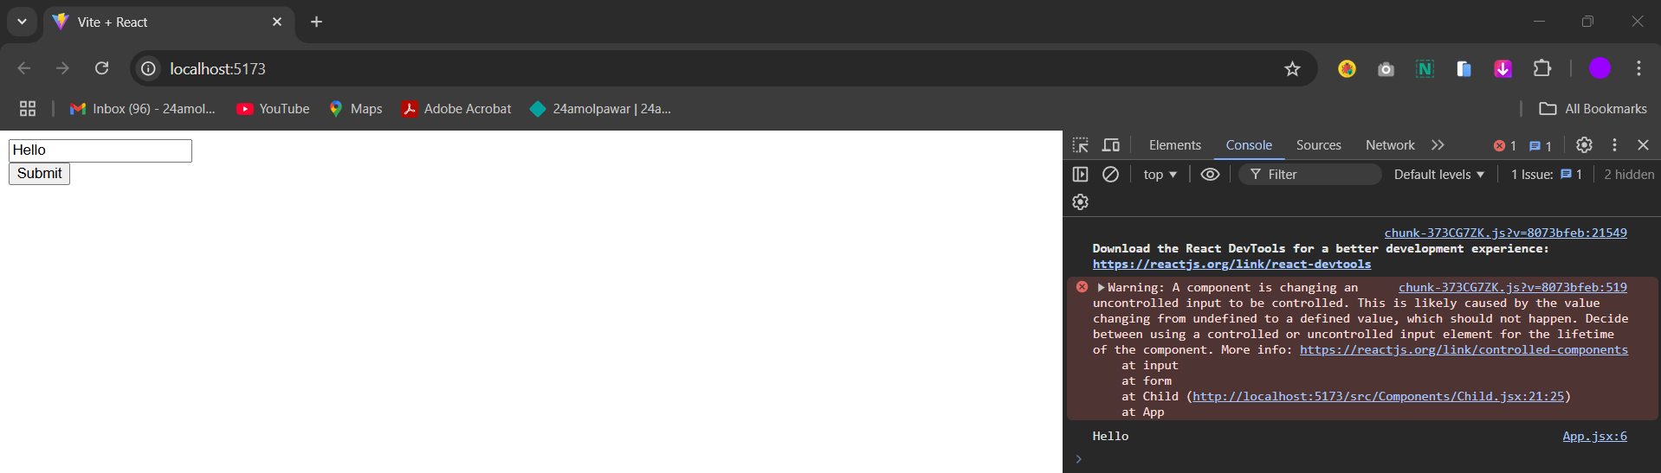

**STATES**

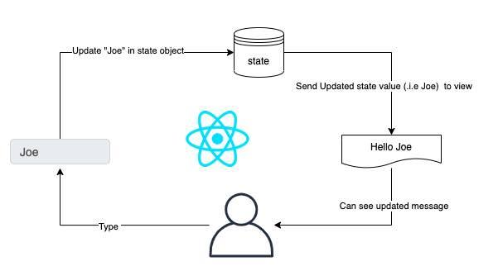

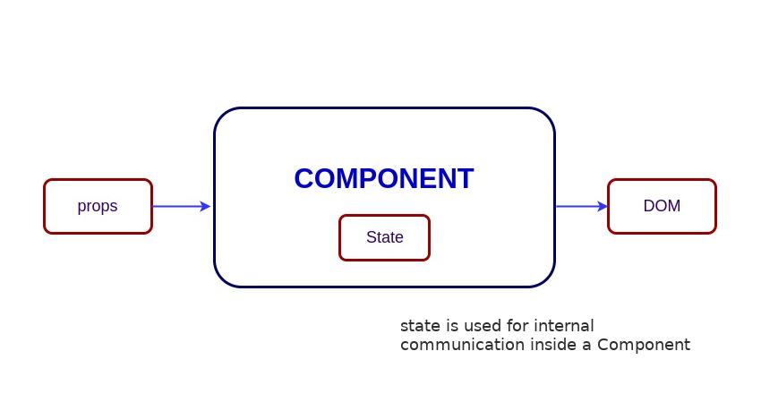



-Props are Immutable In Nature so if any Variable pass from parent Component to Child Component then inside the child component it is not possible to change the Props.

-To Overcome this problem we uses the States.

-In React State is Javascript Object that stores data that can be modify over the time.

-State is manageable within the component and hence component have full control to change the state.

-The state can access in the Functional component using the **Hooks**.

-The state can access the in the class component using **this.state**.

-The State is an adaptable structure i.e used to contain Data or Information about the component.

-A component with the state is known **Stateful** Components.

-It is the Heart of React component which determine the behaviour

Of the component and how it will be Rendered.

-State can be set by using setState() and calling setState() trigger UI update.

**1]INSIDE THE CLASS COMPONENT**

**Syntax**

this.state= {

Key:value;//Properties

}

-To do this, add a class **constructor()** which assigns an initials state object Using **this.state** inside the constructor.

-The **this.state** property can be rendered inside the render() method(Show on UI).

-To set the state, it is required to call the **super()** statement method in the constructor.

-It is because **this.state** is un initialized before the **super()** statement method has been called.

-After to update the state you have declare the **this.setData(){}** method.

**2]INSIDE THE CLASS COMPONENT**

-To use the state inside the Functional Component we have to take the help of Hooks.

-The **useState()** Hook is used in the Functional component.

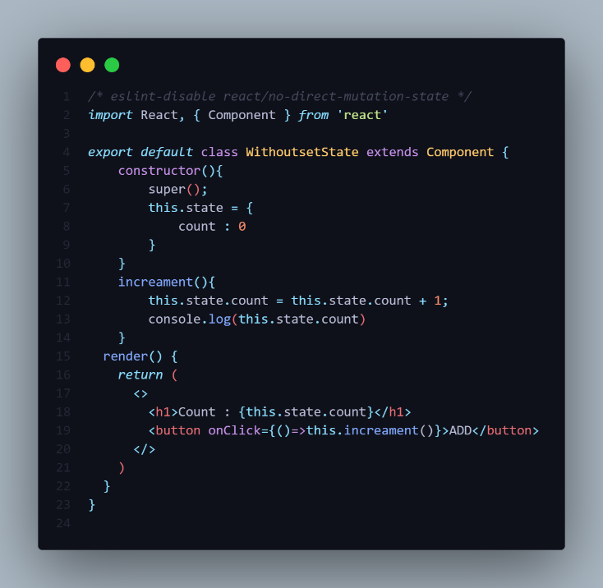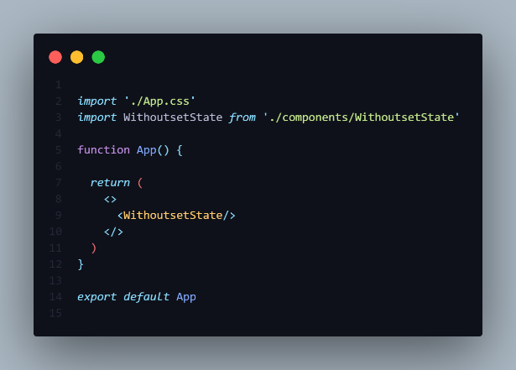

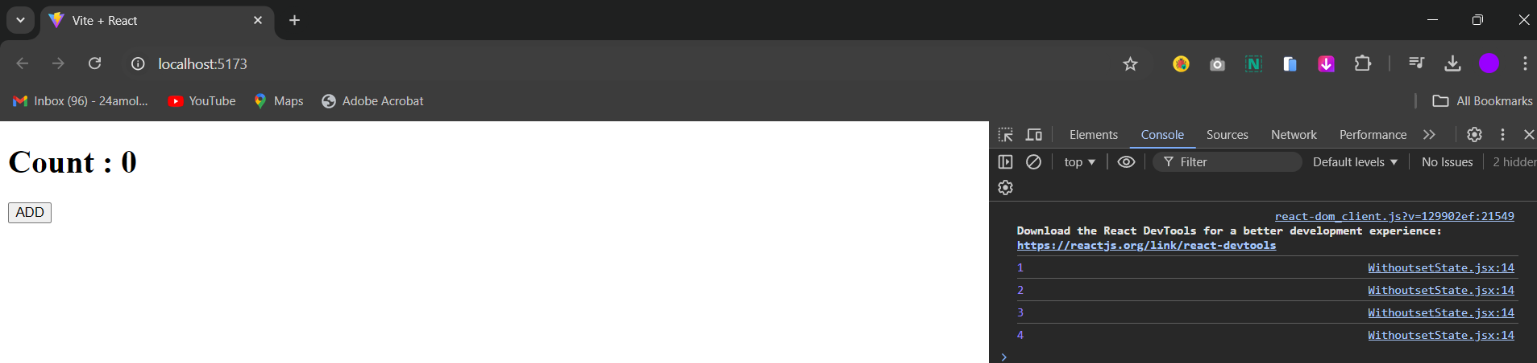

-So Never Modify the state directly take the help of setState() method

**================= NOTE ===================**

-If write a program without setState() method then you try to increment the value direct initialize variable.

-Then the value of the variable it does not reflect on the UI it will only increment on the browser.

this**.**state**(**{

Key:value;//Properties

},() => {

//Callback function code

}

**)**

**setState()**

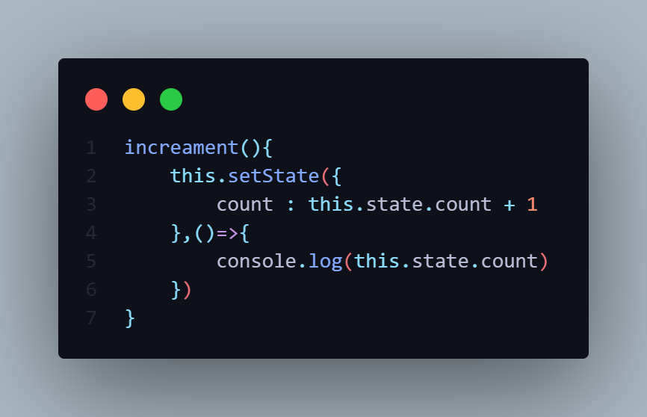

-The setState() method accepts two parameters

1]First is Object {}.

2]Callback Function()=>{}.

**1]COUNTER PROGRAM WITHOUT CALLBACK FUNCTION FUNCTION**

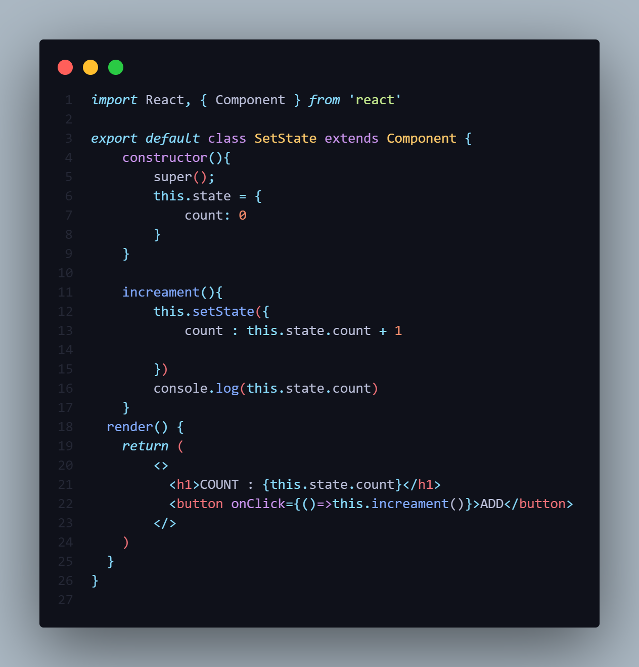

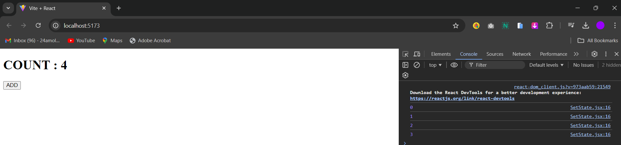

-Without callback function the UI Render First then the browser.

-The UI count is More **+1** greater than browser count.

-So to overcome this we have to use the callback function.

**2]COUNTER PROGRAM WITH CALLBACK FUNCTION**

-So use callback Function i.e **Arrow Function** [()=>{}].

-The Arrow function is callback function which handles the Asynchronous condition.

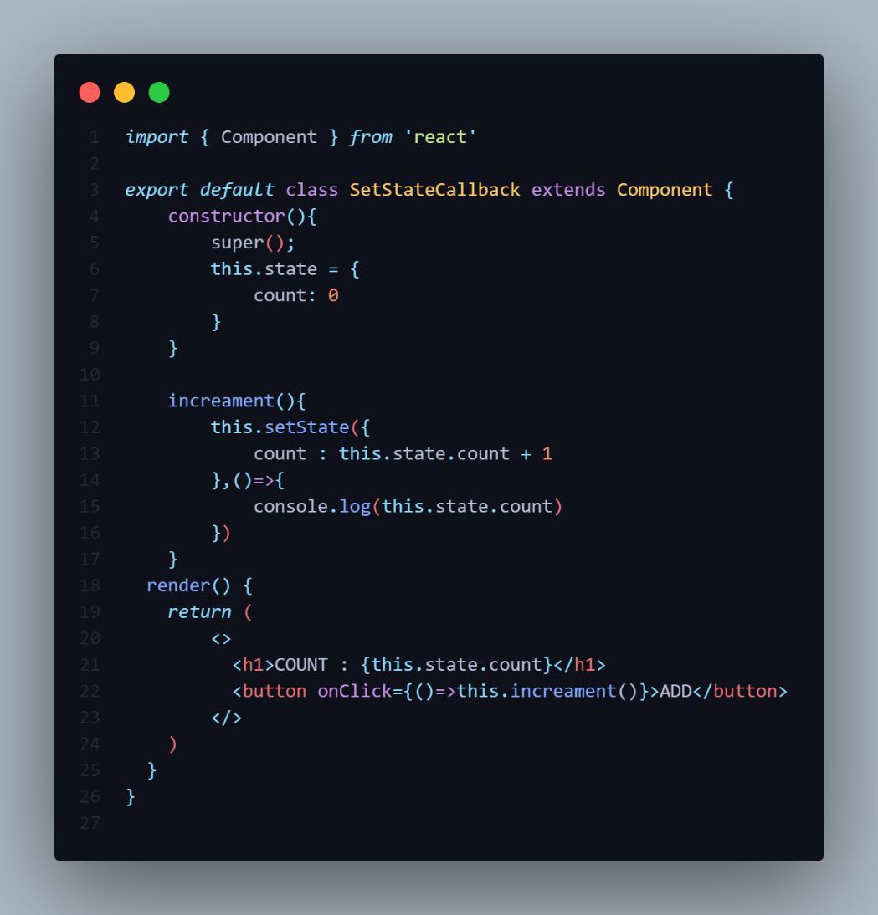

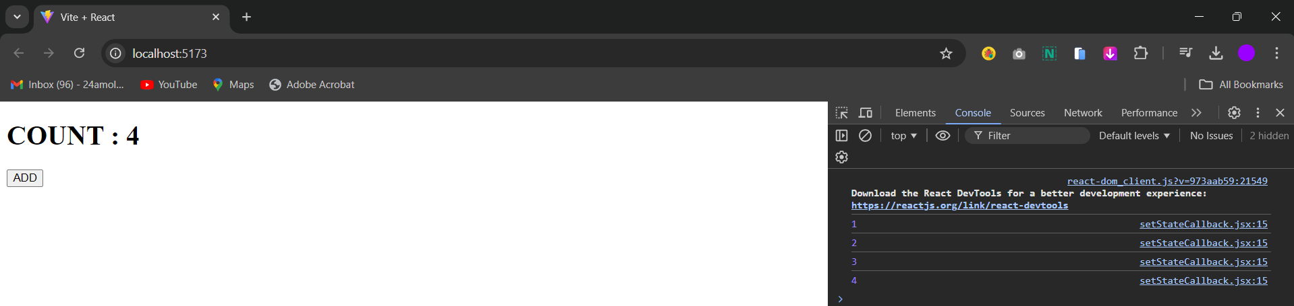

**MULTIPLE CALLBACK**

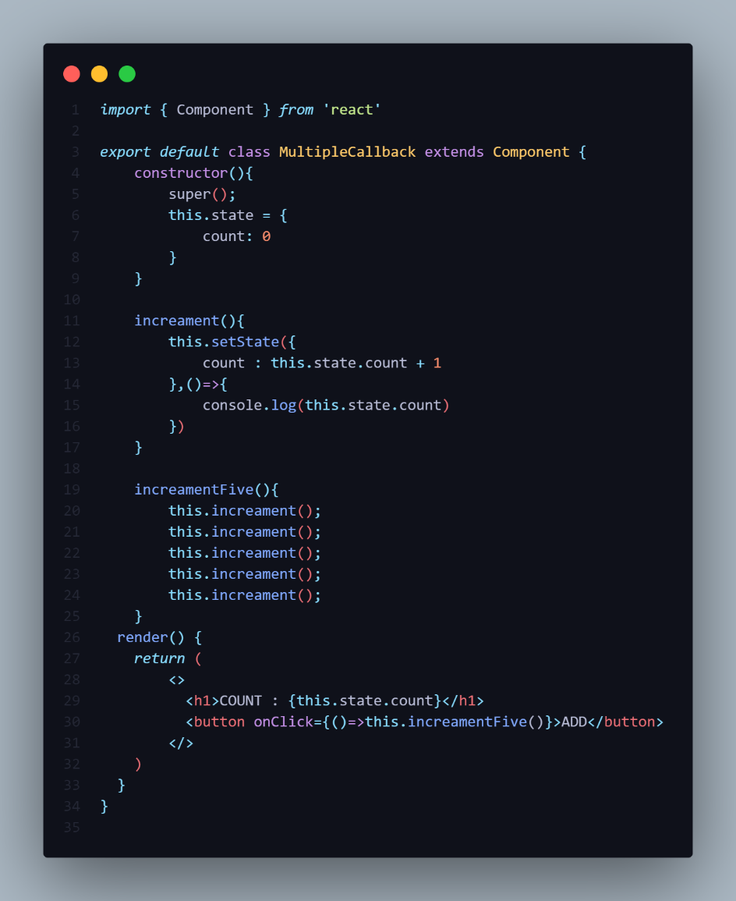

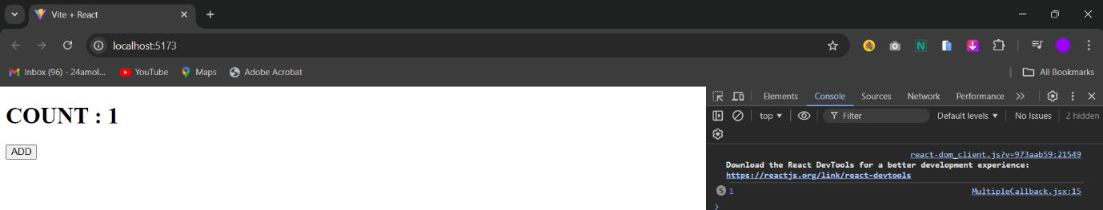

-Let consider this scenario the **increament()** method called 5 times.

-In this scenario when we click on Button the value change **1** on the UI and In the console the **1** is called **5** times.

-This behaviour because React may Group of Multiple calls into single update for better performance.

-In this Multiple setState() calls in Single Update and the updated count does not carry over for different calls.

-All the Five setState Calls are done one single go.

-So whenever you have update setState based the previous state we need pass **Function** as an argument in setState() method instead of Regular **Object**.

-Inside the Function we have to pass the **Object**.

-In the below we have update state using **prevState**.

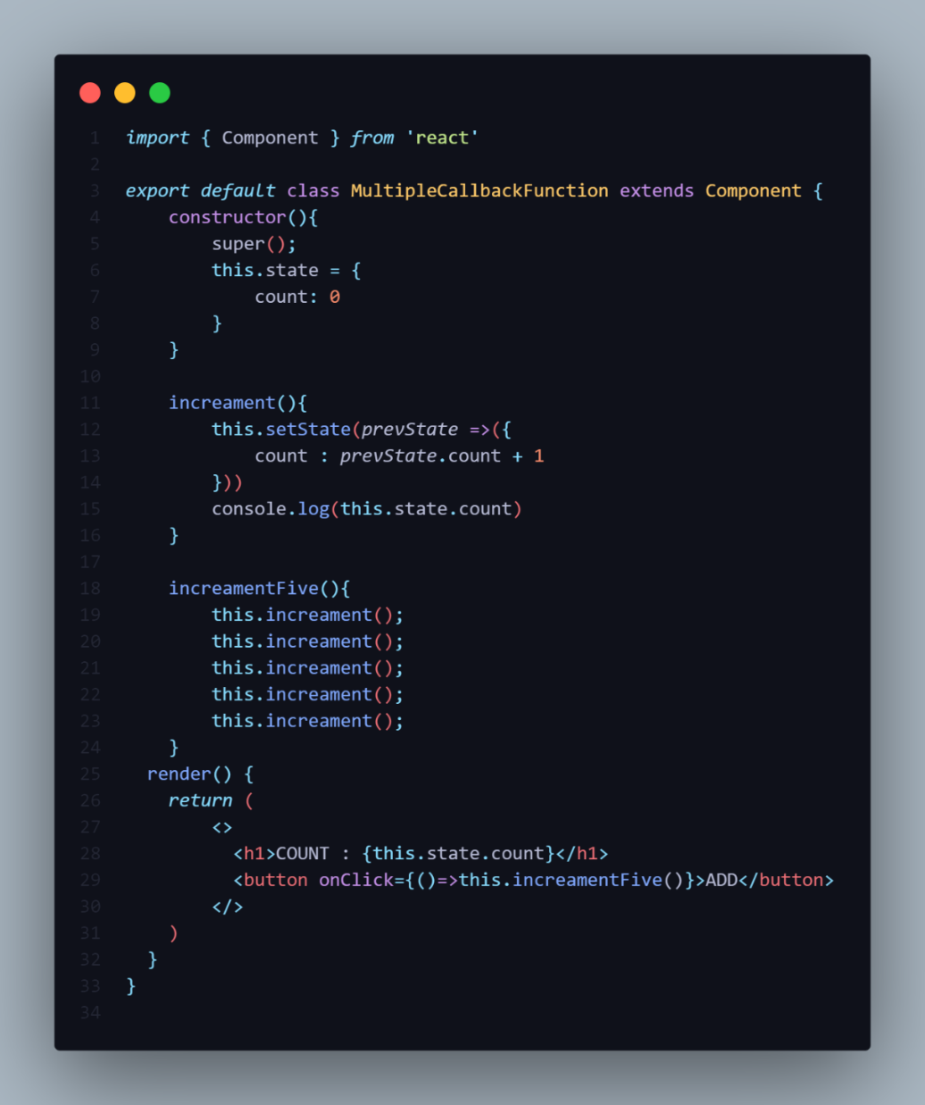

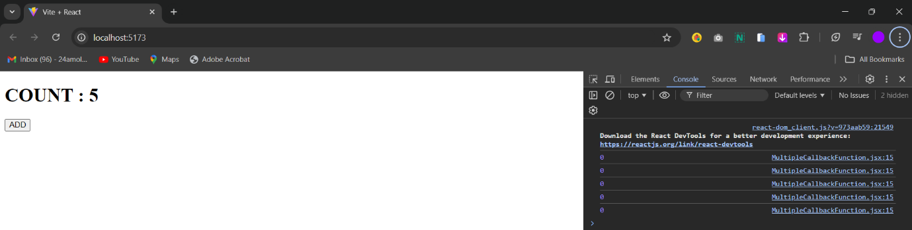

**1]INSIDE THE CLASS COMPONENT**

**EXAMPLE NO 1:-**

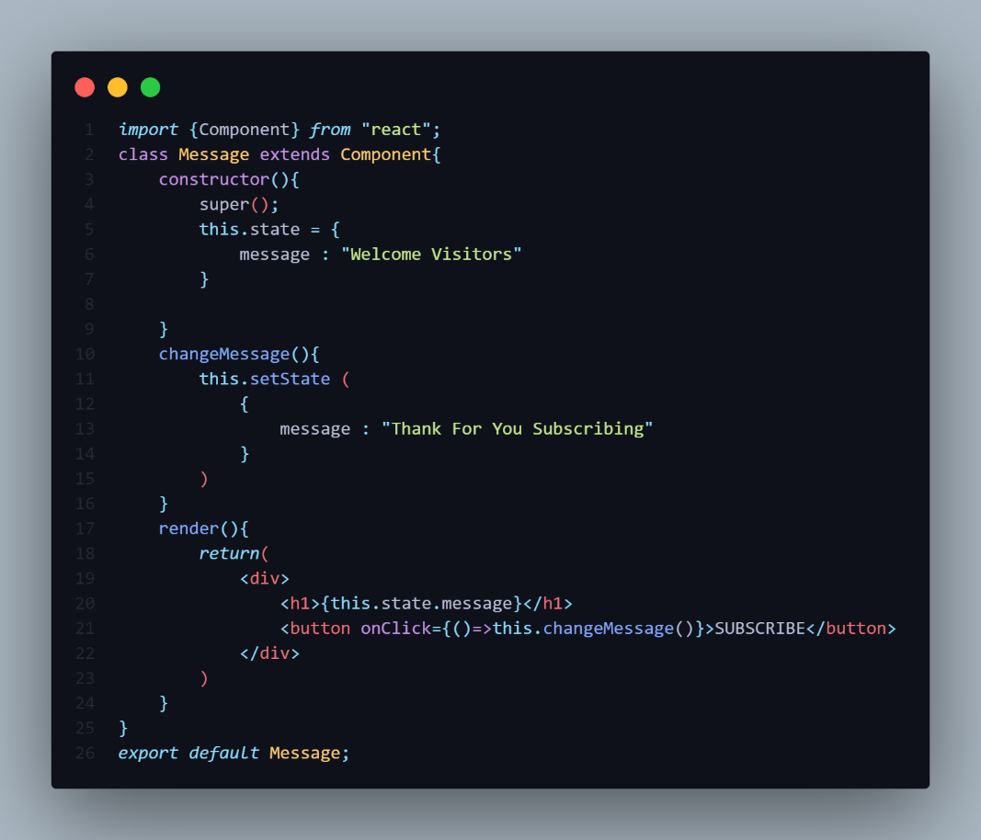

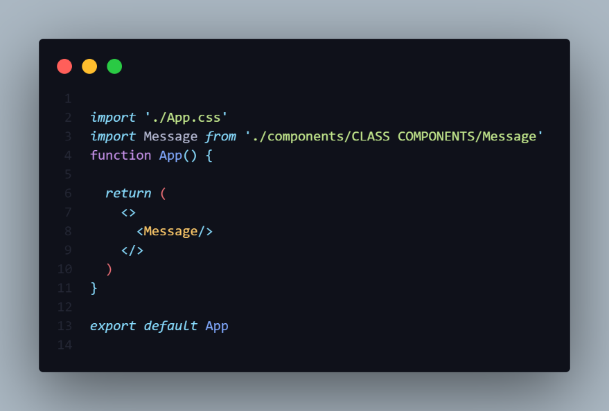

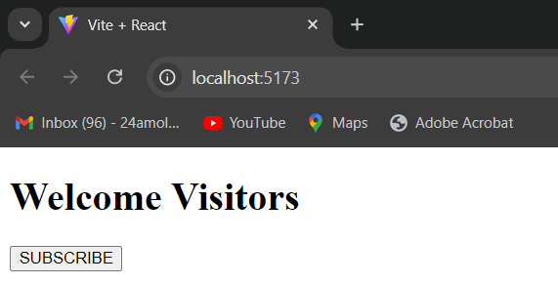

**STATE DESTRUCTURING**

-In React class components, you can use destructuring to access the state values directly within your **render()** method or other class methods.

Benefits:

* **Cleaner Code:** Destructuring simplifies the code and improves readability by avoiding repetitive access to this.state.
* **Easier to Read**: It makes it clear which state variables are being used in a given piece of code.
* **Less Verbose:** It reduces the amount of code needed to access state values.

**EXAMPLE NO 1**

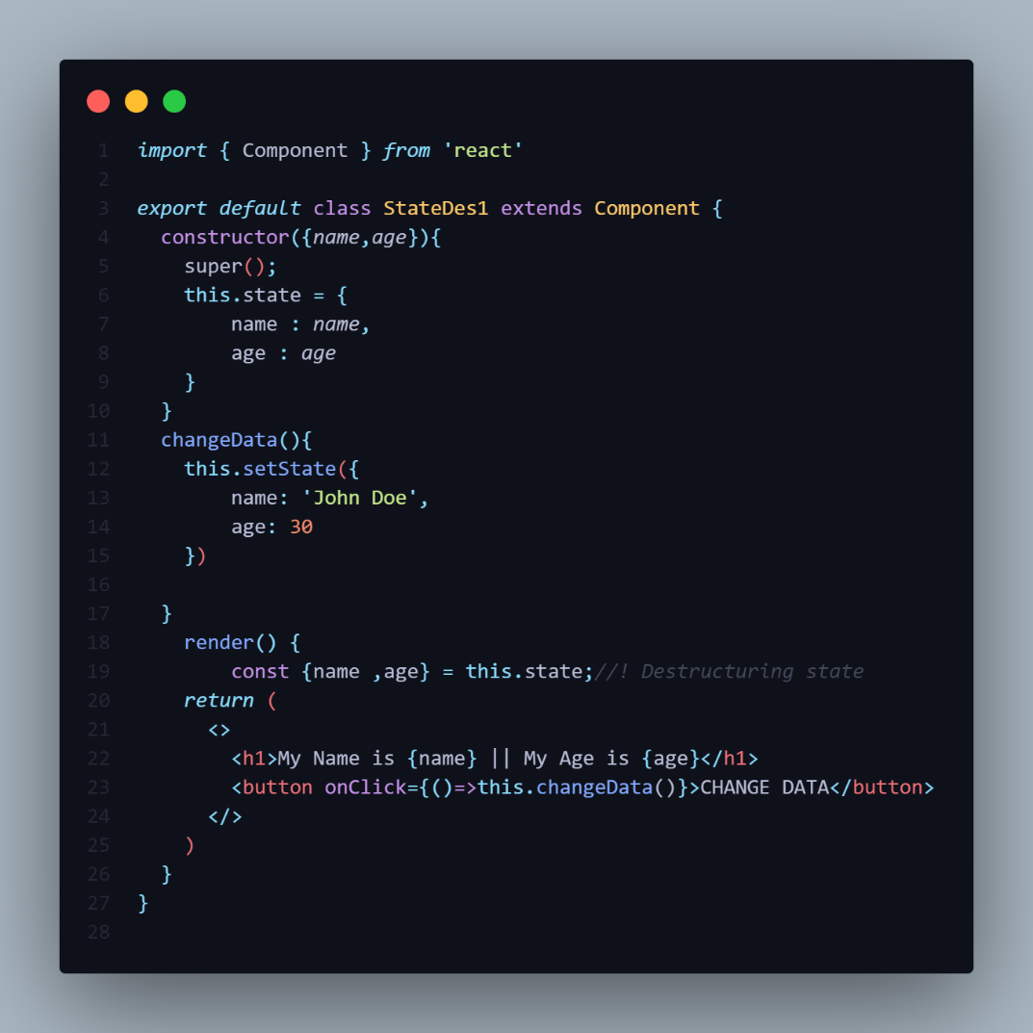

-In the line No 19 we done the state destructuring so we does not need to use **this.state** always we can directly access the properties.

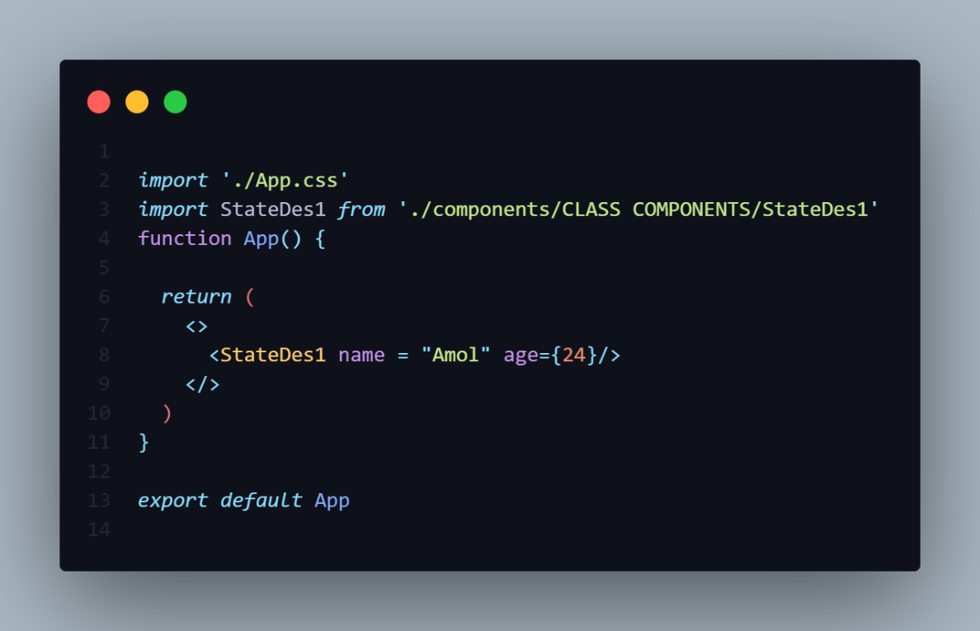

-This the initial state output

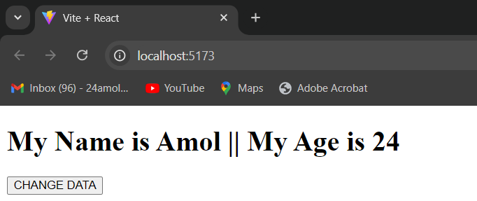

-After clicking the change data button output is like

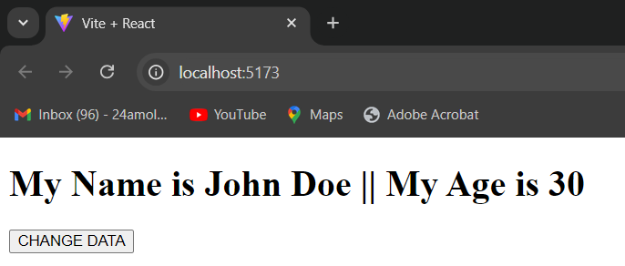

**EXAMPLE NO 2**

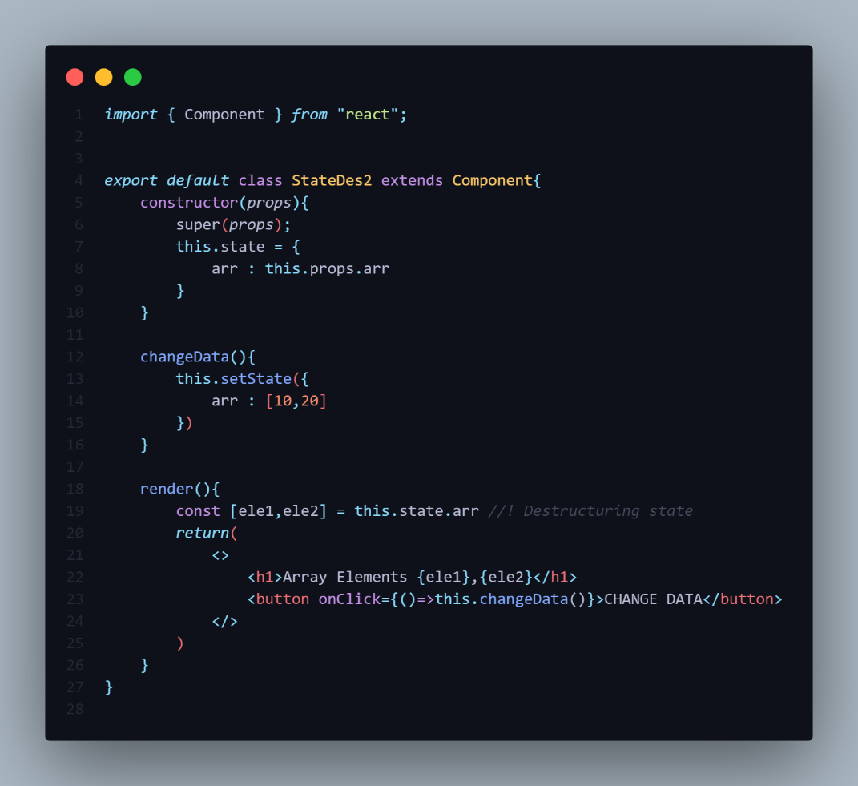

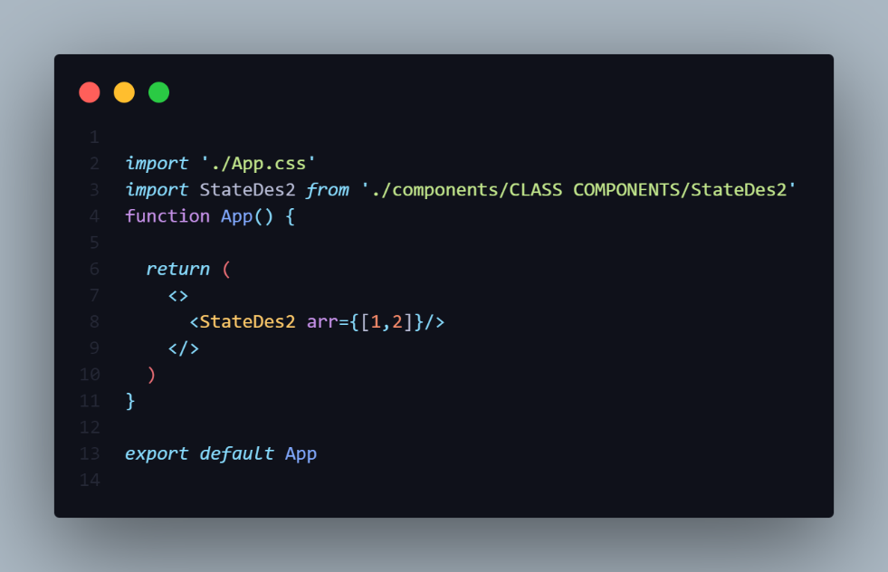

-Consider without De-Structuring the state we have use the array **this.state.arr** so it is complicated.

-After De-Structuring the we have to use directly using **ele1** & **ele2**.

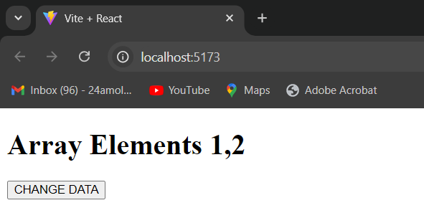

-After changing the data

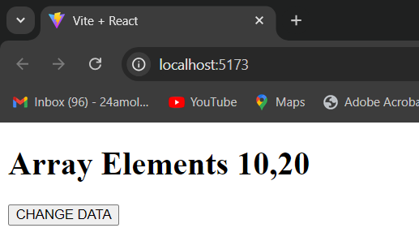

**================== NOTE =================**

-State De-Structuring in class done inside the **render()**

**DIFFERENCE BETWEEN STATES AND PROPS**

|  |  |  |
| --- | --- | --- |
| SrNo | Props | States |
| 1 | Props get passed to the component From Parent to Child. | States managed within the component |
| 2 | Child component does not have control on props | Child component have full control on States so it is Mutable. |
| 3 | Props are the function parameter | States are the variable declared in the function body. |
| 4 | Props are Immutable. | State can be changed. |
| 5 | Props accessed In Functional Component using **props**. | States accessed in the Functional Component using **useState()** hook. |
| 6 | Props accessed in the Class Component using **this.props**. | States accessed in the Class Component using **this.state**. |
| 7 | Props are read only in Nature | State change can be asynchronous. |
| 8 | Props allows you to pass the data from one component to another component as an argument. | State holds the information of the component |
| 9 | Props can be accessed by the child component | State cannot be accessed by the child component |
| 10 | State can be rendering dynamic change with the component | Props are used to communicate between the components |
| 11 | Props make component reusable | State cannot make components reusable |
| 12 | Props are passes Externally and controlled by the whatever renders the component | The state internal and control by the React Component Itself. |

|  |  |  |  |
| --- | --- | --- | --- |
| SrNo | Condition | State | Props |
| 1 | Can get initial value from Parent component? | Yes | Yes |
| 2 | Can we change by the Parent Component? | No | Yes |
| 3 | Can set default value inside the component? | Yes | Yes |
| 4 | Can change inside the component? | Yes | No |
| 5 | Can set initial value for the child component? | Yes | Yes |
| 6 | Can change in child component? | No | Yes |

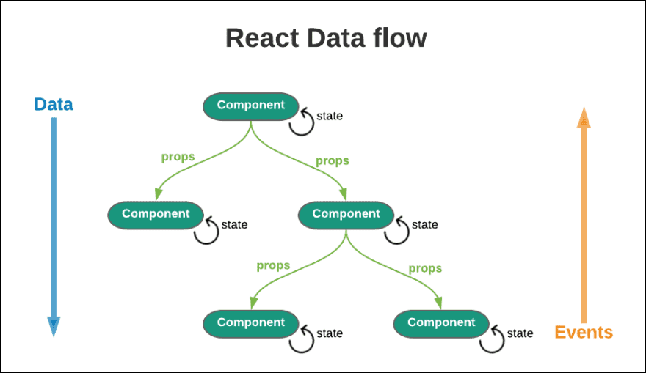

**EVENT HANDLING**

-In React The Event Name always is **CamelCase**.

-Just like HTML DOM events, React can perform actions based on user events.

-React has the same events as HTML: click, change, mouseover etc.

-React events are written in camelCase syntax:

onClick instead of onclick

-React event handlers are written inside curly braces:

onClick={shoot}  instead of onclick="shoot()".

### React:[Get your own React.js Server](https://www.w3schools.com/react/react_server.asp)

<button onClick={shoot}>Take the Shot!</button>

### HTML:

<button onclick="shoot()">Take the Shot!</button>

**Adding event handlers**

To add an event handler, you will first define a function and then [pass it as a prop](https://react.dev/learn/passing-props-to-a-component) to the appropriate JSX tag.

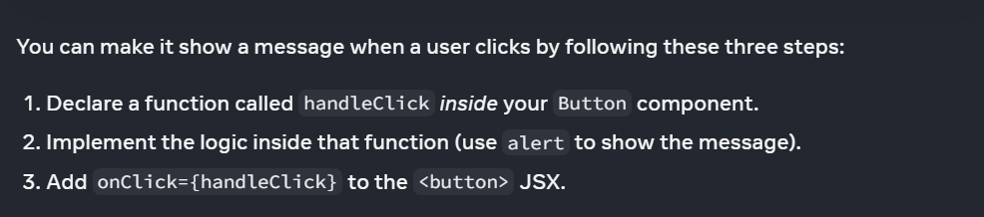

================ IMPORTANT=================

-when you passing **FunctionCall()** then that time you are returning something.So are passing **FunctionCall()**  then pass inside the **ArrowFunction()**.

-Pass directly **FunctionReference** that not returning anything.

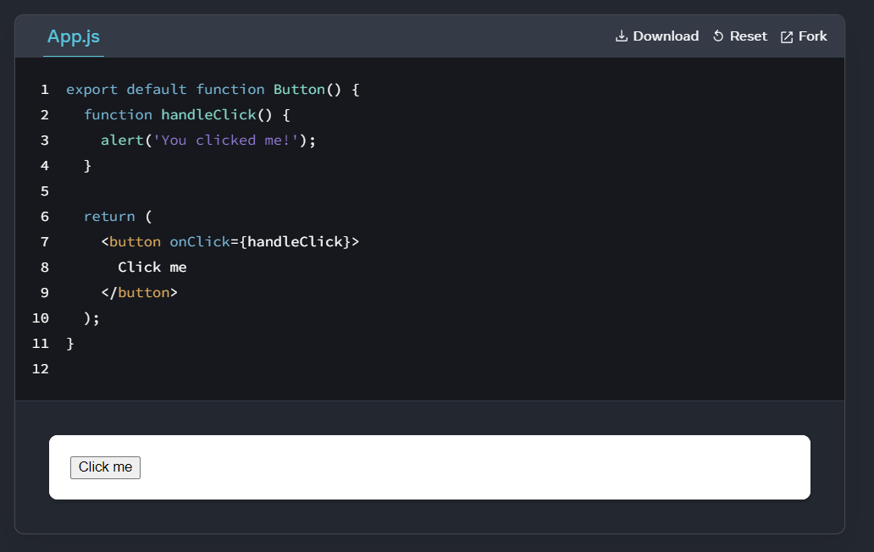

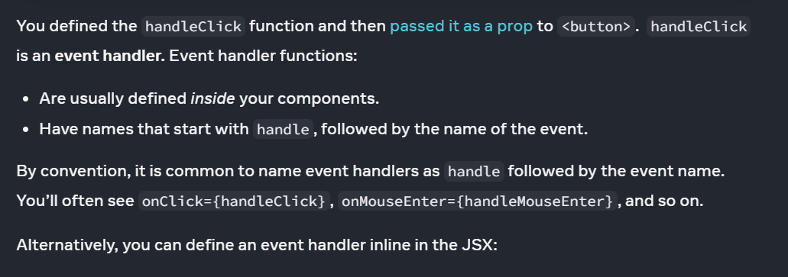

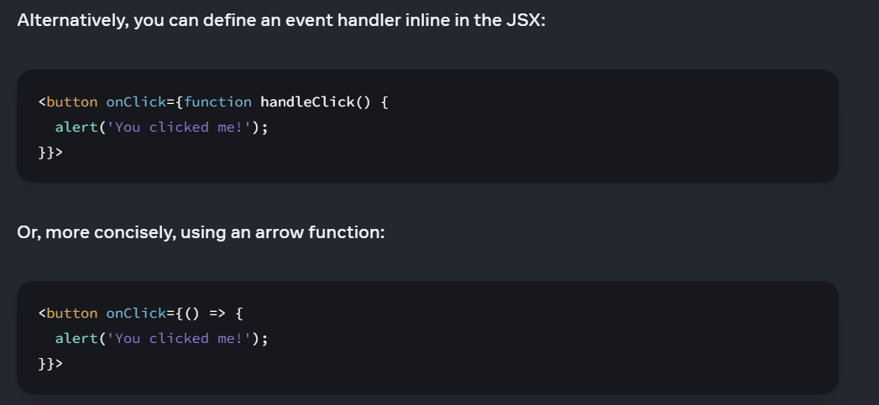

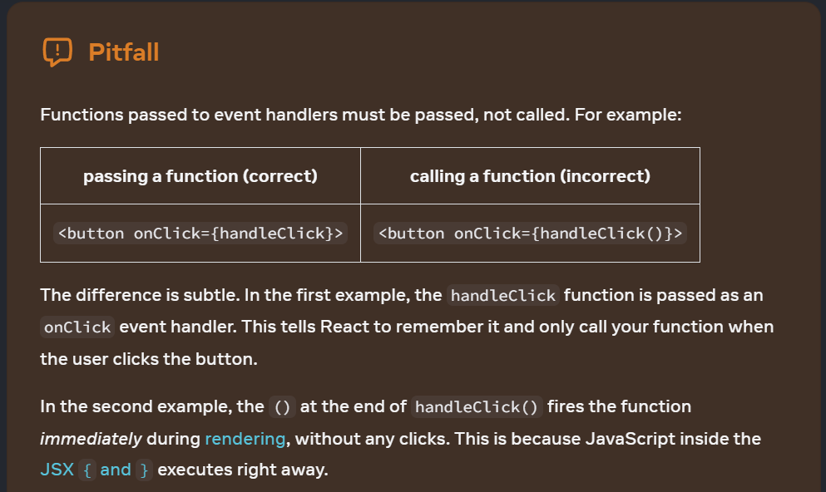

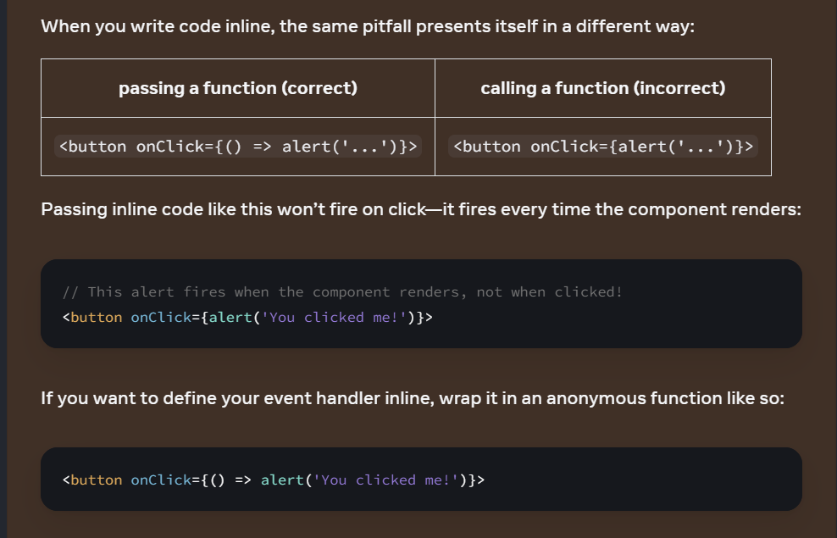

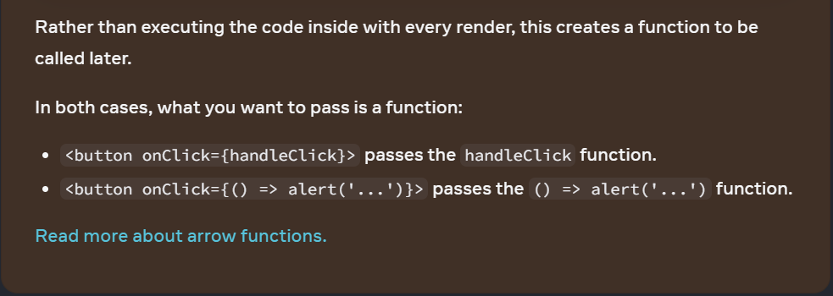

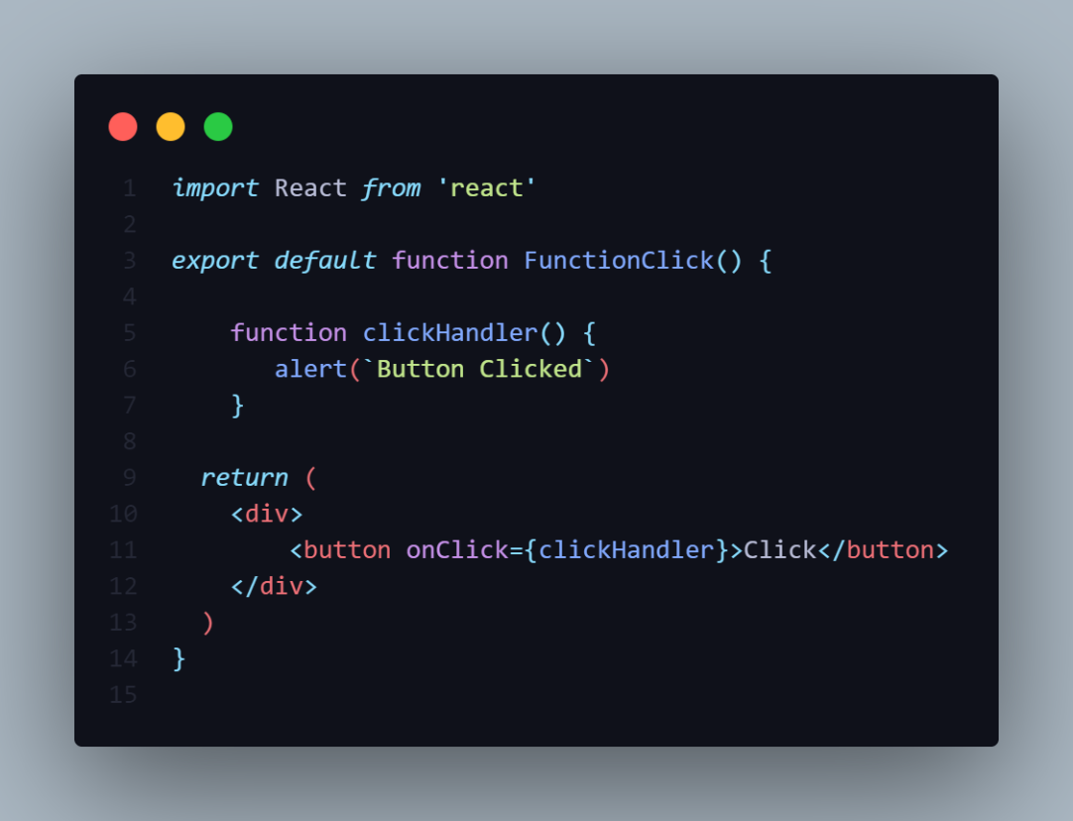

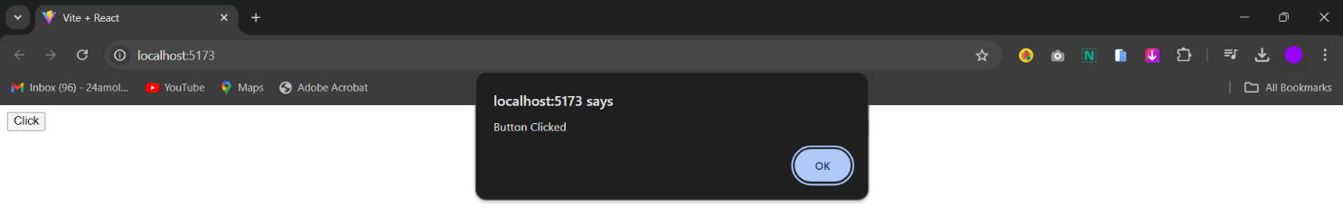

**NOTE**

1.Do Not Pass **Function Call()**.

**Example:-onClick={** clickHandler()**}**

2.If you are calling Function then that time Pass a **Function Reference**[Without Parenthesis()] or **EventHandler**.

**Example:-onClick={** clickHandler**}**

3.Either use the **Arrow Function** & inside the arrow function passs the **FunctionCall()**.

**Example:-onClick={()=>** clickHandler()**}**

**HANDLING EVENT IN FUNCTIONAL COMPONENT**

1.Do Not Pass **Function Call()**.

**Example:-onClick={** clickHandler()**}**

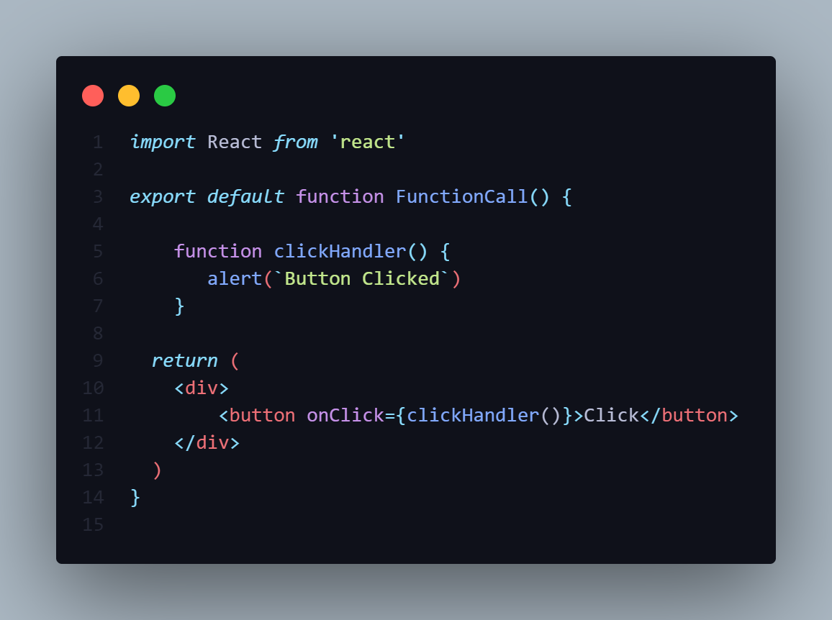

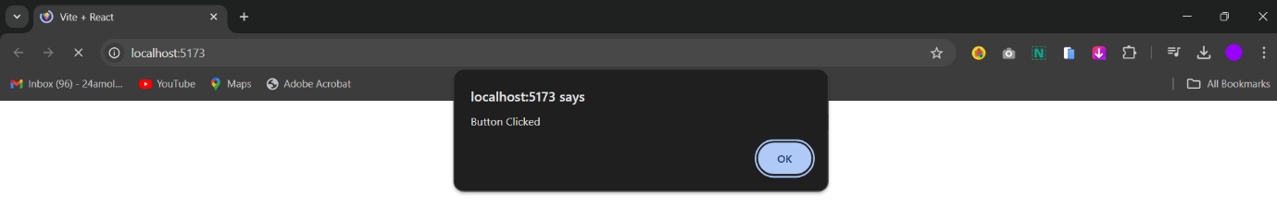

-When You are passing the **FunctionCall()** then Function is gets called **automatically** whenever the component renders.

-This is not a correct approach of event triggers.

-The event Object is automatically fires when you run the code.

2.If you are calling Function then that time Pass a **Function Reference**[Without Parenthesis()] or **EventHandler**.

**Example:-onClick={** clickHandler**}**





-If you are passing Function Reference only then Function is Fire when you click on the Button.

-Function Reference mean you are passing the **Function** **Address**.

-When you Pass the Function address then function never triggers automatically.

3.Either use the **Arrow Function** & inside the arrow function pass the **FunctionCall()**.

**Example:-onClick={()=>** clickHandler()**}**

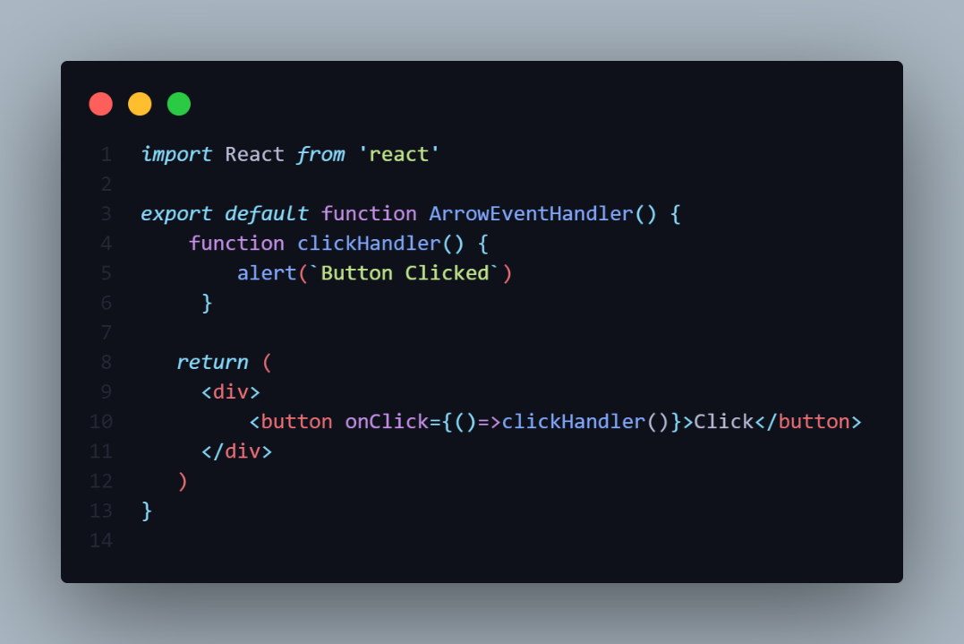

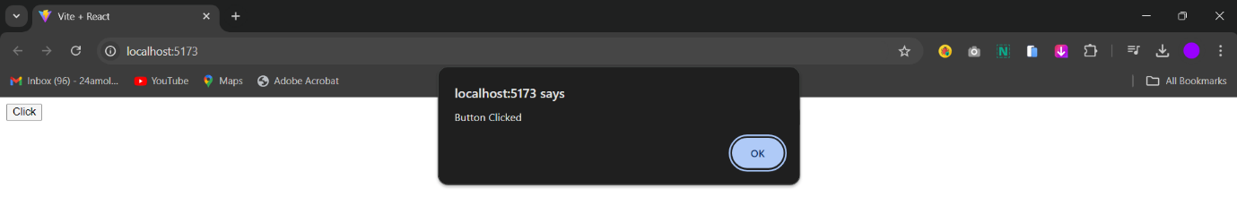

-To avoid there is another way i.e Pass The **FunctionCall()** inside the **Arrow Function** {**()=>**FunctionCall()**}**.

**HANDLING EVENT IN CLASS COMPONENT**

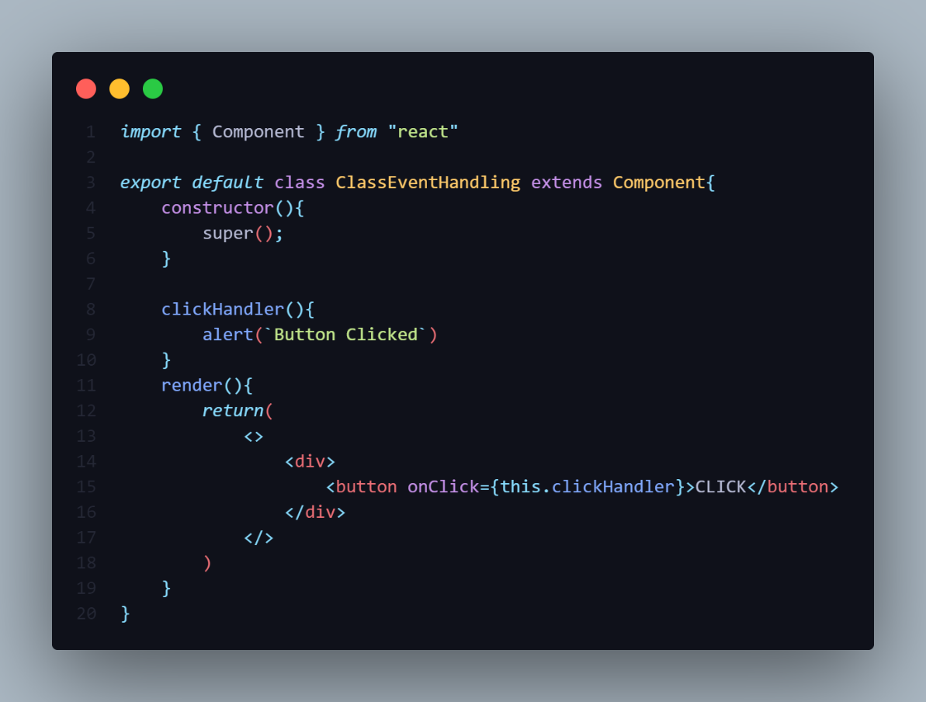



-In the class we use the Methods.

**NOTE**

1.Do Not Pass **Method Call()**.

**Example:-onClick={** this**.**clickHandler()**}**

2.If you are calling Function then that time Pass a **Method Reference**[Without Parenthesis()] or **EventHandler**.

-Use of **this** keyword in the class is Mandatory.

**Example:-onClick={** this**.**clickHandler**}**

3.Either use the **Arrow Function** & inside the arrow function pass the **MethodCall()**.

**Example:-onClick={()=>** this**.**clickHandler()**}**

1.Do Not Pass **Method Call()**.

**Example:-onClick={** this**.**clickHandler()**}**

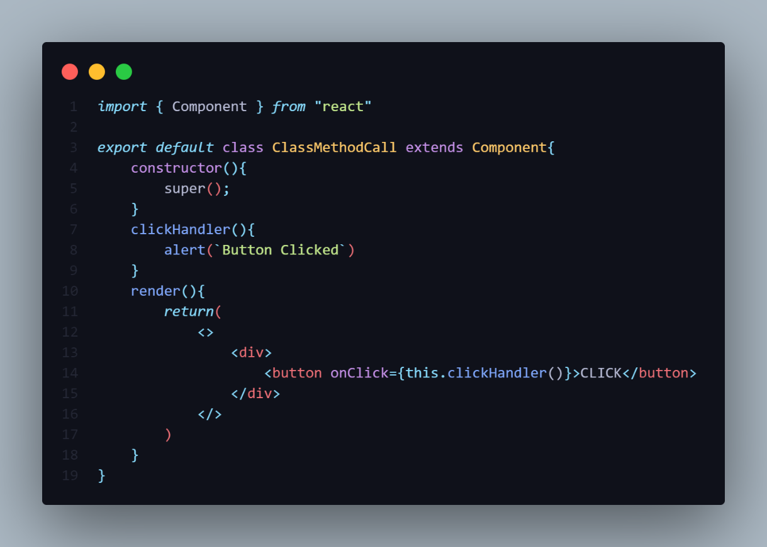



2.If you are calling Function then that time Pass a **Method Reference**[Without Parenthesis()] or **EventHandler**.

-Use of **this** keyword in the class is Mandatory.

**Example:-onClick={** this**.**clickHandler**}**

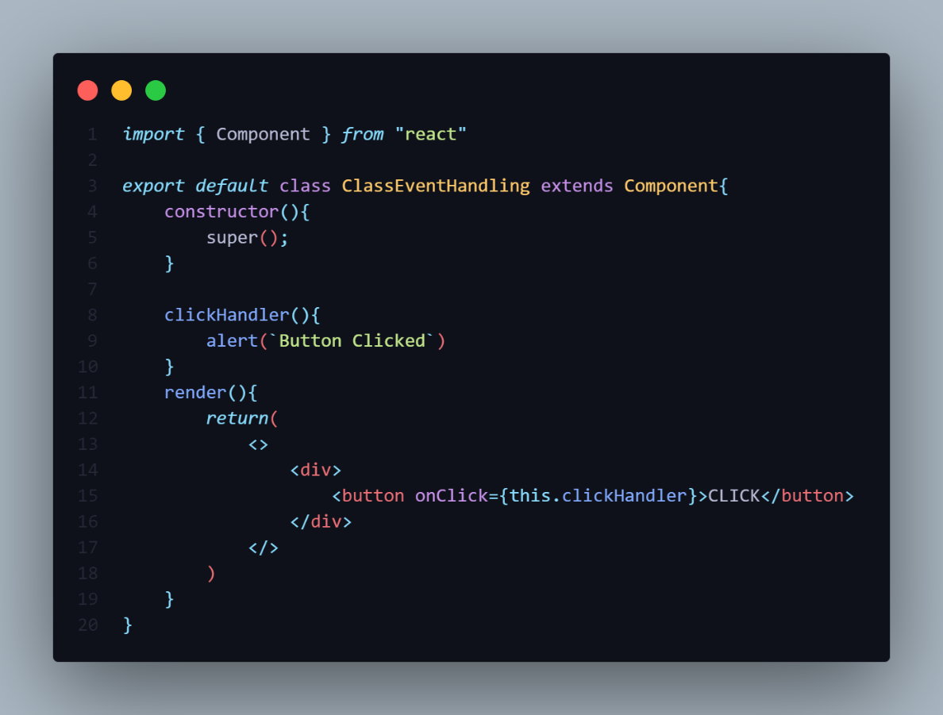



3.Either use the **Arrow Function** & inside the arrow function pass the **Method()**.

**Example:-onClick={()=>** this**.**clickHandler()**}**

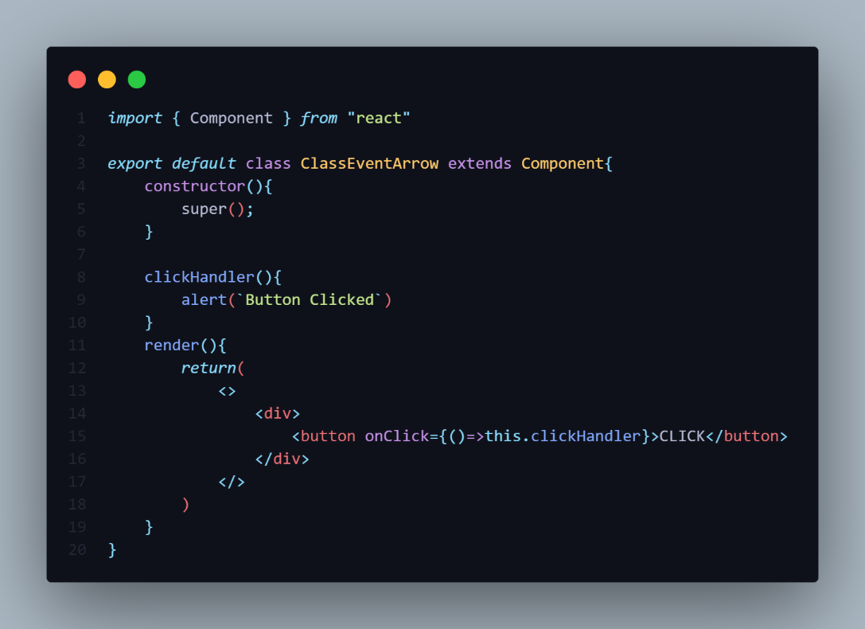



**BINDING EVENT HANDLER**

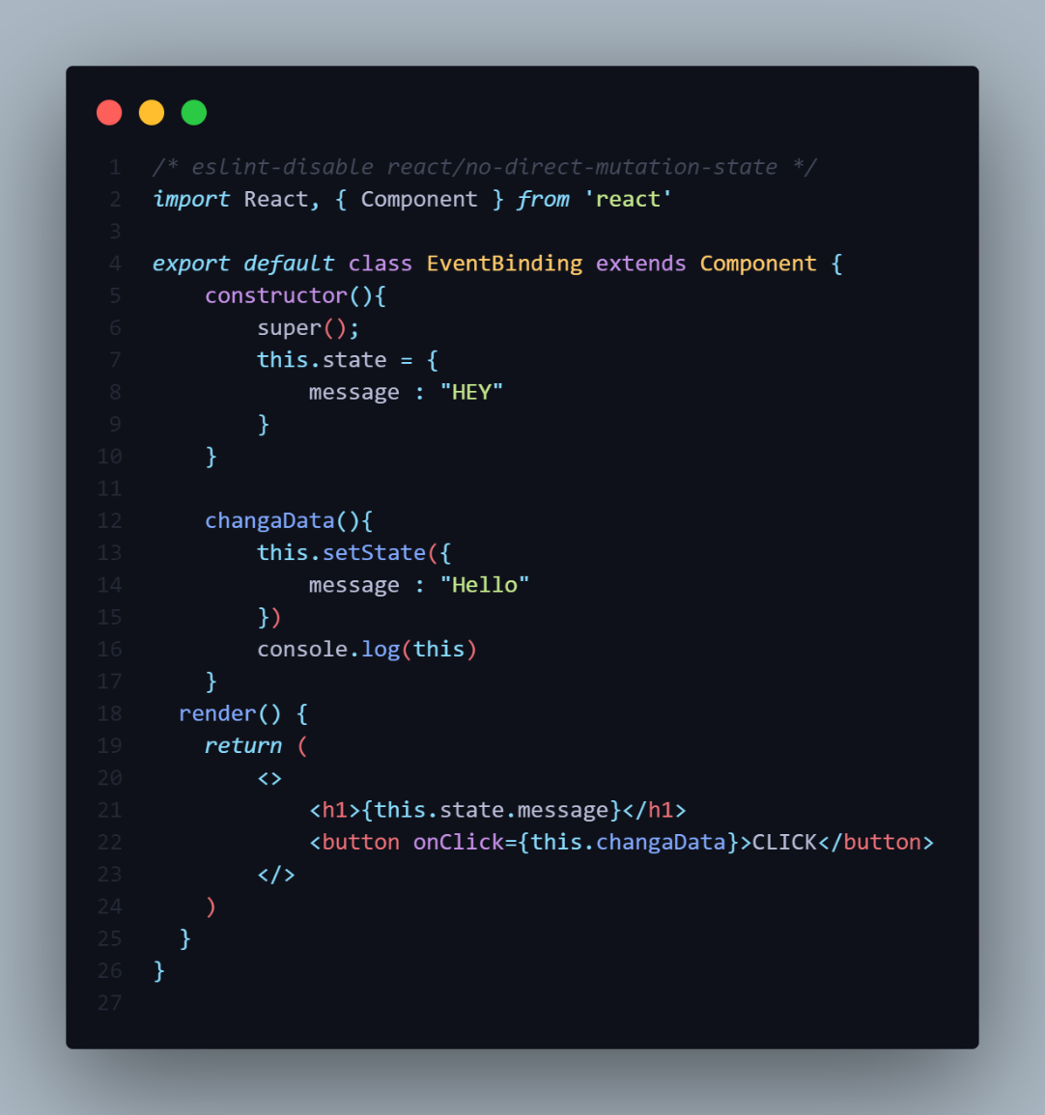

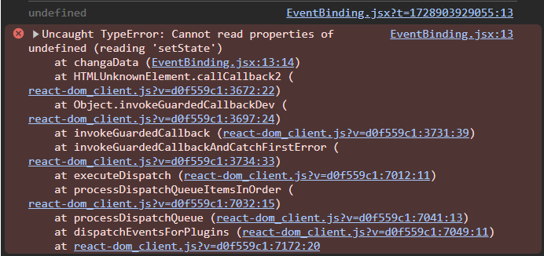

-After running the app it give error called cannot read properties & the **this** keyword shows **undefined**.

-This is typical behaviour of Javascript.

-The **this** keyword in the **Event Handler** is **undefined** so this is the reason Event Binding is necessary.

-There are Following ways to bind the EventHandler

**1]Binding Event Handler in Render Method**

**2]Binding Event Handler using Arrow Function as a Class Property**

**3]Binding Event Handler in the Constructor**

**4]Binding Event Handler using Arrow Function**

**NOTE**

-We use the **this** keyword in the class so it is mandatory to bind the **this** keyword with **EventHandler**.

-The **EventHandler** is a method of Class which is pass on the **Event Object**.

**1]Binding Event Handler in Render Method**

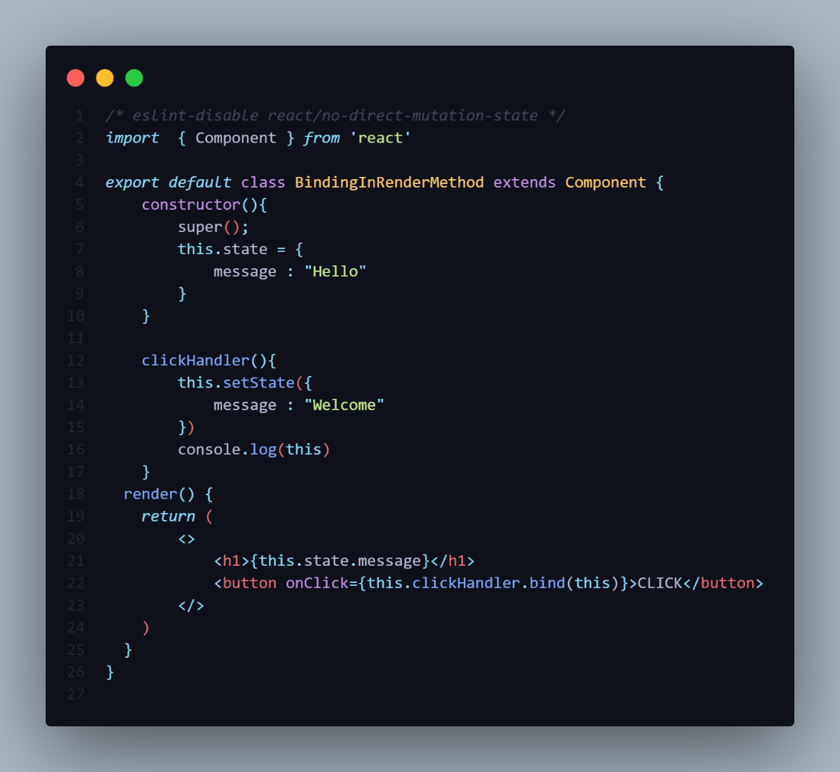

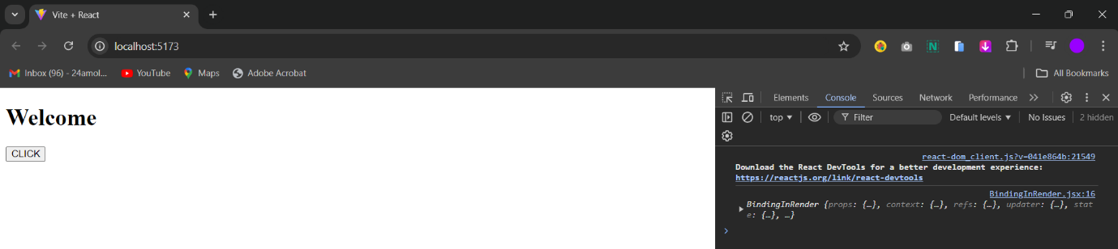

-In this way we directly **bind(this)** in the **onClick()** event.

**2]Binding Event Handler using Arrow Function as a Class Property**

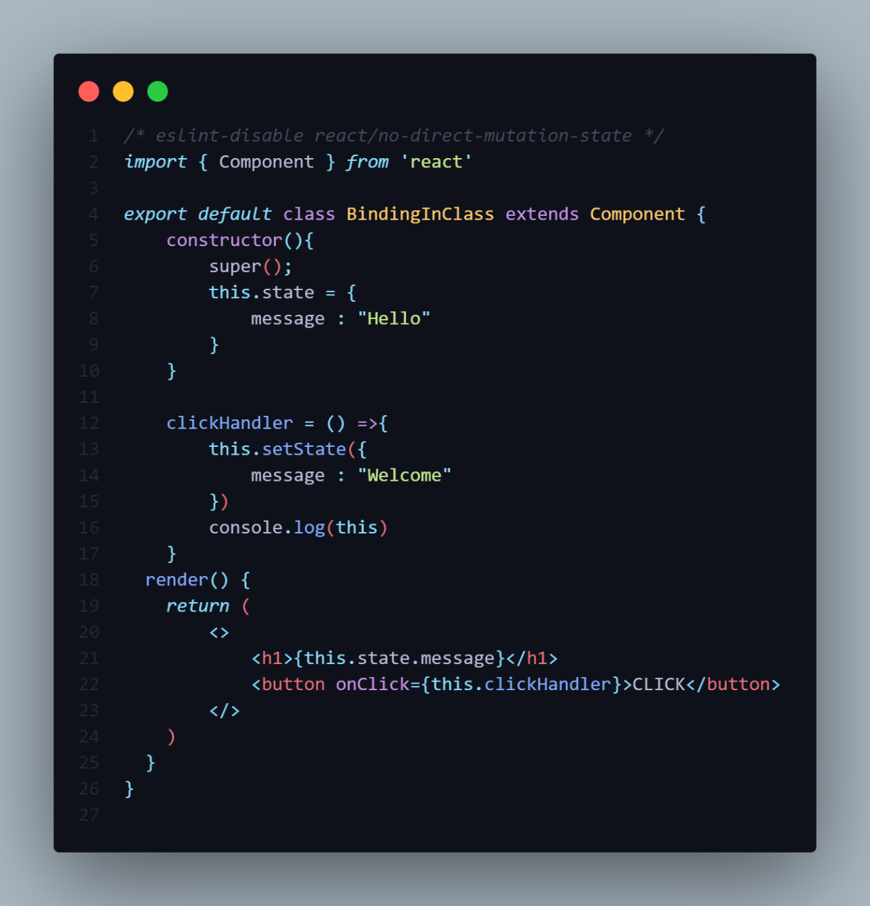



-In this we have declare the **Arrow Function** in class as an property.

**3]Binding Event Handler in the Constructor**

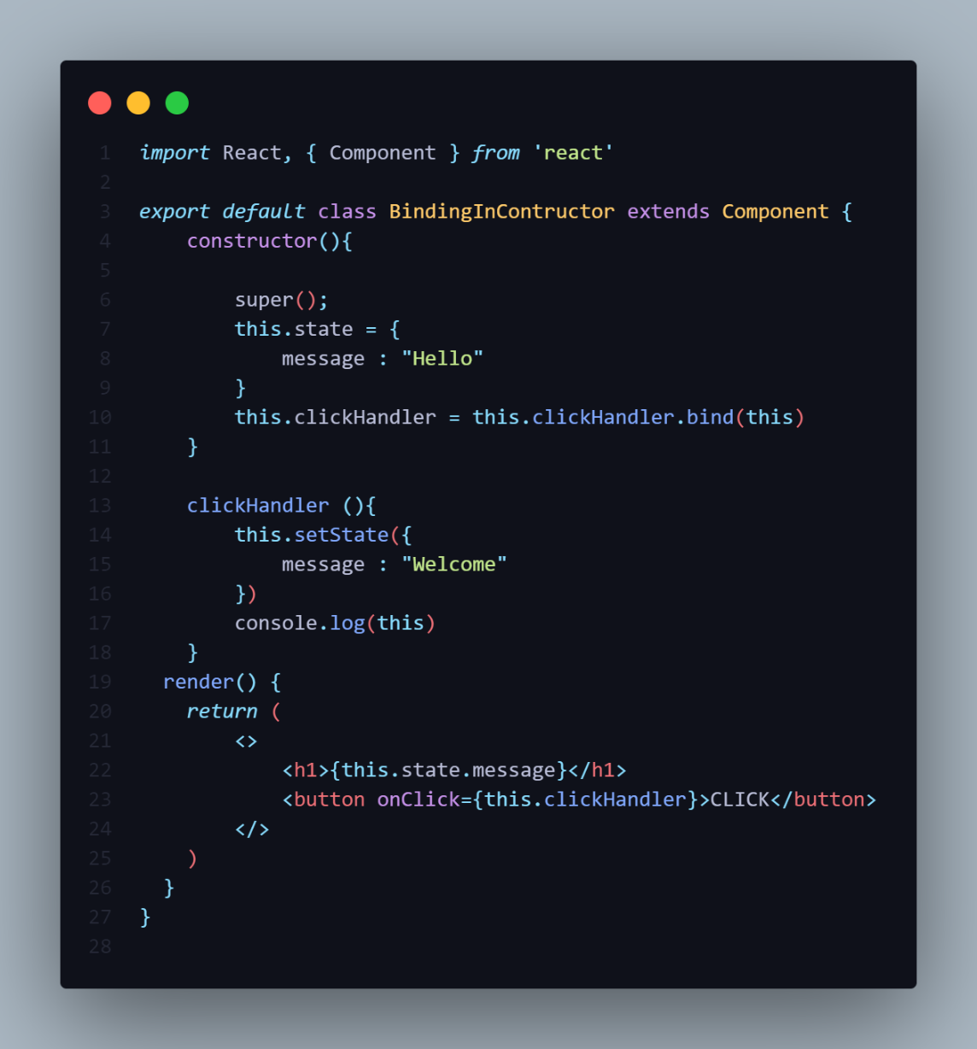



-In this way we bind the **this** keyword inside the Constructor.

**4]Binding Event Handler using Arrow Function**

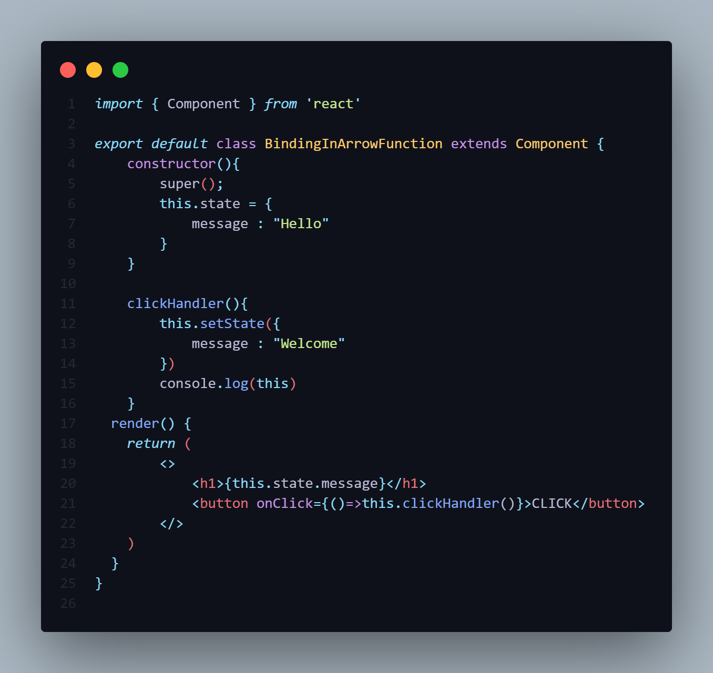



-In this binding we have pass the **this** inside the **Arrow Function** call the **Method()** using method Call Statement.

**CONDITIONAL RENDERING**

-When you building a React Application that time you need to show or hide some HTML based on certain condition.

-We have Four Different Approaches for Conditional Rendering.

**1]IF-ELSE**

**2]ELEMENT VARIABLES**

**3]TERNARY OPERATOR**

**4]CIRCUIT OPERATOR [&& LOGICAL AND]**

**5]SWITCH CASE OPERATOR**

**6]IMMEADIATELY INVOKED FUNCTION IIFE**

**1]IF-ELSE RENDERING**

**EXAMPLE NO 1**

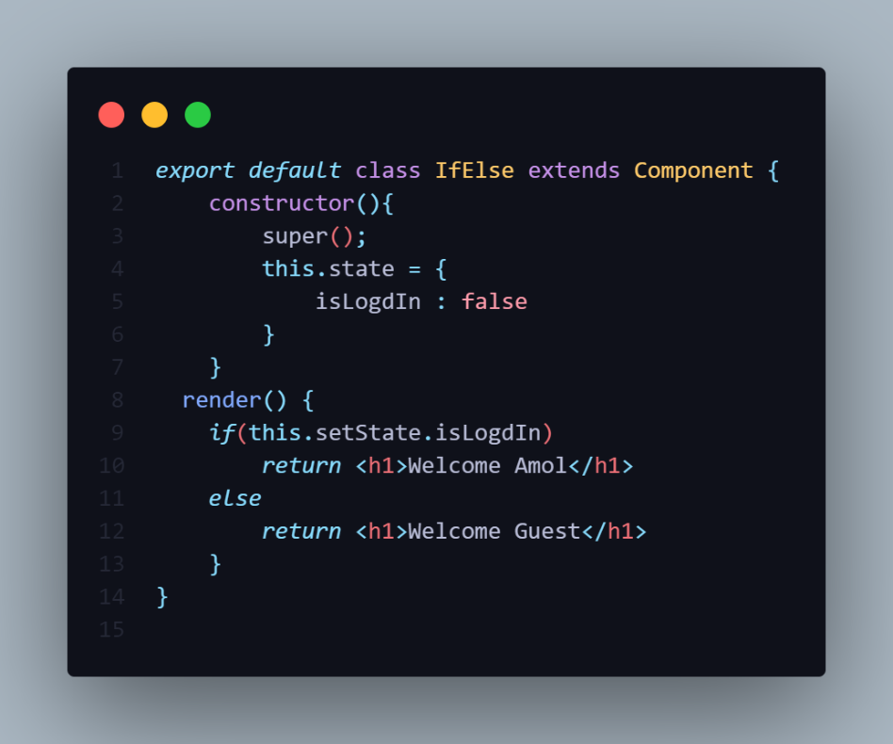

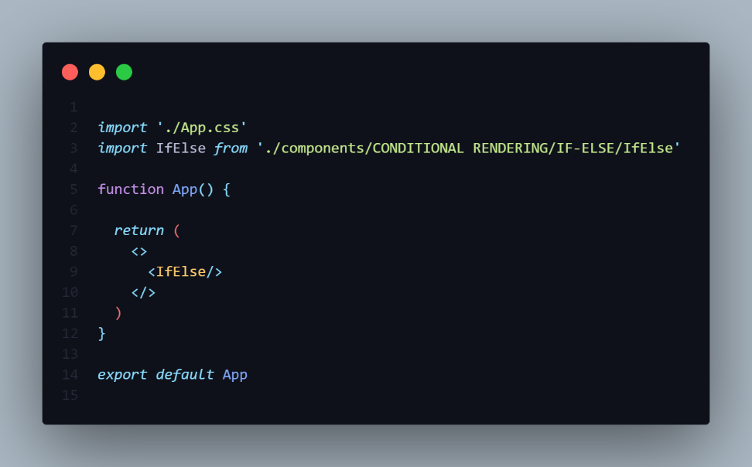

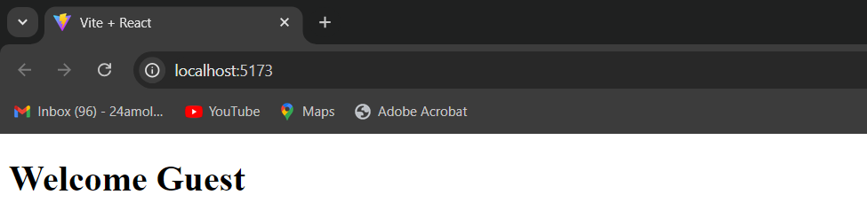

-Using If Else you can Render Only that Element satisfy the condition.

**EXAMPLE NO 2**

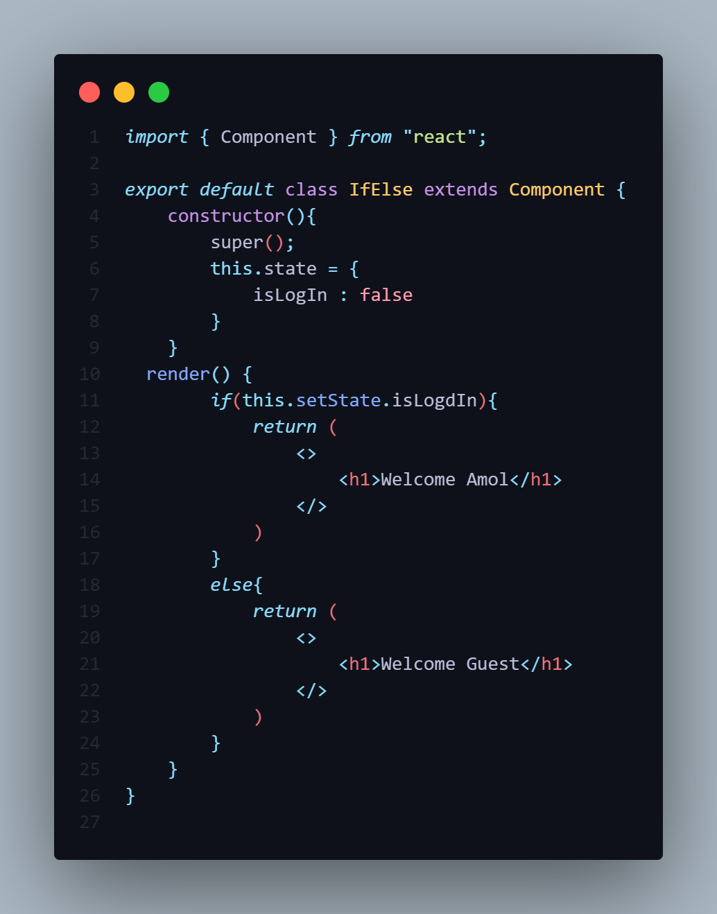

-If there are multiple element then use Example NO2.

-The **IF-Else** is always inside the **render()**.

**2]ELEMENT VARIABLES**

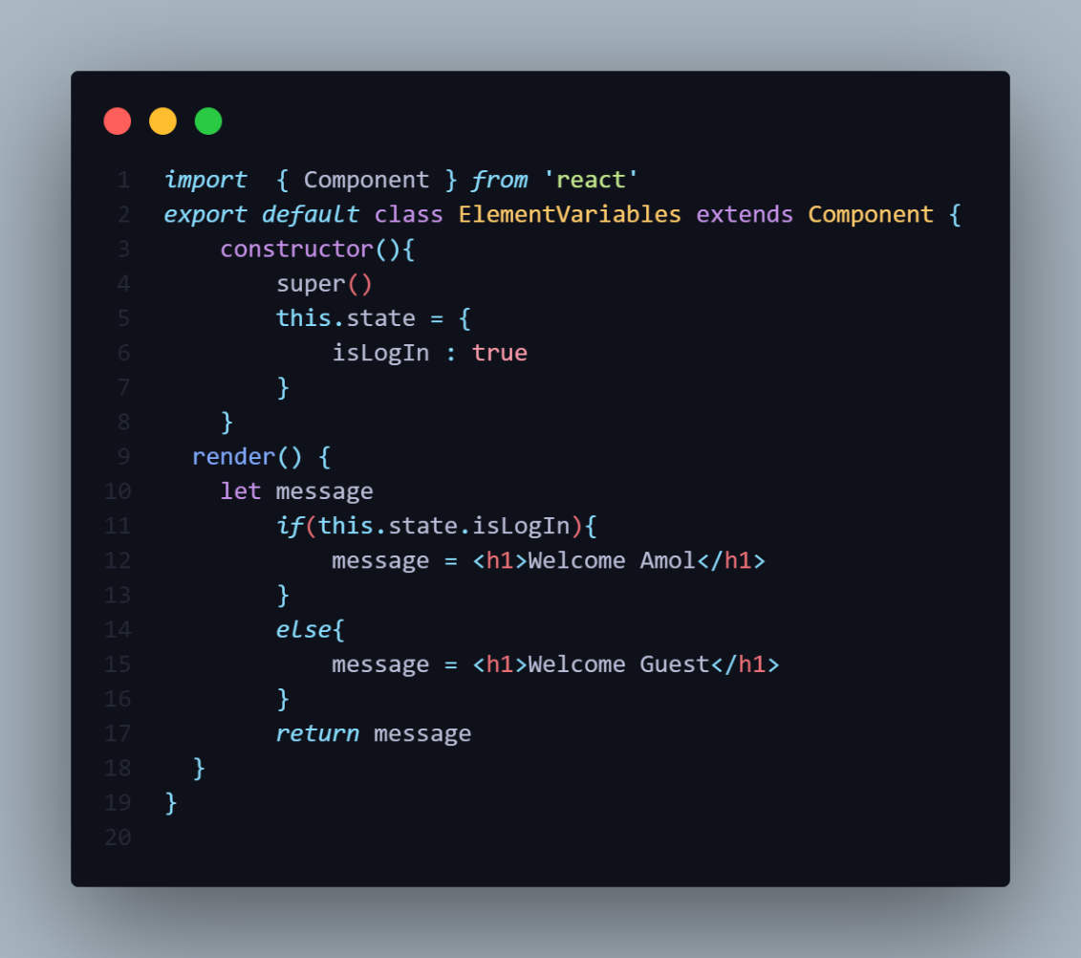

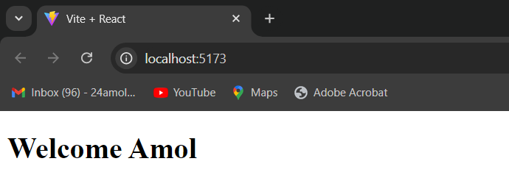

-In this we declare the variable in the render() method then **let message.**

-Then we write the condition in the **state** object based on the condition the variable store the **Element**

-After that return the **variable**.

-That element only render on the UI who statisfy the condition.

**3]TERNARY OPERATOR**

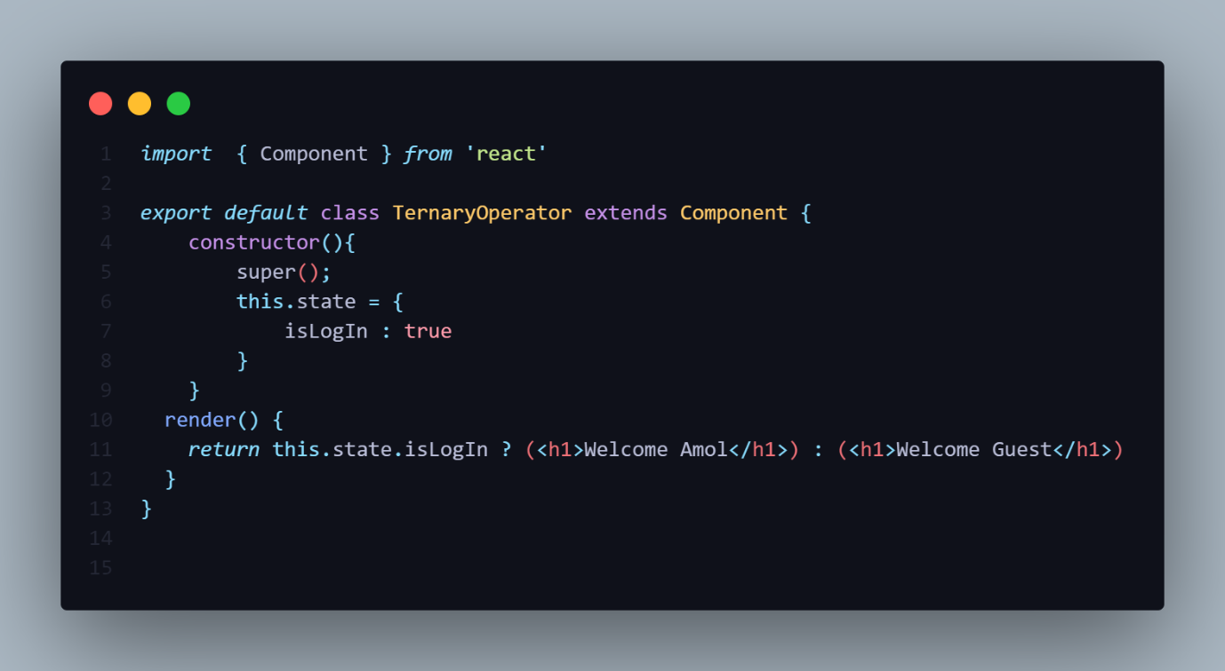



-This approach is Easy to use and more simpler.

-The ternary Operator we director write inside the **return**.

**4]CIRCUIT OPERATOR [&& LOGICAL AND]**

-This operator is used for checking the condition. If the condition is **true**, it will return the element **right** after **&&**, and if it is **false**, React will **ignore** and skip it.

Syntax

1. {
2. condition &&
3. // whatever written after && will be a part of output.
4. }

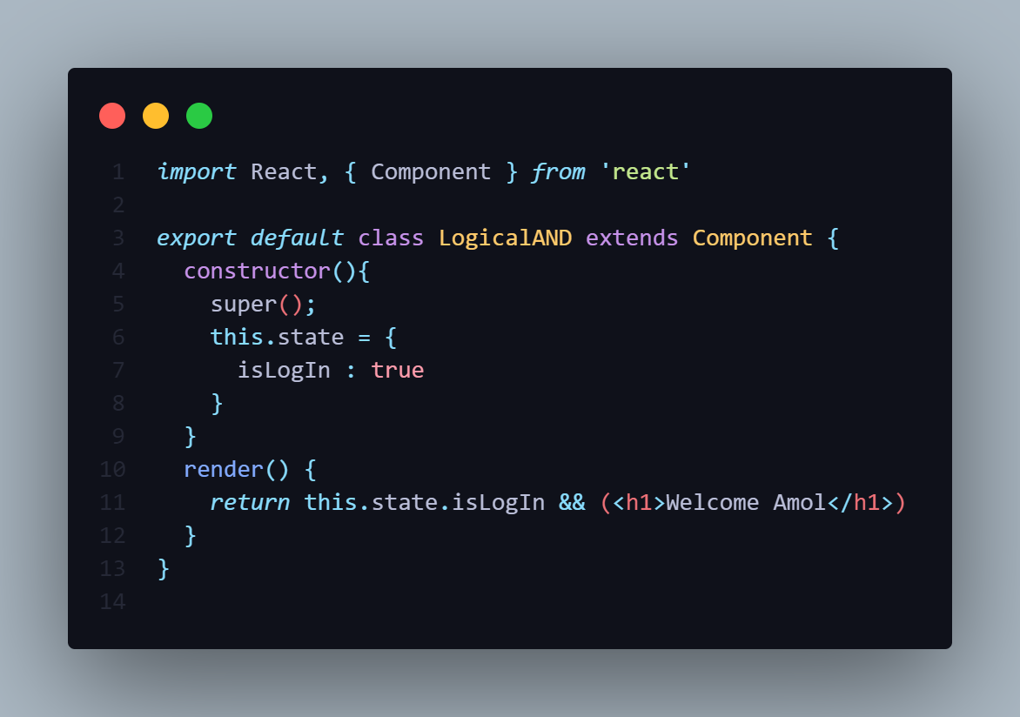



**5]SWITCH CASE**

**6]IMMEADIATELY INVOKED FUNCTION IIFE**

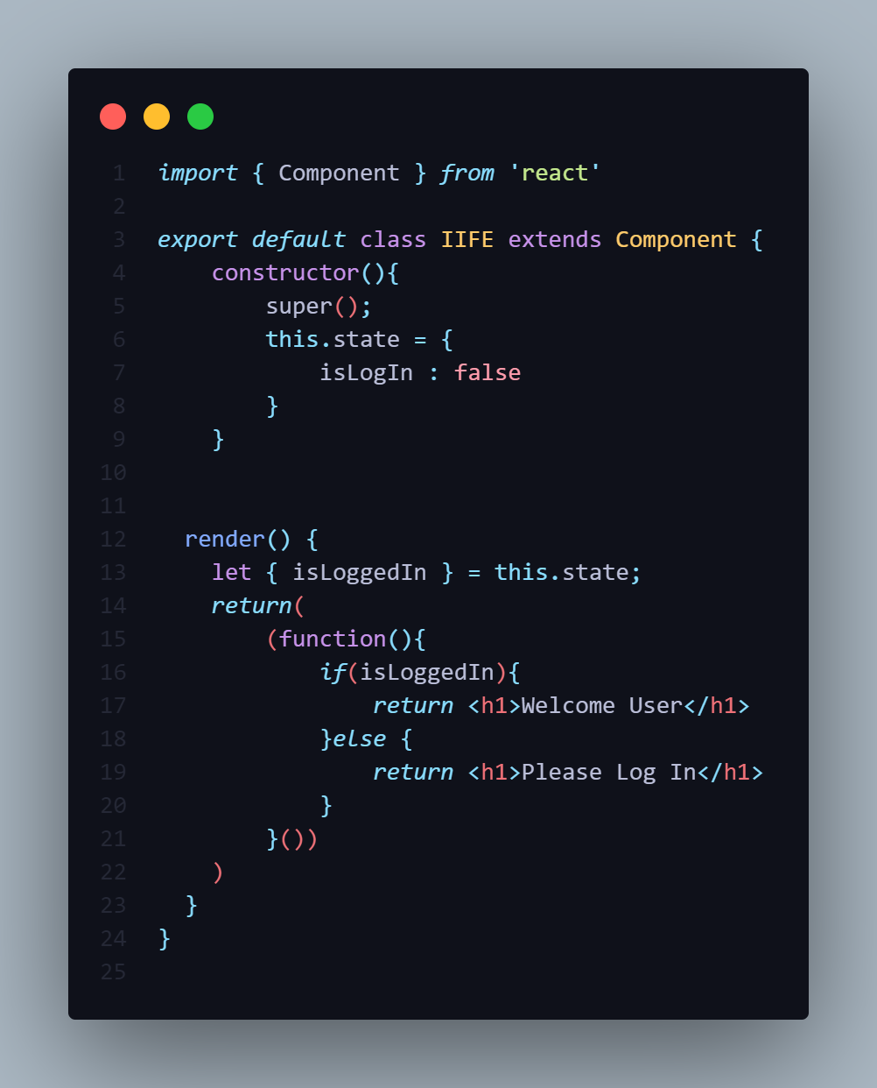

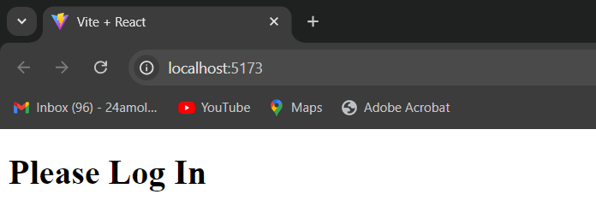

**7]USING ENHANCED JSX LIBRARIES**

-Certain libraries expose functionality to extend JSX, making it possible to implement conditional rendering directly with JSX. One of such libraries is [JSX Control Statements](https://github.com/AlexGilleran/jsx-control-statements). It is a [Babel](https://babeljs.io/) plugin that transforms component-like control statements into their JavaScript counterparts during transpilation.

-After installing the babel-plugin-jsx-control-statements package and modifying your Babel configuration, the application could be rewritten like this:

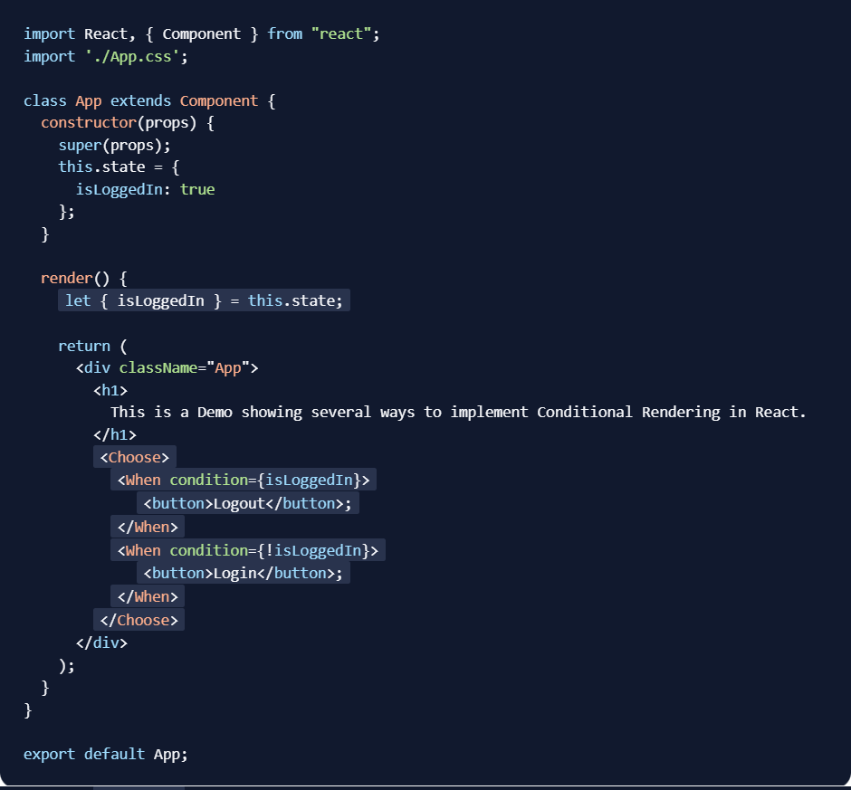

**MAP**

-One of the best thing about React is that is relay on Javascript to iterate array.

-In ReactJS, the map() method is commonly used to render lists of elements dynamically. It iterates over an array and returns a new array with the elements transformed according to the callback function you provide. This is especially useful for rendering lists of components in React.

**Key**

-A “**Key**” is a special String attribute you need to include when creating list of items.

-Keys give the elements a stable identify.

-Keys help React identify which items have changed, added or removed.

-This help in efficient update of the User Interface

-In React, the key prop is **mandatory** when rendering lists using the map() method. The key helps React identify which items have changed, been added, or removed, which is important for performance optimization when rendering lists.

-If you don't want to use the key prop, you can omit it. React will still work, but you may receive a warning in the console advising you to add a key for performance reasons, especially if the list changes dynamically (e.g., adding, removing, or reordering items).

**=============== WARNING ===============**

-In React, the key prop is **mandatory** when rendering lists using the map() method. The key helps React identify which items have changed, been added, or removed, which is important for performance optimization when rendering lists.

-If Don’t pass key we get warning Each child have unique “Key”

**EXAMPL NO 1**

**1.()=>()**

-In this we does not need write the return.

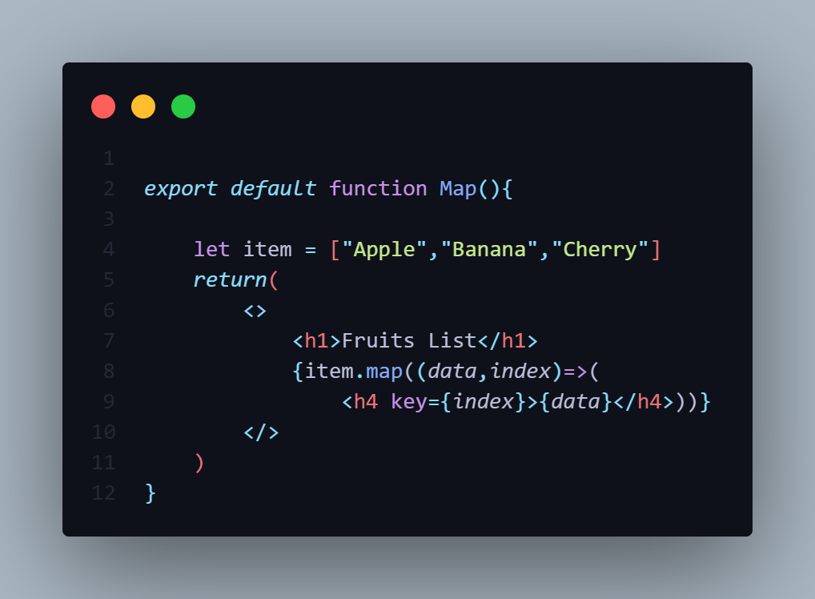

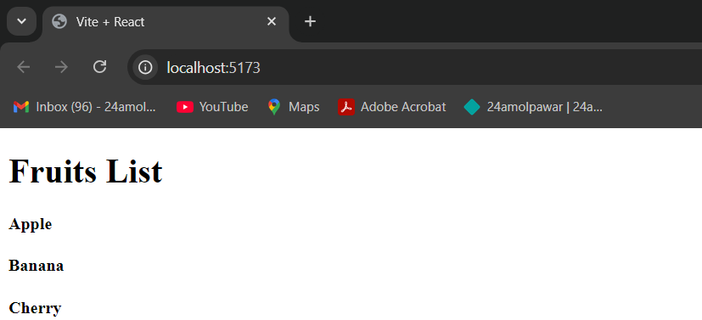

**EXAMPL NO 2**

**2.()=>{}**

-In the to write the **return** in the **arrow function** is mandatory.

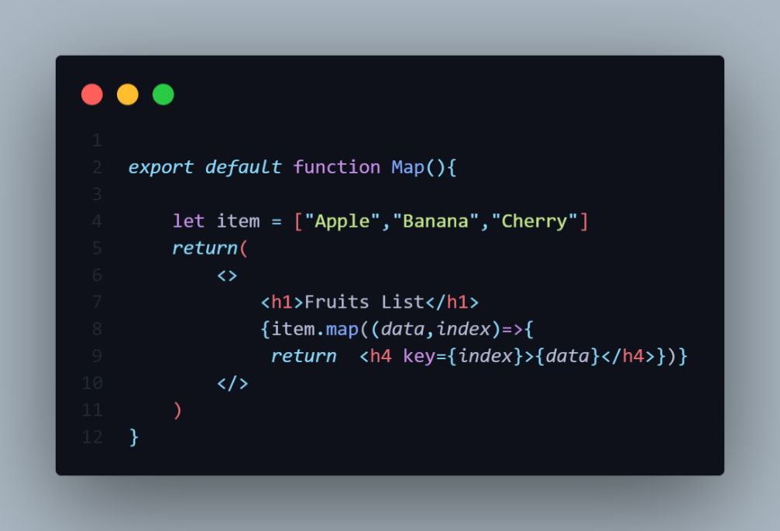



**Explanation:**

* items is an array of fruits.
* The map() method is used to iterate over the items array and return a <li> element for each item.
* Each list item also gets a **key** prop, which is required by React to uniquely identify each element in a list.

**EXAMPL NO 3**

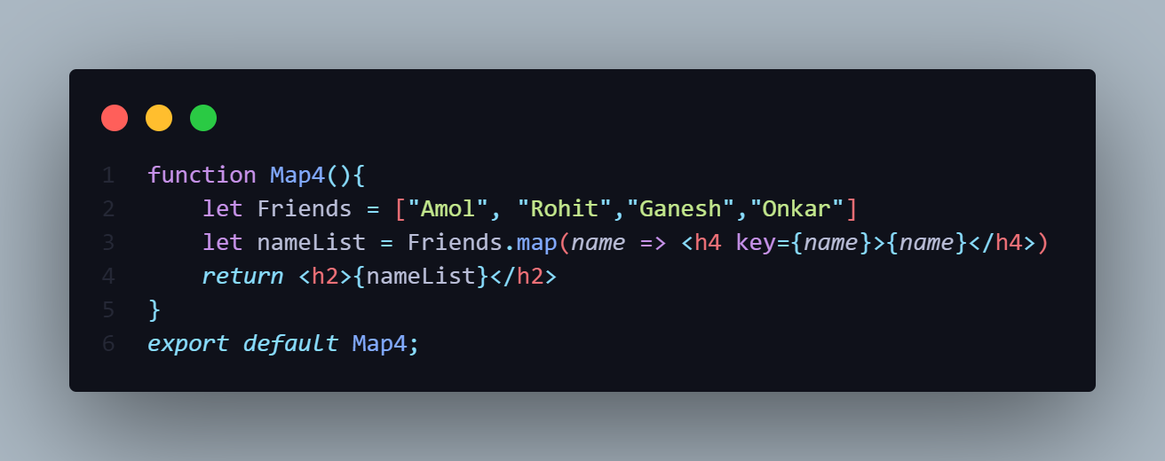

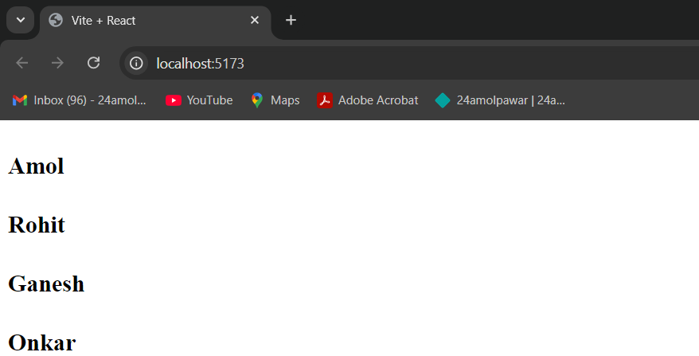

**MAP - KEY**

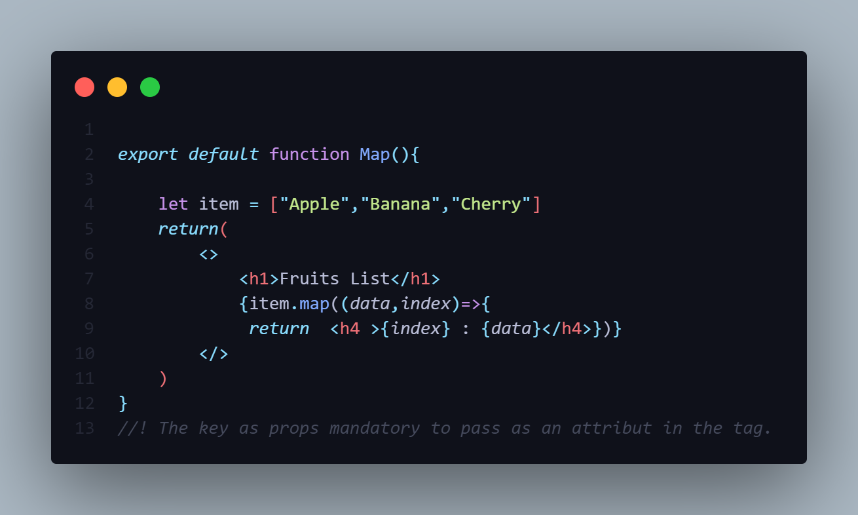

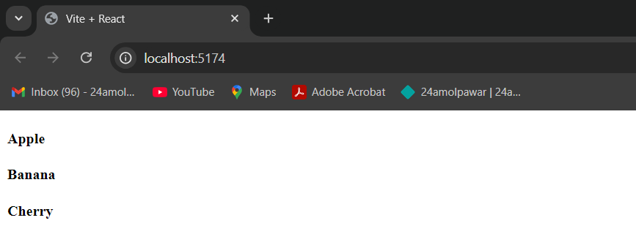

-After rendering the Map component Browser will give the output but it will also give you the warning called Each child have unique “Key”.

-In React, the key attribute is **essential** when rendering lists using the map() method. The key helps React identify which items have changed, been added, or removed, which is important for performance optimization when rendering lists.



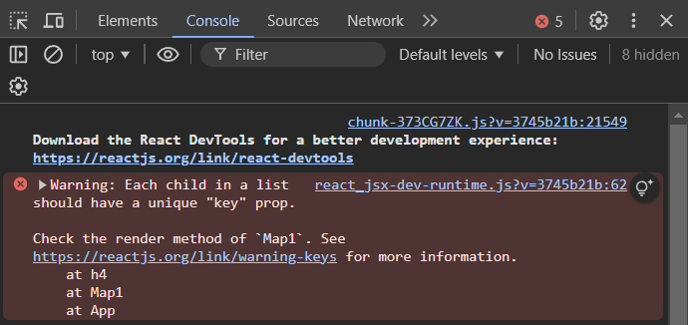

**1. Rendering Arrays with map()**

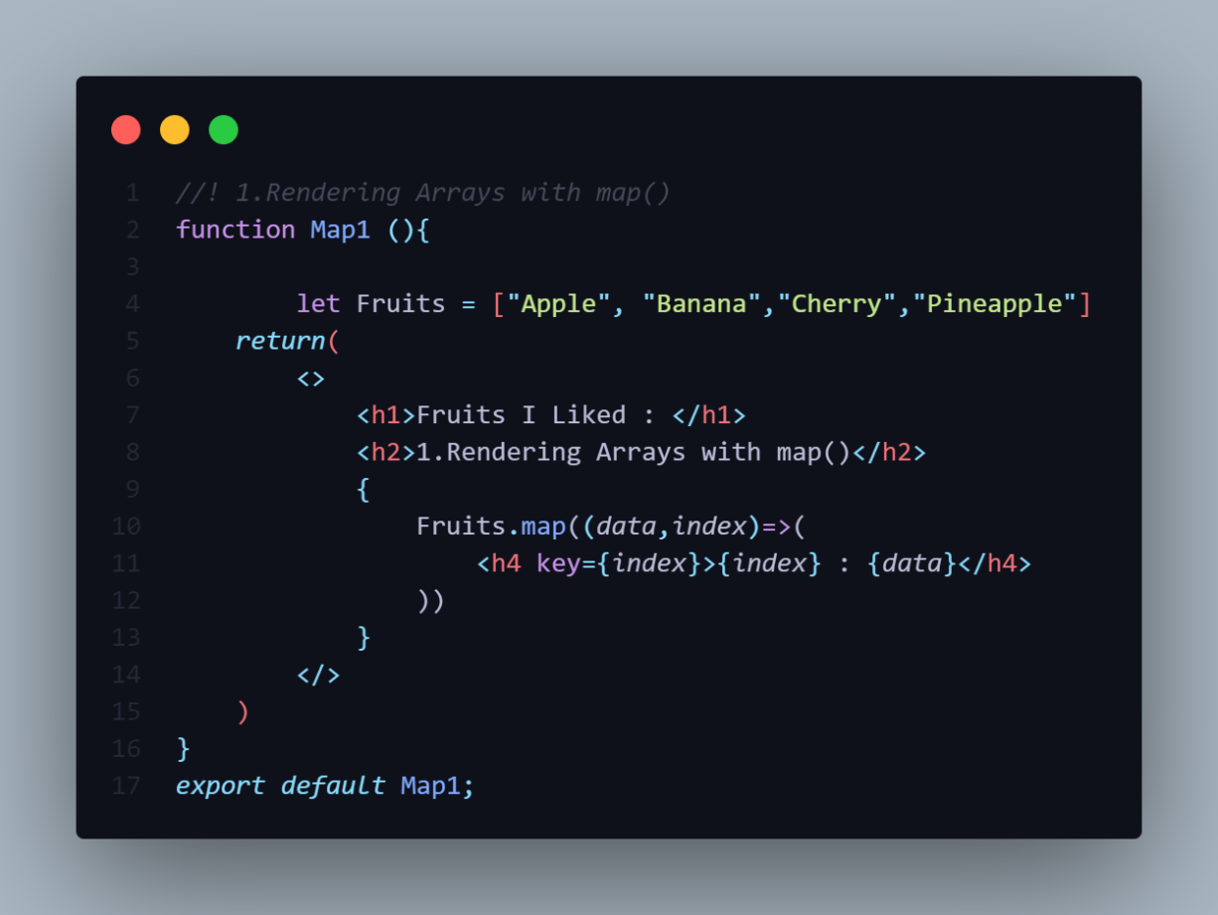

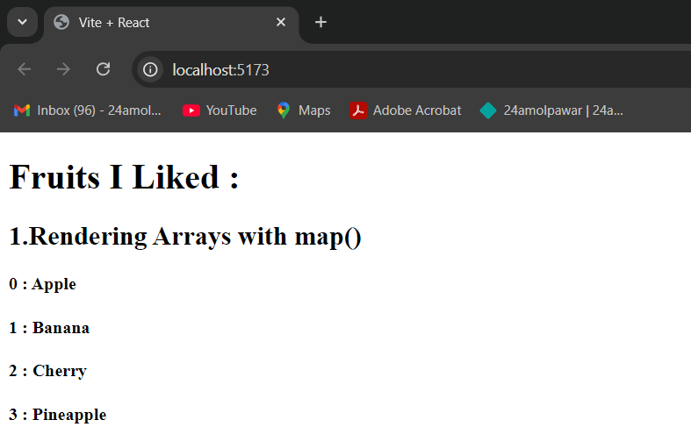

**2. Rendering Object with map()**

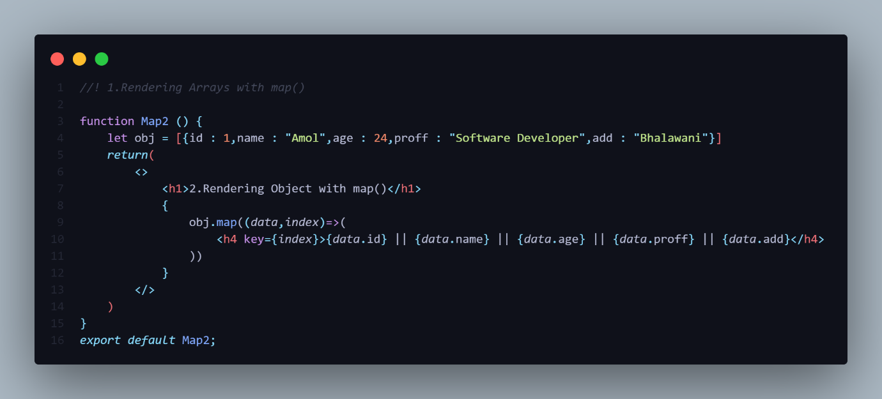

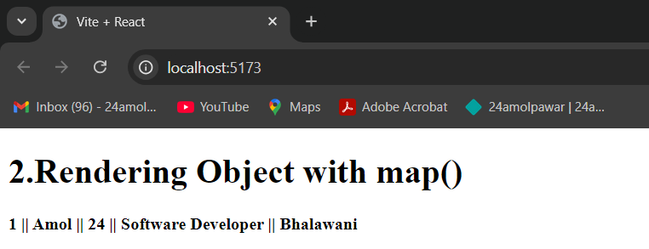

**3. Using Arrays in React State**

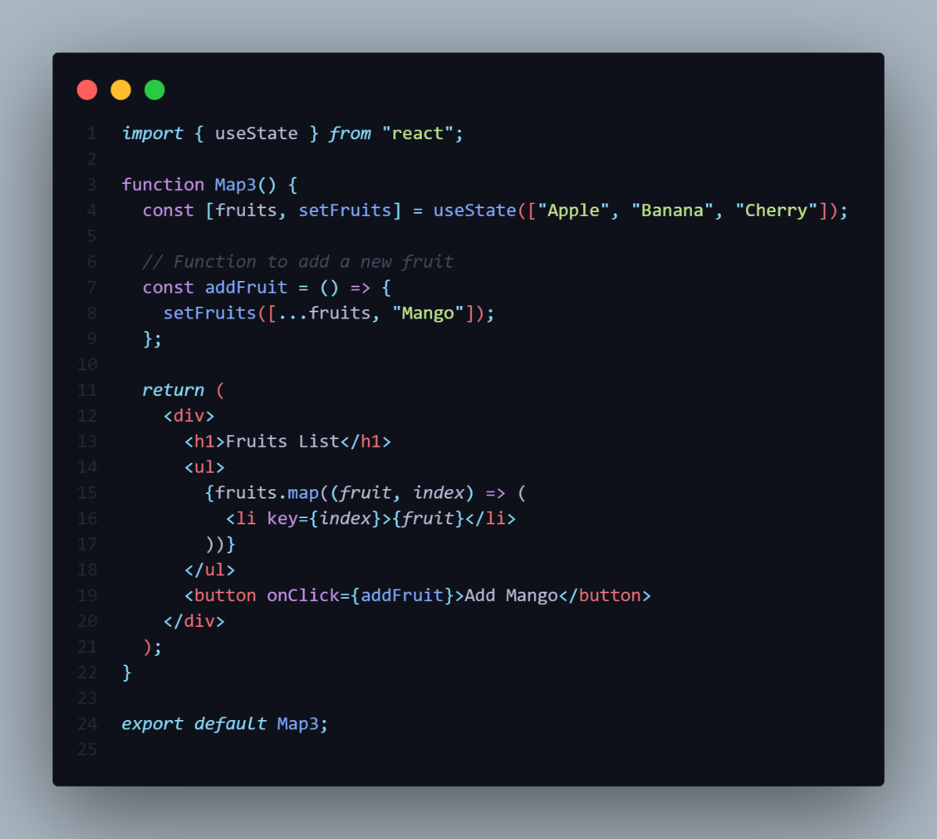-You can store arrays in state using React’s useState() hook. You can modify or update the array in state and render it dynamically.

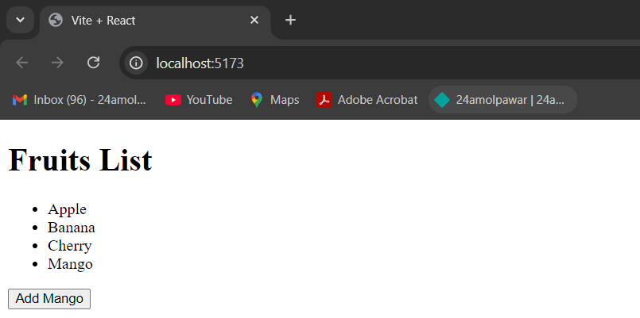

**4. Passing Object To Child Component Using Map**

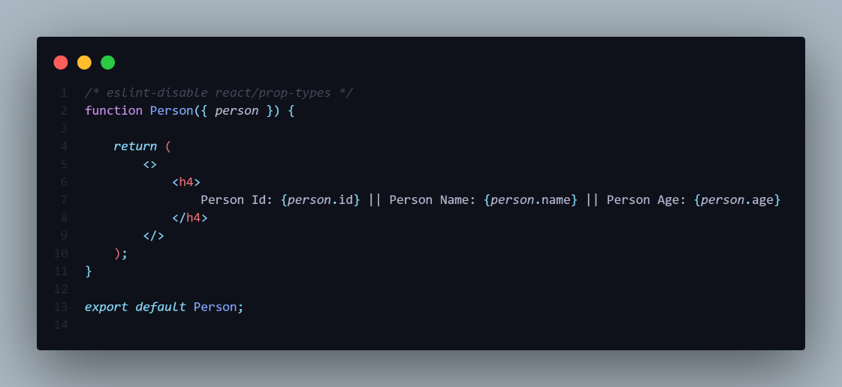

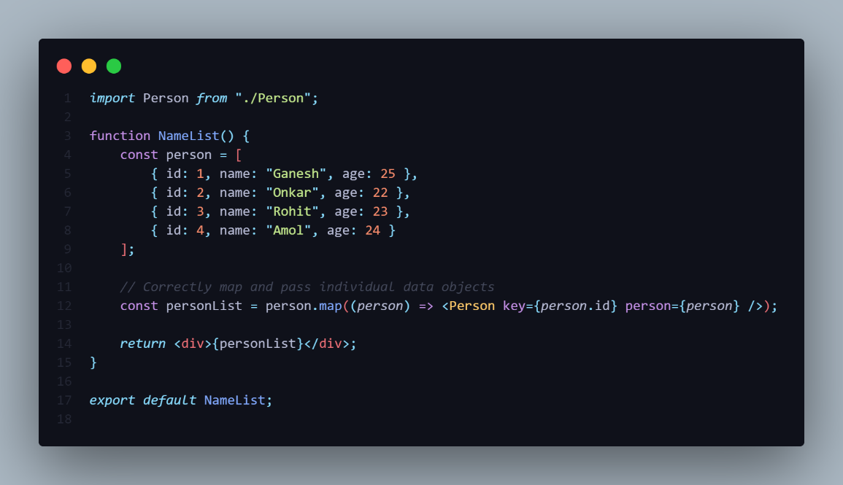

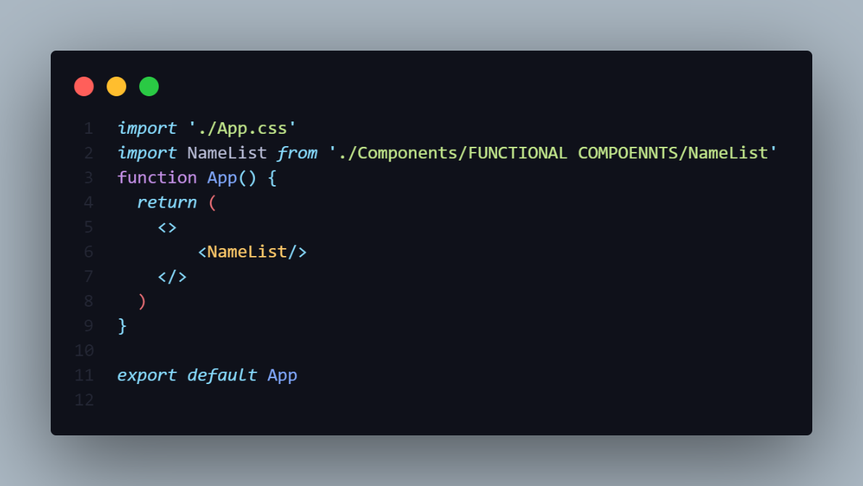

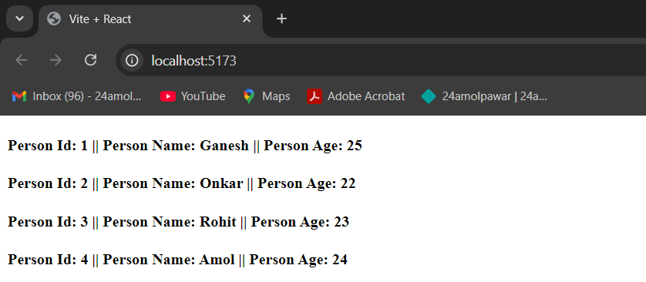

-In the NameList Component is the Parent Component for The Person & Person Is the Child Component For NameList.

-In The **NameList** Component we iterate the Object then It Calls the Person Component then we pass the iterative object variable to the **Person** Component and Store in the **personList** Variable.

-Then in the Person Component we doing the De-structuring of the Object.

**KEY AS AN PROPS**

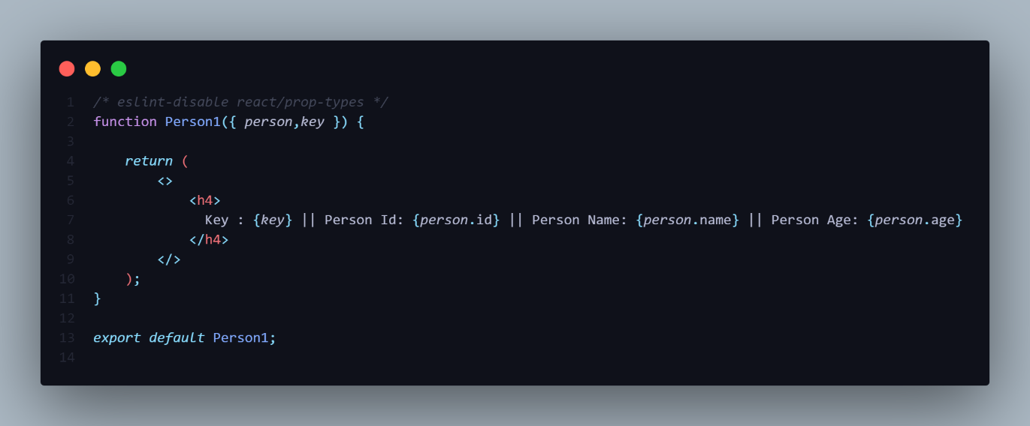

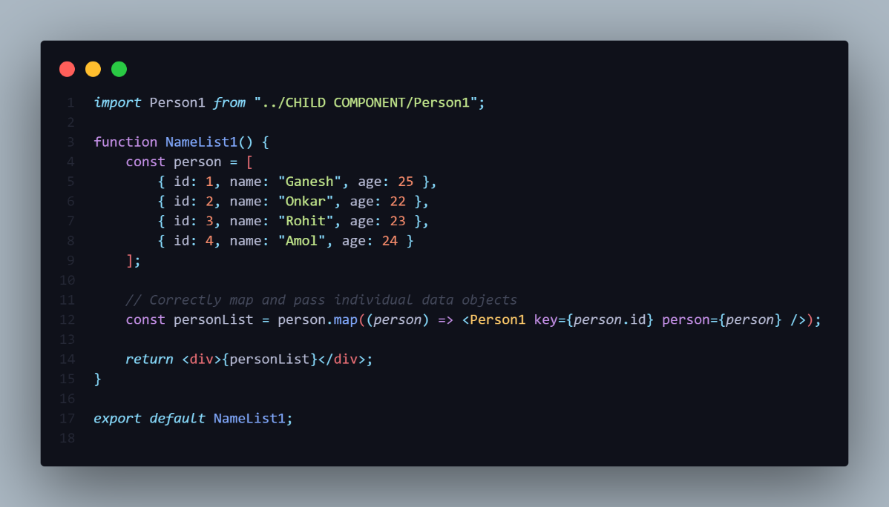

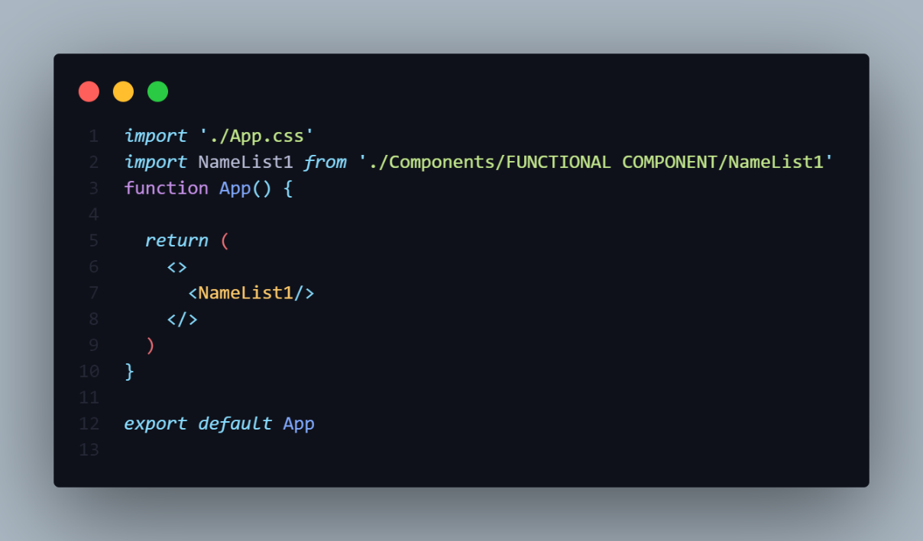

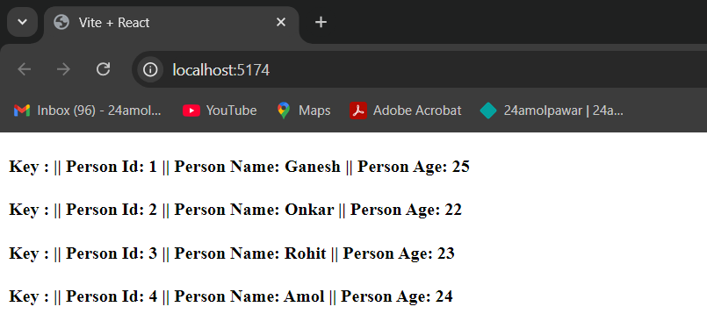

-If Your passing the **key** as an attribute to the Child Component then De-structuring you are trying to access the key it is Not renders in the Browser as shown in the output.

-It will give the Following warning.

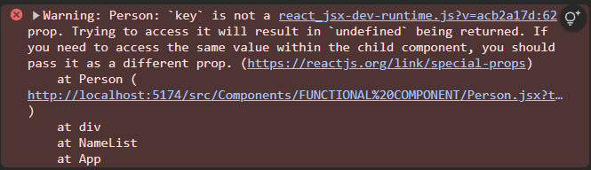

-So we cannot use Key as an Props and Cannot De-Structure it.

-Because key helps React identify which items have changed, been added, or removed, which is important for performance optimization when rendering lists.

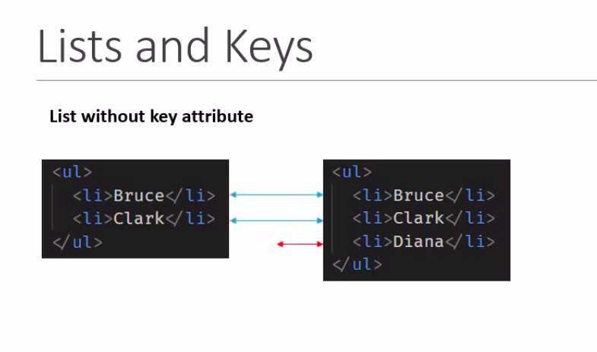

-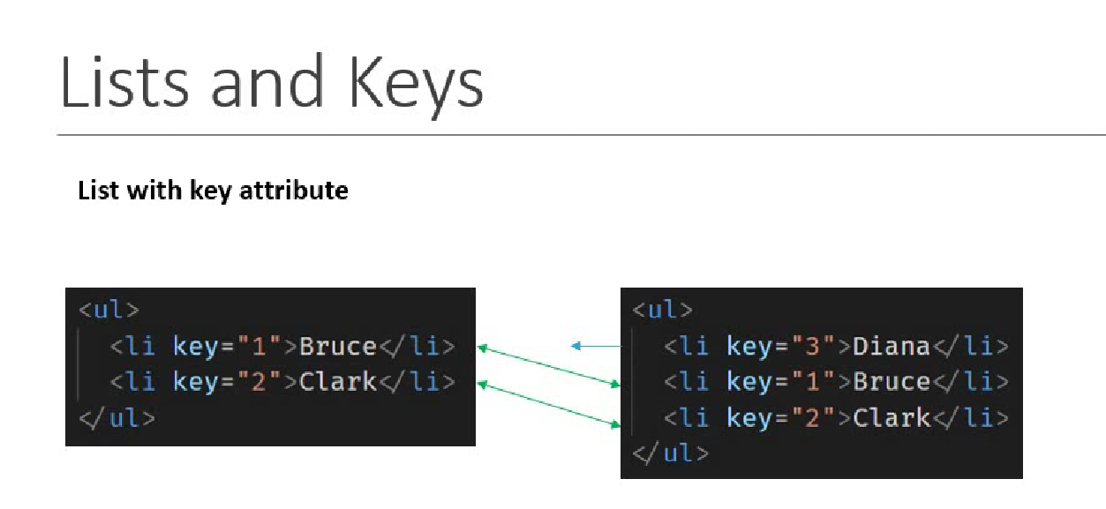

-So Using key React knows which is new Added or the Updated element.

**KEY TO REMOVE**

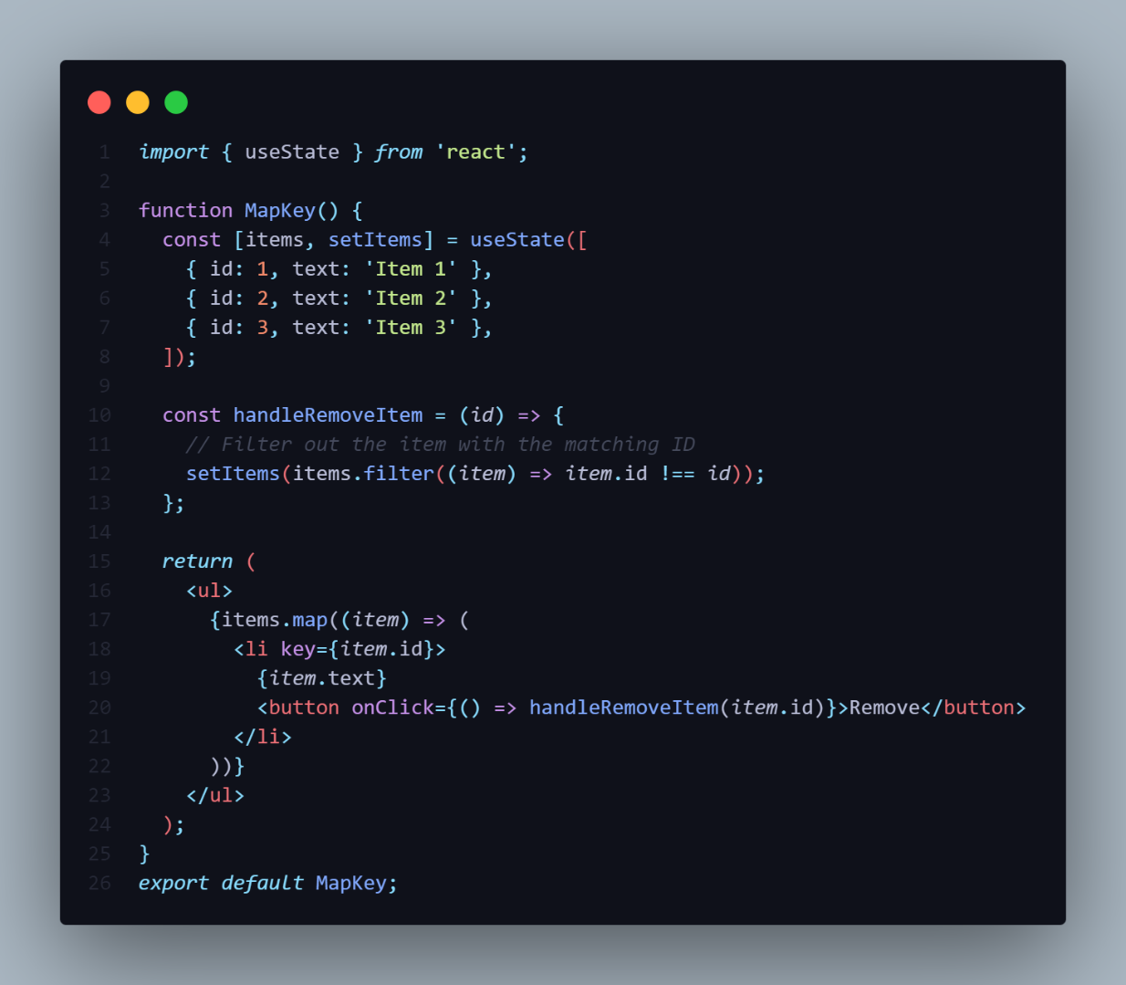

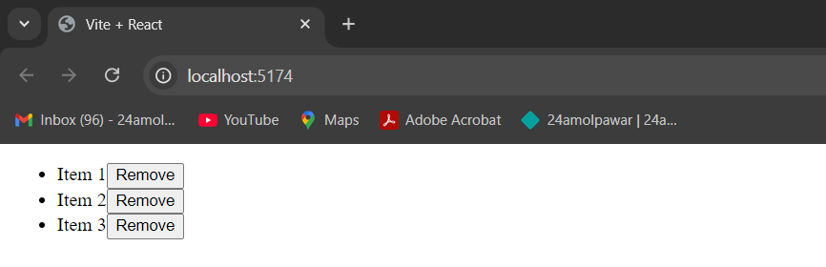

**INDEX AS KEY ANTI PATTERN**

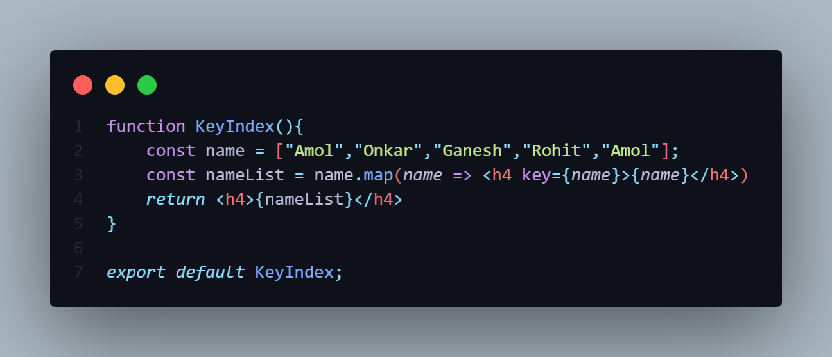

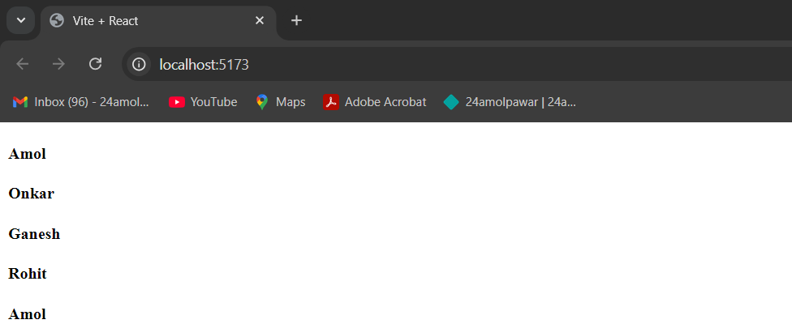

-For Array we don’t have Properties like Key-Value Pair in Object.

**Example**

Const obj = {

Id : 1//Key-Value Pair

}

-So in Array how to Print the Array element with Index value.

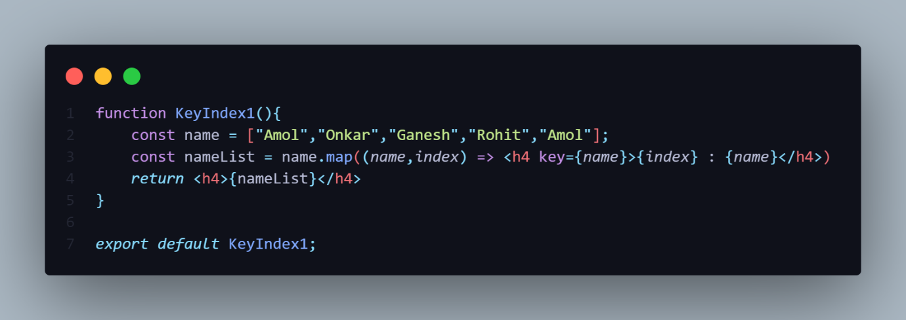

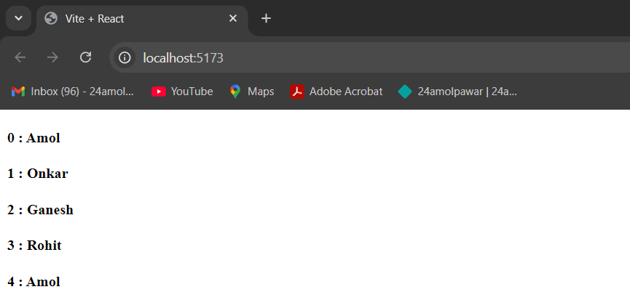

-For That We have Take the extra variable in the **map(**name,index**)** method.

-So By Using name we access the iterative elements from the Array.

-By Using Index we can access the **Index Value** of the array.

**WHEN TO USE INDEX AS KEY**

1.The items in your list do not have a unique id.

2.The list is a Static and will not change.

3.The list will never be reordered or filtered.

-If the Above three condition stratify then you can use Index as an Key.

**STYLING [CSS] IN REACT**

-There are many Ways Add Css in React.

1]CSS Stylesheets[External Css]

2]Inline Styling

3]CSS Modules

4]CSS Using JS Libraries.

5]Element CSS [Javascript Object]

6]Conditional Css [Ternary Operator]

7]Using Frameworks [Tailwind,Bootstrap]

8]Template Literal

**1.CSS STYLESHEET [EXTERNAL]**

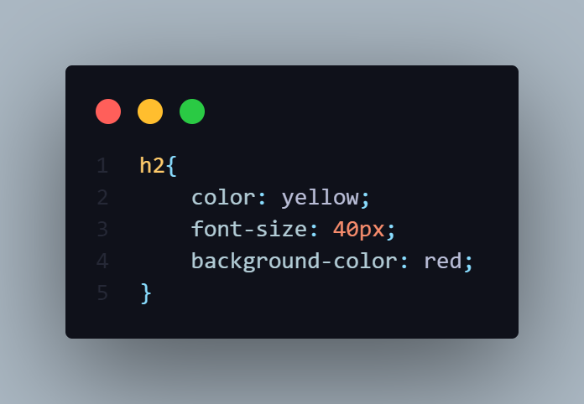

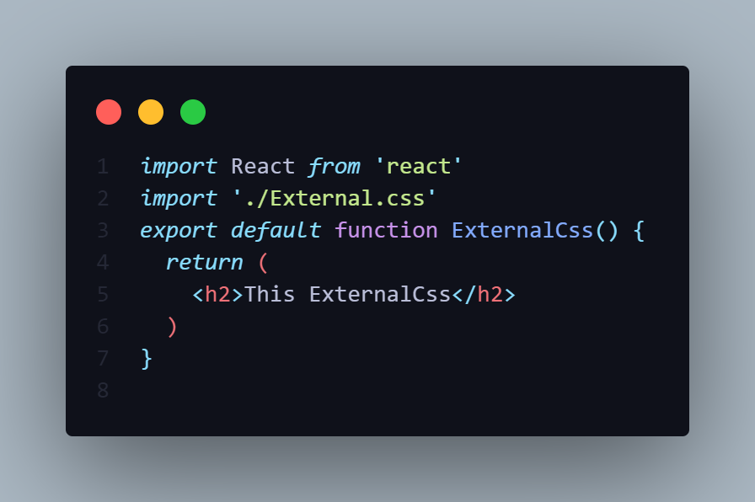

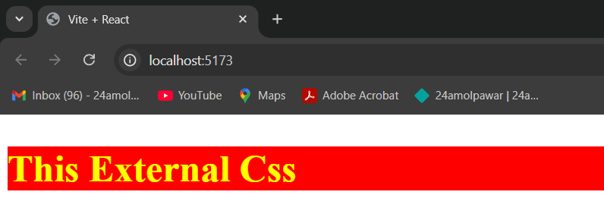

**2.CSS MODULE**

**style.module.css**

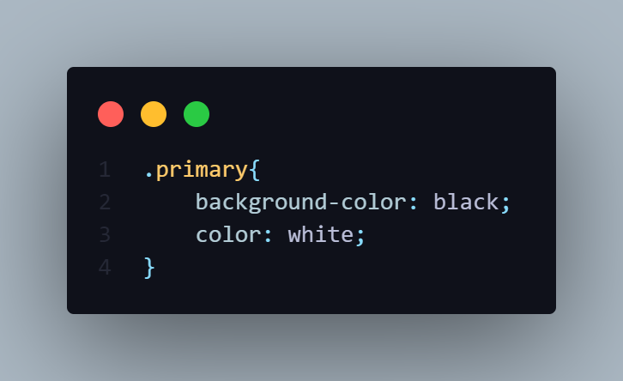

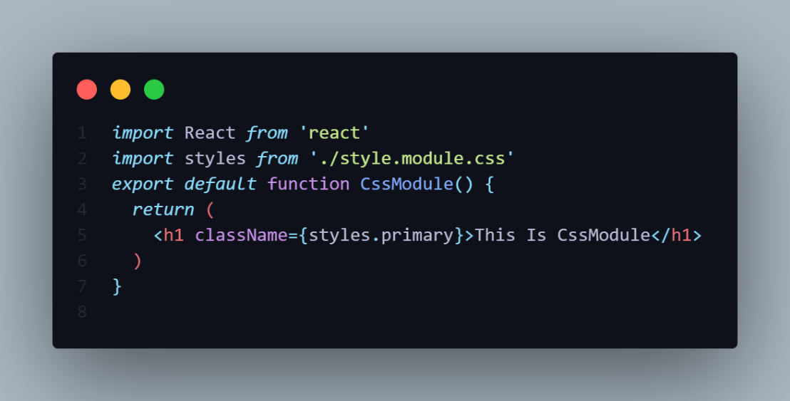

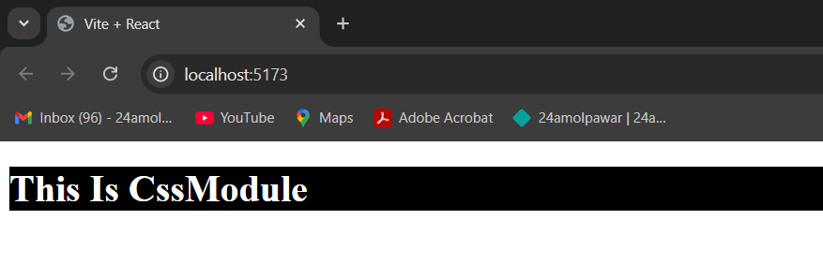

**RULE:**

1.Give File Name **style.module.css** in lowercase

2.You Have Import Like Module (Component)

**Ex**: import from ‘./styles.module.css’

3.For Accessing using {styles.primary} in **className**.

**3.ELEMENT MODULE [Javascript Object]**

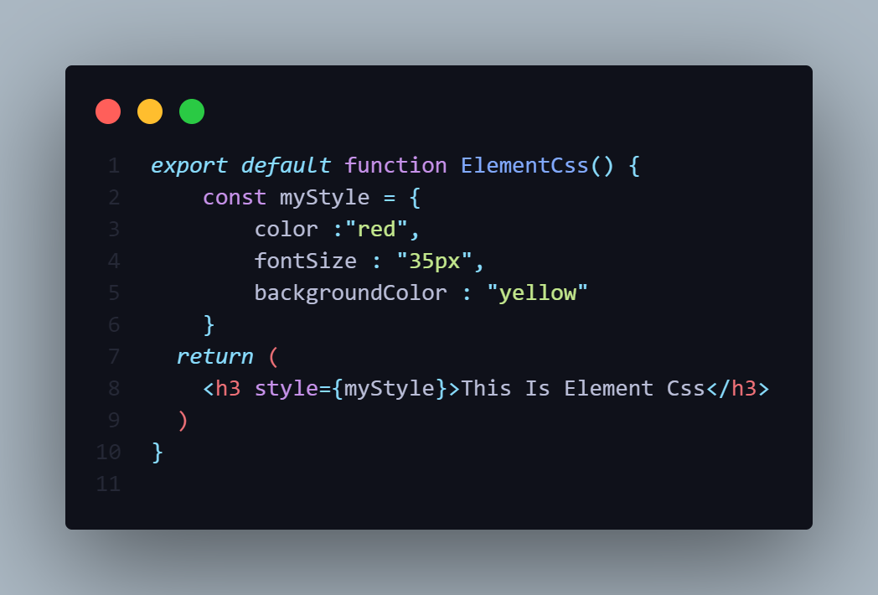

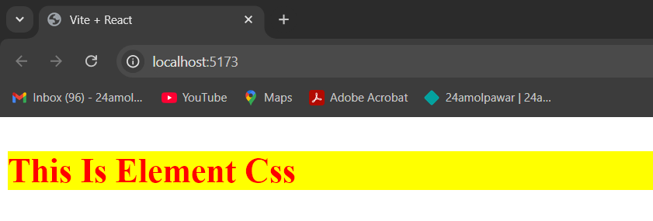

**4.USING FRAMEWORK**

**Framwork.css**

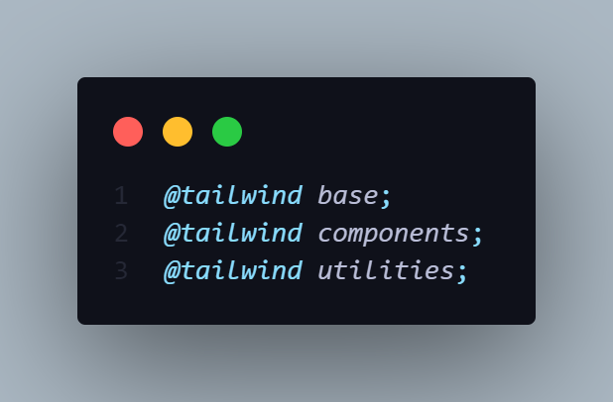

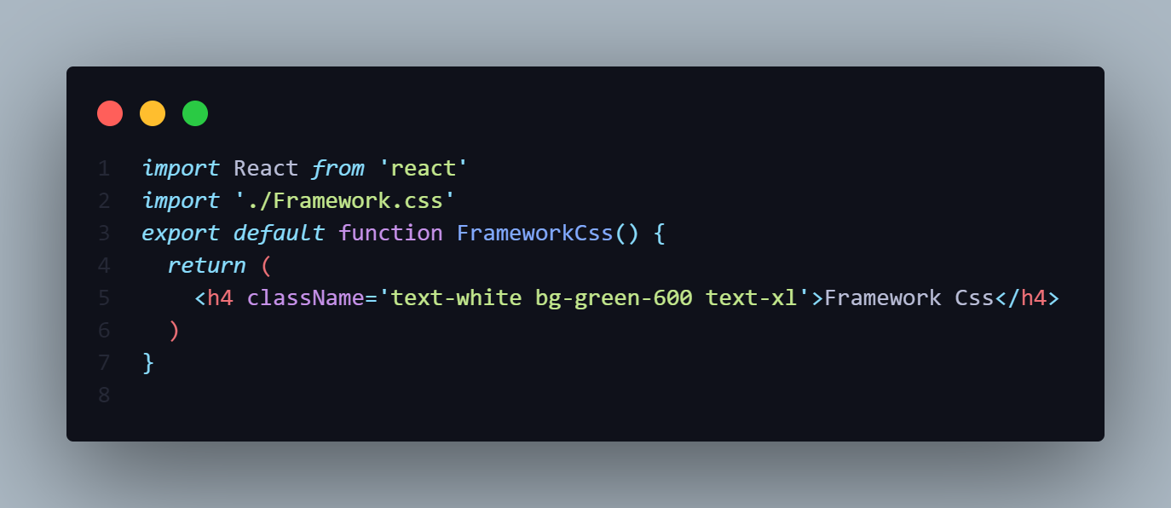

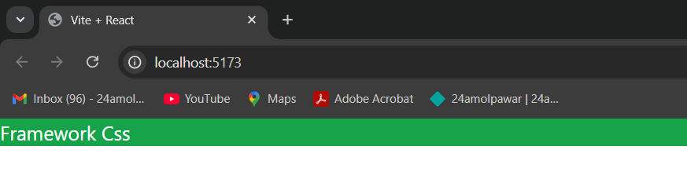

**RULE :**

1]Make separate Css File copy tailwind CSS utilities

**FORM HANDLING**

-

**COMPONENT LIFECYCLE METHODS**

-When we create the React Component the component goes through his several stages in its Life Cycle.

-React provide the built-in methods that we can override particular at stages in the Lifecycle.

-The Life Cycle method available only Class Component.

-The **useEffect()** hook is partially relate the Life Cycle Methods

-Each component in React has a lifecycle which you can monitor and manipulate during its three main phases.

-The three phases are: **Mounting**, **Updating**, and **Unmounting**.

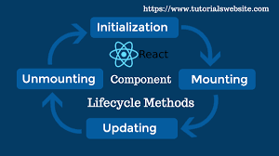

* **Mounting** − Mounting represents the rendering of the React component in the given DOM node.
* **Updating** − Updating represents the re-rendering of the React component in the given DOM node during state changes / updates.
* **Unmounting** − Unmounting represents the removal of the React component.

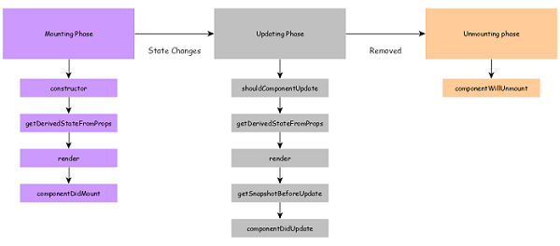

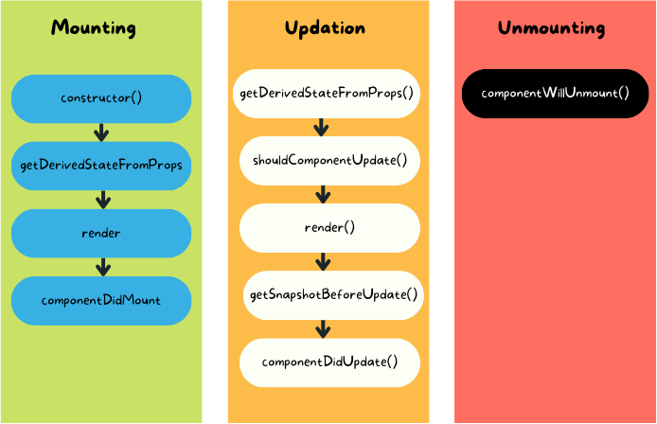

**CLASS COMPONENT**

**MOUNTING**

-Mounting means whenever react is injected in DOM.It is the phase in which component is inserted in DOM.

-The Mounting LifeCycle Methods calls when an instance of the component is being create and inserted into the DOM.

Mounting means putting elements into the DOM.

-During Mounting phase we have Four Lifecycle Methods:-

**1]Contructor()**

**2]getDerivedStateFromProps()**

**3]render()**

**4]ComponentDidMount()**

-The render() method is required and will always be called, the others are optional and will be called if you define them.



**1. Constructor (Class Component)**

* The constructor() method is called before the component is mounted.( executed before rendering the Component.)
* It's mainly used for setting the initial state and binding methods.
* Available only in class components.
* It’s an ES6 feature and not a React provided method.
* React uses the constructor to pass the props to parent Component extended from React library.

-The constructor() method is called with the props, as arguments, and you should always start by calling the super(props) before anything else, this will initiate the parent's constructor method and allows the component to inherit methods from its parent (React.Component).

constructor(props){

   super( props );

}

-Passing of props to parent Component helps us to use this.props in the component.

-We can initialize the state for the component in constructor. Important point is we should not use setState method in constructor. Because setState is designed to update the state and not for creation of state.

-Use of setState inside constructor can result into unpredictable component or re-render of component in infinite way.

constructor**(**props**)**{

   super( props );

this.state = {

      test: ‘example’

   }

}

**================= NOTE =================**

* Side effects like call to web api should be avoided in constructor. Because web api calls takes time to return result and by that time constructor method will complete its execution.
* Do Not Make HTTP request From constructor.
* Method binding can also be done in constructor e.g e.g. this.handleNewUser=this..handleNewUser.bind(this);>

**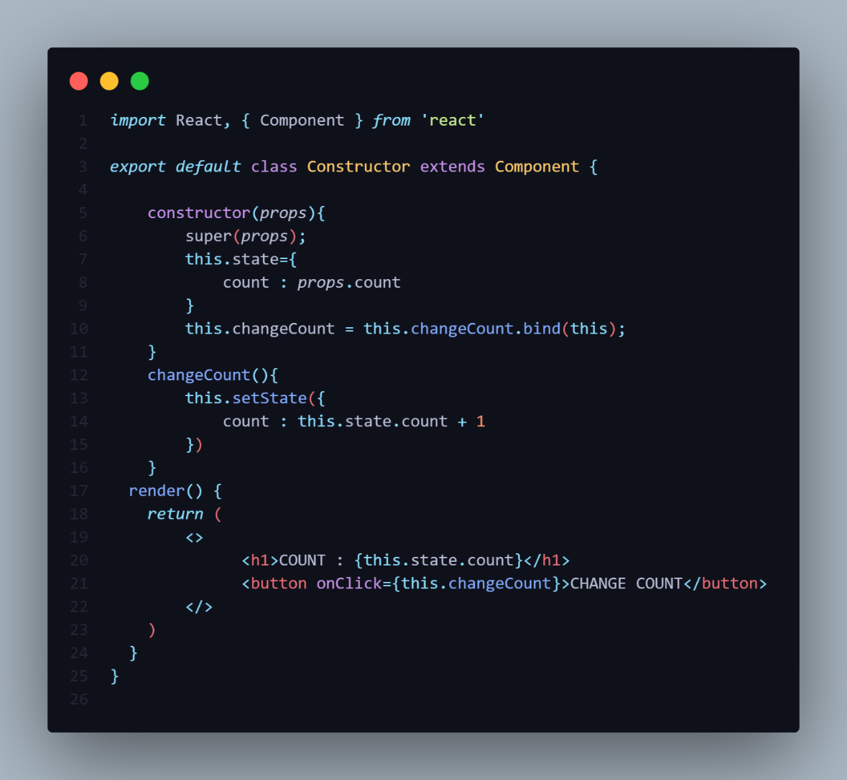**

**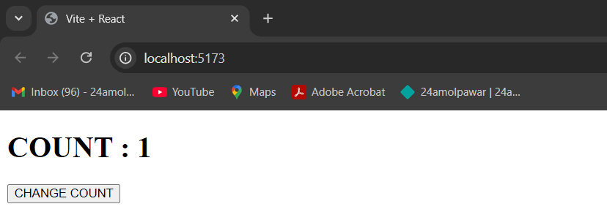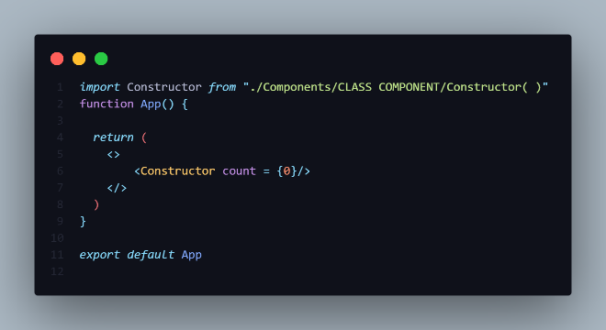**

**2]getDerivedStateFromProps()**

-getDerivedStateFromProps is a **static lifecycle method** in React class components that was introduced in React 16.3.

- It is used to derive state from props and is called **before rendering** the component. This method replaces the older componentWillReceiveProps lifecycle method.

-The getDerivedStateFromProps() method is called right before rendering the element(s) in the DOM.

-This is the natural place to set the state object based on the initial props.

-It takes state as an argument, and returns an object with changes to the state.

Syntax:-

static getDerivedStateFromProps**(**nextProps, prevState**)** **{**

// Return an object to update the state, or null to indicate no state update.

return null;

**}**

**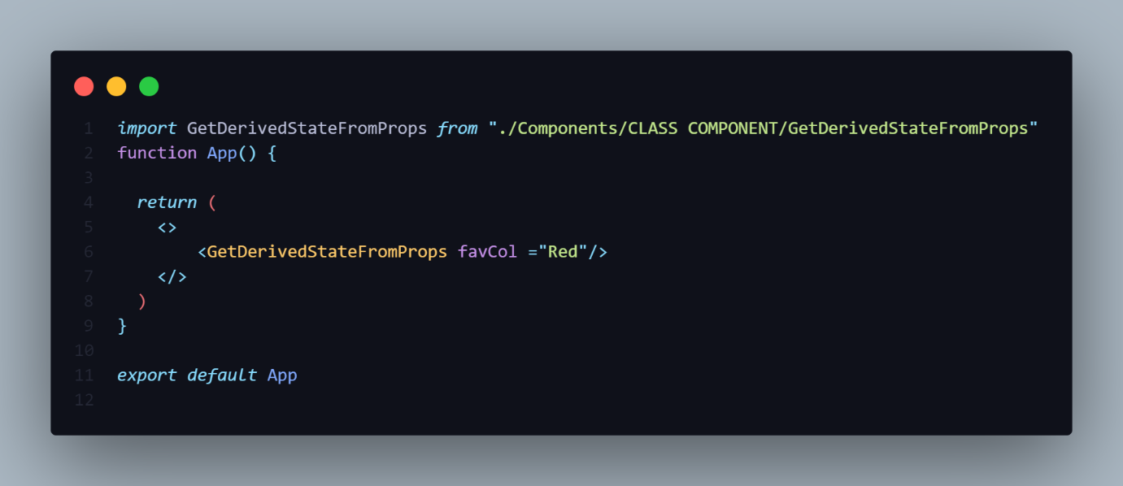**

**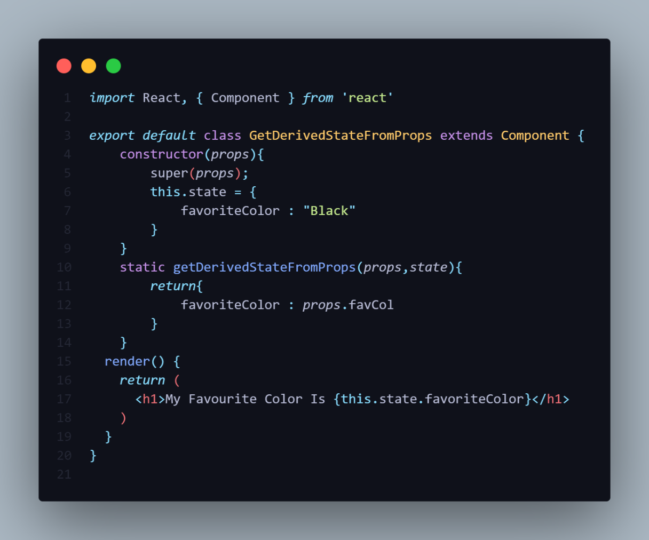**

**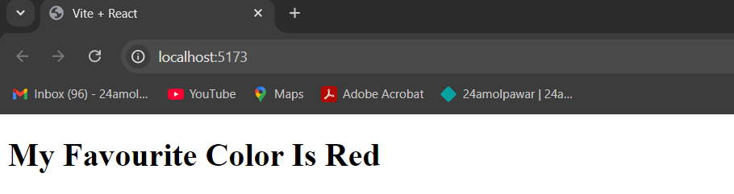**

**NOTE : -**

1]Write Same getDerivedStateFromProps(props,state) syntax

2]We cannot use the **this.setState** in this method because the **getDerivedStateFromProps()** is **static** method

**Usage of getDerivedStateFromProps in Updates:**

1. When it’s called:
   * getDerivedStateFromProps is invoked right before every render, whether it's for the initial mounting or subsequent updates. This includes when the parent component re-renders or the props are updated.
2. Parameters:
   * It receives two parameters:
     + nextProps: The new props that the component will receive.
     + prevState: The current state of the component before the update.
3. Return Value:
   * It should return an object to update the state or null if no state update is necessary.
4. Stateless:
   * getDerivedStateFromProps is a static method, so it doesn’t have access to the component instance (this). You can only modify the state based on the inputs provided.

**3]render()**

-The render() method is of course called when a component gets updated, it has to re-render the HTML to the DOM, with the new changes.

-The render() method is required, and is the method that actually outputs the HTML to the DOM.

* Executing render method gives React an idea of what needs to update on the actual DOM.
* React keeps a copy of Original DOM, we call it as virtual DOM.
* Changes happen on virtual DOM and in the end, React compares the virtual DOM with original DOM to update the latter.
* This method structures and prepares the jsx code to return to DOM
* Inside the render method, we can jsx code of child component.
* So Lifecycle method for child component will run at this point of time.
* Do not change or interact with DOM or make AJAX call.

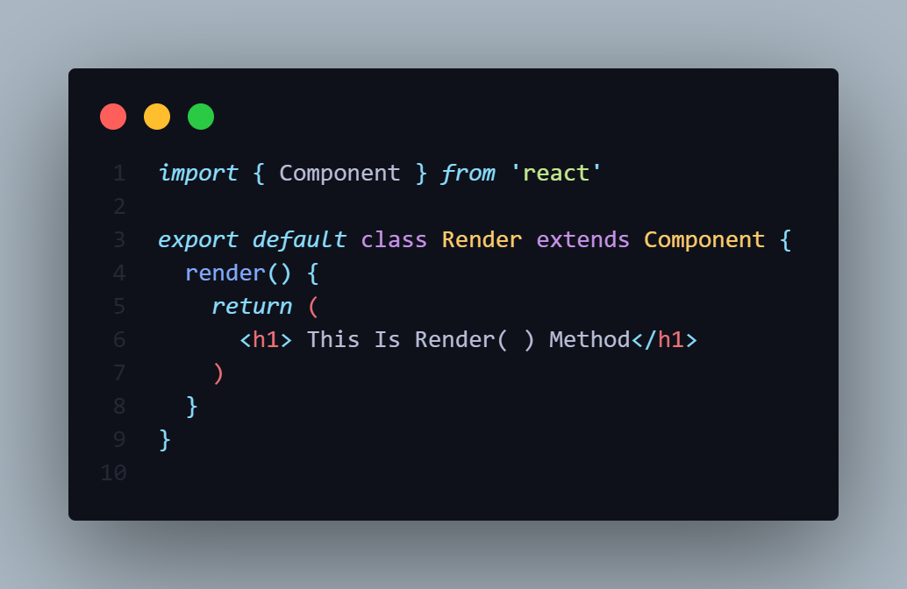

**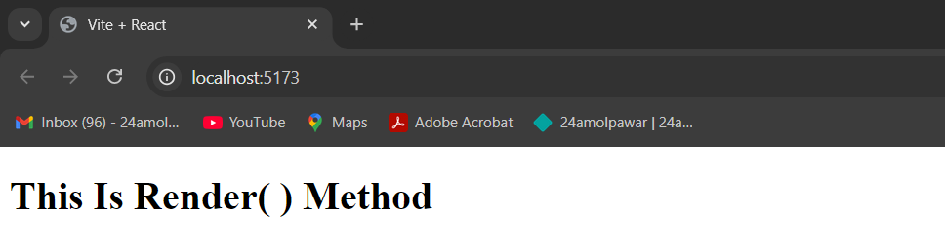**

**4]ComponentDidMount()**

-The componentDidMount() method is called after the component is rendered.

-This is where you run statements that requires that the component is already placed in the DOM.

-It's typically used for side effects such as fetching data from an API, setting up subscriptions, or starting timers.

* Execution of this method means component is successfully mounted or created on real DOM.
* Here we can do side effects like using timers, calling web api, adding event listeners.
* This method gets called only once in the lifecycle of stateful component.
* Use of setState in this method can trigger render again to update DOM.
* We are able to do side effects inside this method because it executes only once so there will not be an infinite loop if we update the state using setState.
* If we want to manipulate a dom node, then this method is the best place to do that.

class MyComponent extends React.Component {

componentDidMount() {

// API call or subscription setup

}

render() {

return <h1>Component Mounted</h1>;

}

}

**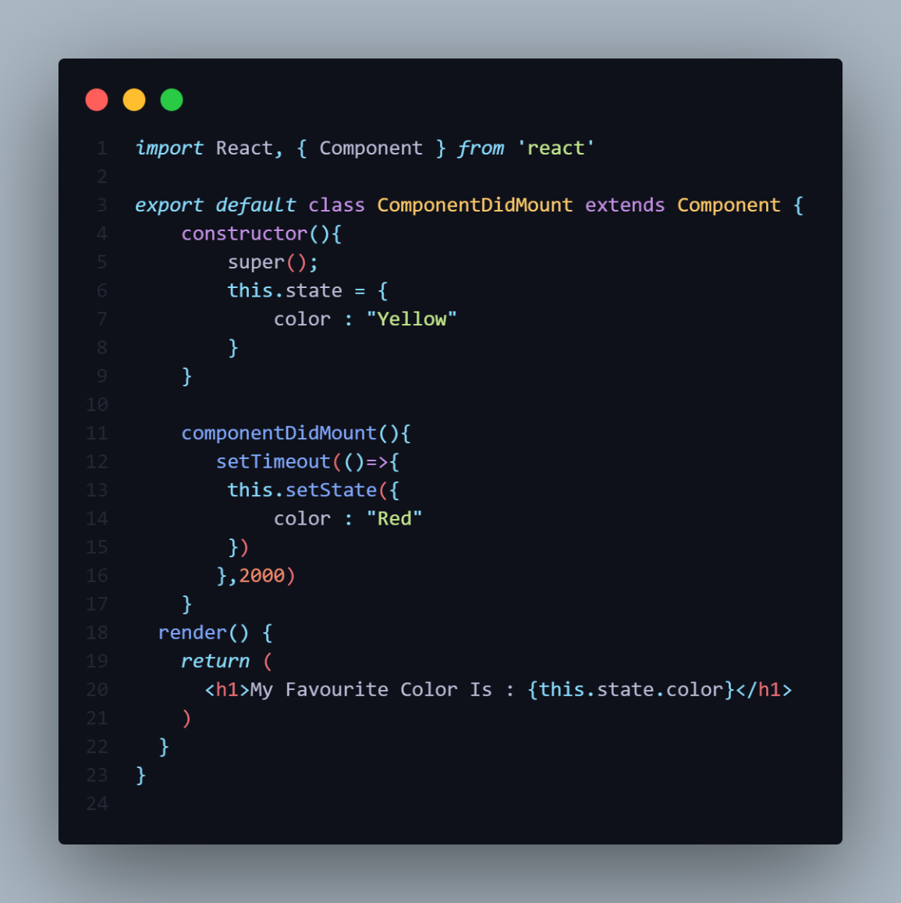**

**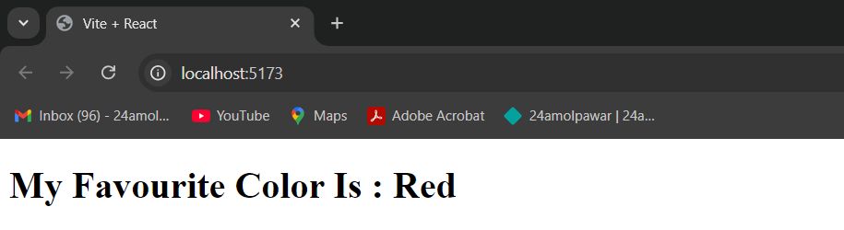**

-The **ComponentDidMount()**  methods change the state after render component using **setTimeout()** function.

**EXECUTION OF MOUNTING METHODS**

**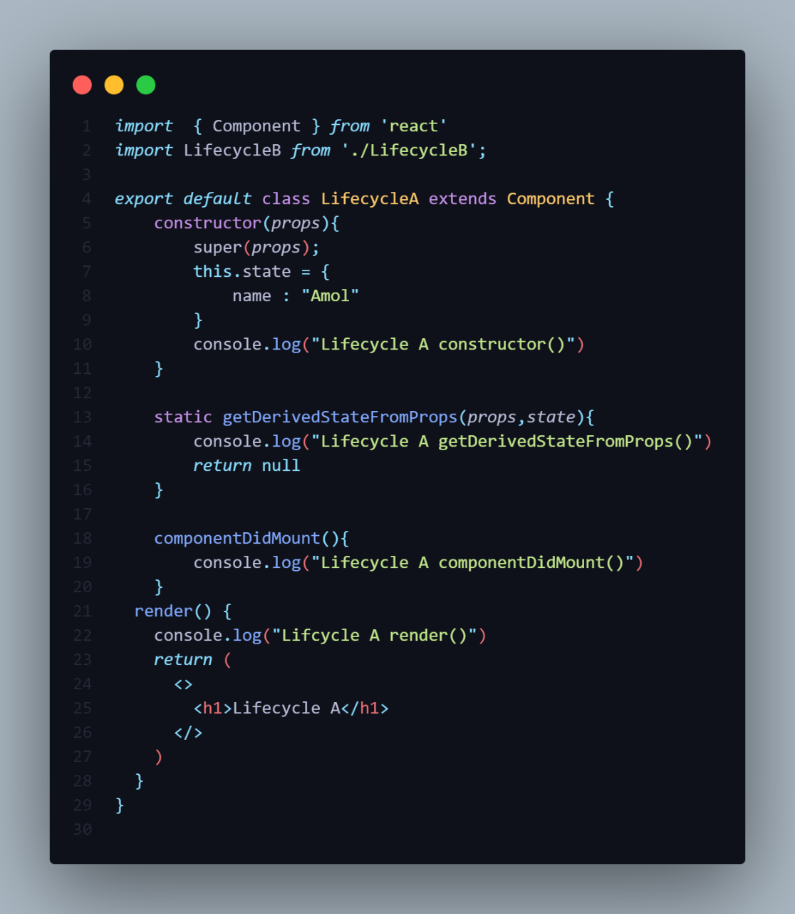**

**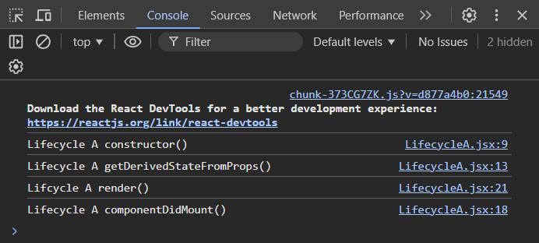**

**AFTER ADDING CHILD COMPONENT**

**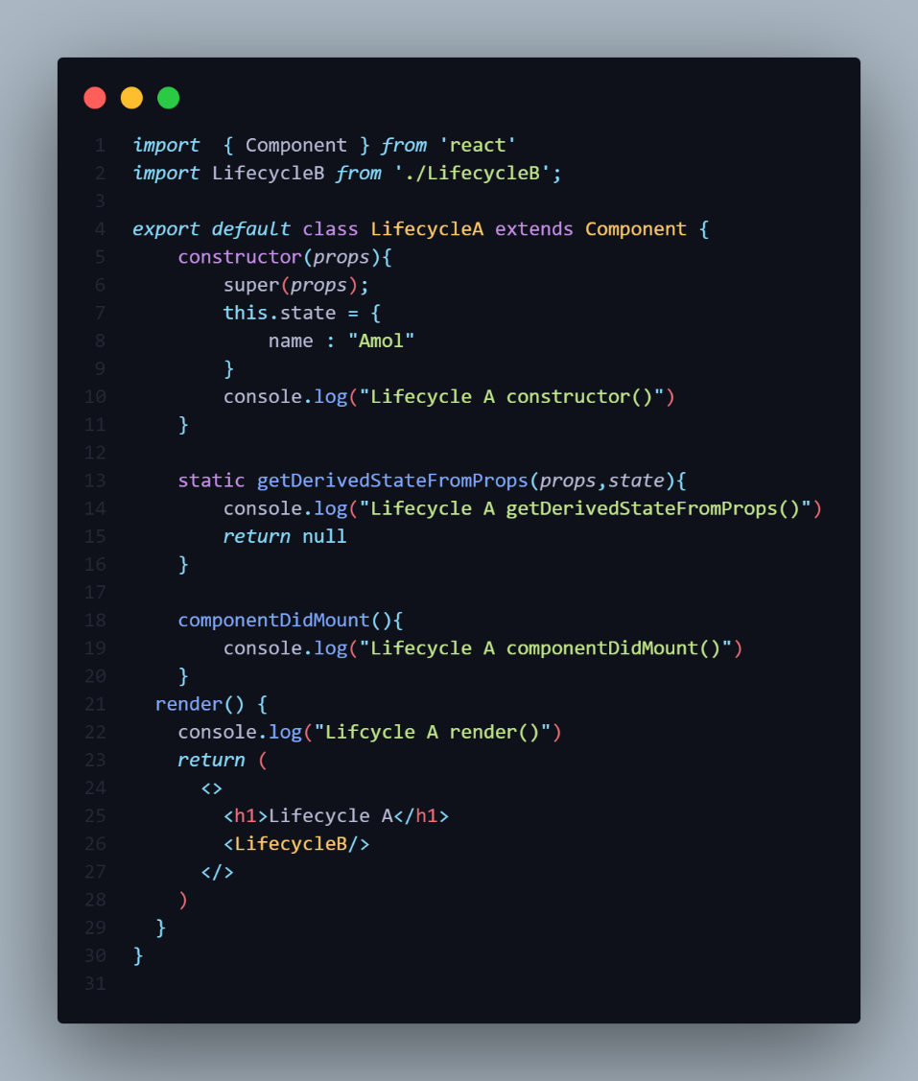**

**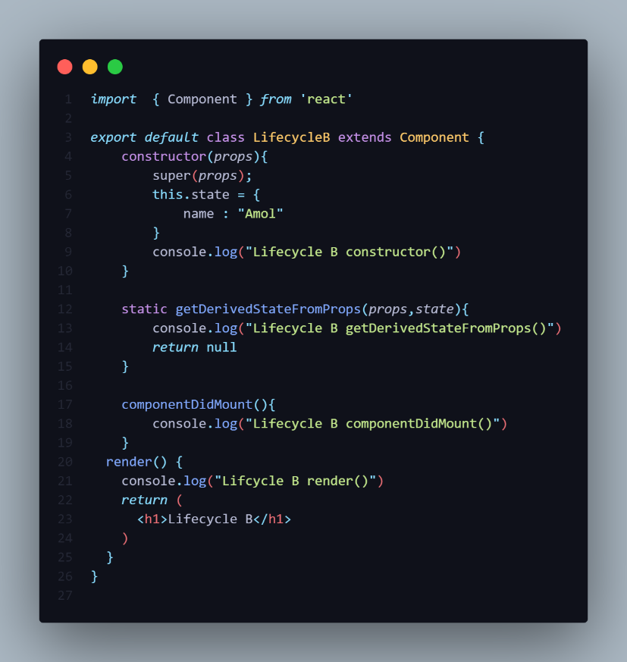**

**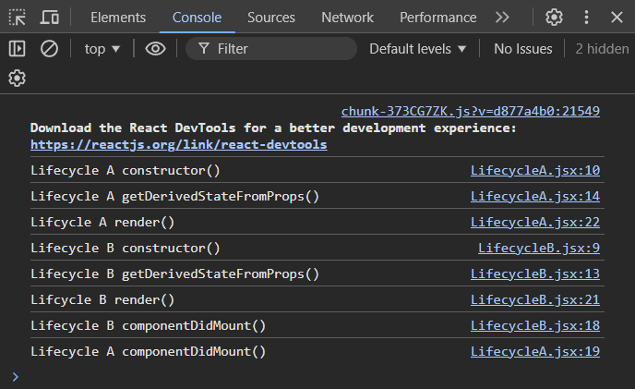**

NOTE:

-Look at the console of the browser If you are added child Component then its methods also gets executed.

-But the ComponentDidMount() method of Lifecycle A is executes lastly.

**FUNCTIONAL COMPONENT**

**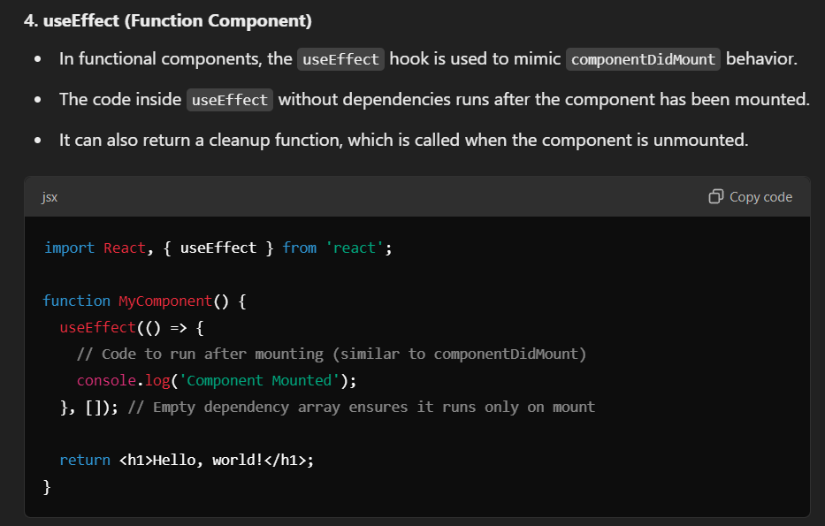**

**UPDATING**

-The Updating LifeCycle methods calls when a component being re-rendered as a result of changes to either **props** or **State**.

-A component is updated whenever there is a change in the component's state or props.

-It is the phase where existing node are updated in Node.

-During the Updating phase we have Five Methods:-

**1]Static getDerivedStateFromProps()**

**2]ShouldComponentUpdate()**

**3]render()**

**4]getSnapshotBeforeUpdate()**

**5]ComponentDidUpdate()**



**1]static getDerivedStateFromProps()**

-Also at updates the getDerivedStateFromProps method is called. This is the first method that is called when a component **gets** **updated**.

-This method is calls when component Re-Renders.

-This is still the natural place to set the state object based on the initial props.

-getDerivedStateFromProps is a **static lifecycle method** in React class components that was introduced in React 16.3.

- It is used to derive state from props and is called **before rendering** the component. This method replaces the older componentWillReceiveProps lifecycle method.

-The getDerivedStateFromProps() method is called right before rendering the element(s) in the DOM.

-It takes state as an argument, and returns an object with changes to the state.

Syntax:-

static getDerivedStateFromProps**(**nextProps, prevState**)** **{**

// Return an object to update the state, or null to indicate no state update.

return null;

**}**

**NOTE : -**

1]Write Same getDerivedStateFromProps(props,state) syntax

2]We cannot use the **this.setState** in this method because the **getDerivedStateFromProps()** is **static** method

**Usage of getDerivedStateFromProps in Updates:**

1. When it’s called:
   * getDerivedStateFromProps is invoked right before every render, whether it's for the initial mounting or subsequent updates. This includes when the parent component re-renders or the props are updated.
2. Parameters:
   * It receives two parameters:
     + nextProps: The new props that the component will receive.
     + prevState: The current state of the component before the update.
3. Return Value:
   * It should return an object to update the state or null if no state update is necessary.
4. Stateless:
   * getDerivedStateFromProps is a static method, so it doesn’t have access to the component instance (this). You can only modify the state based on the inputs provided.

**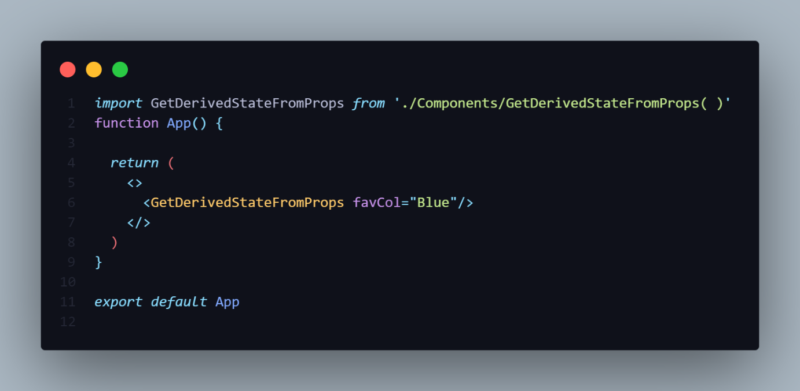**

**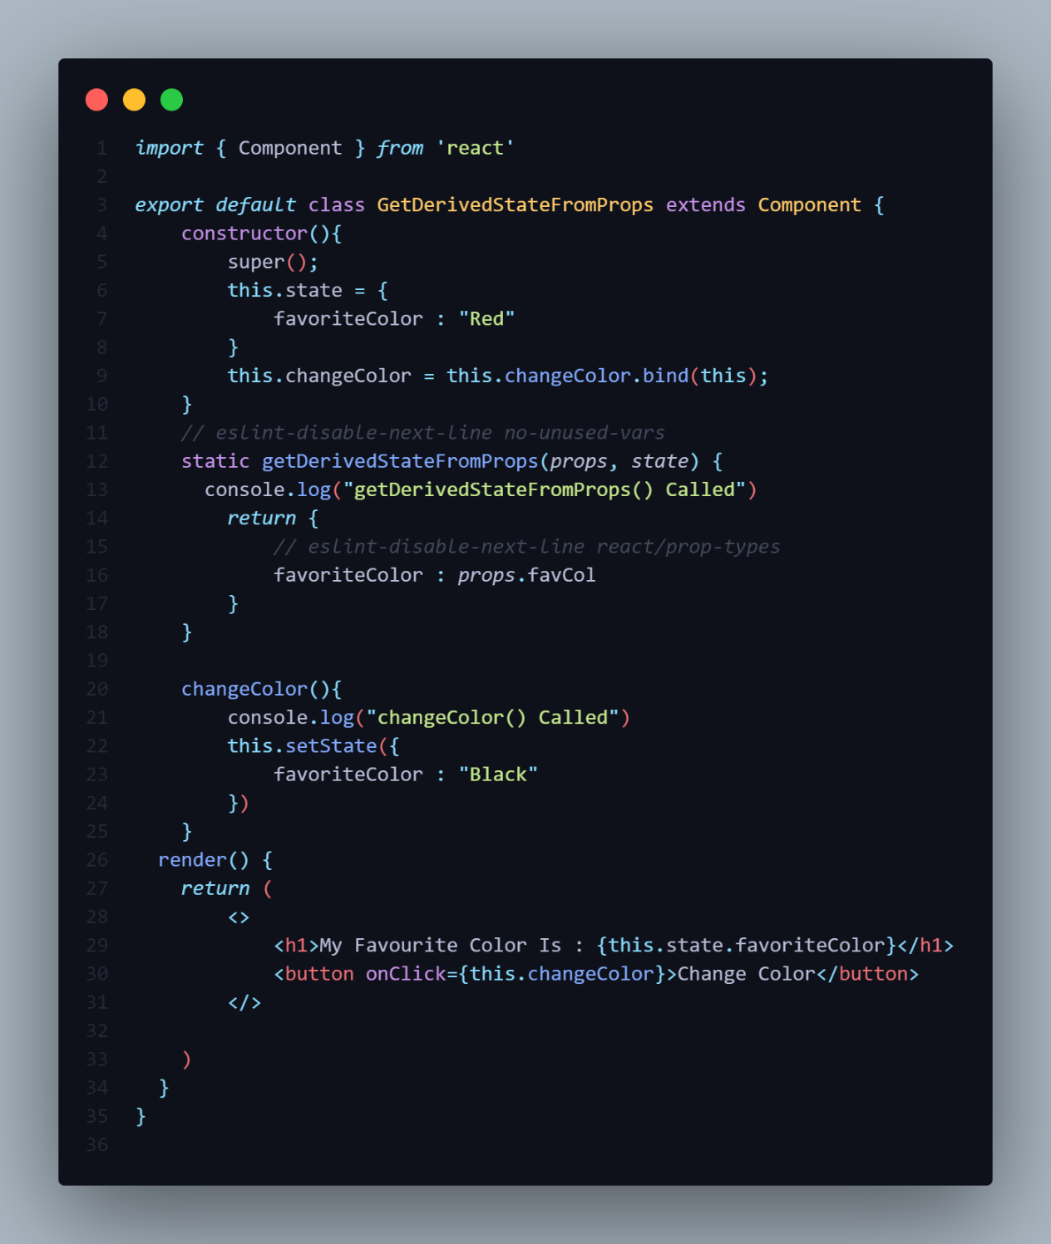**

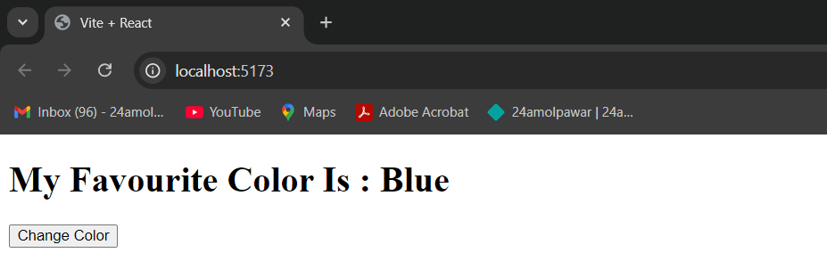

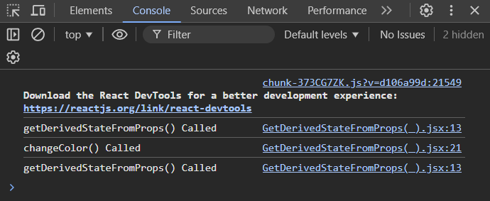

Explanation:

1. Component Initialization:
   * The component has an initial state with favoriteColor set to "Black".
   * The changeColor function is defined to update the state to "Orange" when invoked by clicking the button.
2. getDerivedStateFromProps:
   * This static lifecycle method is called before rendering the component.
   * It checks the incoming props and updates the state accordingly.
   * Specifically, it updates the favoriteColor in the state based on the prop favCol.
3. State Update on Prop Change:
   * If the prop favCol changes, the state will be updated to match the new value of favCol.
4. Rendering:
   * The component renders the current favorite color from the state and displays it in an <h1> tag.
   * Clicking the button invokes changeColor, which sets the favorite color to "Orange".

Issues/Improvements:

1. PropTypes: Since you're using props (favCol), it would be a good idea to define the prop type using prop-types to avoid possible warnings or errors during development.
2. Behavior of getDerivedStateFromProps: This method will override any changes to the state from within the component (such as when the button is clicked). For example:
   * If the prop favCol is passed as "Blue", clicking the button to change the color to "Orange" will momentarily change the state. But, since getDerivedStateFromProps runs before every render, it will reset the state back to "Blue", effectively overriding the button's effect.

**================== NOTE =================**

-If there is method getStateFromProps() present in the class & also there another custom method in the class which change color using event handling.

-Then That time First it change color using props in getStateFromProps()

After clicking the event you want change color then the getStateFromProps() is override.

-This method is calls when component Re-Renders.

**2]ShouldComponentUpdate()**

-The shouldComponentUpdate(nextProps, nextState) method is a React lifecycle method that allows you to optimize component performance by preventing unnecessary re-renders. It is called before the rendering process begins, whenever the component’s props or state change.

* This method returns a **Boolean** value **true** or **false**. Based on the return value React executes the render method which updates the actual DOM.
* The default value is **true**.
* We can add custom logic if requires in this method like comparing some variables to decide the process of updating.
* Side effects should be avoided.

**Syntax**

shouldComponentUpdate**(**nextProps**,** nextState**)** **{**

// Return true if the component should re-render, false otherwise

**}**

**Parameters:**

1. **nextProps**: The next set of props the component will receive.
2. **nextState**: The next state the component will have.

**Return Value:**

* **true**: React will proceed with the re-rendering.
* **false**: React will skip the re-rendering process for that update.

-By default, React re-renders the component whenever its props or state change. However, by using shouldComponentUpdate, you can control whether the component should update by comparing the current state/props with the next state/props.

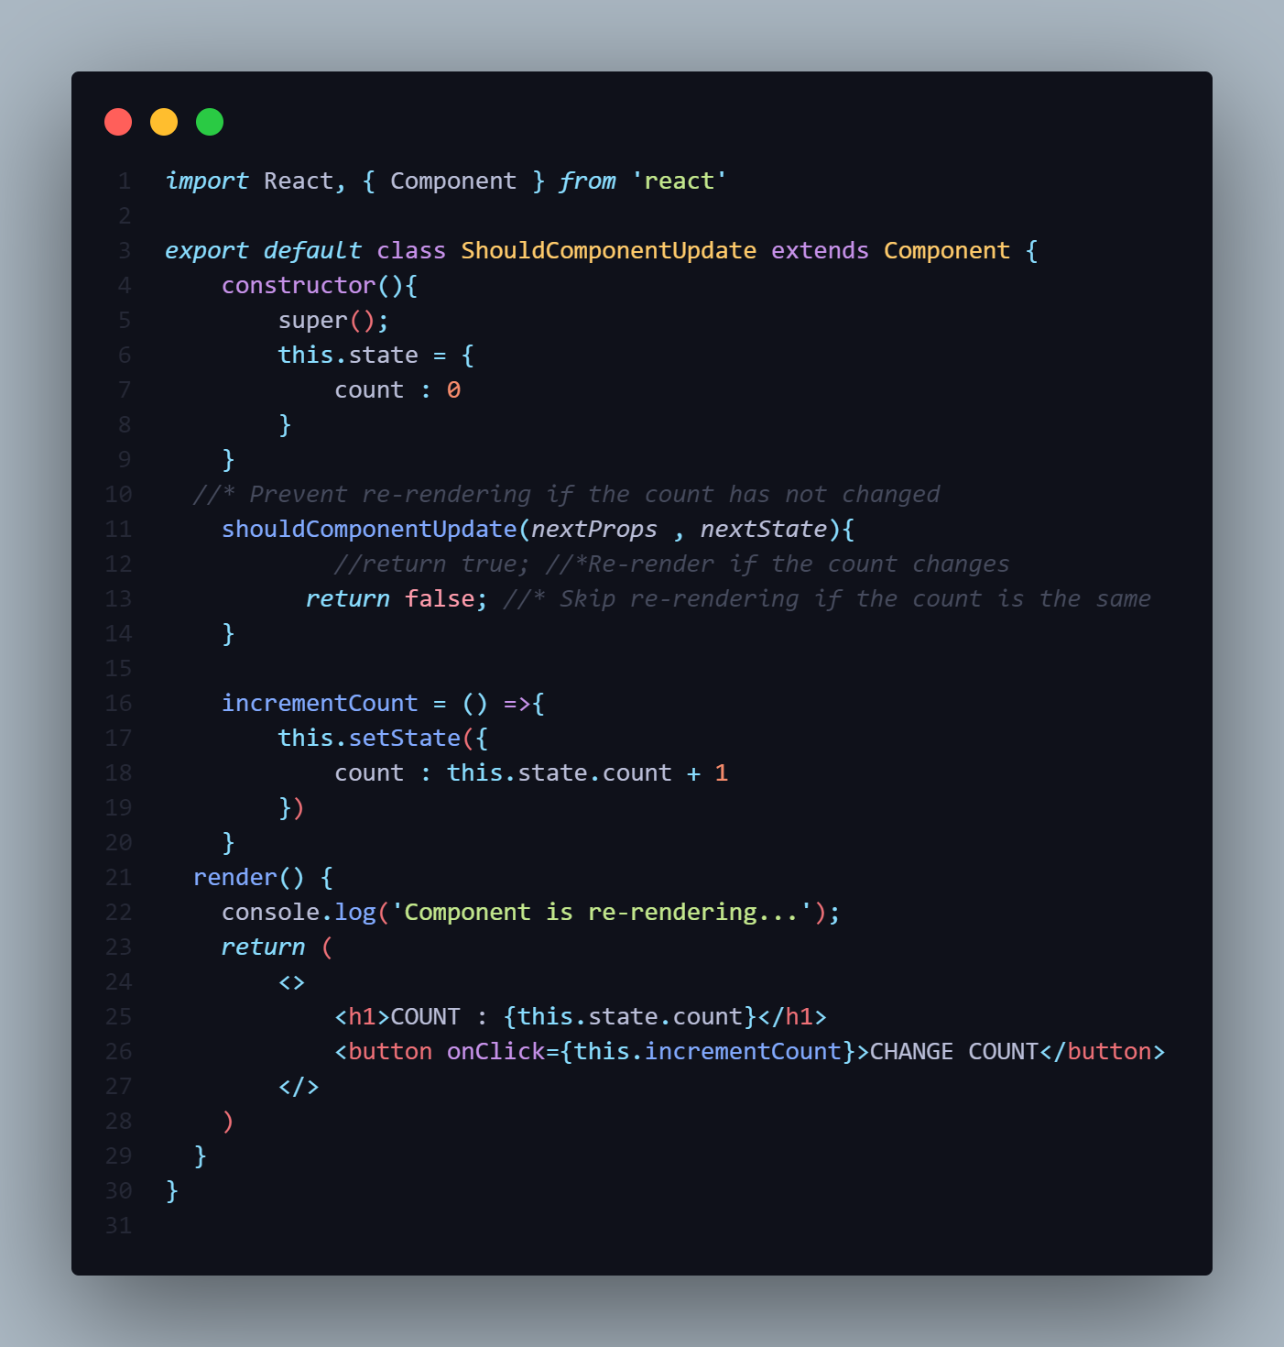

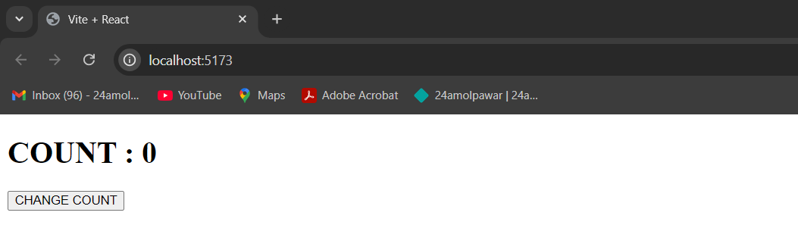

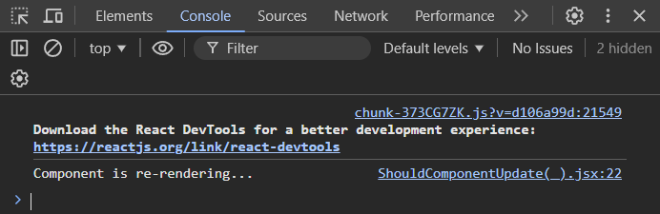

**When to Use:**

* Conditional Re-renders: Use shouldComponentUpdate when you need fine-grained control over when a component should re-render.
* Performance-Critical Components: For components that deal with heavy computations or large datasets, this method can help to optimize performance.

**================== NOTE =================**

-This method give us power that component is Re-render[Update] or Not.

* **true**: React will proceed with the re-rendering.
* **false**: React will skip the re-rendering process for that update.

**3]render()**

-The render() method is of course called when a component gets updated, it has to re-render the HTML to the DOM, with the new changes.

-The render() method is required, and is the method that actually outputs the HTML to the DOM.

* Executing render method gives React an idea of what needs to update on the actual DOM.
* React keeps a copy of Original DOM, we call it as virtual DOM.
* Changes happen on virtual DOM and in the end, React compares the virtual DOM with original DOM to update the latter.
* This method structures and prepares the jsx code to return to DOM
* Inside the render method, we can jsx code of child component.
* So Lifecycle method for child component will run at this point of time.
* Do not change or interact with DOM or make AJAX call.

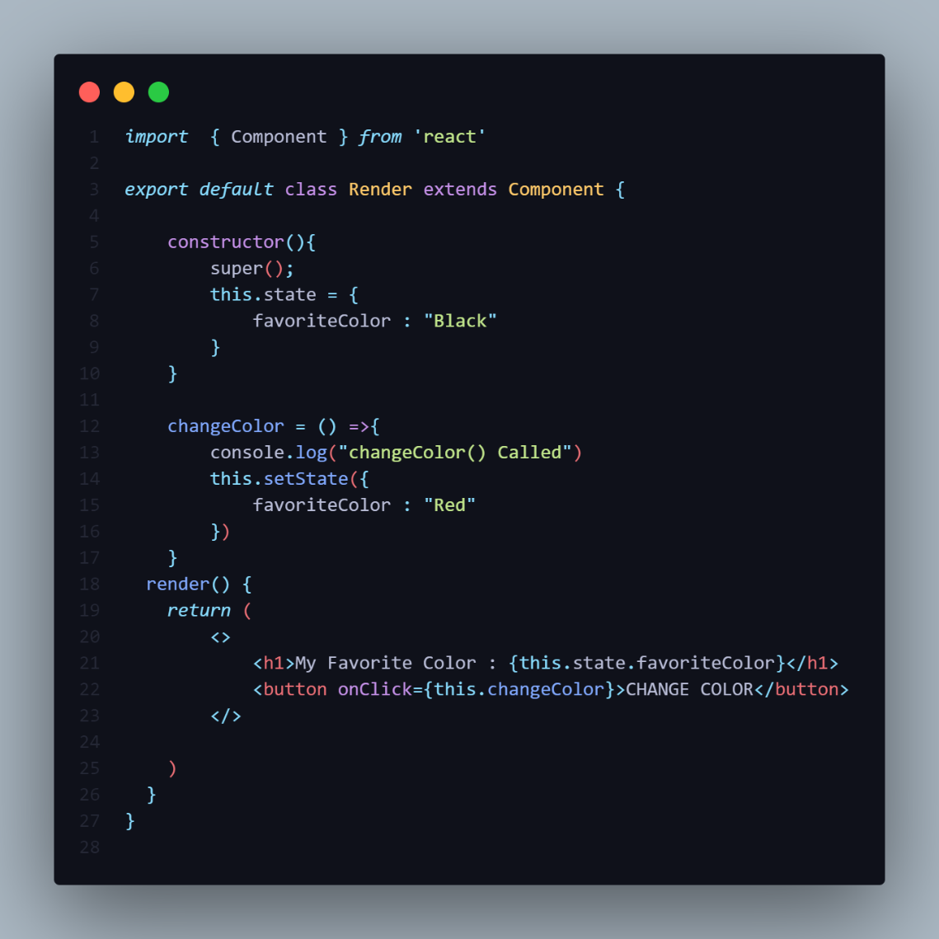

**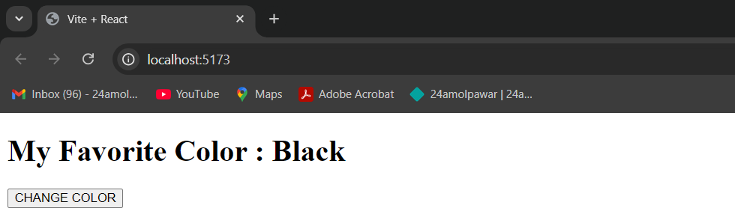**

**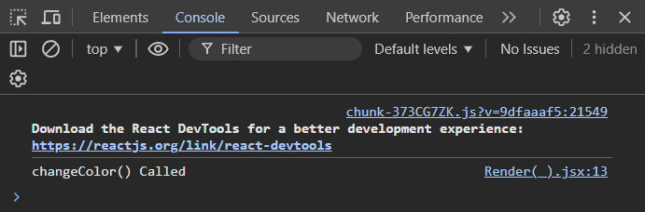**

-The render() method is used to display JSX on the Browser.

-In the above example you can see that First HTML is rendered on the browser.

-The If you define **changeColor()**  method that update the state of the object in the class.

-Then you added one button after that you handle the event using button.

-If you clickon that button the state of the Class is changes i.e from **Black**  to **Red** color.

-That means state ogf the class is updated then that time the **render()**  agains **Re-render**.

-As you see in the browser console whenever I clicked on that button then the render method is called each times.

**4]getSnapshotBeforeUpdate()**

-The getSnapshotBeforeUpdate() method is invoked just before the DOM is being rendered.

-It is used to store the previous values of the state after the DOM is updated.

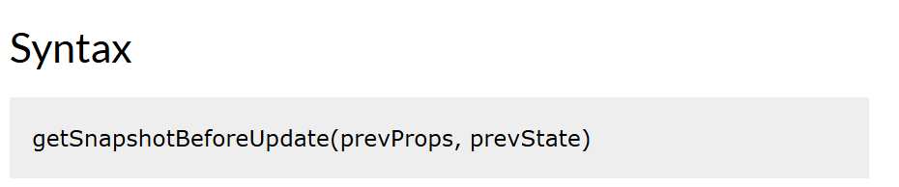

**UNMOUNTING**

-It is the phase where component is removed(destroyed) from node.

-The Unmounting Lifecycle method is called when a component being removed from the DOM.

-During Unmounting we just have one methods.

**1]ComponentWillUnmount()**

-This method is invoked immediately before a component is unmounted and destroyed.

-In this method you can perform some clean up task like **Cancelling any network requests**, **removing event handlers**, **cancelling any subscription** and also invalidation timers in setTimeout() or setInterval().

-Do not call setState() method. Because the component will never be re-rendered.

**ERROR HANDLING**

-The Error-Handling Lifecycle methods being called when there is a error during re-rendering in Lifecycle method or in the Constructor of any child component.

-During Error Handling phase we have two methods.

**1]static getDerivedStateFromError()**

**2]ComponentDidCatch()**

**Pure Component**

-In React, a pure component is a class component that extends React.PureComponent instead of React.Component.

-PureComponent provides a performance optimization over regular components.

-It provides a built-in implementation of the shouldComponentUpdate() lifecycle method that performs a shallow comparison of the component's current props and state with the next props and state.

-We have a lifecycle method called shouldComponentUpdate which by default returns true (Boolean) value.

-The purpose of the shouldComponentUpdate is we can custom implement the default behavior and decide when react should update or re-render the component.

-When working with React pure components, we can utilize their behavior to optimize behavior as pure components automatically handle the shouldComponentUpdate() method and we don’t need to explicitly implement it.

How it works:

* **Shallow comparison:**

A pure component compares the values of its props and state by checking if they are the same reference. If the references are the same, it assumes that the data hasn't changed and skips the re-render.

* **Performance optimization:**

By preventing unnecessary re-renders, pure components can improve the performance of your application, especially when dealing with large component trees or frequent updates.



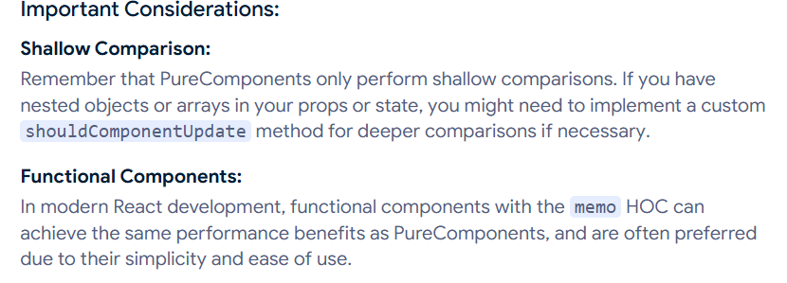

**EXAMPLE NO 1:-**

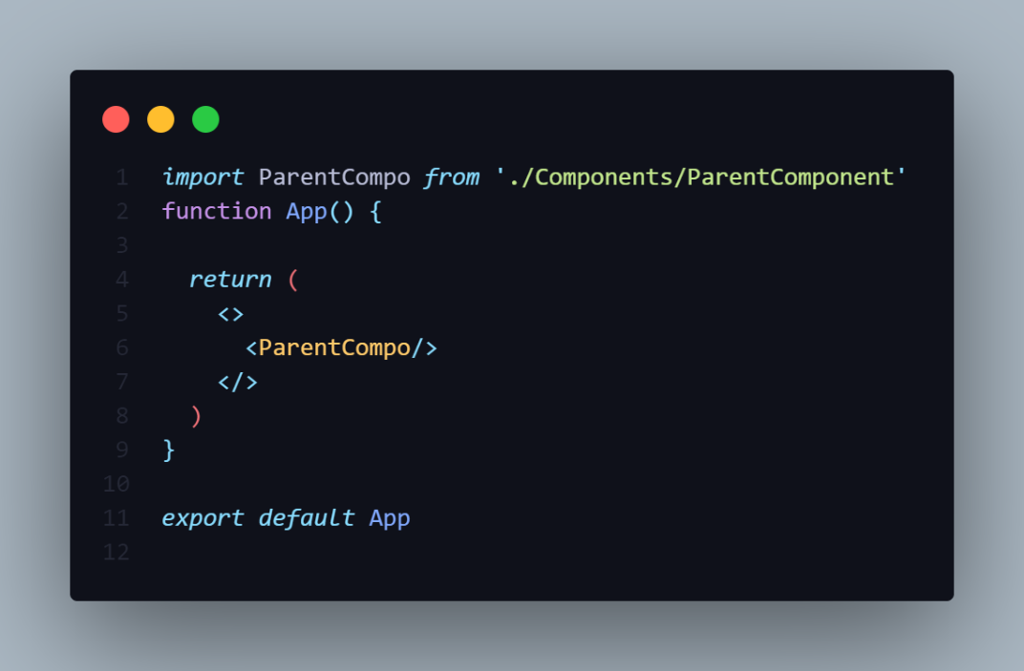

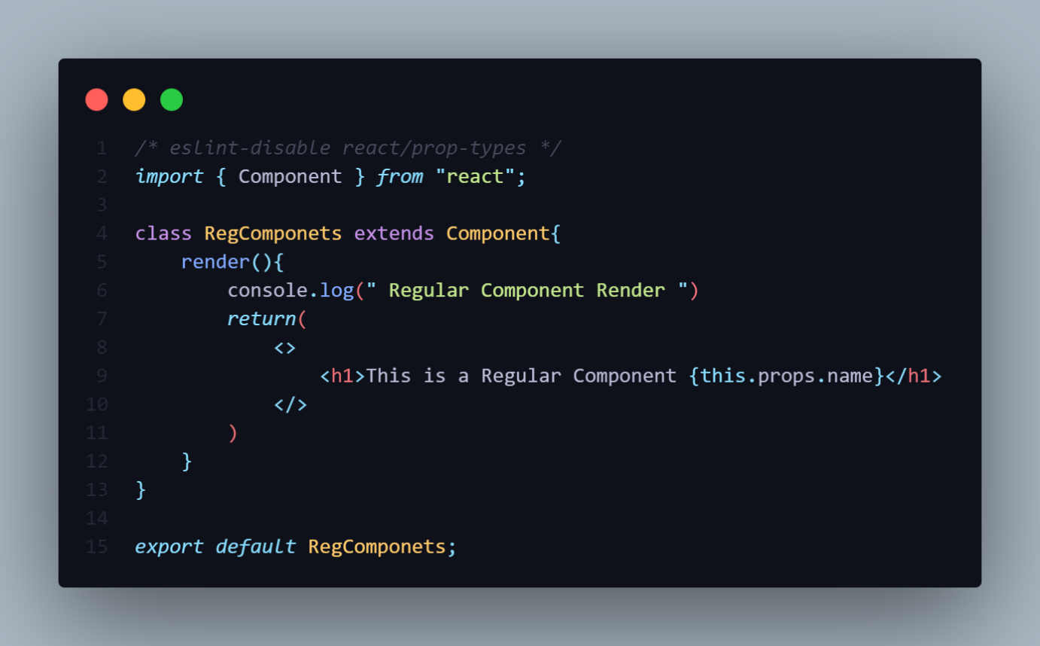

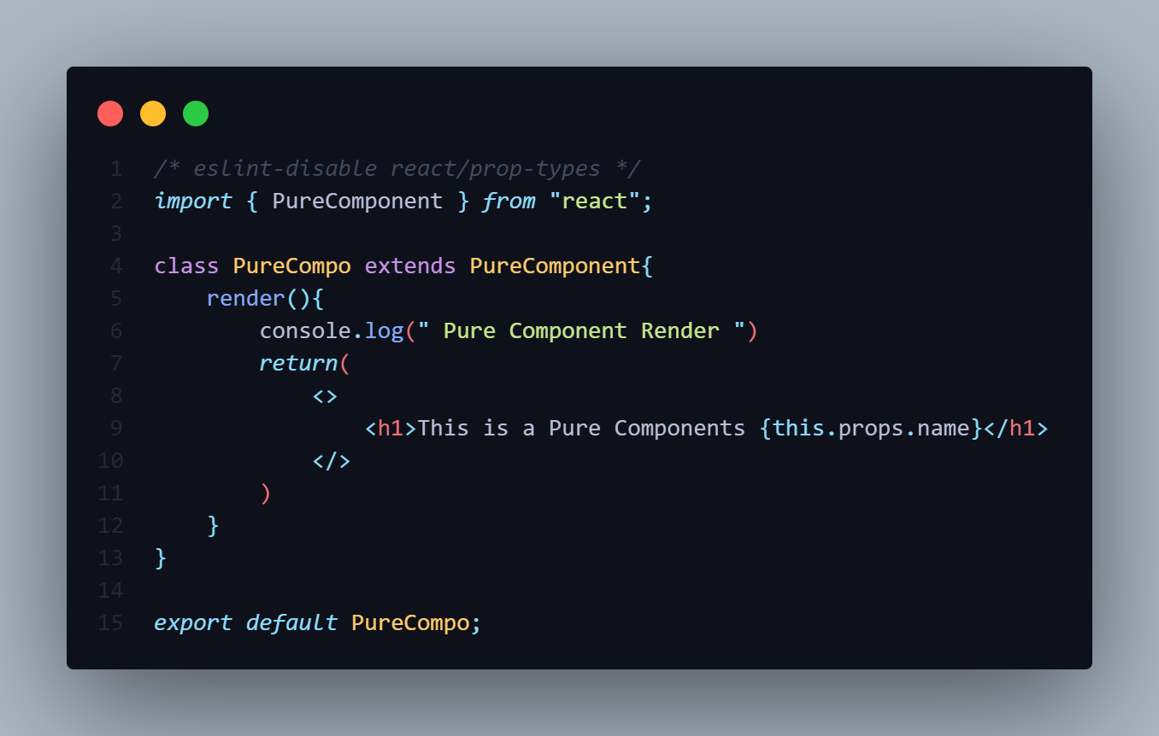

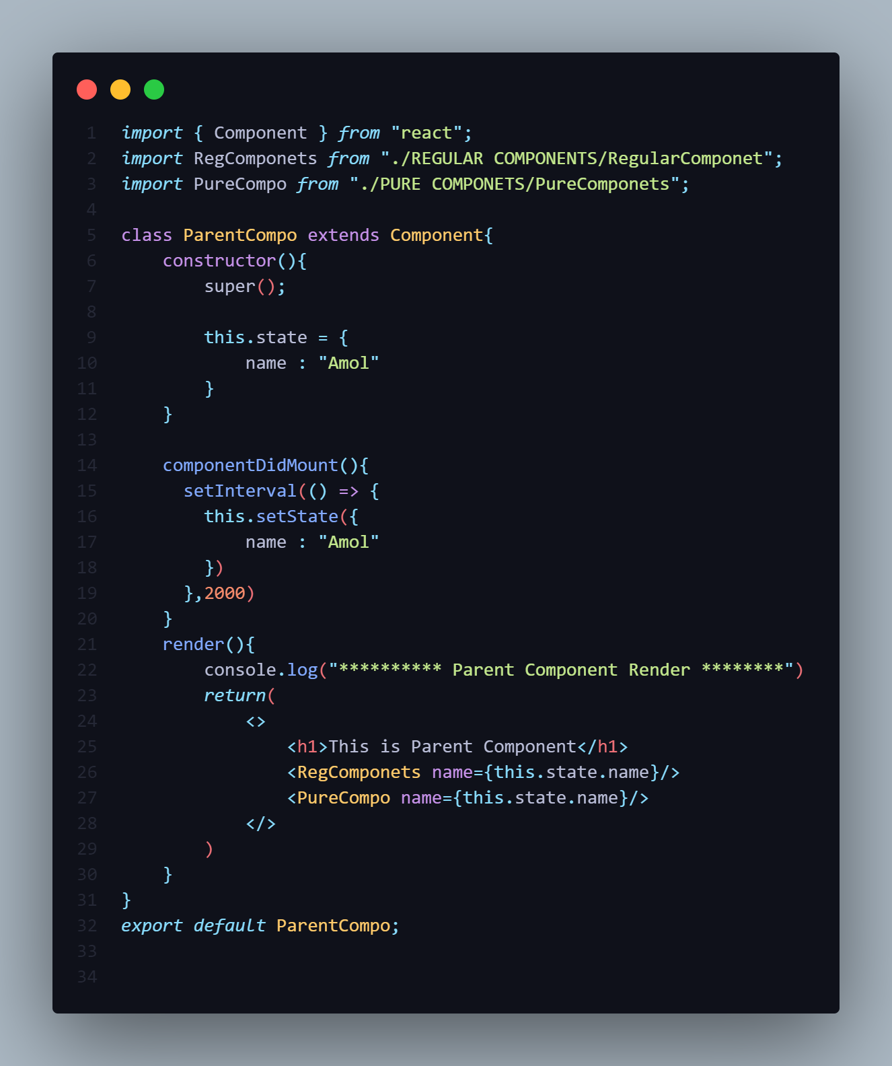

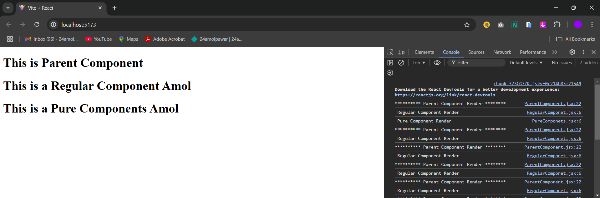

-In the above example the **Regular** **Component** and **Parent** **Component** re-renders **infinitely** but the Pure Component only once render it does not re-render **infinitely**.

-So it prove that in the Pure component provides a built-in implementation of the **shouldComponentUpdate()** lifecycle method that performs a shallow comparison of the component's current props and state with the next props and state.

-So the Pure Component prevent from unnecessary re-renders.

The main difference between regular components and pure components in React is how they handle re-rendering:

* **Regular components**

Re-render by default when their props or state change. This can lead to performance issues, especially in applications with frequent state updates. Regular components may require manual implementation of the shouldComponentUpdate method.

* **Pure components**

Automatically compare props and state to determine if they need to re-render. This prevents unnecessary re-renders and improves performance, especially in large and complex component trees. Pure components implement the shouldComponentUpdate method automatically.

**Difference between Pure Component and Regular Component**

|  |  |  |
| --- | --- | --- |
| SrNo | Regular Component | Pure Component |
| 1 | A regular component does not implement the shouldComponentUpadate() method. It always return the true by default. | A pure component on the other hand implements shouldComponentUpadate() with a shallow props and state comparision. |

**SHALLOW COMPARISON?**

-In React, shallow comparison is a technique used in Pure Components to compare props and state to determine if a re-render is necessary

* **How it works**

Shallow comparison compares the values of primitive types and the references of object types. It checks if the new props and state are the same as the old ones.

* **Benefits**

Shallow comparison can lead to significant performance boosts, especially in larger applications. This is because it prevents unnecessary re-renders, which can happen when a single change triggers a cascade of re-renders across many components

**Comparison with regular components**

Regular components might re-render even if props or state don't change. This can lead to potential performance issues

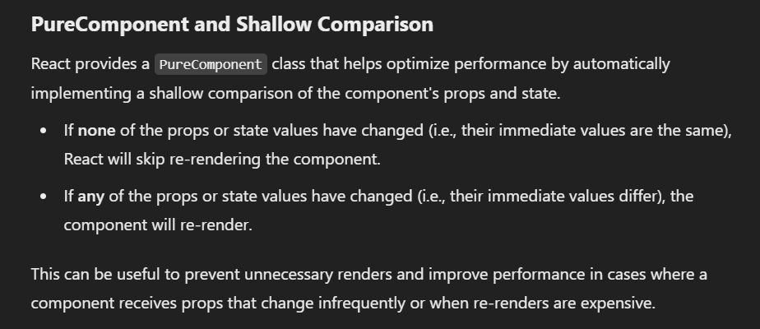

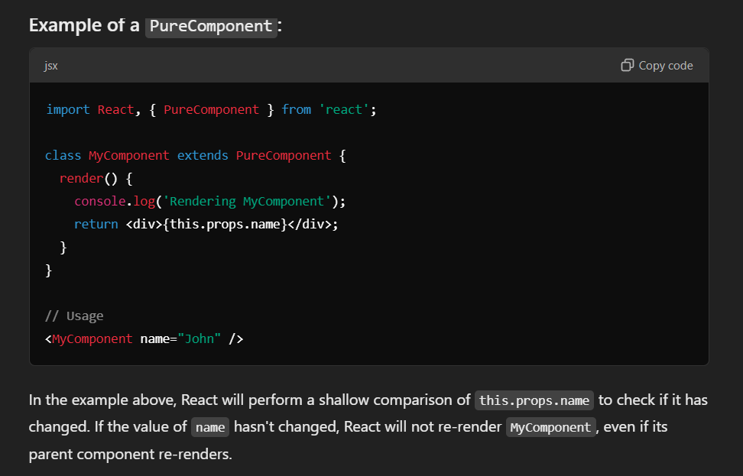

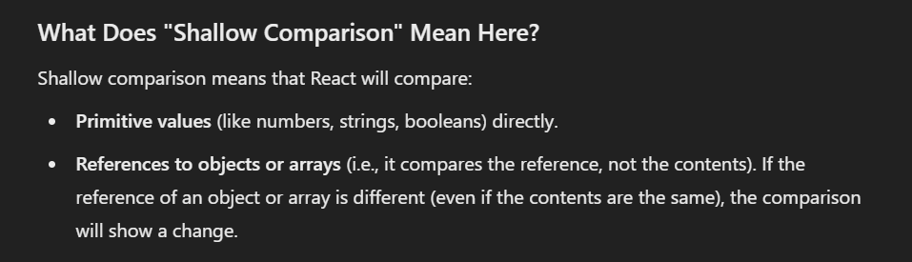

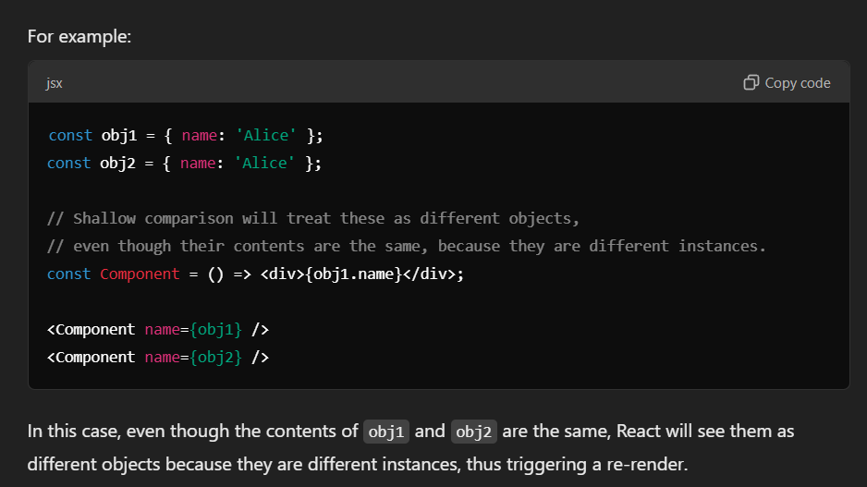

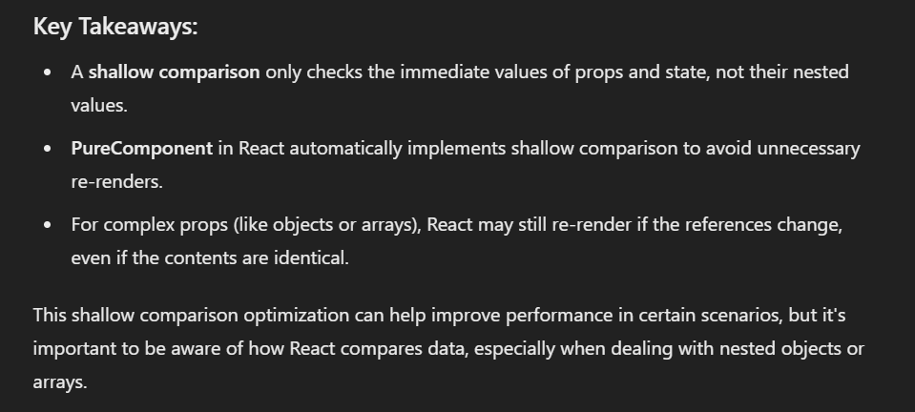

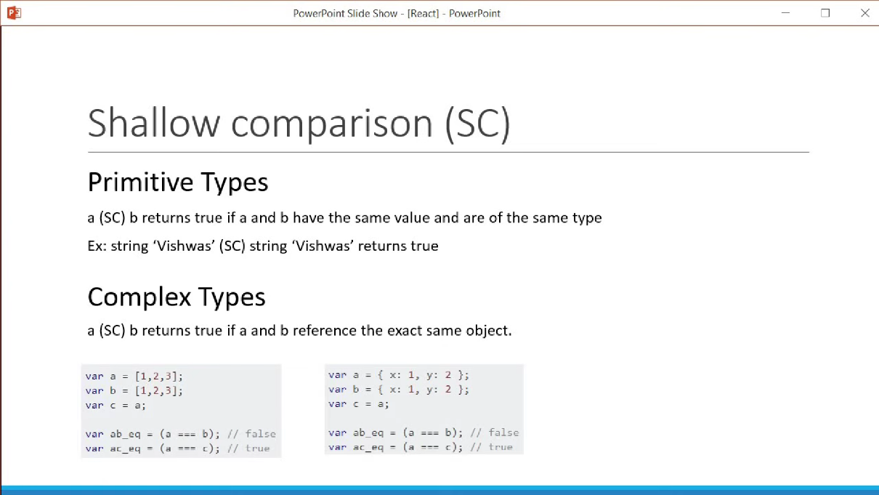

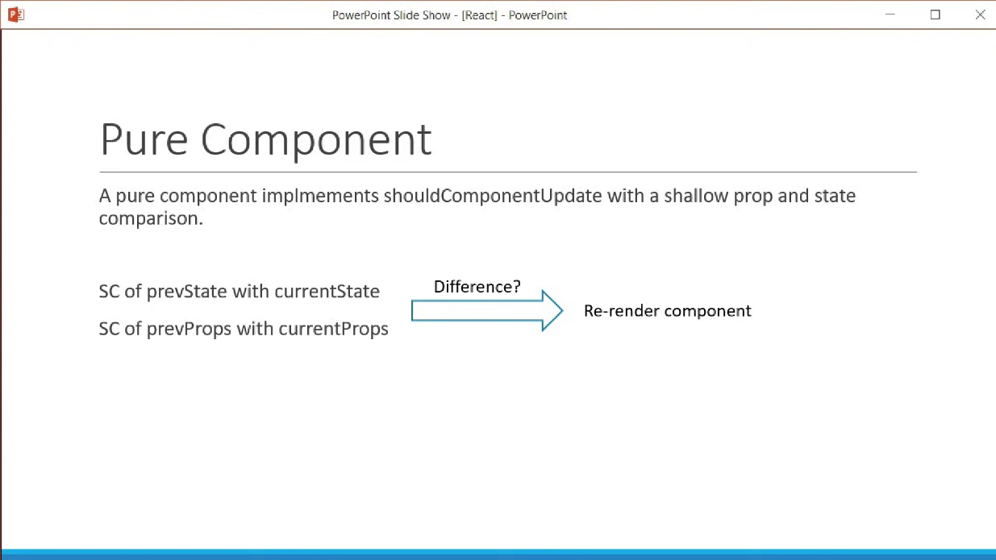

**MEMO**

-In ReactJS, memo is a higher-order component (HOC) that helps optimize the performance of your components by preventing unnecessary re-renders.

-We have React.PureComponent as well which can do shallow comparison of state and props. But in functional component we don’t have such methods.

-Now, React has provided a memo method which will do the same functionality for the functional components.

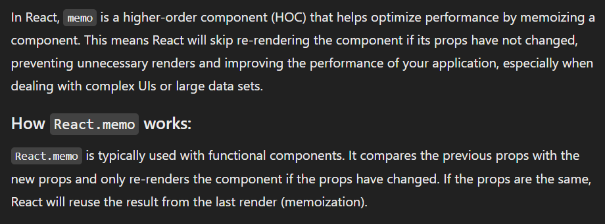

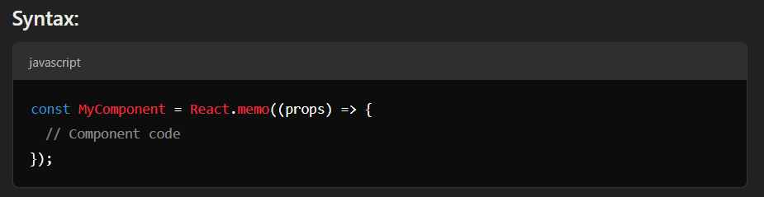

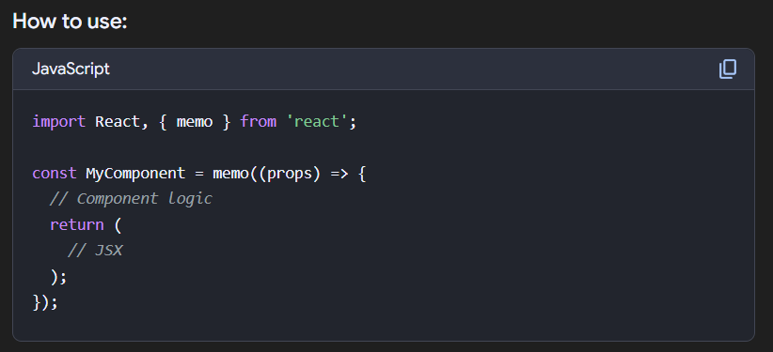

**FOR EXAMPLE**

**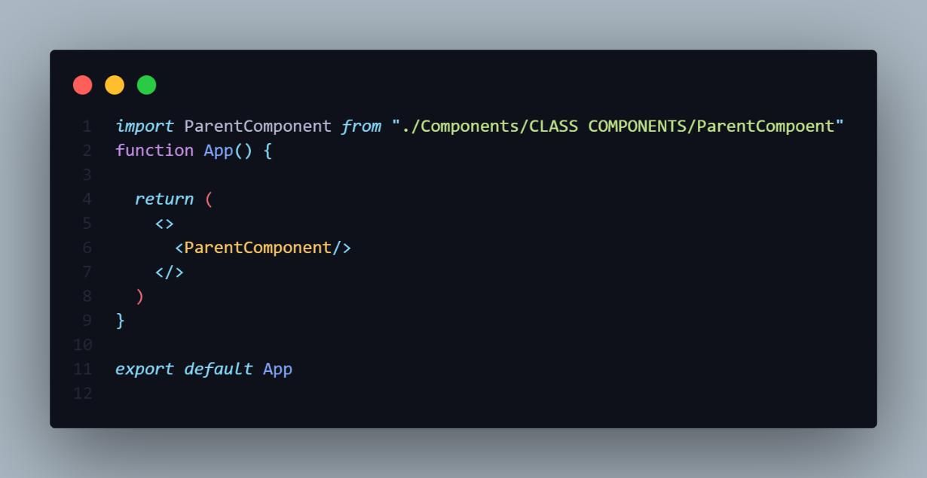**

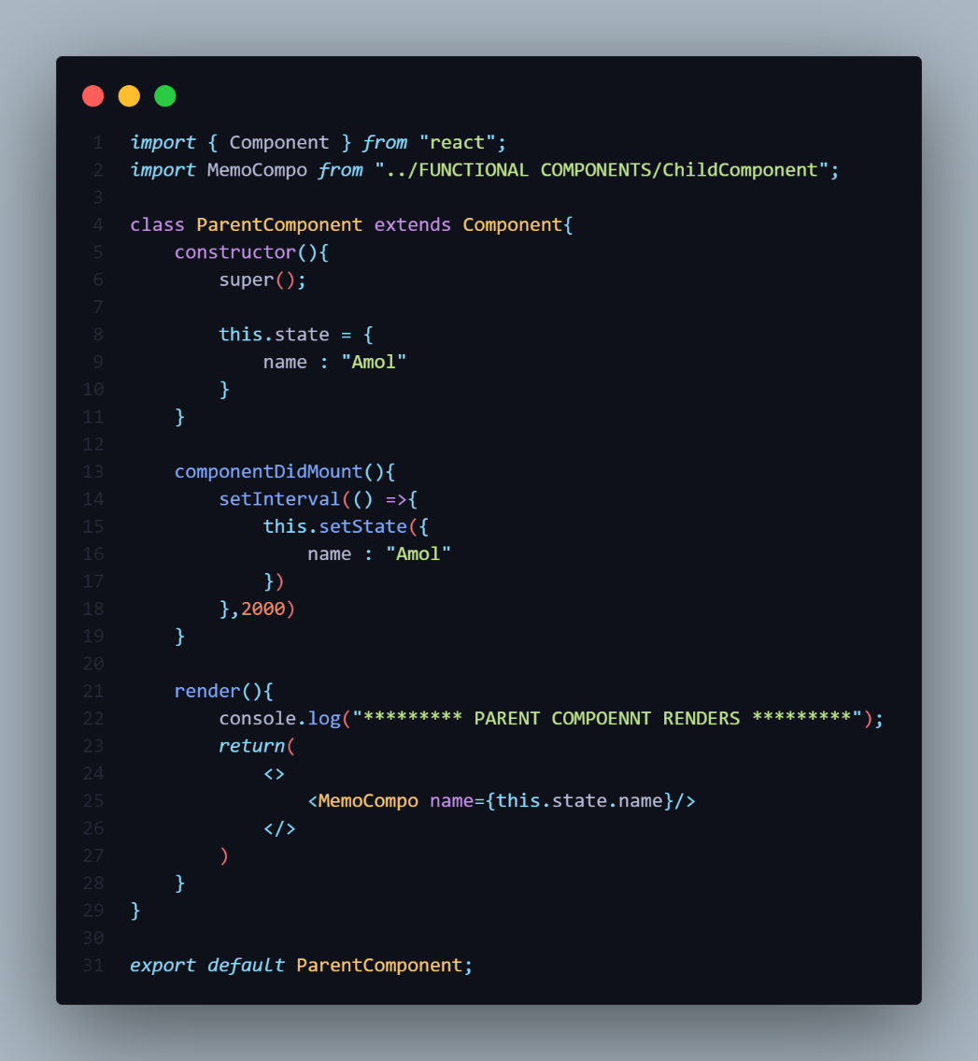

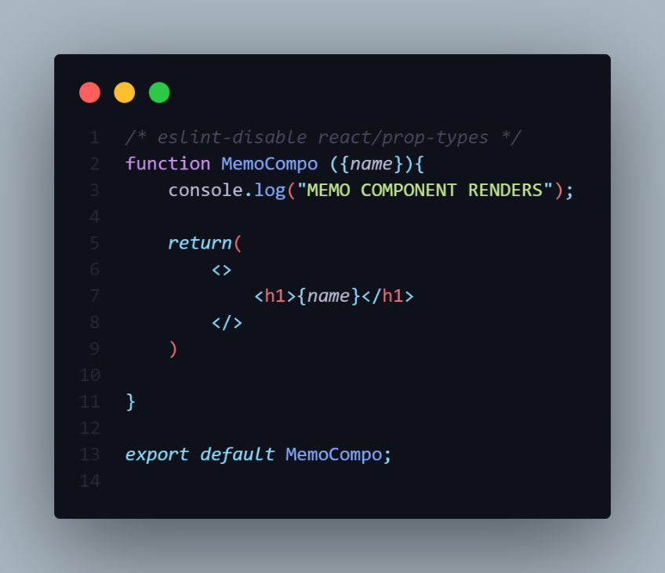

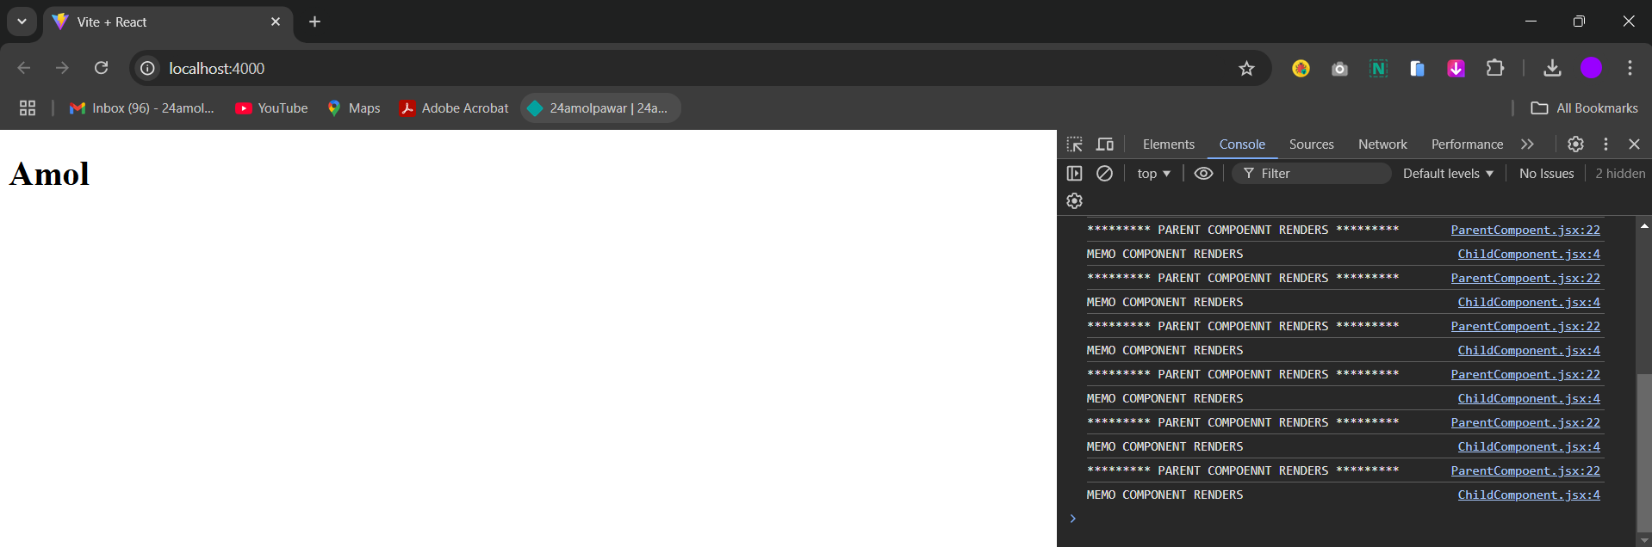

-In the above code the Functional Component i.e **MemoCompo** re-renders unwantedly.

-To Prevent of re-rendering of Functional Component we use **React.Memo()** method.

**=================NOTE===================**

**React.Memo()** is not a function it is a method that accepts the Functional Component as an Argument.

**I]**You can also declare the Functional Component like above in the **React.Memo()**.

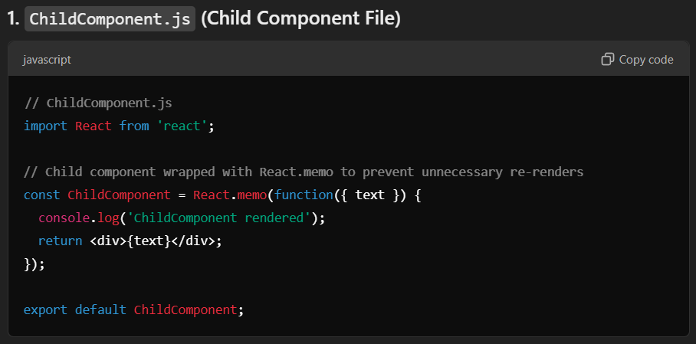

**ii]**We can directly pass the Functional Component in the **React.Memo()**.

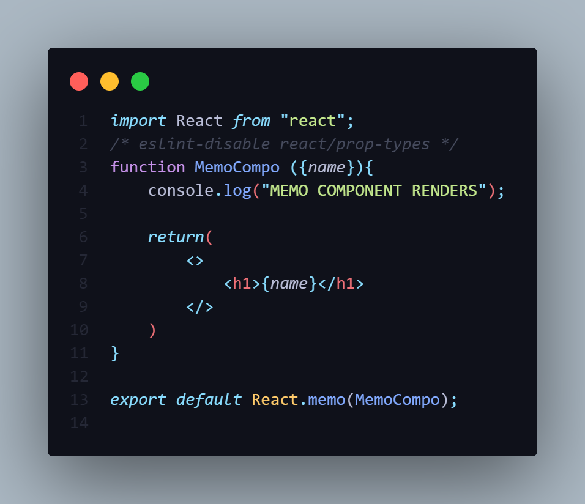

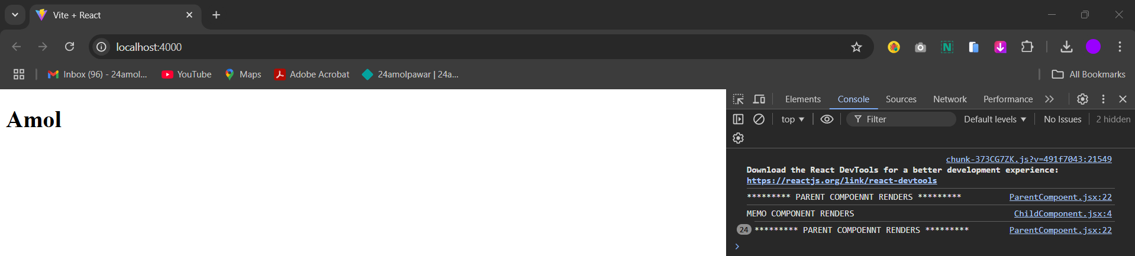

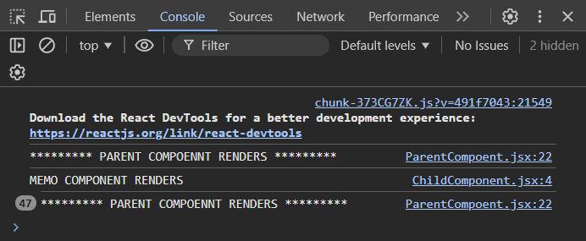

-So now you can see the Output in the browser the Parent Component will Only Re-renders the Functional Component does not Re-renders.

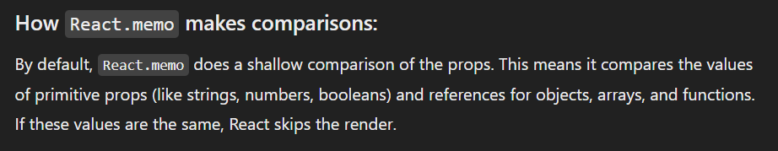

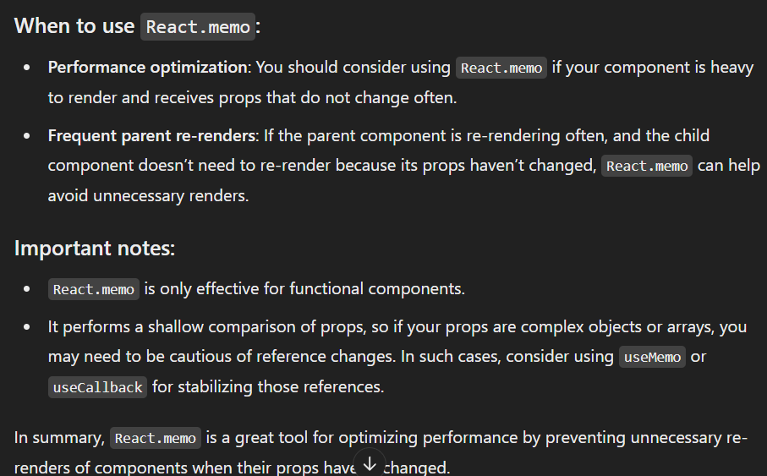

**REFS**

-Refs in React provide a way to directly access and interact with DOM elements or React components. They are often used to:

1. **Manage focus, text selection, or media playback.**
2. **Trigger animations.**
3. **Integrate third-party libraries that require DOM manipulation.**

-In Class Component we can create Refs **React.CreatRefs()** method.

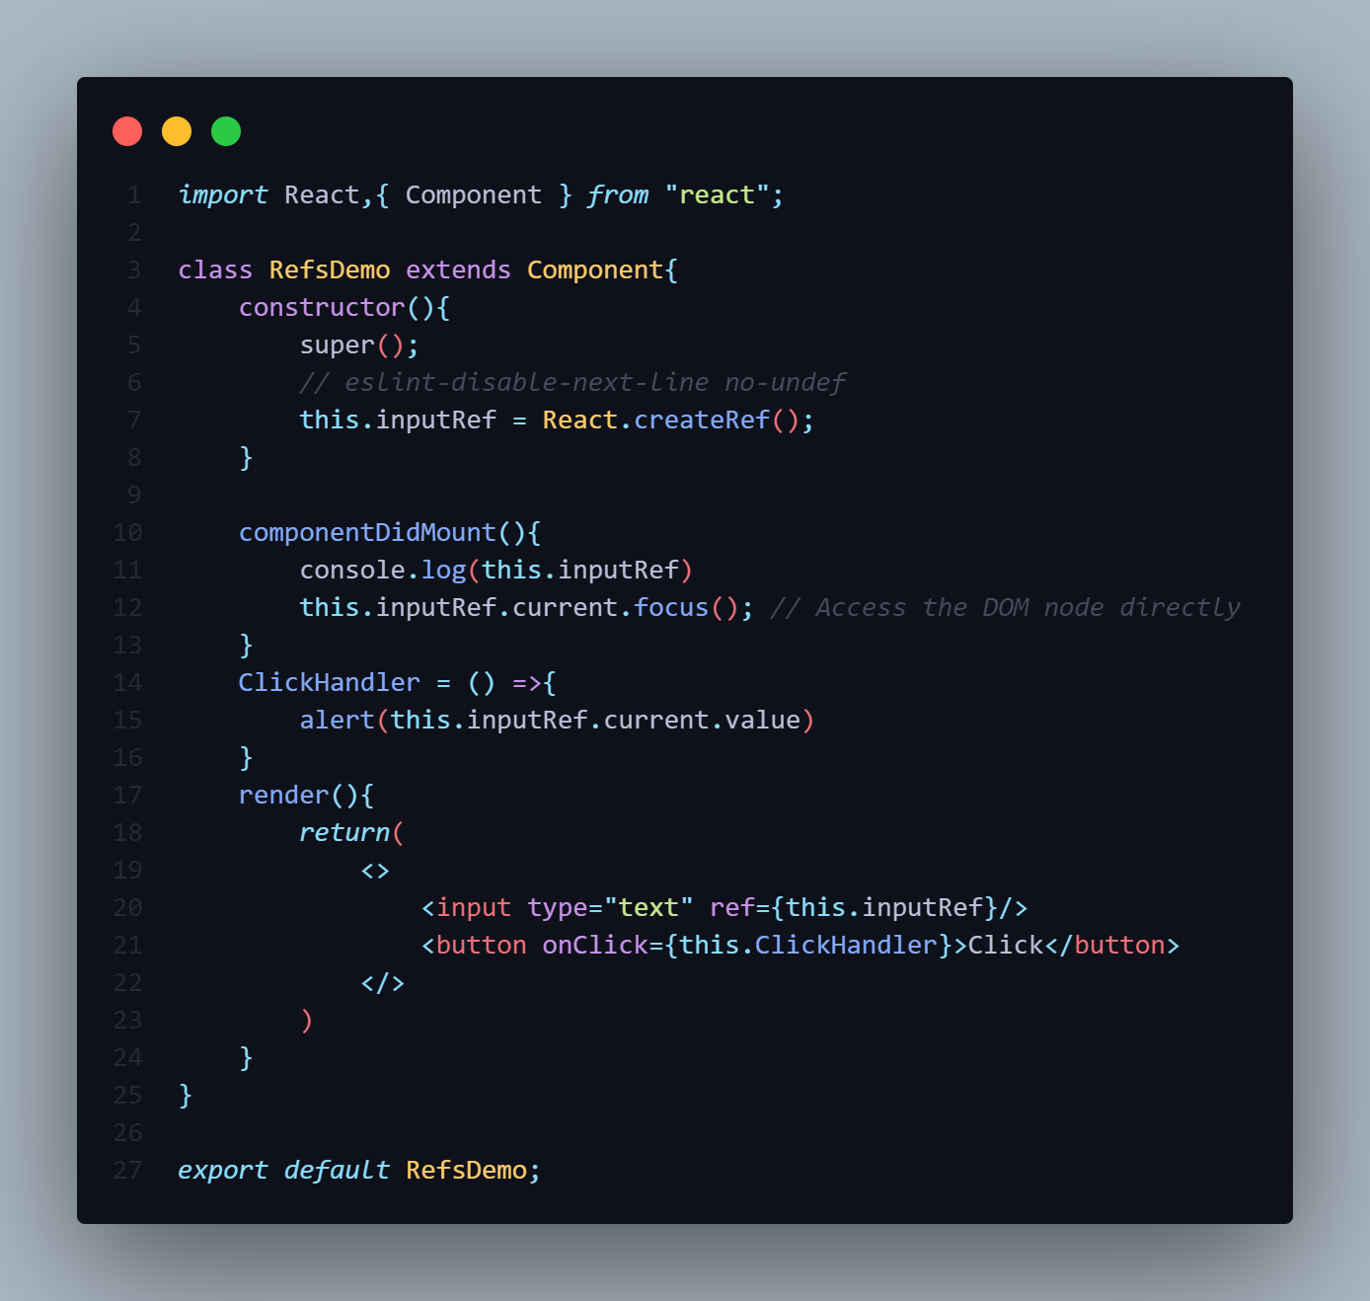

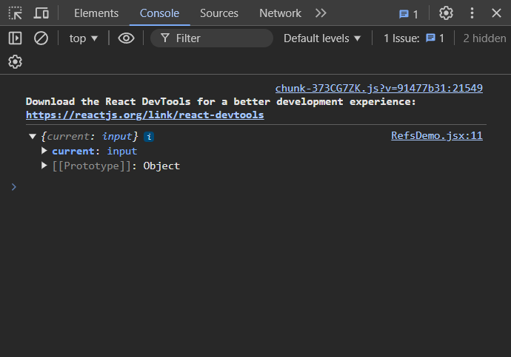

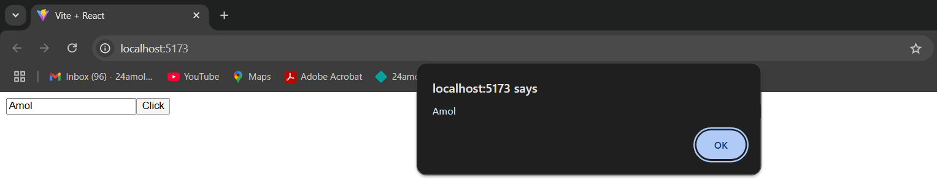

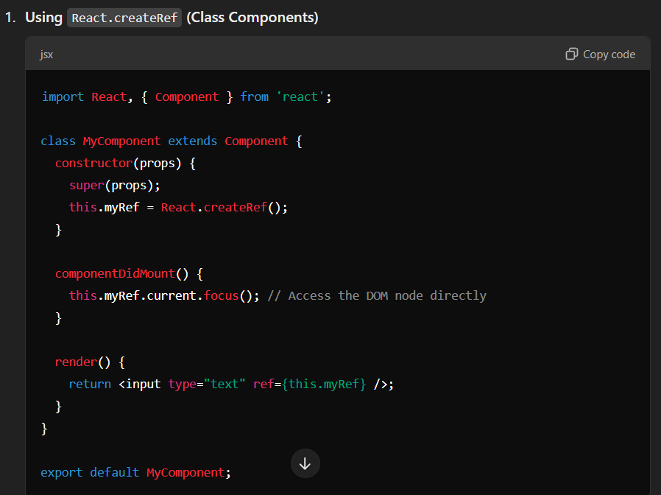

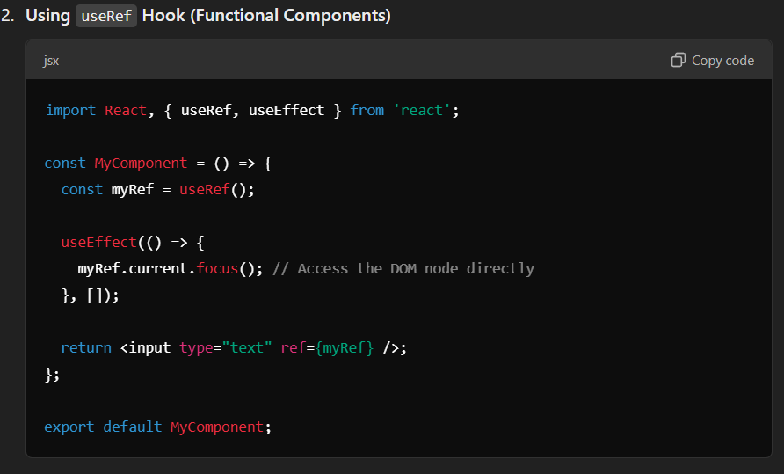

**REFS FORWARDING**

**PROPS DRILLING**

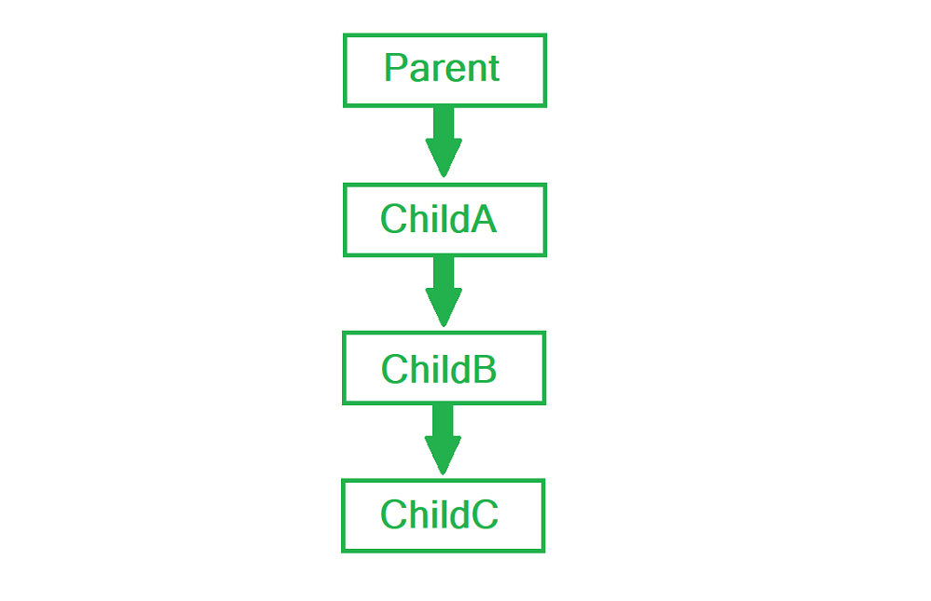

**CONTEXT API**

1]Create

2]Provide

3]Consume

**HIGHER OREDR COMPONENT [HOC]**

-Higher Order Component [HOC] is a Pattern where a Function takes a component as an argument and return a new Component.

-Higher component is used for to share the common functionality between the components.

-Higher order components are JavaScript functions used for adding additional functionalities to the existing component. These functions are **pure**, which means they are receiving data and returning values according to that data. If the data changes, higher order functions are re-run with different data input

-If we want to update our returning component, we don't have to change the HOC. All we need to do is change the data that our function is using.

-**Higher Order Component** (HOC) is wrapping around "normal" component and provide additional data input. It is actually a function that takes one component and returns another component that wraps the original one.

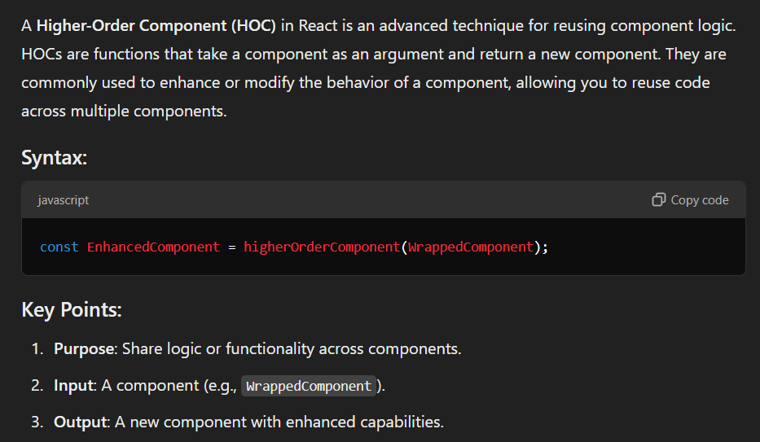

**NEED OF HIGHER ORDER COMPONENT**

**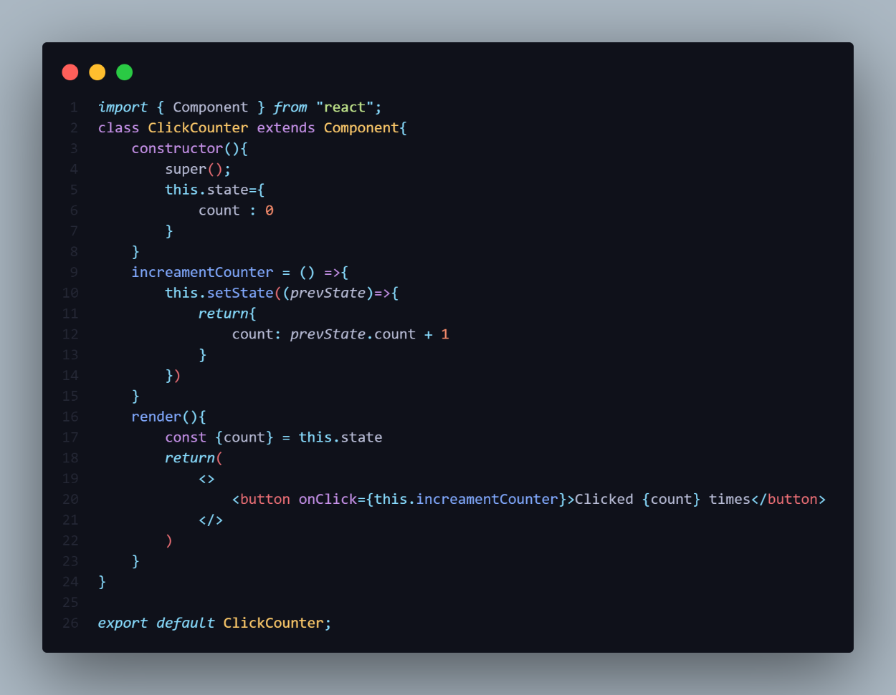**

**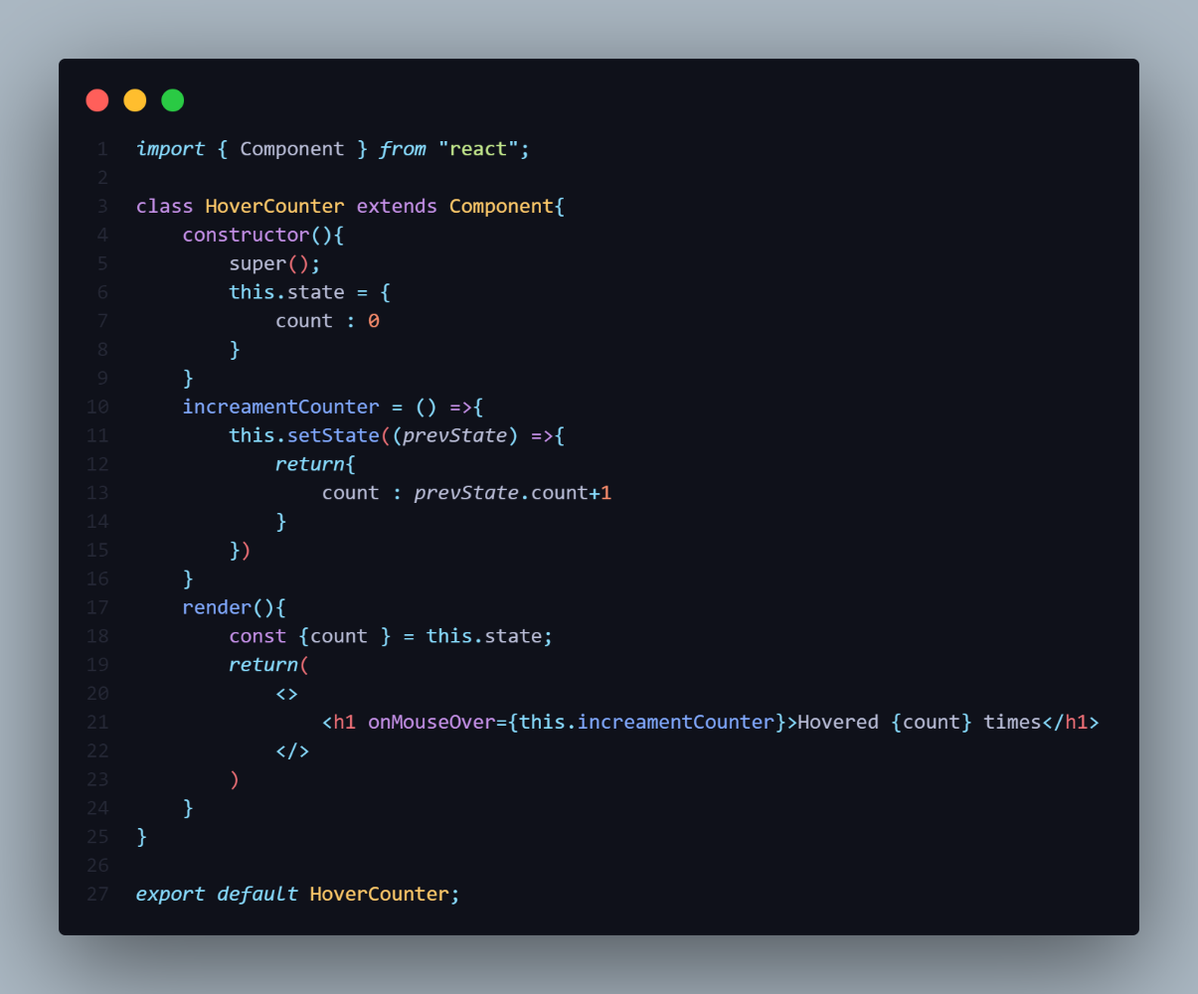**

**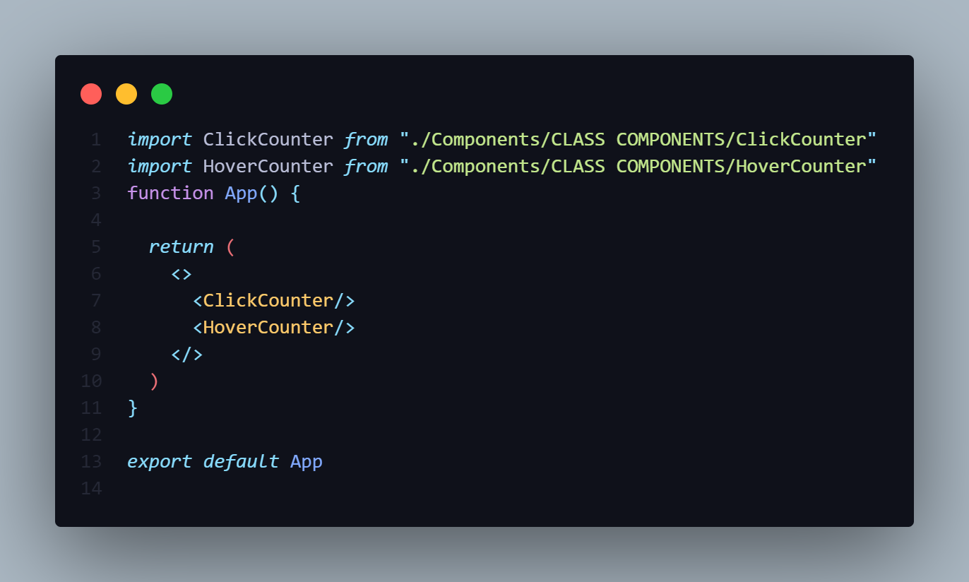**

**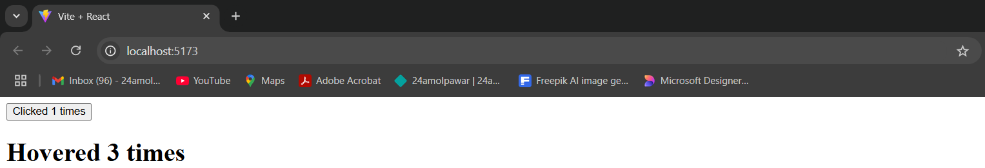**

-So in the both the file Logic is common mean there is a common functionality.

-So Using HOC we can reduce the re-writing of code for different files.

-Using HOC we can share the common functionality to the Component.

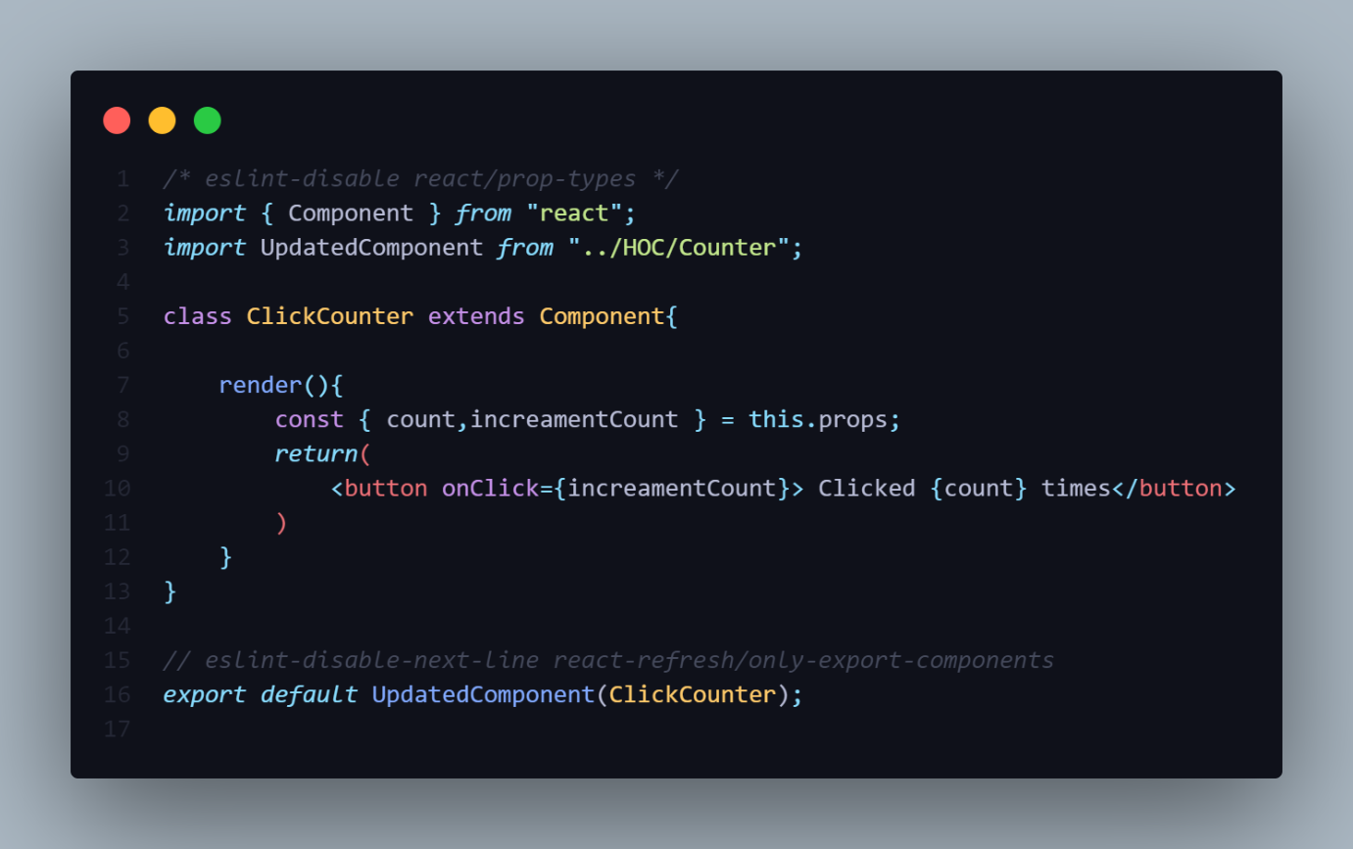

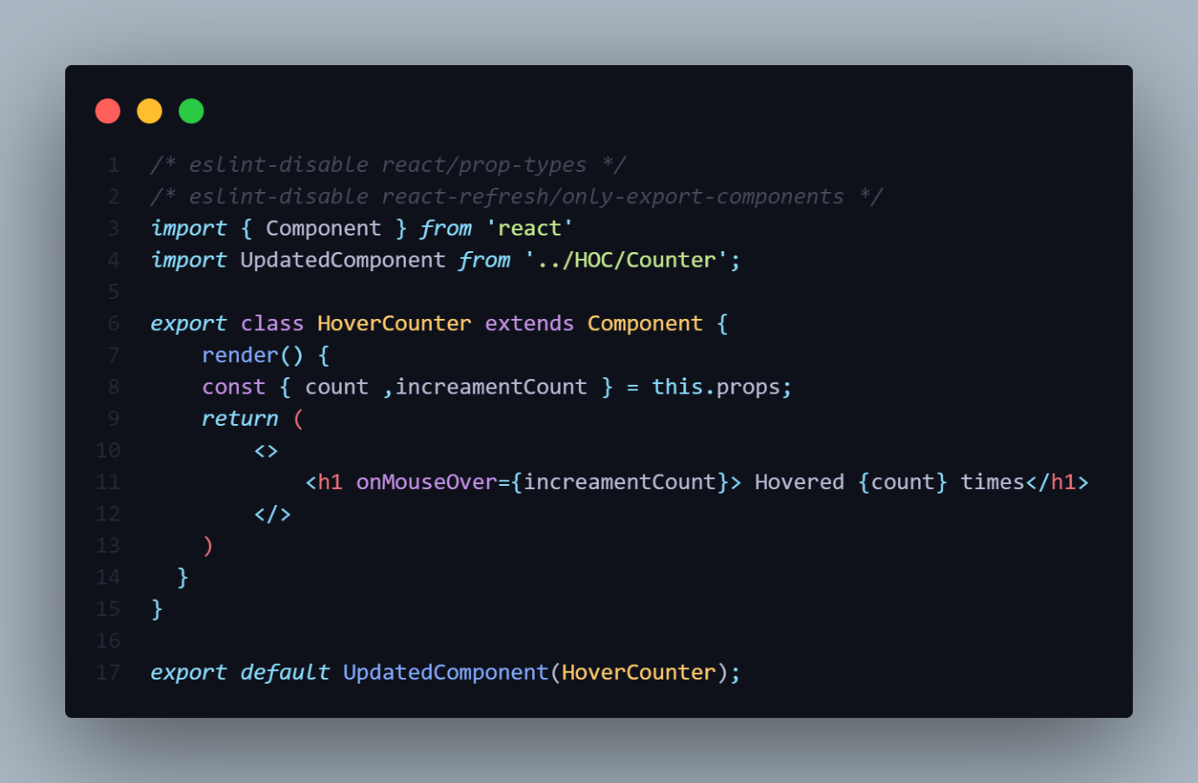

**HIGHER ORDER COMPONENT [HOC]**

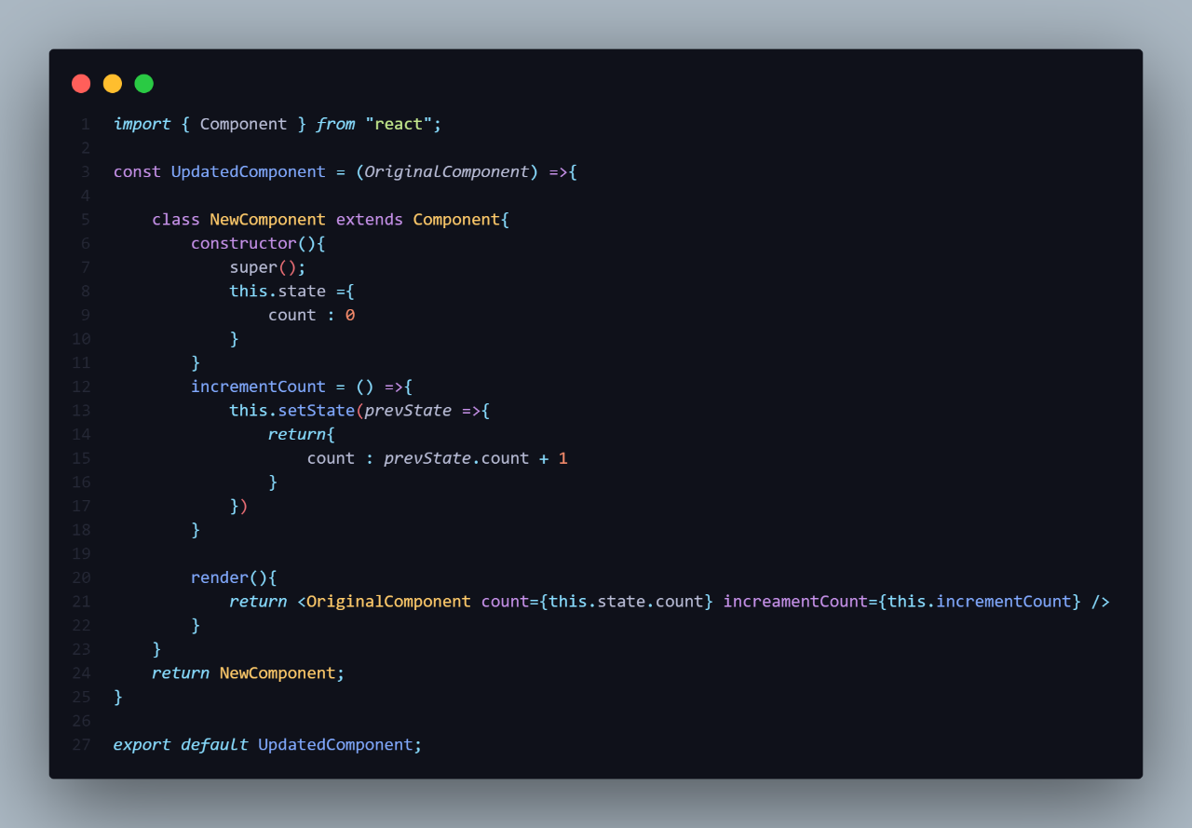

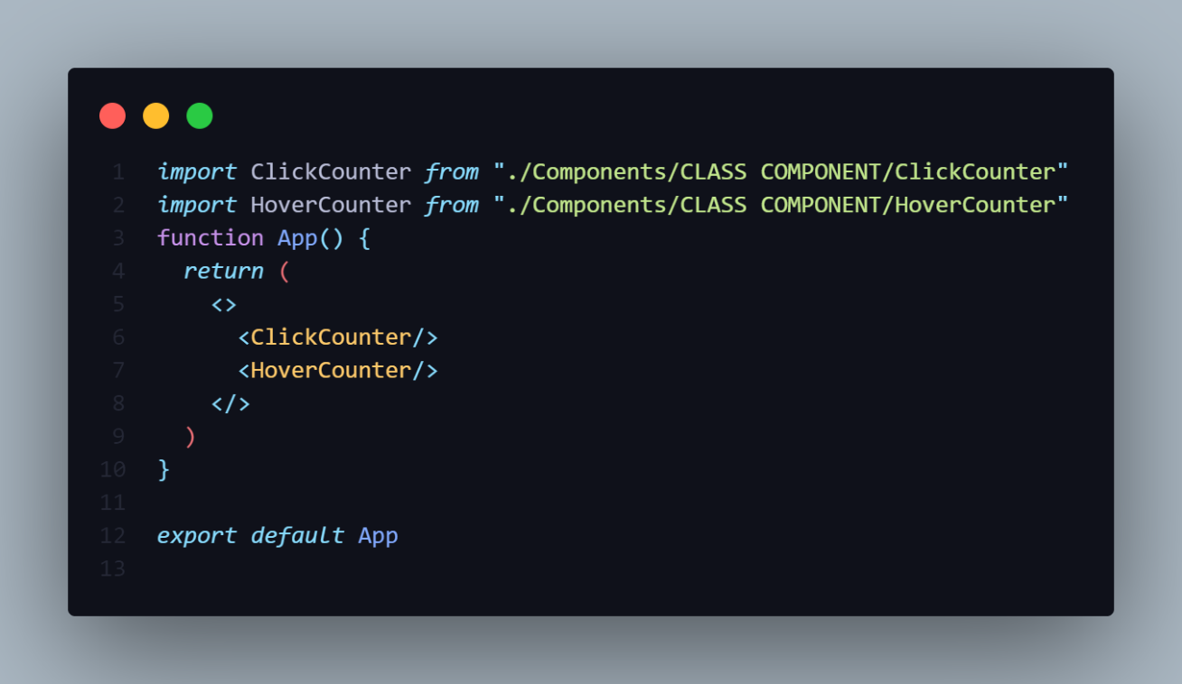

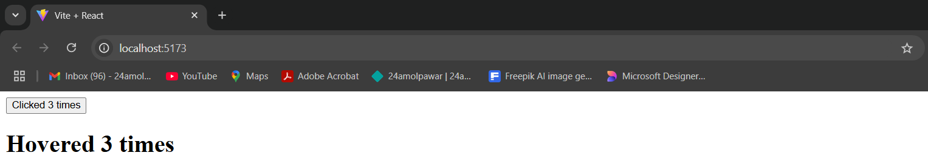

**HOOKS**

-Functions whose names start with **use** are called [*Hooks*](https://react.dev/reference/react) in React.

-Hooks allow function components to have access to state and other React features-

-Hooks are the new feature which allow you use to State and other React features without having a write a class[Inside the Functional Component].

-Hooks are introduced in React 16.8 version.

**Why Hooks?**

**Reason Set 1**

1]Understand how **this** keyword works in Javascript.

2]Remember to bind **Event Handler** in class Component.

3]Class don’t minify very well and make hot reloading very unreliable.

**Reason Set 2**

1]There is no particular way to reuse stateful component logic.

2]HOC and render props pattern do address this problem.This Make the Code harder to follow.

3]There is need to share stateful logic in better way/

**Reason Set 3**

1]Create component for complex scenarios such as data fetching and subscribing to events related code is not organized in one place.

**Ex-**Data Fetching – In component DiMount And Component DidUpdate.

**Ex-**Event Listener – In component DidMount and Component Will UnMount

-Because of Stateful logic cannot break Components into smaller ones.

**IMPORTANT POINTS**

1]Need React Version 16.8 or higher.

2]Hooks don’t contain any breaking changes and the release is 100% backwards-comptible.

3]Classes won’t be removed from react.

4]We cannot use Hooks inside of a class.

5]Hooks don’t replace your existing knowledge of React concepts.

Instead,Hooks provide a more direct API to the React concepts you already Know such as Props,states,Context,Lifecycle.

-There Two Types Of Hooks

**1]PreBuid Hooks**

* useState()
* useEffect()
* useRef()
* useCallback()
* useContext()
* useReducer()
* useId()

**2]Custom Hooks**

**RULES**

-**Don’t call Hooks inside loops, conditions, or nested functions.** Instead, always use Hooks at the top level of your React function, before any early returns.

1]You Must import Hook From React.

2]Hook can declare inside the React Functional Component.

* ✅ Call them at the top level in the body of a [function component](https://react.dev/learn/your-first-component).
* 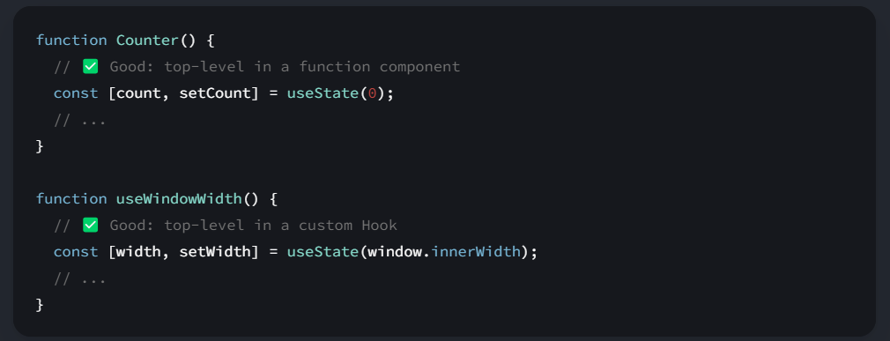✅ Call them at the top level in the body of a [custom Hook](https://react.dev/learn/reusing-logic-with-custom-hooks).

-It’s **not** supported to call Hooks (functions starting with use) in any other cases, for example:

* 🔴 Do not call Hooks inside conditions or loops.

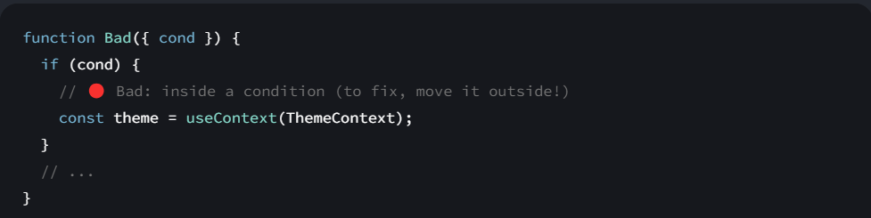

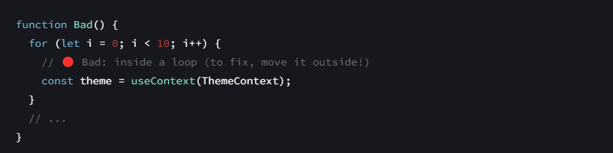

* 🔴 Do not call Hooks after a conditional return statement.

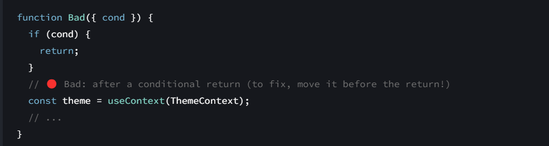

* 🔴 Do not call Hooks in event handlers.

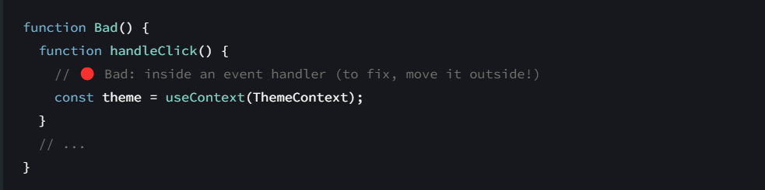

* 🔴 Do not call Hooks in class components.

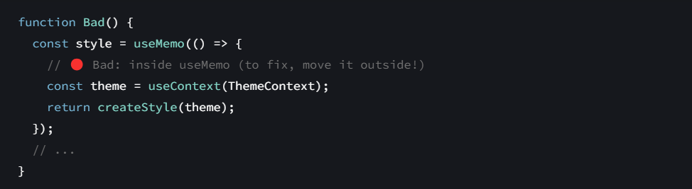

* 🔴 Do not call Hooks inside functions passed to useMemo, useReducer, or useEffect.

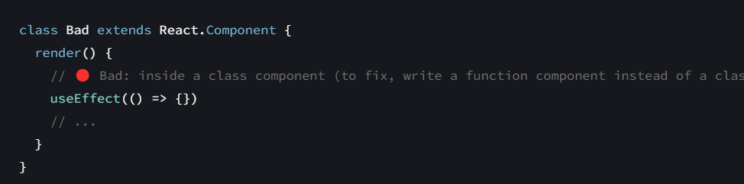

**1.useState()**

-The useState hook is one of the fundamental hooks in React, allowing you to add state to functional components.

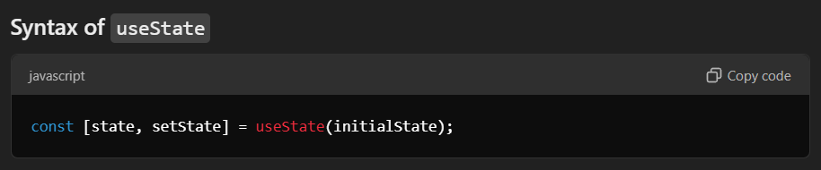

* **state**: The current value of the state.
* **setState**: A function used to update the state.
* **initialStat**e: The initial value for the state when the component is first rendered.

-useState hook is responsible to change the State means Data.

-This change does not means update the value it means to reflect the changes in data in UI.

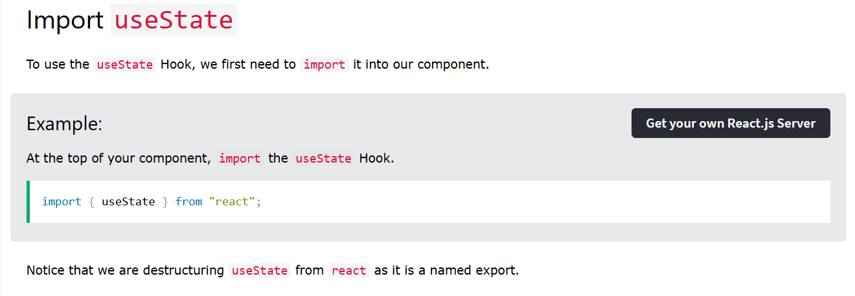

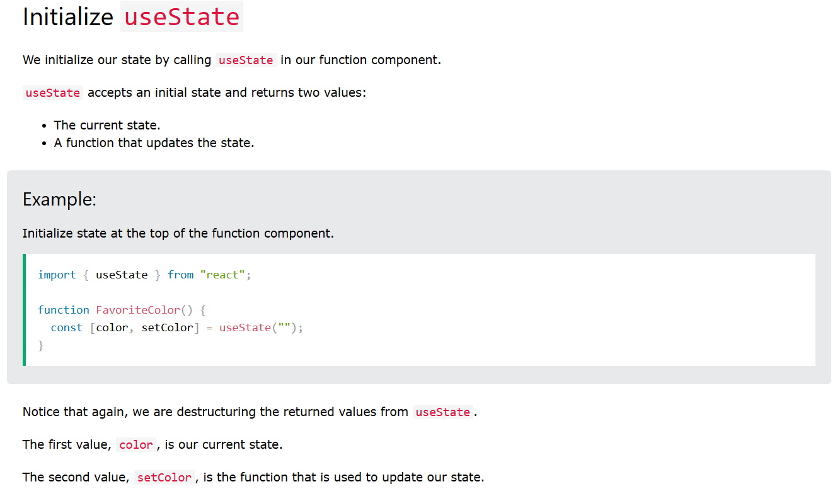

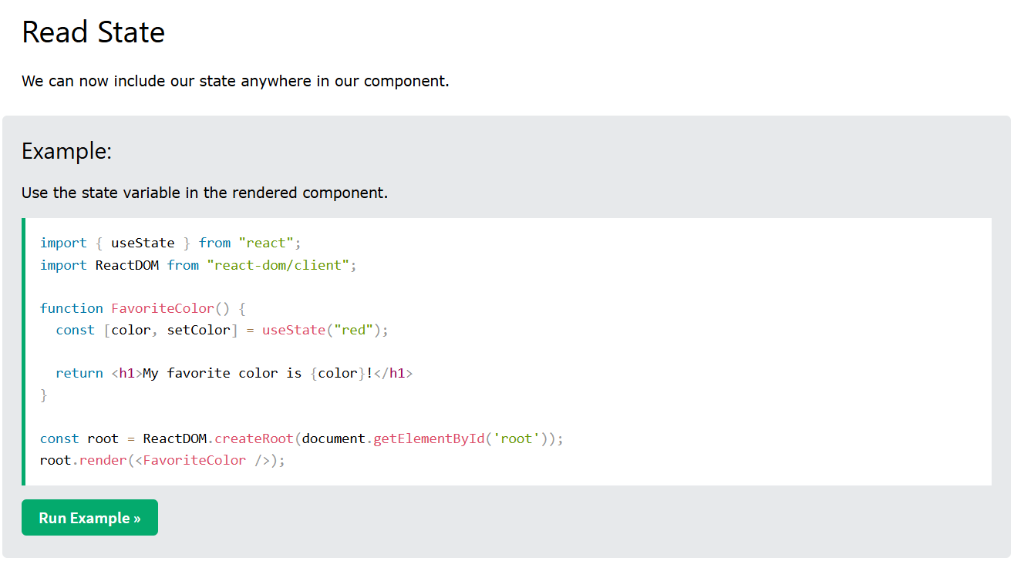

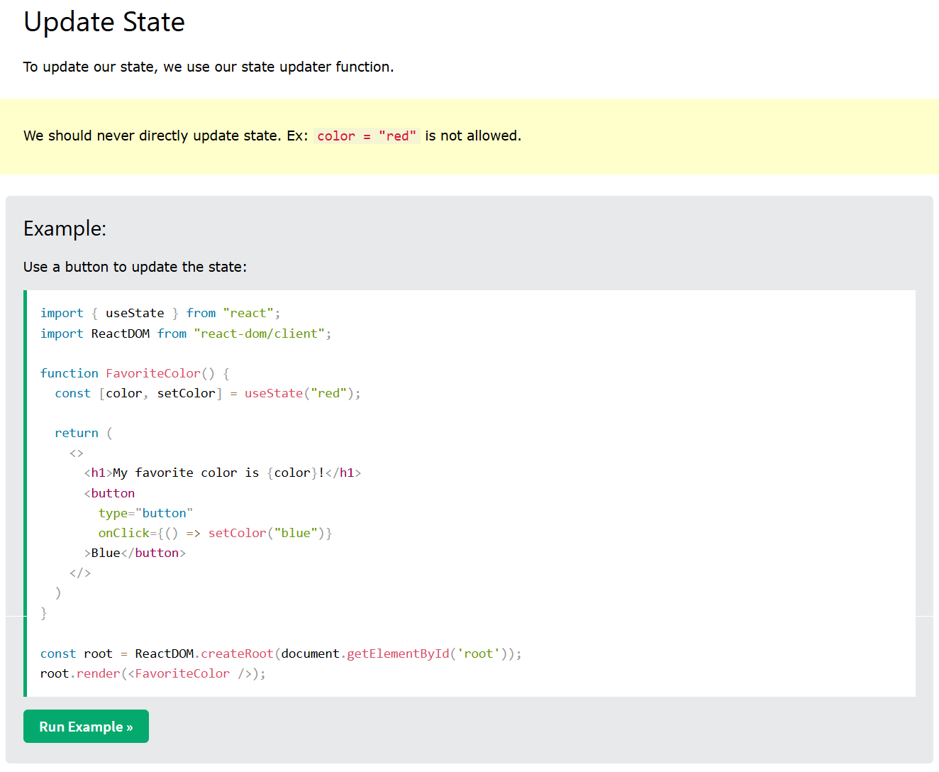

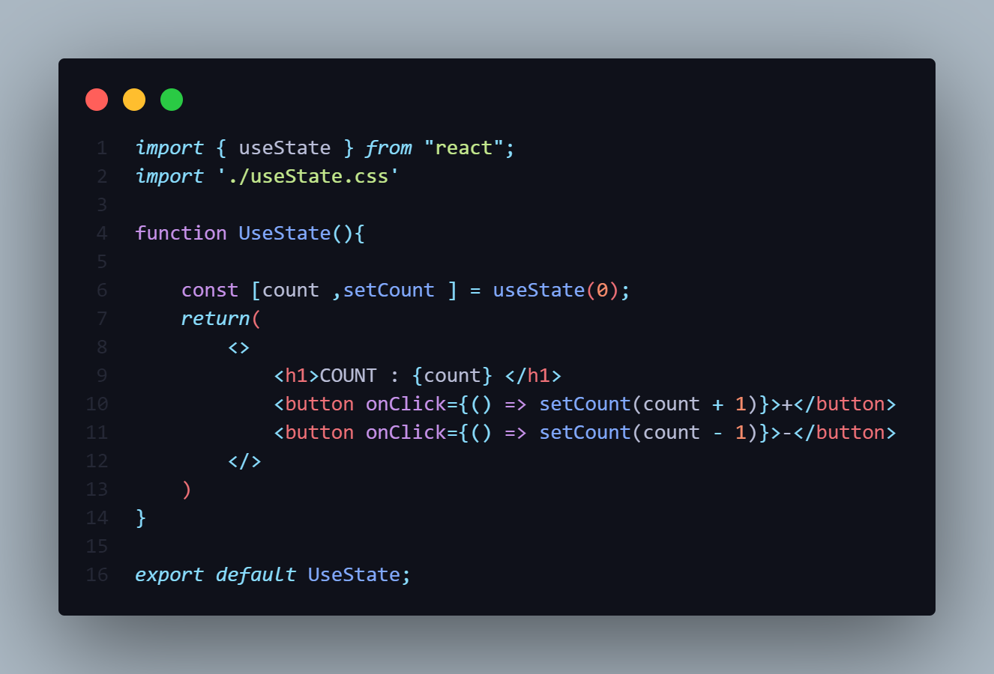

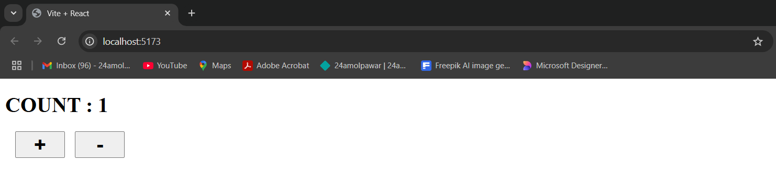

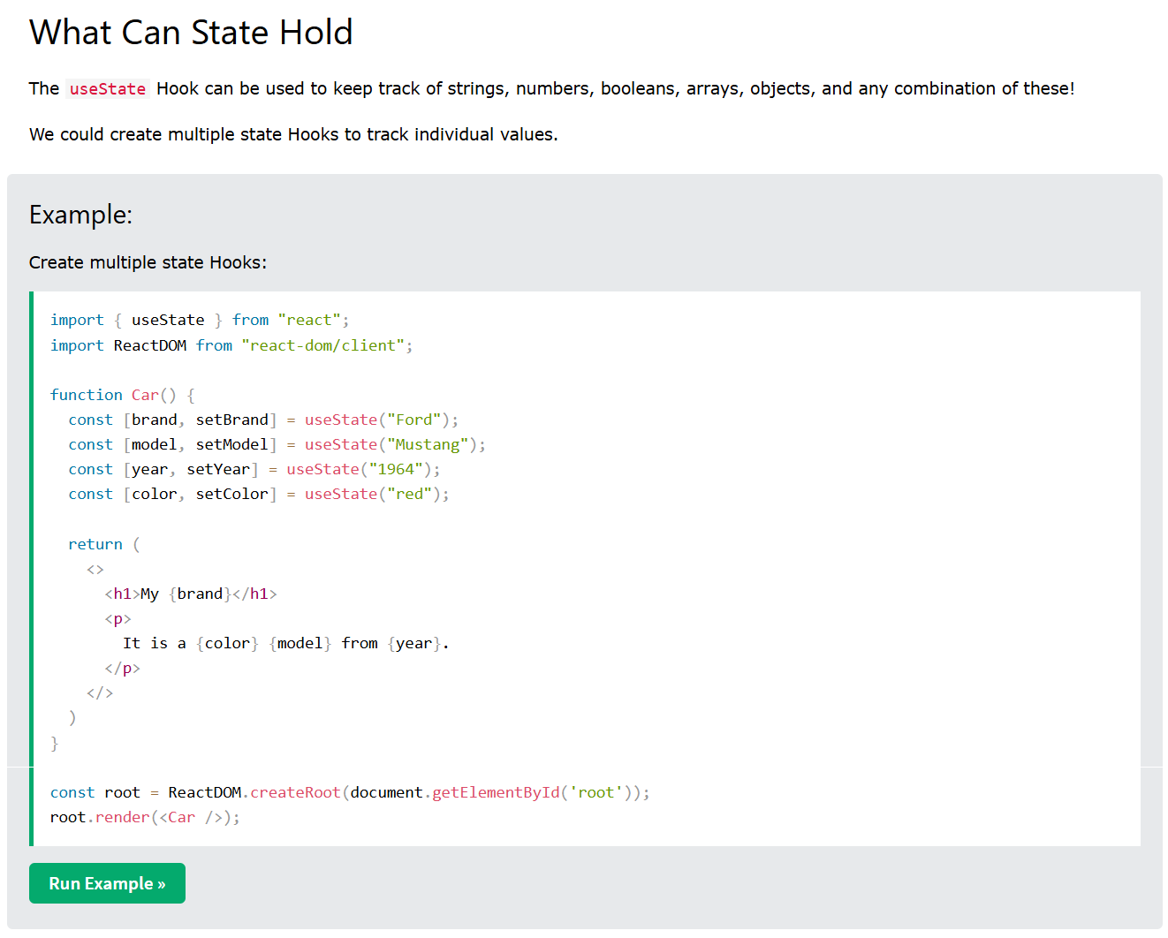

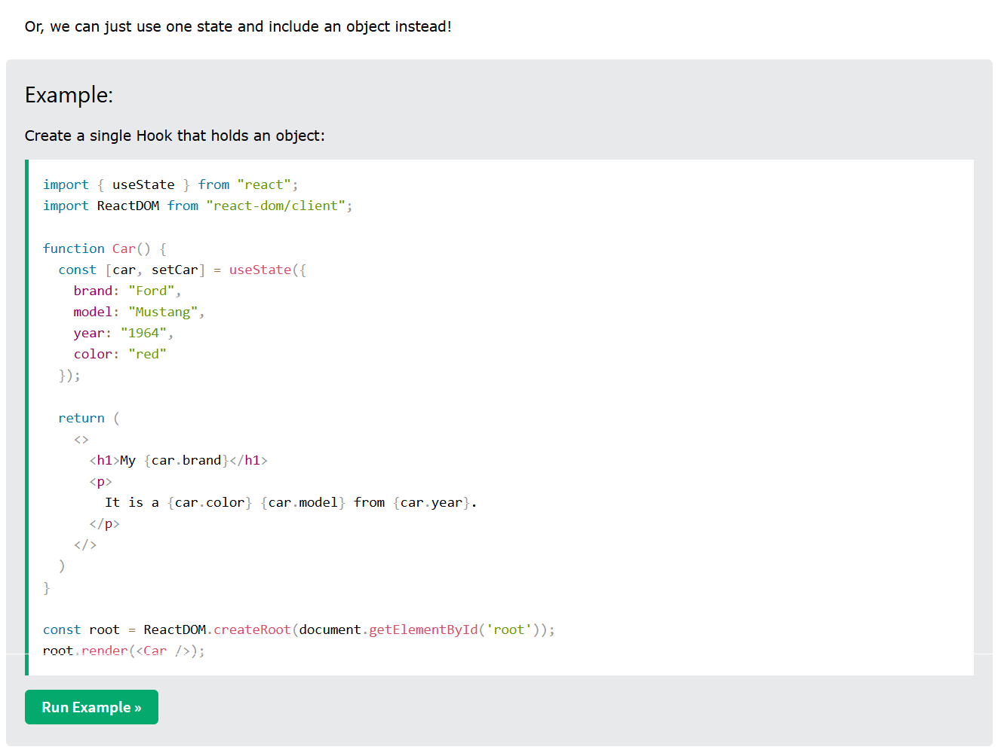

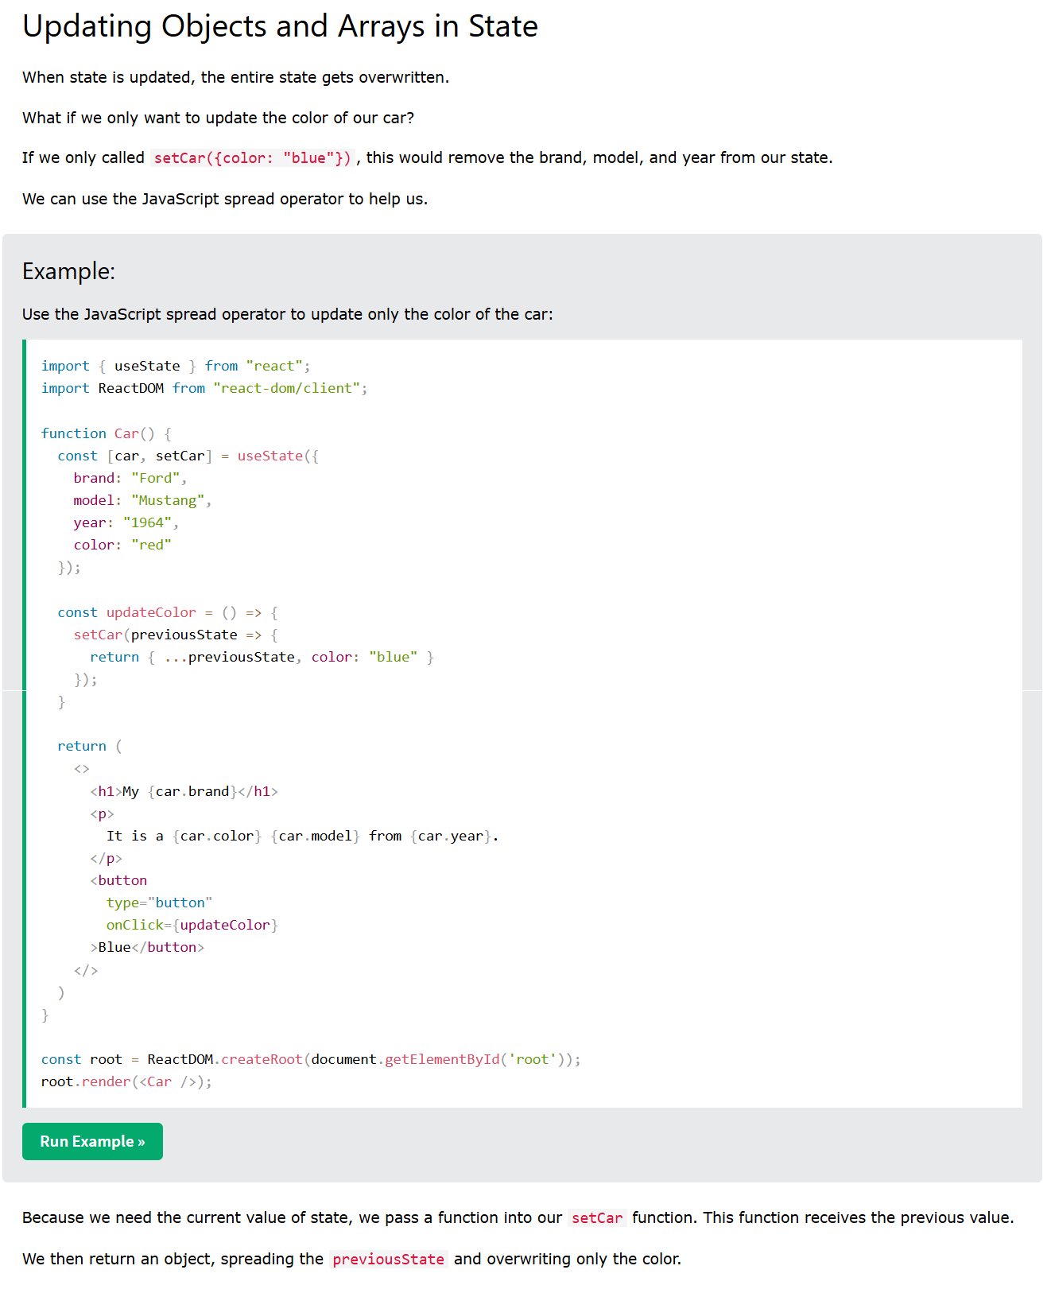

**2.useEffects()**

-useEffect() hook is used to fetch the data externally.

-The useEffect hook in React is used to perform **side effects** in function components.

-Side effect mean not a part of the Function.

-A **side effect** is anything that affects something outside the component, such as fetching data, updating the DOM, or subscribing to events.It is the combination of **componentDidMount**, **componentDidUpdate** and **componentWillUnmount** methods of class-based components.

-useEffect lets you run code at specific times in the component's lifecycle, like when it first loads or when something changes.

-By using this hook we tell the react our component to do something after render.

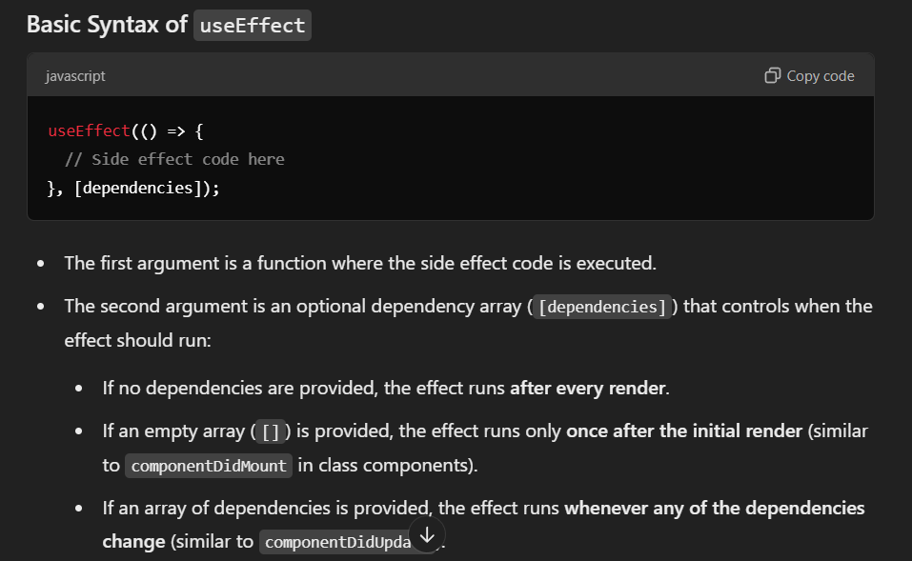

**EXPLAINATION**

useEffect(() => {

// Your side effect code here

}, [dependencies]); // Optional array of dependencies

-It Takes two arguments:-

**Parameters**

1. **First Argument [Effect Function]:**
   * The first argument is a function that contains the code for the side effect. This function is executed after the render is committed to the screen.
2. **SecondArgument [Dependency Array] (Optional):**

-The second argument is an optional array of dependencies that determines when the effect should run:

-**Empty Array []:** The effect runs only once when the component mounts, similar to componentDidMount.

-**With Dependencies:** The effect runs after the initial render and then again whenever any of the dependencies change.

-**No Array:** If you omit the dependency array, the effect runs after every render.

**Simple Explanation:**

* useEffect is like telling React: **"Run this code after the component renders"**.
* It can also be told to **re-run** the code when certain values (called dependencies) change

**Returns**

useEffect returns undefined.

**Example😊**

const tutorials=(props)=>{

   useEffect( ()=>{

      console.log(‘hello’);

      setTimeout( ()=>{ alert(‘hello’); }, 2000);

   }, [] );

}

**How useEffect Works**

1. **Component Mounting**:
   * When the component first renders, the function you provide to useEffect runs after the render is committed to the DOM.
2. **Updating**:
   * If the component updates (for example, state or props change), useEffect can re-run based on the dependencies you provide.
3. **Cleanup**:
   * If you return a function from the effect, React will call this cleanup function when the component unmounts or before the effect runs again (on the next render).

* [Reference](https://react.dev/reference/react/useEffect#reference)
  + [useEffect(setup, dependencies?)](https://react.dev/reference/react/useEffect#useeffect)
* [Usage](https://react.dev/reference/react/useEffect#usage)
  + [Connecting to an external system](https://react.dev/reference/react/useEffect#connecting-to-an-external-system)
  + [Wrapping Effects in custom Hooks](https://react.dev/reference/react/useEffect#wrapping-effects-in-custom-hooks)
  + [Controlling a non-React widget](https://react.dev/reference/react/useEffect#controlling-a-non-react-widget)
  + [Fetching data with Effects](https://react.dev/reference/react/useEffect#fetching-data-with-effects)
  + [Specifying reactive dependencies](https://react.dev/reference/react/useEffect#specifying-reactive-dependencies)
  + [Updating state based on previous state from an Effect](https://react.dev/reference/react/useEffect#updating-state-based-on-previous-state-from-an-effect)
  + [Removing unnecessary object dependencies](https://react.dev/reference/react/useEffect#removing-unnecessary-object-dependencies)
  + [Removing unnecessary function dependencies](https://react.dev/reference/react/useEffect#removing-unnecessary-function-dependencies)
  + [Reading the latest props and state from an Effect](https://react.dev/reference/react/useEffect#reading-the-latest-props-and-state-from-an-effect)
  + [Displaying different content on the server and the client](https://react.dev/reference/react/useEffect#displaying-different-content-on-the-server-and-the-client)

NOTE: Whenever the state is updated the useEffect always runs once. Depended on the dependencies of Second Parameter.

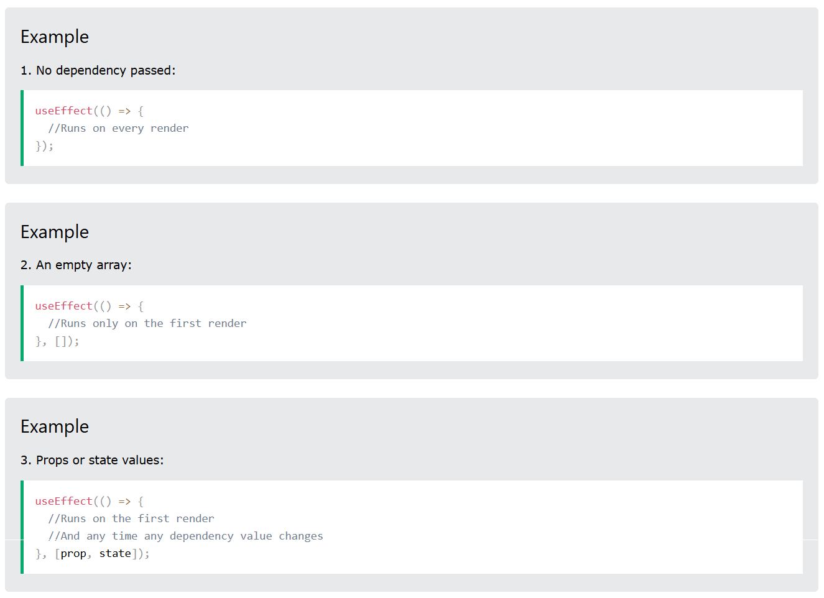

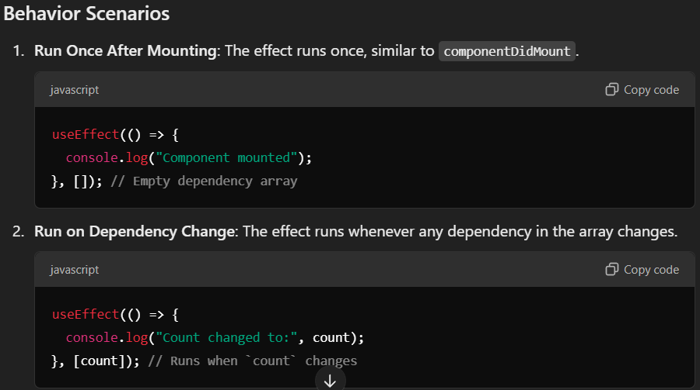

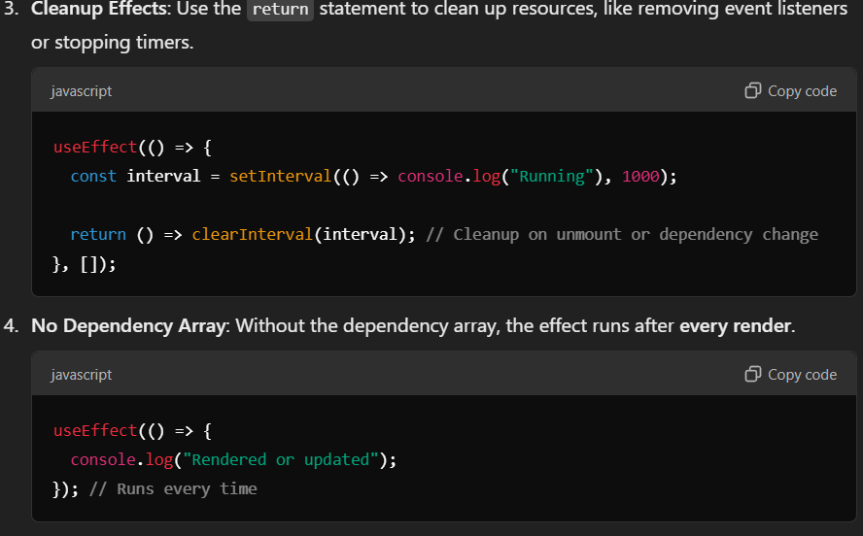

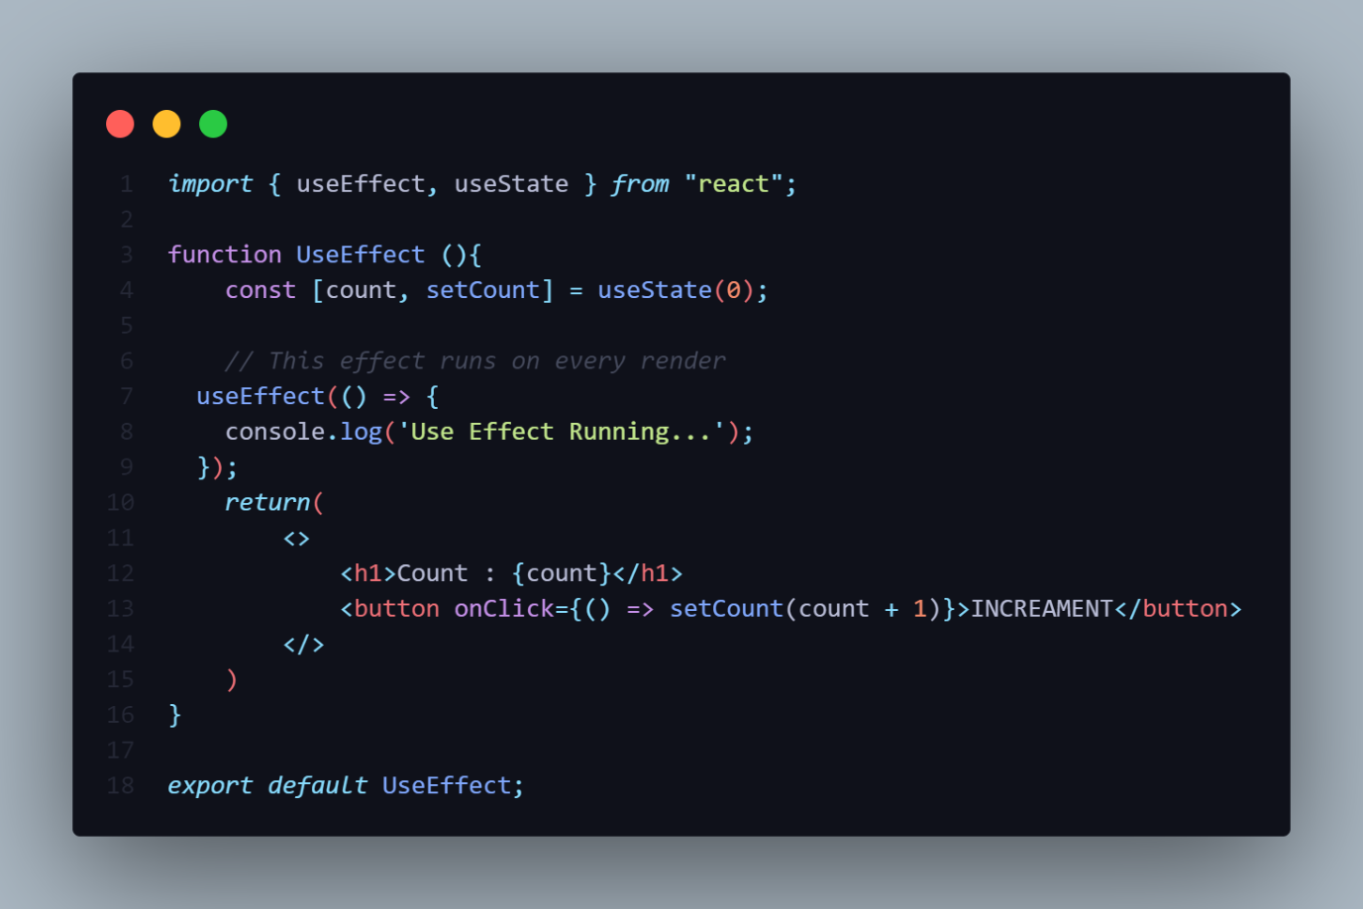

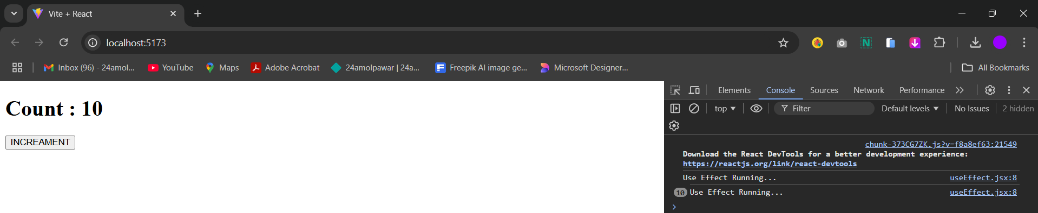

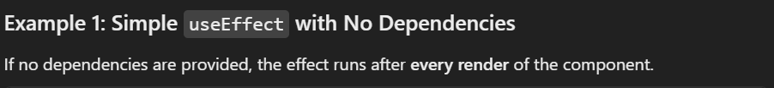

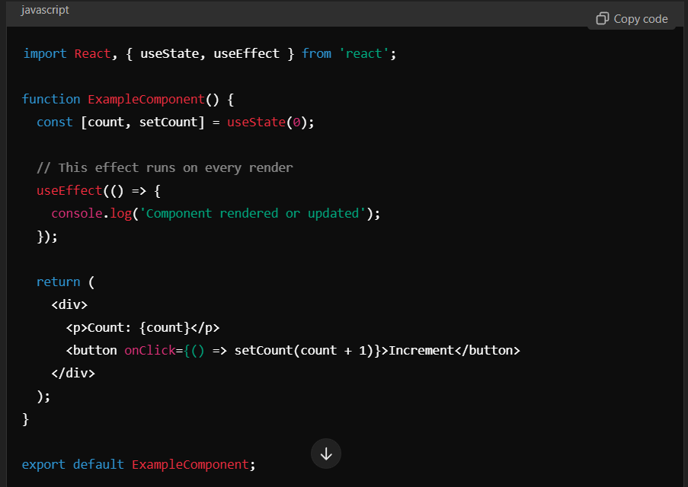



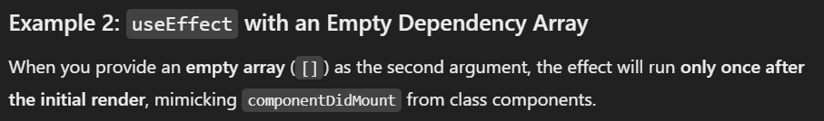

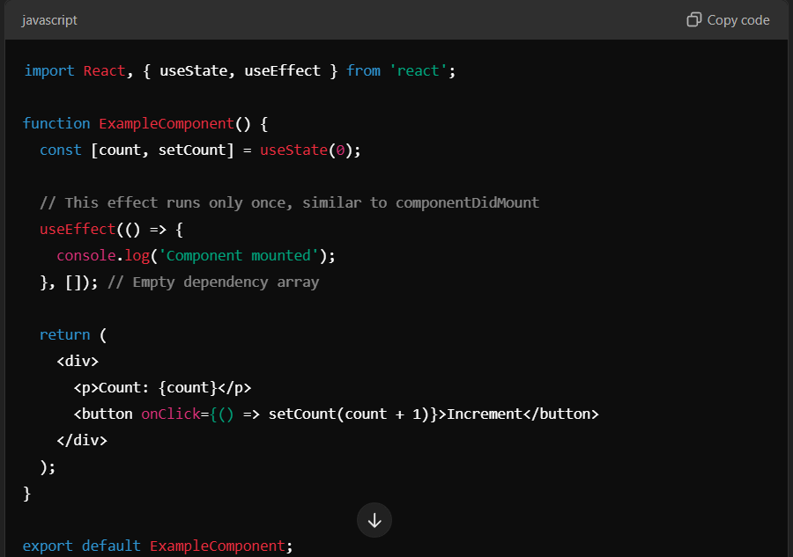

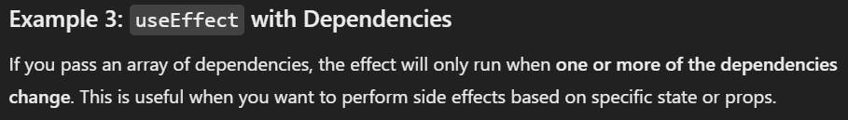

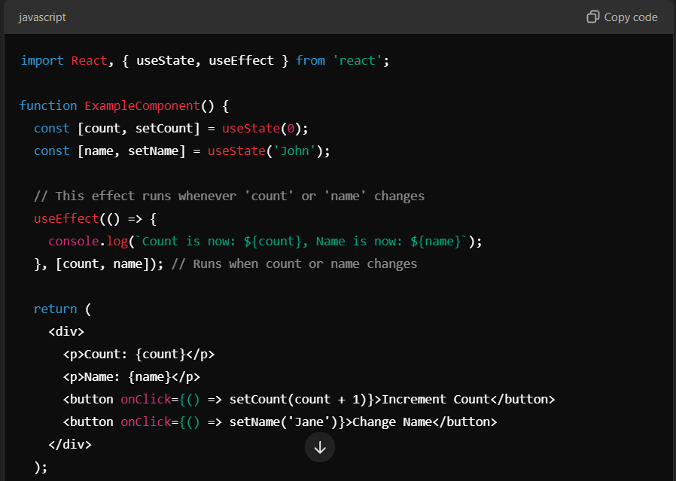

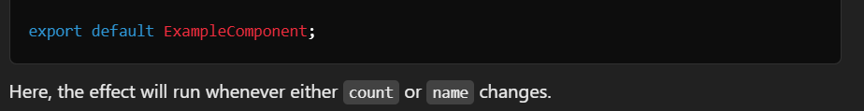

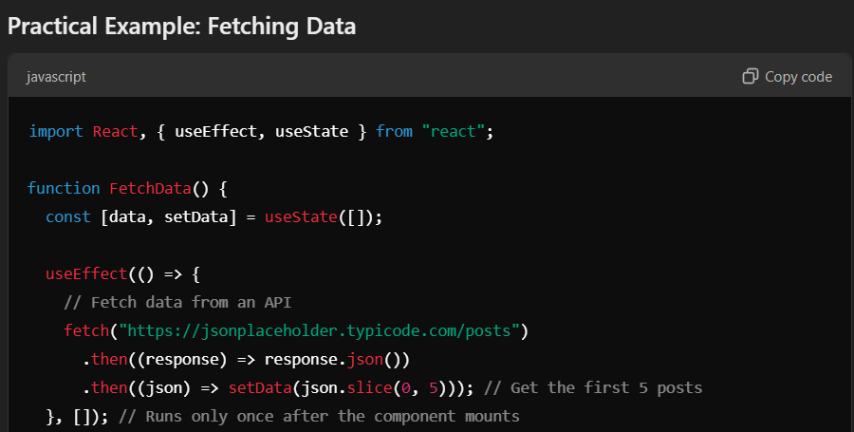

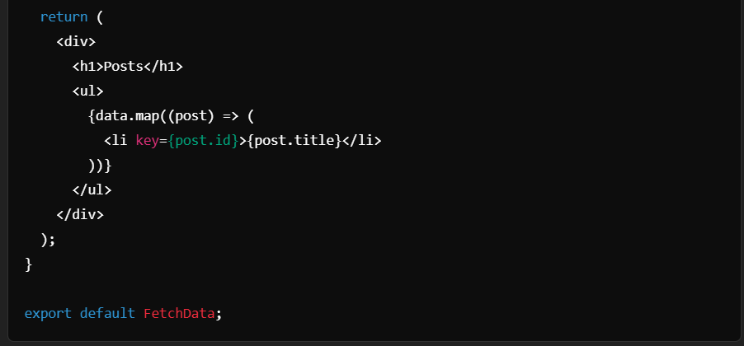

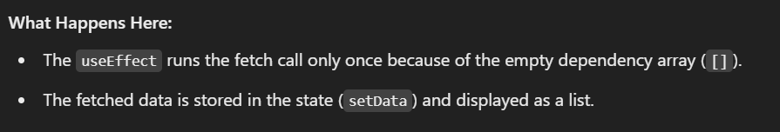

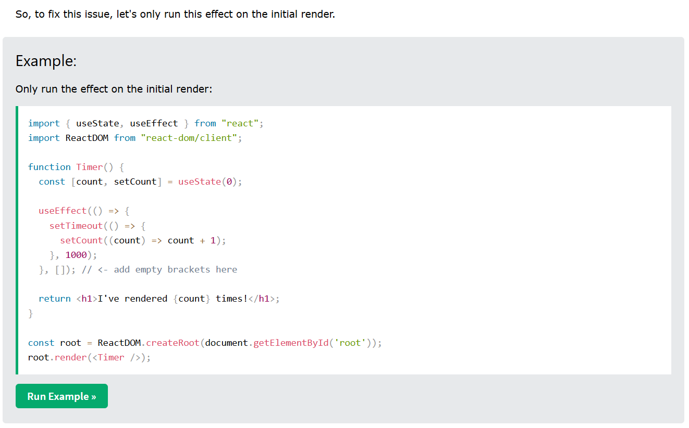

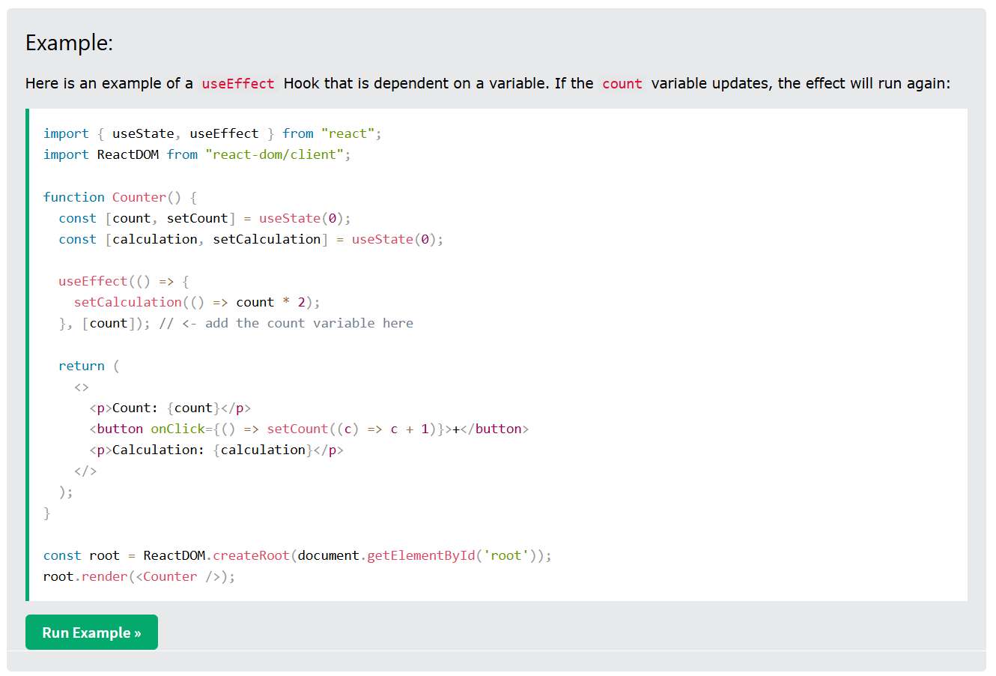

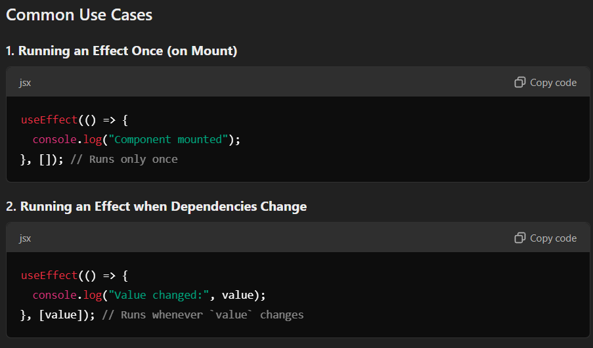

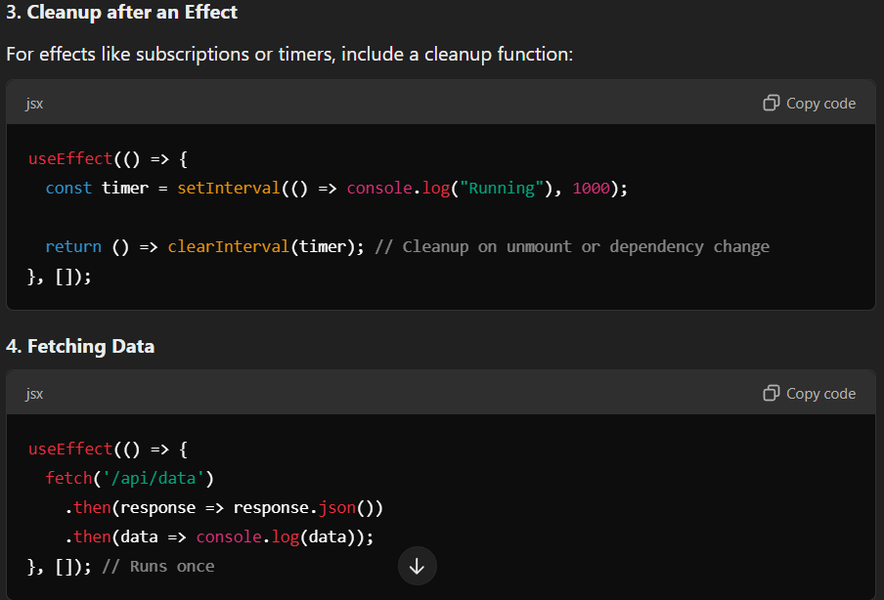

**3.useCallback()**

-useCallback() and useMemo() hook both hook are used to optimized the application by memoizing value and function.

-In React suppose we have component and inside this component we have value to get this value in React we use **children** keyword.

-It is used to optimized the Function by putting that function in cache Memory.

**Memo**

-Memo is a Higher order Function i.e used to memorize(optimize)

A component which means it caches the output of the component and only re-render if the props of that component it change.

**4.useMemo()**

-It is used to optimize Function value and object.

**5.useRef()**

-While using the useRef() Hook and providing and null as the initial value and storing it in a variable when do **console.log**()

-To check the value present inside the variable we will get current as an object and its value null.

let userName = useRef(null);

    let email = useRef(null);

    console.log(userName)

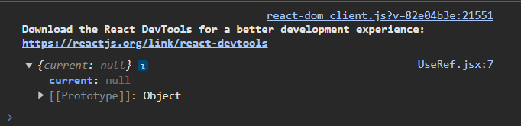

-Here null is the value of current property and current property is an **Object.**

-So when we use **useRef()** hook we will get one object with one property and this property called **current.**

**6.useId()**

**Syntax**



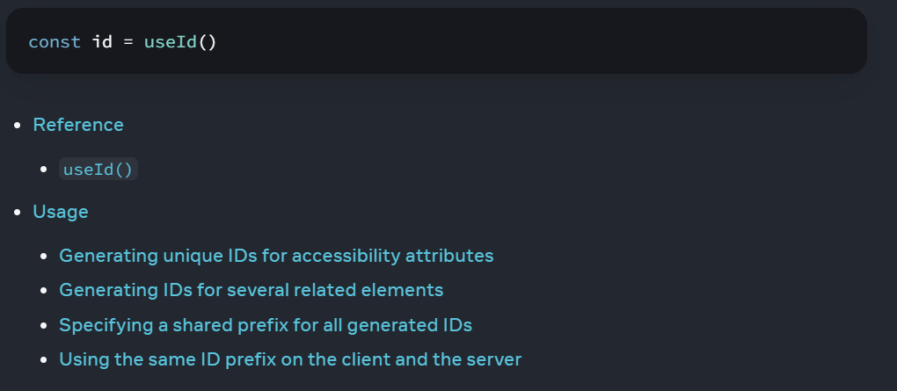

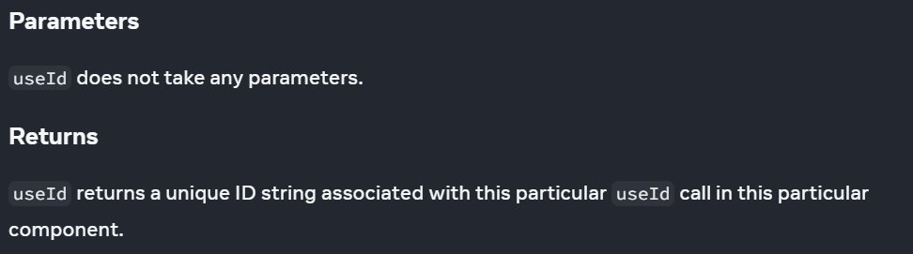

-useId() is a React Hook for generating unique IDs that can be passed to accessibility attributes.

-useID() Hook in React is Used for generating unique ID.

-By using these unique ID we can pass or we can access any element.

-It does not take any Parameters.

-It return unique Id String.

-useId() hook should not be used to generate key in list.

**preventDefault() method**

-The preventDefault() method cancels the event if it is cancelable, meaning that the default action that belongs to the event will not occur.

For example, this can be useful when:

* Clicking on a "Submit" button, prevent it from submitting a form
* Clicking on a link, prevent the link from following the URL

**7.useReducer()**

-useReducer() hook optimize our app performance when we writing complex code.

-useReducer() it returns also return two vales same as useState() hook

1]currState

2]Function[Dispatch]

-The Dispatch function is responsible for all things in useReducer() hook.

-useReducer() hook accepts two things 1]Reducer 2]Initial state

-Here the reducer function accepts two values 1]current State 2]Action

-This action is responsible for change the state of Current State.

-This action comes from Dispatch Function.

-On the basis of current state and actions the reducer will return new state.

**CUSTOM HOOKS**

-Custom hooks in React are JavaScript functions that allow you to share logic between components

-Custom Hooks always prefix[start] with **use** to define it hooks.

-Custom Hooks are uses Built-In[Predefined] Hooks.

-Don’t use in **Side Effect()** Function

-Use in Only Pure Functions. Not Impure Function.

* **When to use them**

Custom hooks can be useful for a variety of use cases, including:

* + Form handling
  + Animation
  + Declarative subscriptions
  + Timers
  + Wrapping effects
  + Migrating to better patterns
  + Communicating intent

**REACT-ROUTER-DOM**

-It is third party library.

-As we know we are getting useEffect(),useState() etc hooks from React in the same way we will get **<Link>** & **<NavLink>** From **React-Router-Dom**

-As we know anchor tag in HTML for the Linking the url files in the same way we use **<Link>** tag in React.

-If we use anchor tag at the place of **<Link>** tag so while clicking on that button or link our React page will Re-render but by using <Link> for the same process Page Re-Render & Refresh will not occur.

**HIGHER ORDER COMPONENT**

-In hoc we pass another component as an argument and it return another new component.

-HOC are the type of wrapper function.

-Higher order component are used whenever we want to share common code among multiple component.

**USE MEMO**

-Memeoization is an optimized techniques that make application mode effective and master.

-It does this by storing the result in the cache.

-

**IMPORTANT QUESTIONS**

**QNO1 :- Is Browser is Understand JSX?**

No, browsers do not understand JSX directly:

* What is JSX?

JSX stands for JavaScript syntax extension, which is a JavaScript extension that allows developers to describe React's object tree using an HTML template-like syntax.

* Why browsers don't understand JSX?

Browsers can only read JavaScript objects, but JSX is not a regular JavaScript object.

* How to enable browsers to read JSX?

To enable browsers to read JSX, you need to use a transpiler to transform JSX into regular JavaScript. The most popular transpiler for JSX is Babel.

* How does the transpiler work?

The transpiler transforms JSX into React function calls that the browser can understand.

JSX can make the development and debugging process easier for developers. It combines the beauty of HTML and the power of JavaScript.

**QNO2 : - Where the Virtual DOM is Present?**

**INDEX.js**

*import* React *from* 'react';

*import* ReactDOM *from* 'react-dom/client';

*import* App *from* './App';

const root = ReactDOM.createRoot(document.getElementById('root'));

root.render(

  <React.StrictMode>

    <App />

  </React.StrictMode>

);

-Virtual Dom Present inside the Index.js which is the entry point of our application.

-ReactDom uses the render() method for kick-start of our applications.

**QNO3 : - Explain the Index.Js File?**

*import* React *from* 'react';

*import* ReactDOM *from* 'react-dom/client';

*import* App *from* './App';

const root = ReactDOM.createRoot(document.getElementById('root'));

root.render(

  <React.StrictMode>

    <App />

  </React.StrictMode>

);

*import* React *from* 'react';

-It is the foundation libraries that tells it is a React App.

-It takes the reference from React

*import* ReactDOM *from* 'react-dom/client';

-It is foundation library that tell it is an webApp.

-Because it take Virtual DOM from **'react-dom/client';**

const root = ReactDOM.createRoot(document.getElementById('root'));

root.render(

  <React.StrictMode>

    <App />

  </React.StrictMode>

-React will give us power of JSX which means by the help of JS we can render the HTML.

-JSX is almost similar as HTML.

-By the help of JSX we can create the our own TAG

For Example **<App/>**

**QNO4 : - Is there any script file is linked with index.html file?**

🡺Yes but it dies not shown in the index.html because it is present in the **package.json** file.

-If create the React-App using **vite** then it shown the that linked script file.

{

  "name": "npx-demo",

  "version": "0.1.0",

  "private": true,

  "dependencies": {

    "@testing-library/jest-dom": "^5.17.0",

    "@testing-library/react": "^13.4.0",

    "@testing-library/user-event": "^13.5.0",

    "react": "^18.3.1",

    "react-dom": "^18.3.1",

    "react-scripts": "5.0.1",

    "web-vitals": "^2.1.4"

  },

    "react-scripts": "5.0.1",

-It links the Javascript file to the index.html

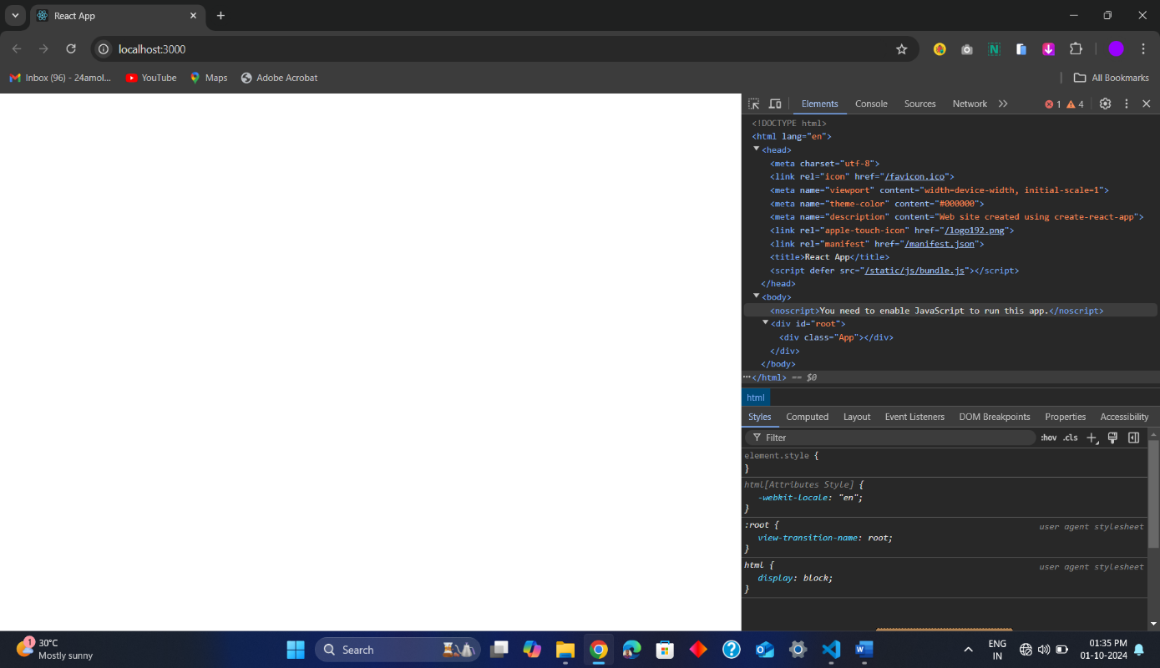

<script defer="" src="/static/js/bundle.js"></script>

**QNO5:- can you change the start command name in reactjs?**

🡺Yes, you can change the start command name in a React project created with Create React App. Here's how:

Method 1: Using package.json scripts

* Open package.json: Open the package.json file in the root of your project.
* Modify the start script: Locate the scripts section and change the start script's name. For example:

**Code :-**

"scripts": {  
 "mystart": "react-scripts start", *// Change "start" to "mystart"*  
 "build": "react-scripts build",  
 "test": "react-scripts test",  
 "eject": "react-scripts eject"  
 }

* Run your new command: Now, you can start your development server using:

Code

npm run mystart

Method 2: Using npm-run-all

* Install npm-run-all: If you don't have it already, install the npm-run-all package:

Code

npm install --save-dev npm-run-all

* Modify package.json: Add a new script with your desired command name:

**Code :-**

"scripts": {  
 "start": "react-scripts start",  
 "dev": "npm-run-all -p start watch-css", *// Example: Run "start" and "watch-css" in parallel*  
 *// ... other scripts*  
 }

Run the new command.

Code

npm run dev

QNO 6:- What is webpack in React?

QNO7: What is Yarn?

🡺 Yarn is a package manager for JavaScript, originally developed by Facebook (now Meta) in 2016. It's an alternative to npm (Node Package Manager) and aims to be faster, more secure, and more reliable.

Key features of Yarn:

* Faster installation:

Yarn uses a local cache and parallel downloads to install packages faster than npm.

* Deterministic builds:

Yarn generates a yarn.lock file that ensures consistent package versions across different environments.

* Security:

Yarn verifies the integrity of packages using checksums before installation.

* Offline mode:

Yarn can install packages from its cache even without an internet connection.

* Compatibility:

Yarn is compatible with the npm registry and can use the same package.json file

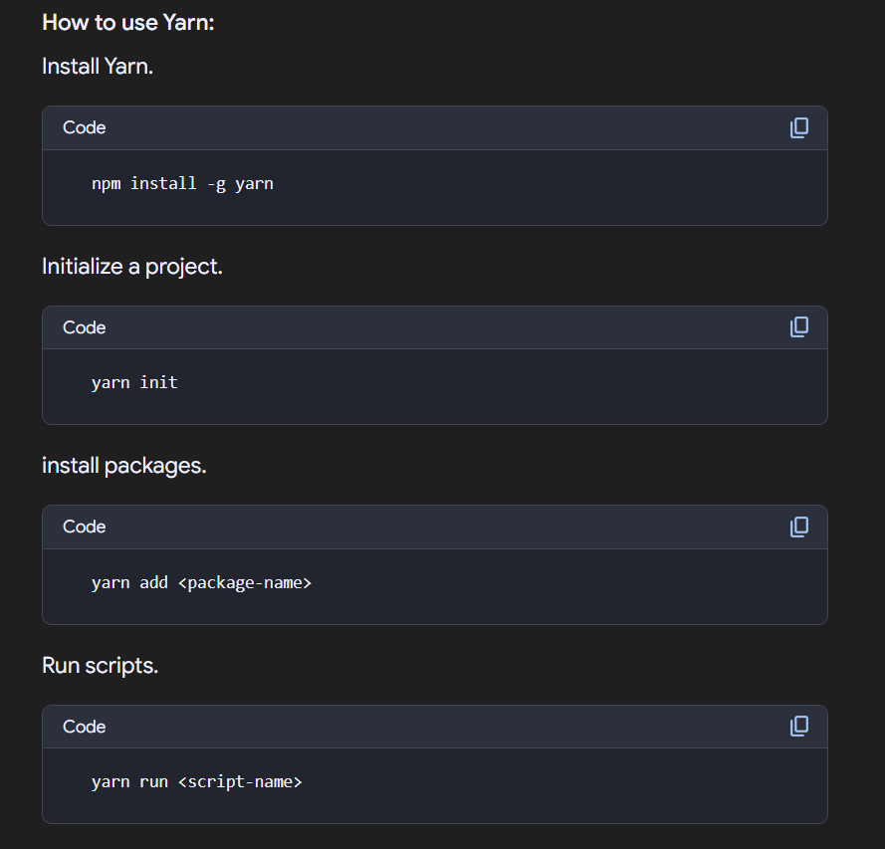

Yarn vs npm:

While both Yarn and npm are excellent package managers, Yarn has some advantages over npm, such as faster installation, deterministic builds, and offline support. However, npm is still the default package manager for Node.js and is widely used.

Choosing the right package manager:

* If you're starting a new project, Yarn is a great choice due to its performance and reliability.
* If you're working on an existing project that uses npm, you can continue using npm or migrate to Yarn if you want to take advantage of its features.

QNO8 : - How To Open Vite Dev Server Directly On The Browser?

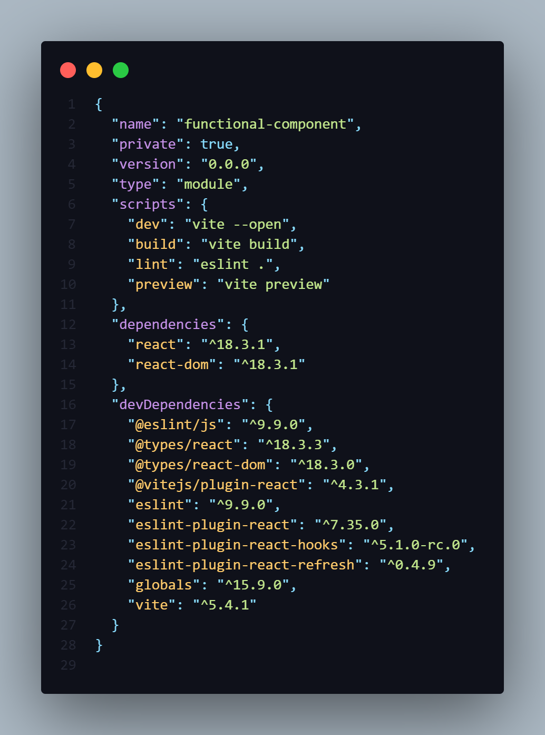

--open

**1.**GO to the 🡺 **Package.json File**

**2.**Then go the **scripts.**

**3.**In value section add **–open** after the vite.

**“dev” : “ vite –open”,**

NOTE:-

-For Normal app CRA [CREATE-REACT-APP] having same changes in same file.

NOTE:-

QNO9 : - How change command name of npm run dev of Vite App?

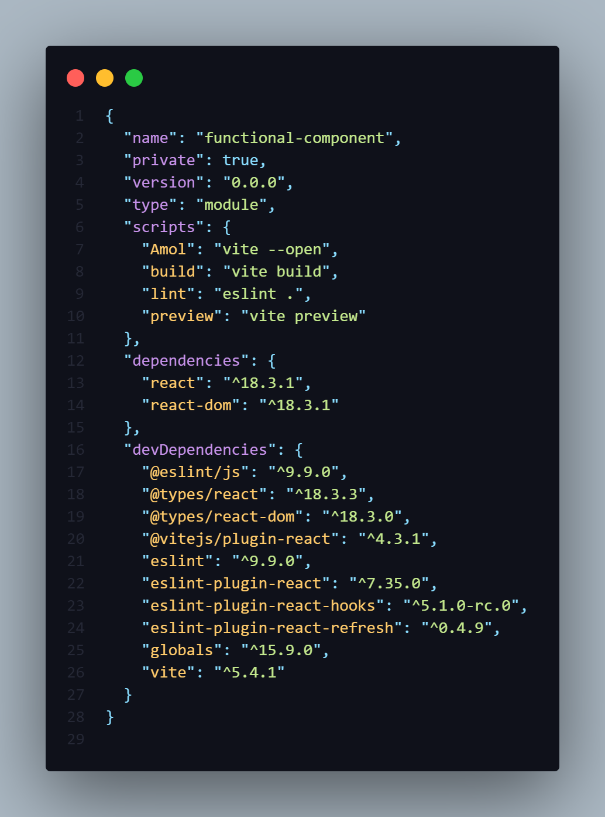

Amol

**1.**GO to the 🡺 **Package.json File**

**2.**Then go the **scripts.**

**3.**Instead of **dev** you have add own command ex **Amol**

**“Amol” : “ vite –open”,**

NOTE:-

-For Normal app CRA [CREATE-REACT-APP] having same changes in same file.

QNO10 : - How to Chang in Port No In CRA APPS[Normal Apps]?

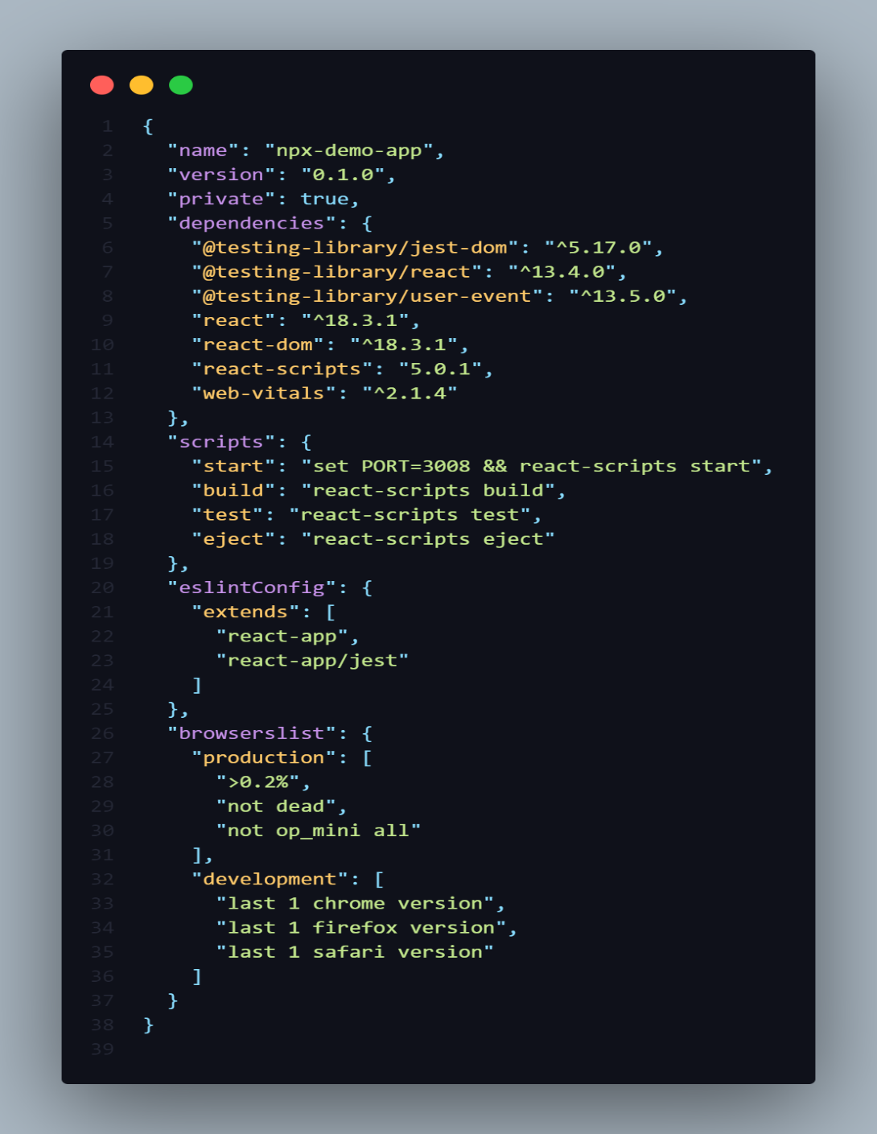

**1.**GO to the 🡺 **Package.json File**

**2.**Then go the **scripts.**

**3.**The inside the first Pair add **set PORT = 3008**

**4.**save the File.

QNO11 : - How to Chang in Port No In Vite APPS?

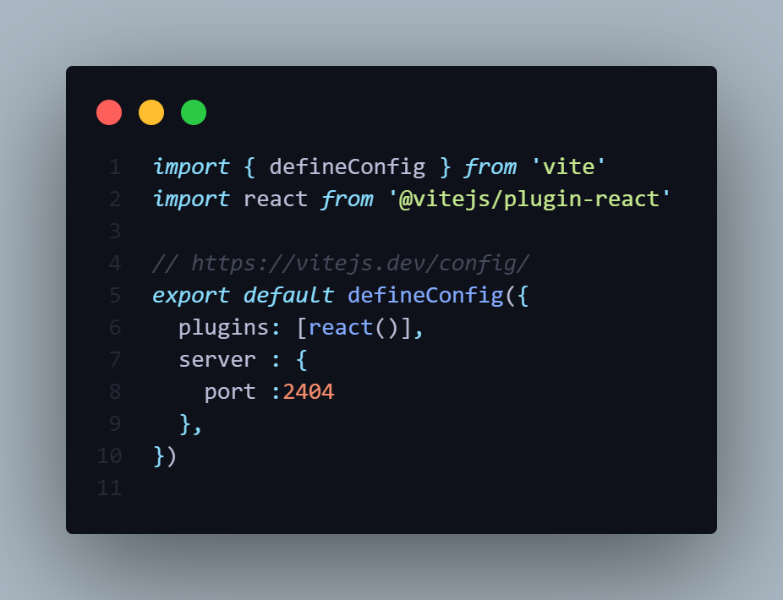

* 1. Go to the **vite.config.js** file
  2. After plugins add new Pair name **server : [port : 2404]**
  3. Save the file.

**IMPORTATANT NOTE**

**1.( ) => { }**

**2.( ) => ( )**

-In JavaScript, both => () and => {} are part of **arrow function** syntax, but they have different meanings depending on whether you use parentheses () or curly braces {}. Let's break them down:

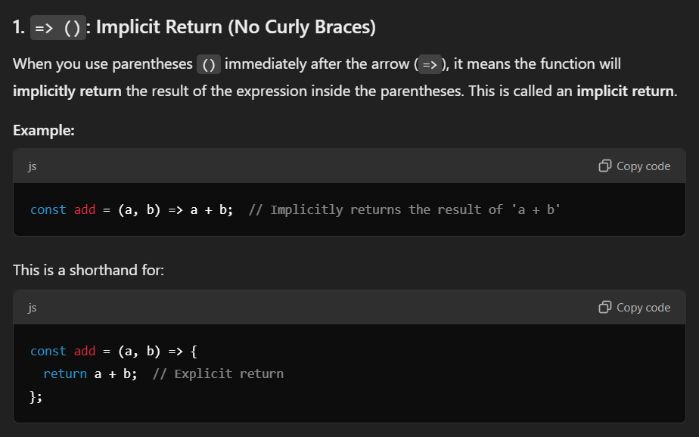

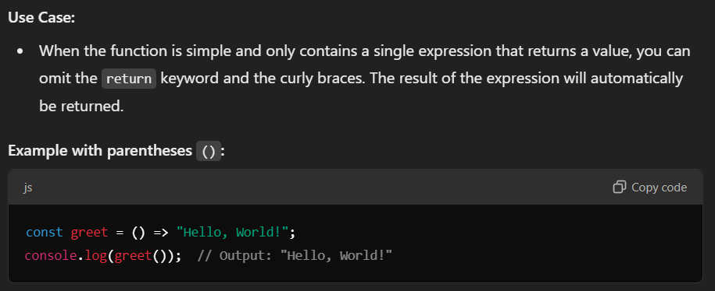

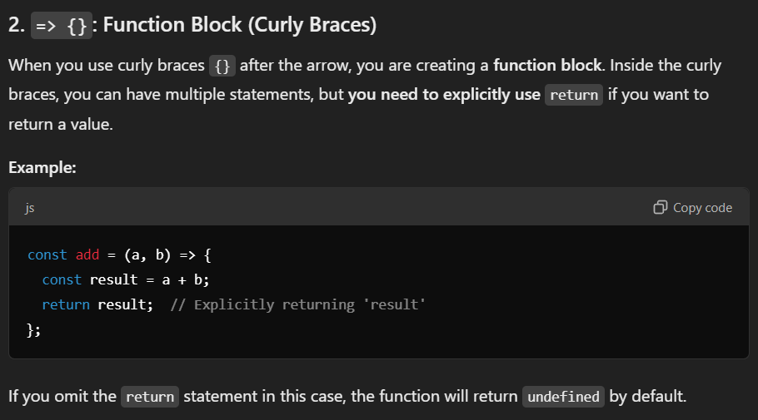

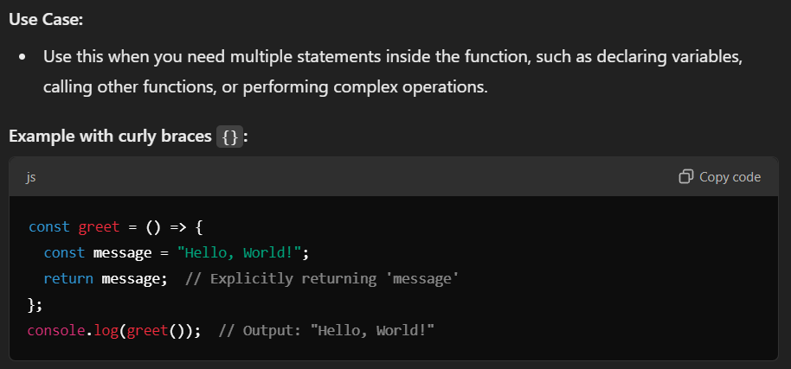

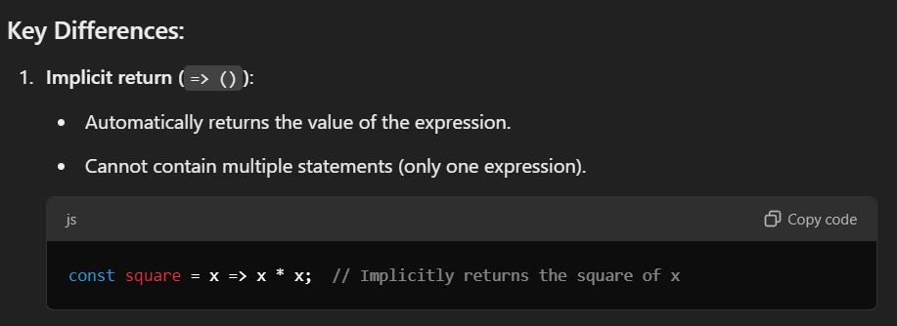

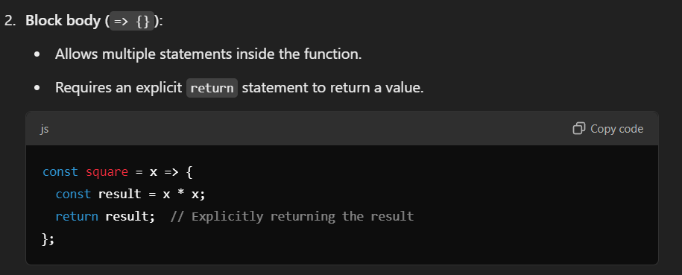

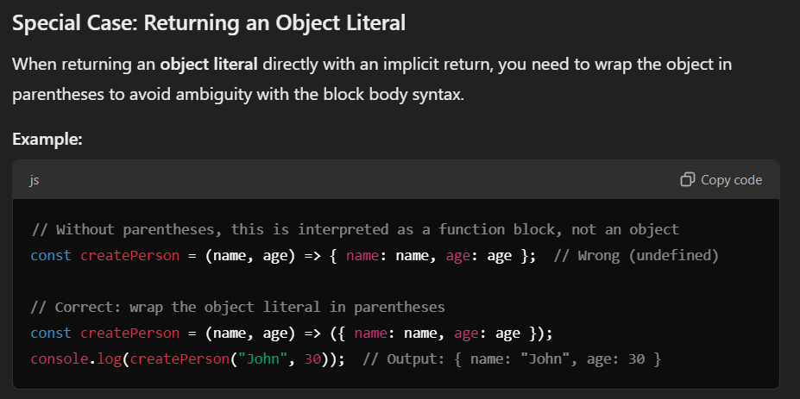

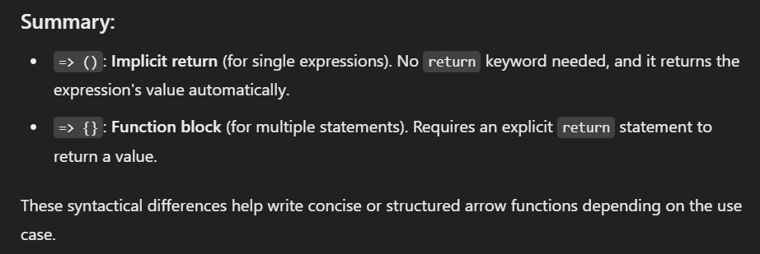

**USEFUL WEBSITES**

Readymade Component :- <https://www.devui.in/>